**Lab Report No: 03**

**Lab Report Name: Introduction to python**

**Name: S.M.SANOWER HOSSAIN**

**ID: IT-16047**

**Objective:** The objective of this lab is to run python on local machine and run some codes to familiarize ourselves with this language.

**Introduction:** Python is an interpreted, object-oriented, high-level programming language with dynamic semantics. Its high-level built in data structures, combined with dynamic typing and dynamic binding, make it very attractive for Rapid Application Development, as well as for use as a scripting or glue language to connect existing components together. Python's simple, easy to learn syntax emphasizes readability and therefore reduces the cost of program maintenance. Python supports modules and packages, which encourages program modularity and code reuse. The Python interpreter and the extensive standard library are available in source or binary form without charge for all major platforms, and can be freely distributed.

**Installation:**

We can download python from ‘ <https://www.python.org/downloads/> ‘

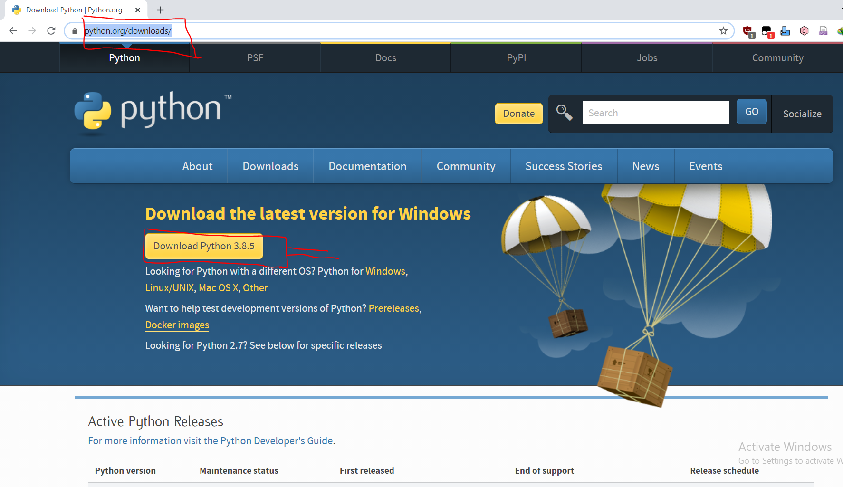

After downloading the file we can start installation procedure for python. We should select add to path option when installing python. Otherwise our computer will not be able to find necessary interpreter for running python scripts. I will not run cmd for interpreting instead I’ll use Windows Powershell. Everything can be done in cmd too. But powershell UI is convenient and very clean.

**Checking python installation in out system:**

Run py –version in powershell/cmd



As we can see my pc is running python 3 perfectly.

Now lets run some python script.

Testing some features of python:

1.Print Function

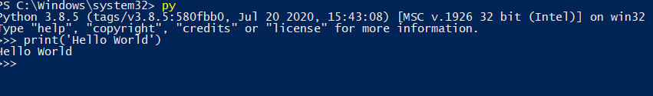

2.Addition

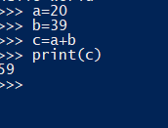

2.Subtraction

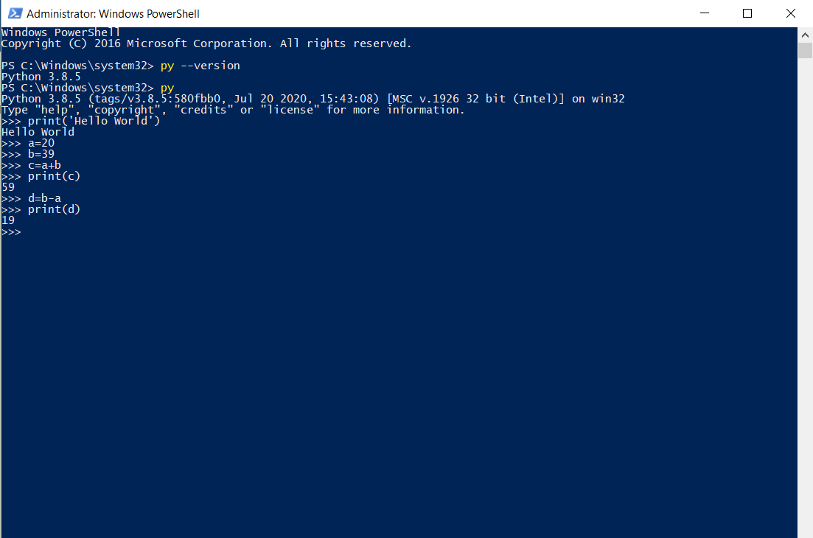

**Conclusion**: There are many benefits of learning Python, especially as your first language, which we will discuss. It is a language that is remarkably easy to learn, and it can be used as a stepping stone into other programming languages and frameworks. If you’re an absolute beginner and this is your first time working with any type of coding language, that’s something you definitely want. Python is widely used, including by a number of big companies like  
Google, Pinterest, Instagram, Disney, Yahoo!, Nokia, IBM, and many others. The Raspberry Pi – which is a mini computer and DIY lover’s dream – relies on Python as it’s main programming language too.