Equipment Hub
  - Connected Worker Platform for Material Handling & Industrial Automation
SANTECH
May 2026

Scan a QR. Get the right manual, every time.
A Connected Worker Platform purpose-built for material handling and industrial automation. Stick a code on every machine. Your technicians scan, see authored content scoped to that exact serial, and resolve issues without flipping through 700-page PDFs.
Three things you get:
- No app to install — runs in any phone or tablet browser
- Built for the shop floor — gloved hands, bright sunlight, harsh wifi
- Compliance-grade audit trail on every scan, view, and procedure step
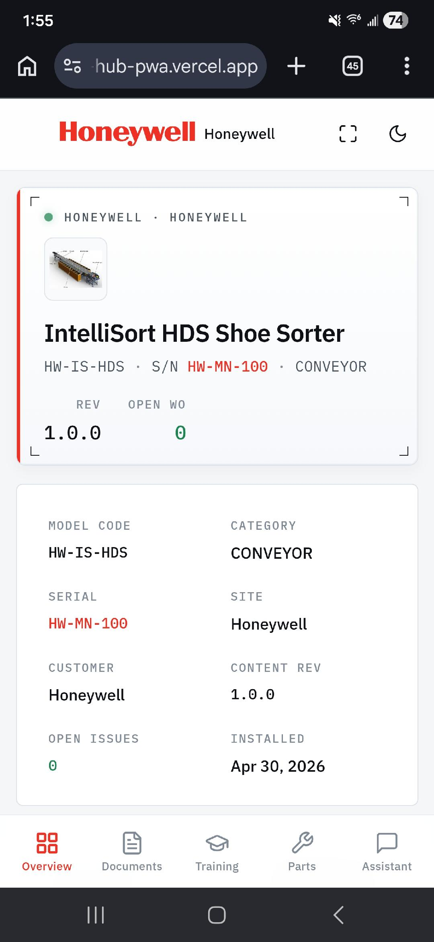
Asset overview on the technician’s phone

How it works
From scan to fix in three steps. No new hardware, no new software for your team — your existing documentation becomes a structured, searchable, audited resource.

01 · Stick a QR on the machine
Branded QR labels printed and shipped. Place them next to nameplates, control panels, or access doors. Each code resolves server-side — re-targetable when equipment is replaced, revocable on theft, and audit-logged on every scan.

02 · Tech scans with any phone
Native camera, no app to install. The PWA loads instantly and resolves to the asset’s authored content pack — model, serial, content rev, install date, all in one screen.

03 · Right answer, every time
Section-anchored manuals, parts lists with diagrams, structured procedures, AI assistant grounded on your published content. Safety-critical procedures quoted verbatim — never paraphrased.
Why this matters: MHI technicians spend 20–40% of their wrench time hunting for the right manual page. Equipment Hub collapses that to a single QR scan — and every interaction is audit-logged for compliance, training records, and procedure evidence.

Features

01 · Identification
One scan. The whole asset.
Brand-aware UI shows model code, serial, content revision, customer, install date, and any open work orders — before the tech even reads a manual.

Asset overview
- Scoped to the exact serial — two identical machines at different sites can have different content versions
- Branded per OEM with custom logos, colors, and accessibility-validated contrast
- Server-side QR resolution — re-target on equipment swap, revoke on theft

02 · Documentation
Sectioned by part. Anchored to the page.
Manuals split into part-specific sections. Page ranges for PDFs, time codes for video, text excerpts for markdown. Authored once against an asset model.
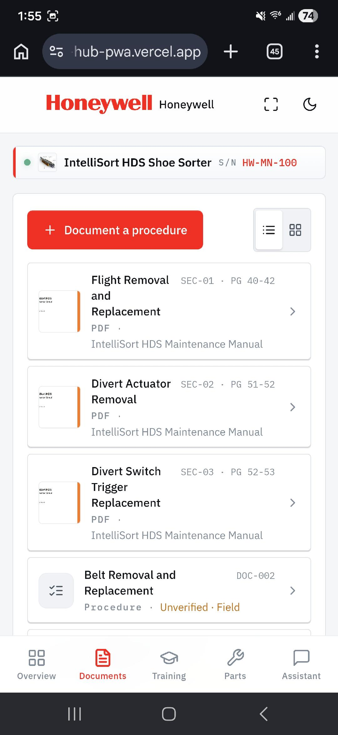
Sectioned documentation list
- Page anchors with optional Y-crops for sub-page boundaries
- Automatic re-validation when an OEM publishes a manual revision
- Procedures author-able as structured checklists with step-by-step evidence

03 · AI Assistant
An AI that knows your equipment.
Ask anything about the equipment. Answers are grounded on the published content for that exact serial — every claim traces back to a section in the manuals. Safety-critical procedures are quoted verbatim, never paraphrased.
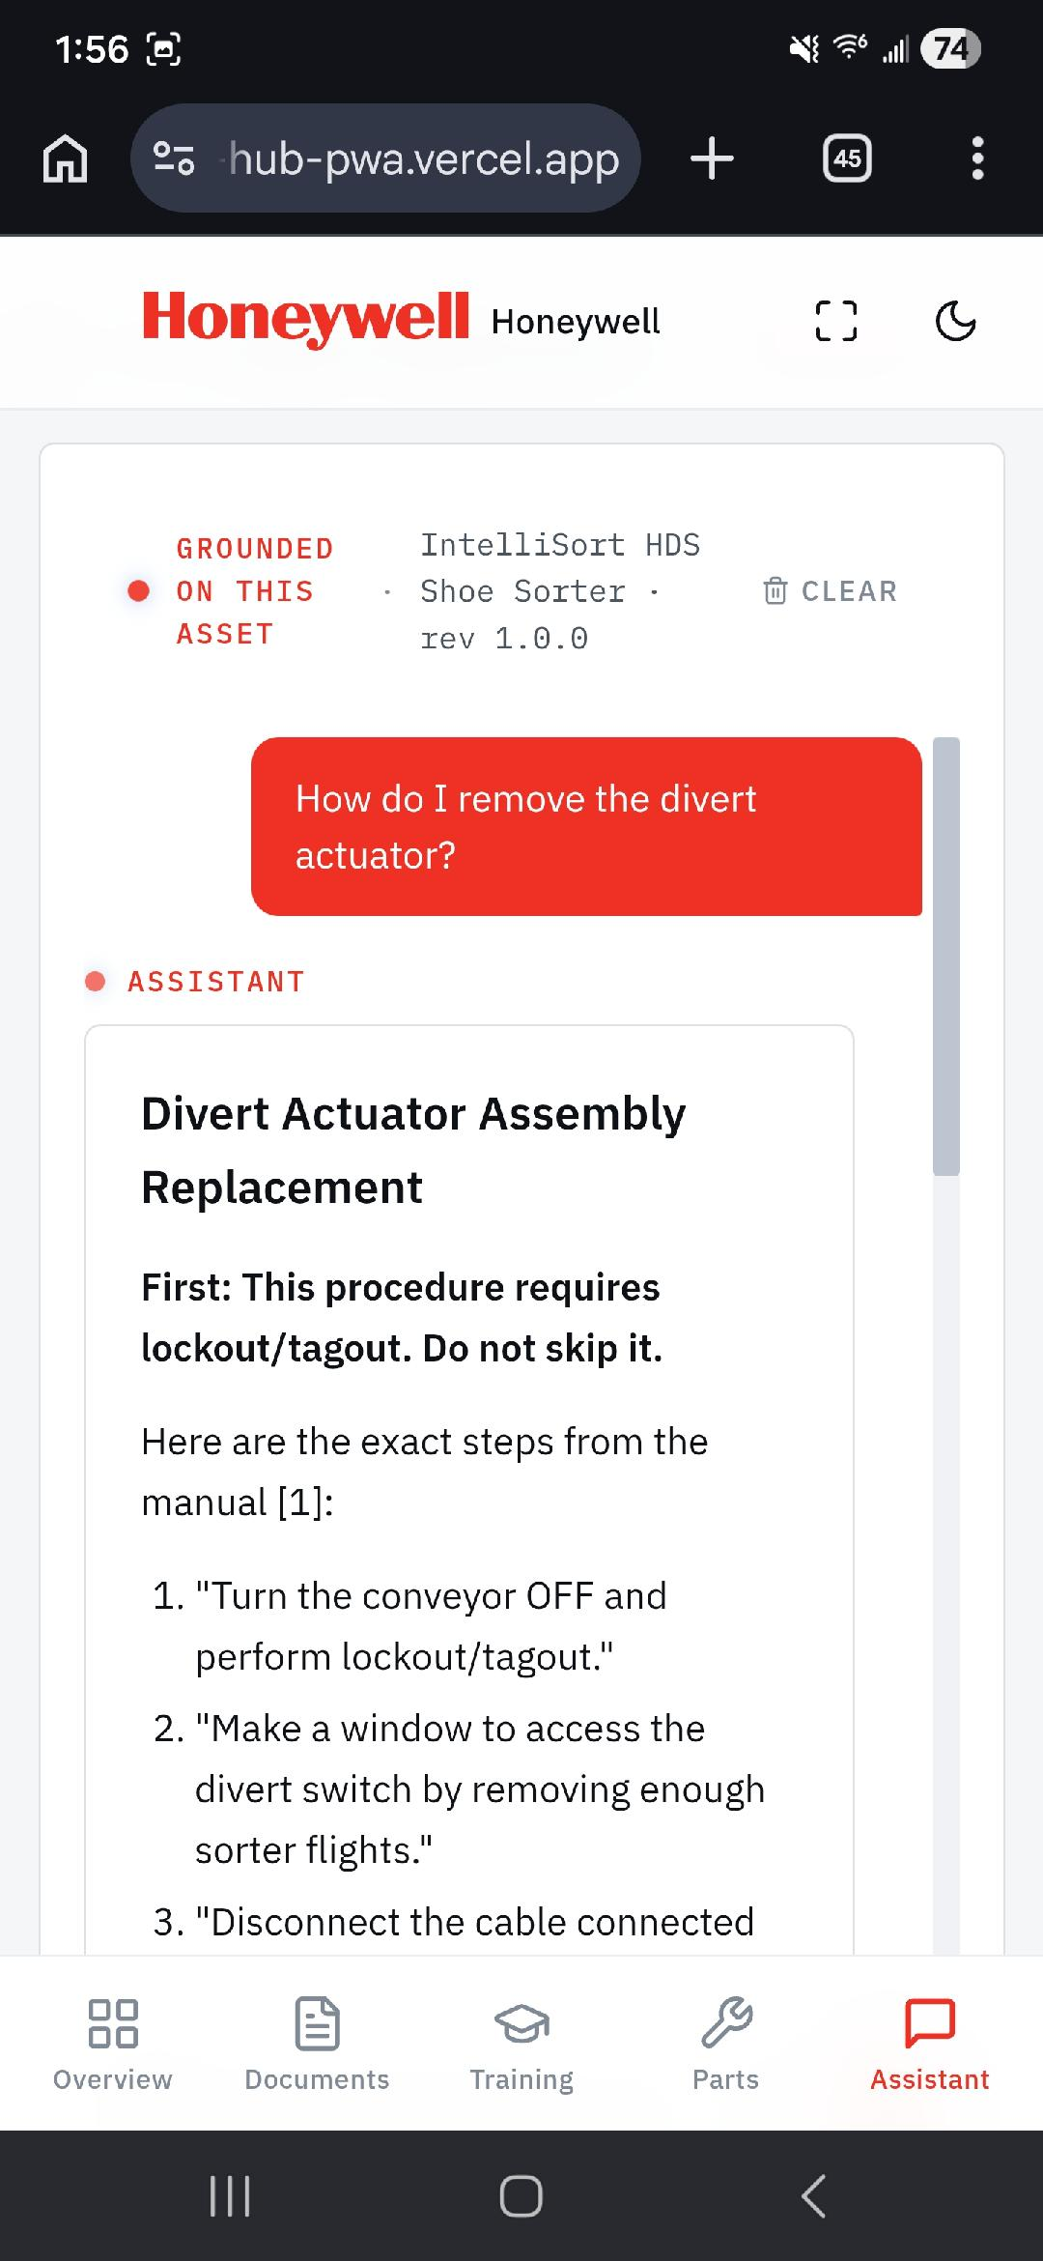
AI assistant grounded on the asset
- RAG retrieval over the asset’s pinned content version
- Refuses to summarize lockout/tagout — quotes the OEM directly
- Source citations on every paragraph

04 · Procedure Viewer
Open straight to the right page.
PDF sections render at the exact page range with safety warnings visually flagged. Pinch-to-zoom on phones, fullscreen on tablets. Every view is audit-logged with timestamp, user, and content revision.
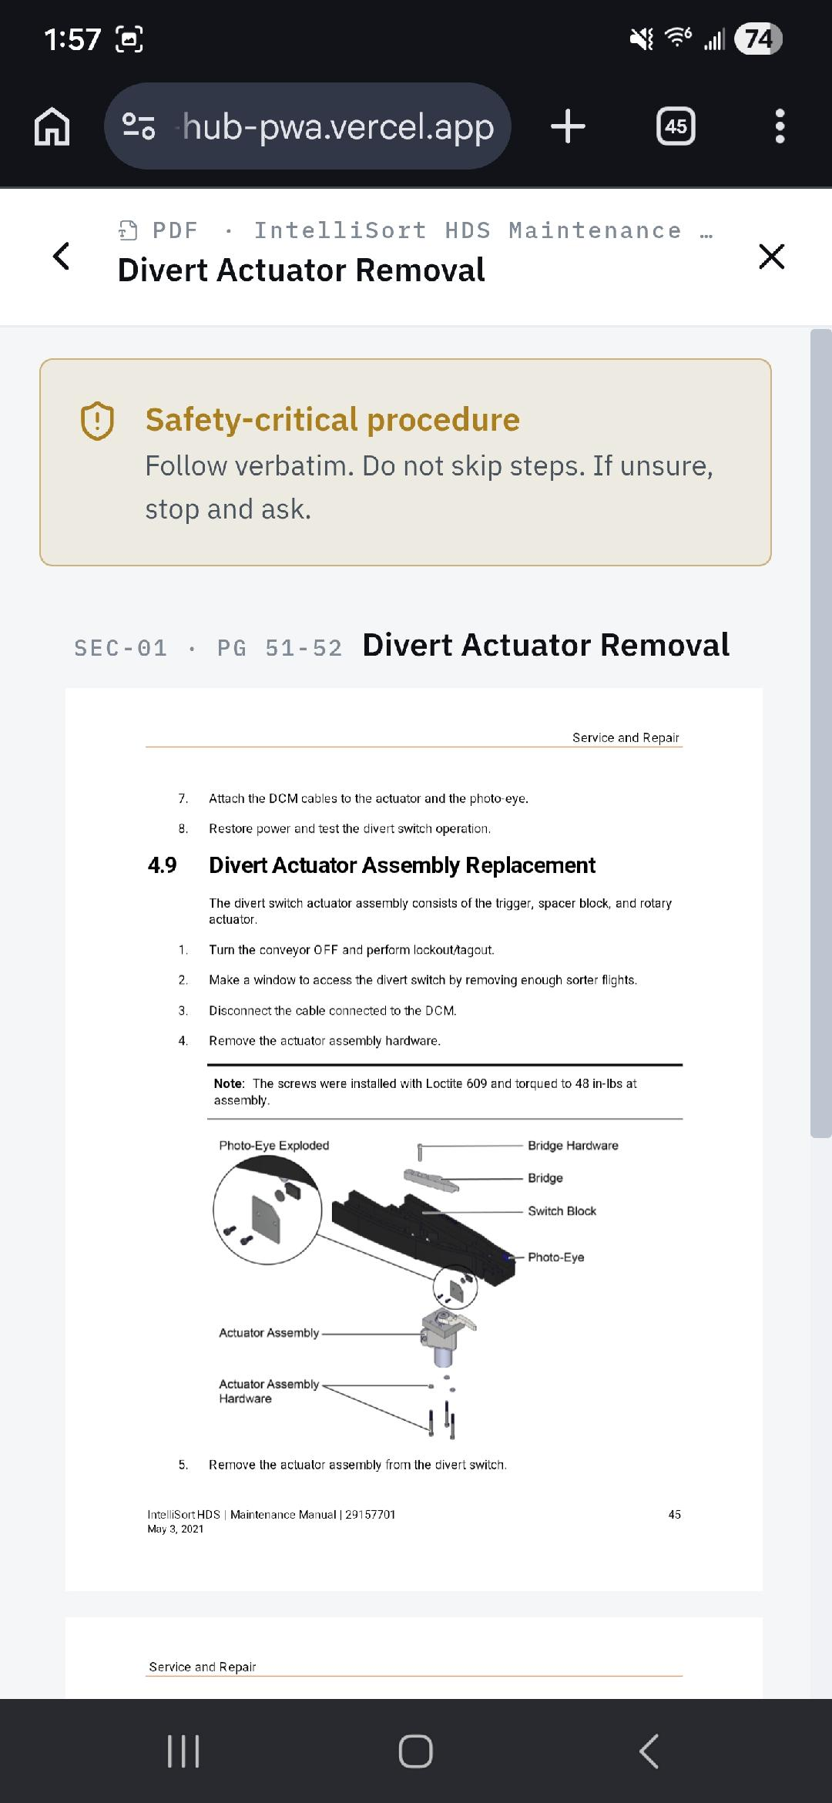
PDF section view with safety banner
- Native PDF rendering (pdfjs); no print-and-scan workflow
- Safety-critical banner forces verbatim review before override
- Scoped to the asset’s pinned content version — frozen for audit

05 · Parts Catalog
Every part, every diagram, one tap.
Searchable by part number, name, position, or cross-reference. Each part links to its install procedure, exploded views, and OEM-branded ordering — re-routing aftermarket parts revenue back to the OEM that built the equipment.
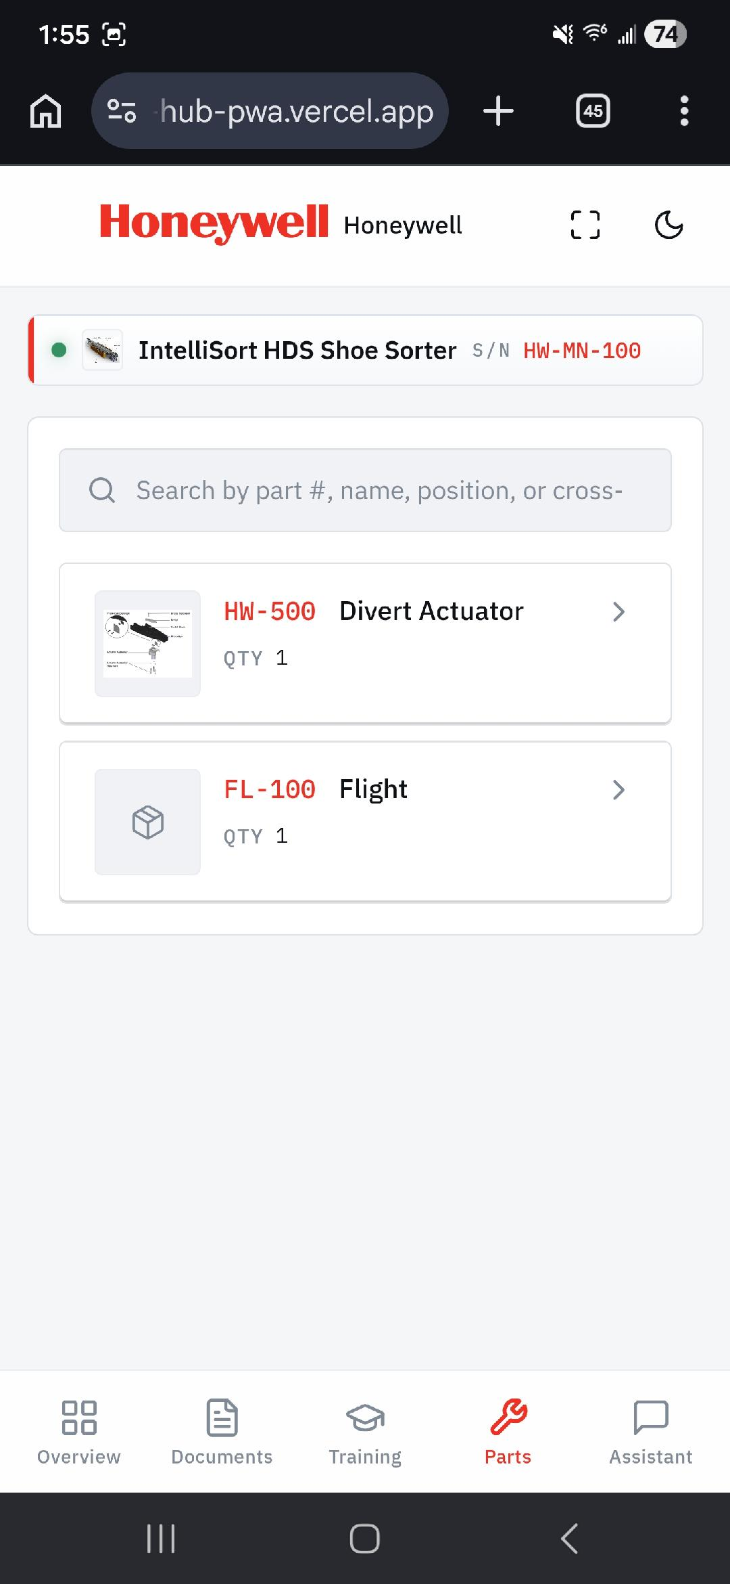
Parts list with search
- BOM hierarchy with parent-part drill-down
- Cross-reference search for legacy part numbers
- OEM-controlled ordering links — capture aftermarket leakage

06 · Issue Reporting
Report from the floor in 30 seconds.
Severity, photos, attachments — issues route to maintenance with the asset, scan history, and content rev already attached. Phase 2 syncs work orders to your CMMS via webhook (Maximo, UpKeep, Fiix) so your existing system stays the source of truth.
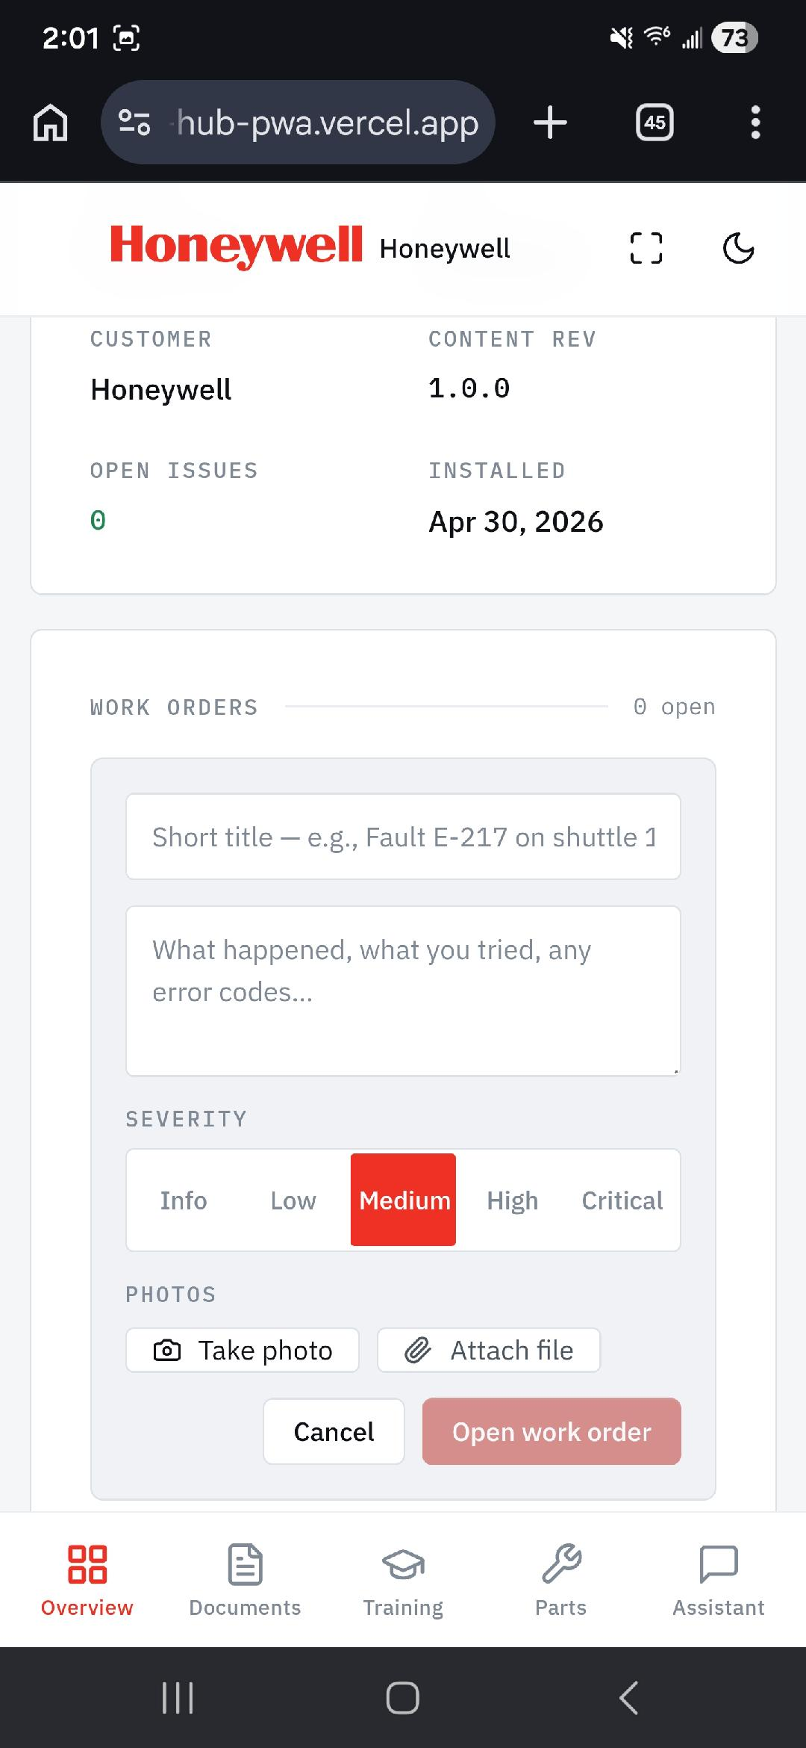
Work order creation form
- Native camera capture with auto-attached EXIF metadata
- Five severity levels with color-coded urgency
- CMMS bidirectional sync on roadmap

07 · Field Authoring
Capture tribal knowledge in real time.
Techs document procedures right at the equipment. Voice-to-title, step-by-step photo and video evidence, time-stamped on every action. Saved as unverified drafts; an admin promotes them to published content. Turn institutional knowledge into authored content without a paper checklist in sight.
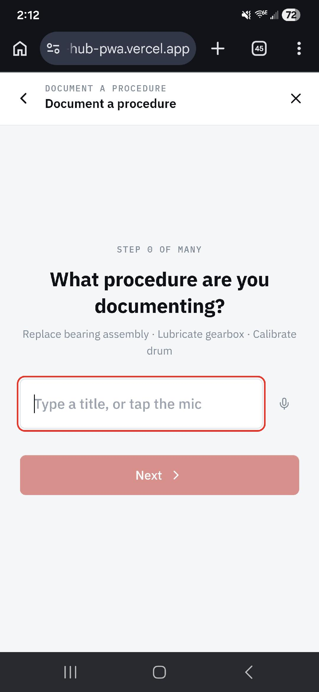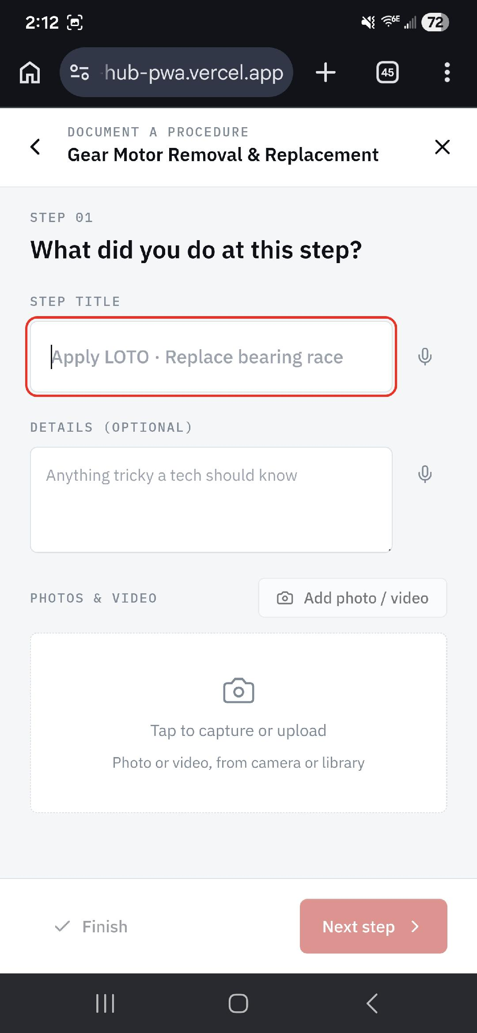
- Voice input for step titles and notes — gloved hands welcome
- Auto-saved drafts survive battery death, app crash, lost signal
- Admin promotion workflow keeps the field log honest
- Every step gets timestamped photo/video evidence
- Procedures become reusable training material on promotion

Three-sided platform
Same QR. Three buyers. Different value.
OEMs, integrators, and end-customers each pay for different value from the same physical asset. The QR sticker outlives any single contract — revenue compounds across the equipment’s full 20-year service life.
Buyer | What they buy | Starting price
OEM | Branded content distribution + aftermarket parts revenue capture | $30k / yr
Integrator | Service-margin protection across active project portfolio | $42k / yr
End-Customer | Unified facility documentation + compliance audit trail | $80k / yr per site
“The whole point is to make the QR sticker on the equipment outlive any single contract that put it there.”
— SANTECH, Documentation services since 2003

Beta Program
Five companies. Ninety days. $0 to participate.
We’re selecting five MHI integrators and OEMs for a structured 90-day beta. SANTECH authors your content, ships branded QR labels, runs weekly check-ins, and gives you founding-member pricing at day 90.
Estimated value of included services: ~$25,000.

What’s included
- Tenant setup and configuration with custom branding
- Content authoring of one major equipment line by SANTECH
- Up to 200 branded QR labels printed and shipped
- AI chat with 5,000 included messages per month
- Dedicated customer success contact + weekly check-ins
- 2-hour onboarding session for technicians

Pricing tiers
Tier | Price
Integrator | $42 – 120k / yr
OEM | $30 – 250k / yr
End-Customer | $80 – 150k / yr per site
Founding member | 50% off list, locked 24 months

Founding-member terms
If you convert at day 90, you lock 50% off list pricing for 24 months. Tenant continues seamlessly with no data loss, no QR re-stickering, no retraining. Authoring services available at standard rates for expansion beyond beta scope.

Equipment Hub · Built by SANTECH

