VISVESVARAYA TECHNOLOGICAL UNIVERSITY

“JnanaSangama”, Belgaum -590014, Karnataka.

LAB RECORD

Bio Inspired Systems (23CS5BSBIS)
Submitted by
SANTHOSH N (1BM23CS302)
in partial fulfillment for the award of the degree of

BACHELOR OF ENGINEERING
in
COMPUTER SCIENCE AND ENGINEERING



B.M.S. COLLEGE OF ENGINEERING
(Autonomous Institution under VTU)
BENGALURU-560019
Aug-2025 to Jan-2026

B.M.S. College of Engineering,
Bull Temple Road, Bangalore 560019
(Affiliated To Visvesvaraya Technological University, Belgaum)
Department of Computer Science and Engineering

CERTIFICATE
This is to certify that the Lab work entitled “ Bio Inspired Systems (23CS5BSBIS)” carried out by SANTHOSH N (1BM23CS302), who is bonafide student of B.M.S. College of Engineering. It is in partial fulfillment for the award of Bachelor of Engineering in Computer Science and Engineering of the Visvesvaraya Technological University, Belgaum. The Lab report has been approved as it satisfies the academic requirements of the above mentioned subject and the work prescribed for the said degree.

Rohith Vaidya K  Assistant Professor  Department of CSE, BMSCE | Dr. Kavitha Sooda  Professor & HOD  Department of CSE, BMSCE

Index
Sl.  No. | Date | Experiment Title | Page No.
1 |  | Genetic Algorithm for Optimization Problems
2 |  | Particle Swarm Optimization for Function Optimization
3 |  | Ant Colony Optimization for the Traveling Salesman Problem
4 |  | Cuckoo Search (CS)
5 |  | Grey Wolf Optimizer (GWO):
6 |  | Parallel Cellular Algorithms and Programs
7 |  | Optimization via Gene Expression Algorithms

Github Link: https://github.com/SANTHoshN302/BIS_302

Program 1 : Genetic Algorithm for Optimization Problems:
Algorithm:
(You should provide the screen shot of your observation book of Algorithm/Logic/Solving of respective problem)

Code:
import random
import math

def fitness_function(x):

return x * math.sin(10 * math.pi * x) + 1

POPULATION_SIZE = 20
MUTATION_RATE = 0.1
CROSSOVER_RATE = 0.8
GENERATIONS = 100
X_BOUND = (-1, 2) # Search space for x

def create_individual():
return random.uniform(*X_BOUND)

def create_population(size):
return [create_individual() for _ in range(size)]

def evaluate_population(population):
return [fitness_function(ind) for ind in population]

def select(population, fitnesses):
total_fitness = sum(fitnesses)
probs = [f / total_fitness for f in fitnesses]
return random.choices(population, weights=probs, k=2)

def crossover(parent1, parent2):
if random.random() < CROSSOVER_RATE:
alpha = random.random()
child1 = alpha * parent1 + (1 - alpha) * parent2
child2 = alpha * parent2 + (1 - alpha) * parent1
return child1, child2
else:
return parent1, parent2

def mutate(individual):
if random.random() < MUTATION_RATE:
mutation = random.uniform(-0.1, 0.1)
individual += mutation
individual = max(min(individual, X_BOUND[1]), X_BOUND[0]) # Keep in bounds
return individual

def genetic_algorithm():
population = create_population(POPULATION_SIZE)
best_individual = None
best_fitness = float('-inf')

for generation in range(GENERATIONS):
fitnesses = evaluate_population(population)

for i, fit in enumerate(fitnesses):
if fit > best_fitness:
best_fitness = fit
best_individual = population[i]

new_population = []
while len(new_population) < POPULATION_SIZE:
parent1, parent2 = select(population, fitnesses)
child1, child2 = crossover(parent1, parent2)
child1 = mutate(child1)
child2 = mutate(child2)
new_population.extend([child1, child2])

population = new_population[:POPULATION_SIZE]

print(f"Generation {generation+1}: Best Fitness = {best_fitness:.5f}, Best X = {best_individual:.5f}")

print("\nOptimization complete!")
print(f"Best solution: x = {best_individual:.5f}, f(x) = {best_fitness:.5f}")

if __name__ == "__main__":
genetic_algorithm()

Output:
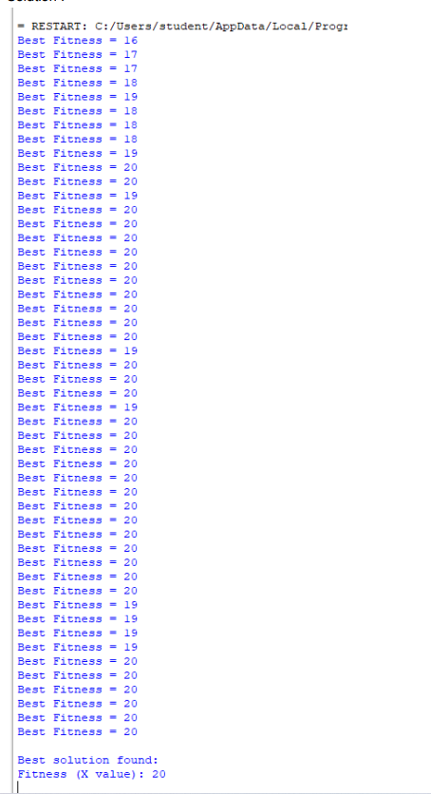

Program 02: Particle Swarm Optimization for Function Optimization:

Algorithm :

Code:
import random
import math
def fitness_function(x):
return x * math.sin(10 * math.pi * x) + 1

# 2. Initialize parameters
NUM_PARTICLES = 30
MAX_ITER = 100
W = 0.7
C1 = 1.5
C2 = 1.5
X_BOUND = (-1, 2)
V_MAX = 0.1

class Particle:
def __init__(self):
self.position = random.uniform(*X_BOUND)
self.velocity = random.uniform(-V_MAX, V_MAX)
self.best_position = self.position
self.best_fitness = fitness_function(self.position)

def update_velocity(self, global_best_position):
r1 = random.random()
r2 = random.random()
cognitive = C1 * r1 * (self.best_position - self.position)
social = C2 * r2 * (global_best_position - self.position)
self.velocity = W * self.velocity + cognitive + social
# Clamp velocity within limits
self.velocity = max(min(self.velocity, V_MAX), -V_MAX)

def update_position(self):
self.position += self.velocity
# Keep particle within bounds
self.position = max(min(self.position, X_BOUND[1]), X_BOUND[0])

def particle_swarm_optimization():

swarm = [Particle() for _ in range(NUM_PARTICLES)]

global_best_particle = max(swarm, key=lambda p: p.best_fitness)
global_best_position = global_best_particle.position
global_best_fitness = global_best_particle.best_fitness

for iteration in range(MAX_ITER):
for particle in swarm:

current_fitness = fitness_function(particle.position)

if current_fitness > particle.best_fitness:
particle.best_fitness = current_fitness
particle.best_position = particle.position

# Update global best
if current_fitness > global_best_fitness:
global_best_fitness = current_fitness
global_best_position = particle.position

for particle in swarm:
particle.update_velocity(global_best_position)
particle.update_position()

print(f"Iteration {iteration+1:03d} | Best Fitness = {global_best_fitness:.5f} | Best X = {global_best_position:.5f}")

print("\nOptimization complete!")
print(f"Best solution: x = {global_best_position:.5f}, f(x) = {global_best_fitness:.5f}")

if __name__ == "__main__":
particle_swarm_optimization()

Output:
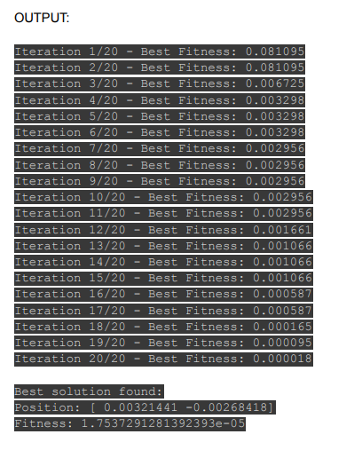

Program 03: Ant Colony Optimization for the Traveling Salesman Problem:

Algorithm:

Code:
import numpy as np

def distance(city1, city2):
return np.linalg.norm(city1 - city2)

def route_length(route, cities):
dist = 0.0
for i in range(len(route) - 1):
dist += distance(cities[route[i]], cities[route[i+1]])
dist += distance(cities[route[-1]], cities[route[0]])
return dist

def select_next_city(current_city, unvisited, pheromone, heuristic, alpha, beta):
pheromone_vals = pheromone[current_city, unvisited] ** alpha
heuristic_vals = heuristic[current_city, unvisited] ** beta
probs = pheromone_vals * heuristic_vals
probs /= probs.sum()
return np.random.choice(unvisited, p=probs)

def aco_tsp(cities, num_ants=20, num_iterations=20, alpha=1.0, beta=5.0, rho=0.5, initial_pheromone=1.0):
num_cities = len(cities)

pheromone = np.full((num_cities, num_cities), initial_pheromone)

heuristic = np.zeros((num_cities, num_cities))
for i in range(num_cities):
for j in range(num_cities):
if i != j:
heuristic[i, j] = 1.0 / (distance(cities[i], cities[j]) + 1e-10)

best_route = None
best_length = float('inf')

for iteration in range(num_iterations):
all_routes = []
all_lengths = []

for ant in range(num_ants):
route = []
unvisited = list(range(num_cities))

current_city = np.random.choice(unvisited)
route.append(current_city)
unvisited.remove(current_city)

while unvisited:
next_city = select_next_city(current_city, unvisited, pheromone, heuristic, alpha, beta)
route.append(next_city)
unvisited.remove(next_city)
current_city = next_city

length = route_length(route, cities)
all_routes.append(route)
all_lengths.append(length)

if length < best_length:
best_length = length
best_route = route

pheromone *= (1 - rho)

for route, length in zip(all_routes, all_lengths):
for i in range(num_cities - 1):
pheromone[route[i], route[i+1]] += 1.0 / length
pheromone[route[i+1], route[i]] += 1.0 / length

pheromone[route[-1], route[0]] += 1.0 / length
pheromone[route[0], route[-1]] += 1.0 / length

print(f"Iteration {iteration+1}/{num_iterations} - Best Length: {best_length:.4f}")

return best_route, best_length

if __name__ == "__main__":

cities = np.array([
[0, 0],
[1, 5],
[5, 2],
[6, 6],
[8, 3],
[7, 9],
[2, 8],
[3, 3]
])

best_route, best_length = aco_tsp(cities)

print("\nBest route found:")
print(best_route)
print("Route length:", best_length)

Output:
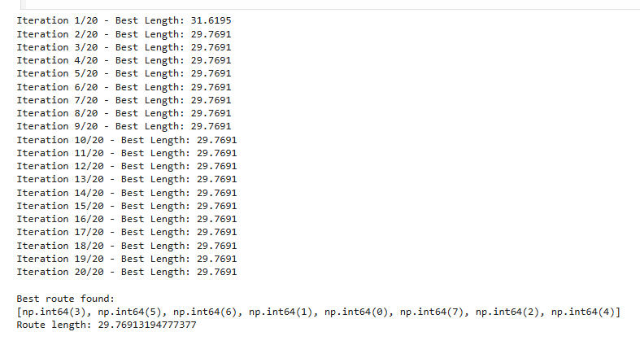

Program 04: Cuckoo Search (CS):
Algorithm;

Code:
import numpy as np
import math

def food_availability(x):
return - (x - 5) ** 2 + 20

def levy_flight(Lambda=1.5):
sigma_u = (math.gamma(1 + Lambda) * math.sin(math.pi * Lambda / 2) /
(math.gamma((1 + Lambda) / 2) * Lambda * 2 ** ((Lambda - 1) / 2))) ** (1 / Lambda)
sigma_v = 1
u = np.random.normal(0, sigma_u)
v = np.random.normal(0, sigma_v)
step = u / (abs(v) ** (1 / Lambda))
return step

def cuckoo_search_nest_location(n=10, iterations=200, pa=0.25, lower_bound=0, upper_bound=10):
nests = np.random.uniform(lower_bound, upper_bound, n)
fitness = np.array([food_availability(x) for x in nests])

best_idx = np.argmax(fitness)
best_nest = nests[best_idx]
best_fitness = fitness[best_idx]

Lambda = 1.5

for t in range(iterations):
for i in range(n):
step_size = 0.1 * levy_flight(Lambda)
new_nest = nests[i] + step_size * (nests[i] - best_nest)
new_nest = np.clip(new_nest, lower_bound, upper_bound)

new_fitness = food_availability(new_nest)
if new_fitness > fitness[i]:
nests[i] = new_nest
fitness[i] = new_fitness

if new_fitness > best_fitness:
best_fitness = new_fitness
best_nest = new_nest

num_abandon = int(pa * n)
worst_indices = np.argsort(fitness)[:num_abandon]
nests[worst_indices] = np.random.uniform(lower_bound, upper_bound, num_abandon)
fitness[worst_indices] = [food_availability(x) for x in nests[worst_indices]]

current_best_idx = np.argmax(fitness)
if fitness[current_best_idx] > best_fitness:
best_fitness = fitness[current_best_idx]
best_nest = nests[current_best_idx]

if (t+1) % 20 == 0 or t == 0:
print(f"Iteration {t+1}: Best nest location = {best_nest:.4f}, Max food = {best_fitness:.6f}")

return best_nest, best_fitness

if __name__ == "__main__":
best_location, max_food = cuckoo_search_nest_location()
print("\nFinal Results:")
print(f"Best nest location: {best_location:.4f}")
print(f"Maximum food collected: {max_food:.6f}")

Output:

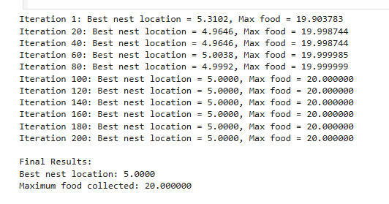

Program 05: Grey Wolf Optimizer (GWO):
Algorithm:

Code:
import numpy as np

def nectar_availability(position):
x, y = position
term1 = 20 * np.exp(-((x - 3) ** 2 + (y - 3) ** 2) / 4)
term2 = 15 * np.exp(-((x - 7) ** 2 + (y - 7) ** 2) / 3)
term3 = 10 * np.exp(-((x - 5) ** 2 + (y - 8) ** 2) / 2)
return term1 + term2 + term3

def gwo_beehive(n_wolves=30, iterations=20, lower_bound=0, upper_bound=10):
dim = 2

wolves = np.random.uniform(lower_bound, upper_bound, (n_wolves, dim))

alpha_pos = np.zeros(dim)
alpha_score = -np.inf
beta_pos = np.zeros(dim)
beta_score = -np.inf
delta_pos = np.zeros(dim)
delta_score = -np.inf

for t in range(iterations):
for i in range(n_wolves):
fitness = nectar_availability(wolves[i])

if fitness > alpha_score:
alpha_score = fitness
alpha_pos = wolves[i].copy()
elif fitness > beta_score:
beta_score = fitness
beta_pos = wolves[i].copy()
elif fitness > delta_score:
delta_score = fitness
delta_pos = wolves[i].copy()

a = 2 - t * (2 / iterations)

for i in range(n_wolves):
for j in range(dim):
r1 = np.random.rand()
r2 = np.random.rand()
A1 = 2 * a * r1 - a
C1 = 2 * r2
D_alpha = abs(C1 * alpha_pos[j] - wolves[i][j])
X1 = alpha_pos[j] - A1 * D_alpha

r1 = np.random.rand()
r2 = np.random.rand()
A2 = 2 * a * r1 - a
C2 = 2 * r2
D_beta = abs(C2 * beta_pos[j] - wolves[i][j])
X2 = beta_pos[j] - A2 * D_beta

r1 = np.random.rand()
r2 = np.random.rand()
A3 = 2 * a * r1 - a
C3 = 2 * r2
D_delta = abs(C3 * delta_pos[j] - wolves[i][j])
X3 = delta_pos[j] - A3 * D_delta

wolves[i][j] = (X1 + X2 + X3) / 3

wolves[i] = np.clip(wolves[i], lower_bound, upper_bound)

print(f"Iteration {t+1:2d}: Best nectar = {alpha_score:.6f} at location x={alpha_pos[0]:.4f}, y={alpha_pos[1]:.4f}")

return alpha_pos, alpha_score

if __name__ == "__main__":
best_hive_location, max_nectar = gwo_beehive()
print("\nFinal optimal beehive location:")
print(f"x = {best_hive_location[0]:.4f}, y = {best_hive_location[1]:.4f}")
print(f"Maximum nectar availability: {max_nectar:.6f}")

Output:
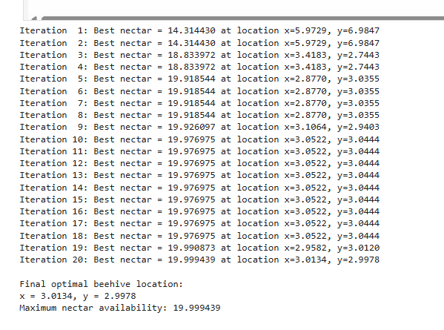

Program 6: Parallel Cellular Algorithms and Programs:
Algorithm:

Code:
import numpy as np

def rosenbrock(x):
return (1 - x[0])**2 + 100 * (x[1] - x[0]**2)**2

grid_size = (10, 10)
num_dimensions = 2
num_iterations = 200
beta0 = 1.0 # Base attractiveness
gamma = 1.0 # Light absorption coefficient
alpha = 0.2 # Randomness factor
radius = 1
search_bounds = (-2, 2)

cells = np.random.uniform(search_bounds[0], search_bounds[1],
size=(grid_size[0], grid_size[1], num_dimensions))

get neighbors (Moore neighborhood)
def get_neighbors(cells, i, j):
neighbors = []
for di in range(-radius, radius + 1):
for dj in range(-radius, radius + 1):
if di == 0 and dj == 0:
continue
ni, nj = (i + di) % grid_size[0], (j + dj) % grid_size[1]
neighbors.append(cells[ni, nj])
return np.array(neighbors)

best_solution = None
best_fitness = float('inf')

for t in range(num_iterations):
new_cells = np.copy(cells)

for i in range(grid_size[0]):
for j in range(grid_size[1]):
firefly = cells[i, j]
fit_i = rosenbrock(firefly)
neighbors = get_neighbors(cells, i, j)

for n in neighbors:
fit_n = rosenbrock(n)
if fit_n < fit_i: # brighter (better)
distance = np.linalg.norm(firefly - n)
beta = beta0 * np.exp(-gamma * distance**2)
step = beta * (n - firefly) + alpha * np.random.uniform(-1, 1, num_dimensions)
firefly = firefly + step
fit_i = rosenbrock(firefly)

new_cells[i, j] = firefly

if fit_i < best_fitness:
best_fitness = fit_i
best_solution = firefly

cells = new_cells

if t % 20 == 0:
print(f"Iteration {t}: Best Fitness = {best_fitness:.6f}")

print("\n============================")
print(" Parallel Cellular Firefly Algorithm Results")
print("============================")
print("Best Solution:", best_solution)
print("Best Fitness:", best_fitness)

Output:
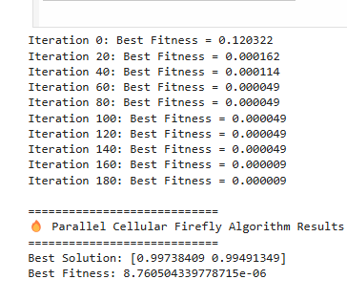

Program 7: Optimization via Gene Expression Algorithms:

Algorithm:

Code:
import random
import math

def fitness_function(x):
return x * math.sin(10 * math.pi * x) + 1 # Objective: maximize this

POPULATION_SIZE = 30
NUM_GENES = 10 # Number of genes per chromosome
MUTATION_RATE = 0.1
CROSSOVER_RATE = 0.8
GENERATIONS = 100
X_BOUND = (-1, 2)

def create_individual():
return [random.uniform(X_BOUND[0], X_BOUND[1]) for _ in range(NUM_GENES)]

def create_population(size):
return [create_individual() for _ in range(size)]

def express_genes(individual):
# Expression step: translate gene sequence into a single functional value (x)
expressed_x = sum(individual) / len(individual)
return expressed_x

def evaluate_fitness(individual):
x = express_genes(individual)
return fitness_function(x)

def tournament_selection(population, k=3):
selected = random.sample(population, k)
selected.sort(key=lambda ind: evaluate_fitness(ind), reverse=True)
return selected[0]

def crossover(parent1, parent2):
if random.random() < CROSSOVER_RATE:
point = random.randint(1, NUM_GENES - 1)
child1 = parent1[:point] + parent2[point:]
child2 = parent2[:point] + parent1[point:]
return child1, child2
else:
return parent1[:], parent2[:]

def mutate(individual):
for i in range(NUM_GENES):
if random.random() < MUTATION_RATE:
individual[i] += random.uniform(-0.1, 0.1)
individual[i] = max(min(individual[i], X_BOUND[1]), X_BOUND[0])
return individual
def gene_expression_algorithm():
population = create_population(POPULATION_SIZE)
best_individual = None
best_fitness = float('-inf')

for generation in range(GENERATIONS):
new_population = []

for ind in population:
fit = evaluate_fitness(ind)
if fit > best_fitness:
best_fitness = fit
best_individual = ind

while len(new_population) < POPULATION_SIZE:
parent1 = tournament_selection(population)
parent2 = tournament_selection(population)
child1, child2 = crossover(parent1, parent2)
child1 = mutate(child1)
child2 = mutate(child2)
new_population.extend([child1, child2])

population = new_population[:POPULATION_SIZE]

expressed_x = express_genes(best_individual)
print(f"Generation {generation+1:03d} | Best Fitness = {best_fitness:.5f} | Best X = {expressed_x:.5f}")

final_x = express_genes(best_individual)
print("\nOptimization complete!")
print(f"Best solution: x = {final_x:.5f}, f(x) = {best_fitness:.5f}")

if __name__ == "__main__":
gene_expression_algorithm()

Output:

