Hibernate
What is Hibernate?
Hibernate is a Java framework that helps you interact with a database without writing most of the SQL manually.
It is an implementation of ORM (Object Relational Mapping).
Hibernate is an open-source ORM framework.
It is used to achieve object–relational mapping (ORM).

Why Hibernate?
- It removes the need to write SQL queries. Reduces boilerplate .
- Reduces time for production
- Provides transactions.
- Handles exception internally.
- It provides ORM mapping.
- It handles large applications.
- It automatically creates tables in DB.
- Can create records.
- CRUD inbuilt operations.
- Embedded methods.

ORM
What is ORM?
ORM = Object Relational Mapping
It is a technique that:
- Maps Java classes → Database tables
- Maps Java objects → Table rows
- Maps Variables → Columns
ORM?
Tool to map Java with relational database.
- Class of Java will become a table.
- Variable created in a class will become a column in DB.
- Objects created for a class will be stored as rows.

Entity
Entity represents the table in database.

Rules to Create Entity Class
- Class should be public and non-abstract.
- Class should be annotated with @Entity.
- Class should have at least one primary key that should be annotated with @Id.
- Every variable should have getter and setter.
- Class should have a no-argument constructor.

Entity Class Example
@Entity
public class User {

@Id
private long id;
private String name;

public User() {
}

public long getId() {
return id;
}

public void setId(long id) {
this.id = id;
}

public String getName() {
return name;
}

public void setName(String name) {
this.name = name;
}
}
Mapping:
- id → column
- name → column
- Each object → row in table

How Will Hibernate Work?
- JDBC API is the only API in Java to communicate with database.
- Hibernate internally uses JDBC API to communicate with database.
- When it comes to JDBC, it needs:
  - Driver software
  - URL
  - Username
  - Password
to communicate with database.

Hibernate framework database

java application username
jdbc url

password
Driverclass_name

Method 1: Create Maven Project using IntelliJ IDEA
Step 1: Open IntelliJ
Open IntelliJ IDEA

Step 2: Create New Project
- Click New Project
- Select Maven
- Choose your JDK (example: JDK 21)
- Click Next

Step 3: Enter Project Details
Fill:
- GroupId → com.example
- ArtifactId → myproject
- Version → 1.0-SNAPSHOT (default is fine)
Click Finish

Step 4: Maven Project Structure Created
You will see:
myproject
├── src
│ ├── main
│ │ └── java
│ └── test
│ └── java
└── pom.xml

Step 5: Understand Important File → pom.xml
pom.xml is the heart of Maven.
Example basic pom.xml:
<project xmlns="http://maven.apache.org/POM/4.0.0"
xmlns:xsi="http://www.w3.org/2001/XMLSchema-instance"
xsi:schemaLocation="http://maven.apache.org/POM/4.0.0
http://maven.apache.org/xsd/maven-4.0.0.xsd">

<modelVersion>4.0.0</modelVersion>

<groupId>com.example</groupId>
<artifactId>myproject</artifactId>
<version>1.0-SNAPSHOT</version>

</project>

Method 2: Create Maven Project using Command Line
Make sure Apache Maven is installed.

🔹 Step 1: Open Command Prompt
🔹 Step 2: Run This Command
mvn archetype:generate
It will ask:
- GroupId
- ArtifactId
- Version
- Package name
After entering details → Maven creates project automatically.

Method 3: Create Maven Project in Eclipse
Using Eclipse IDE
- File → New → Other
- Select Maven Project
- Click Next
- Choose archetype
- Enter GroupId & ArtifactId
- Finish

🎯 What Happens After Creation?
Maven automatically:
- Manages dependencies
- Downloads libraries
- Compiles code
- Runs tests
- Creates .jar file

Basic Maven Lifecycle Commands
Inside project folder:
mvn compile
mvn test
mvn package
mvn clean

Important Concepts
Term | Meaning
GroupId | Company/organization name
ArtifactId | Project name
Version | Project version
pom.xml | Configuration file

Create Hibernate Maven Project using IntelliJ IDEA

- Install Java, Maven, and MySQL.
- Create a new Maven project (via IDE or command line).
- Add Hibernate, MySQL driver, and JPA dependencies in pom.xml.
- Reload/Update Maven project.
- Create a database in MySQL.
- Create hibernate.cfg.xml inside src/main/resources.
- Configure database properties (URL, username, password, dialect).
- Create an Entity class and annotate with @Entity.
- Add mapping entry in hibernate.cfg.xml (if required).
- Create a Hibernate utility class to build SessionFactory.
- Open a Session and begin a Transaction.
- Perform CRUD operation (save/update/delete).
- Commit transaction and close session.
- Run the main class to execute the project.

……………………………………………………………………………………………………………………………………………………………..

Steps to Create hibernate.cfg.xml (Only Points)
- Create a file named hibernate.cfg.xml.
- Place it inside src/main/resources folder.
- Add the basic <hibernate-configuration> XML structure.
- Add database connection properties:
  - driver class
  - URL
  - username
  - password
- Add Hibernate dialect property.
- (Optional) Add show_sql and format_sql properties.
- (Optional) Add hbm2ddl.auto property for table creation.
- Add <mapping> for your entity class.
- Save the file.

Steps to Create Hibernate Configuration File
Create XML File
Create a file named:
hibernate.cfg.xml
Place it inside:
src/main/resources

Add Hibernate Configuration Structure
Add the basic XML structure:
<!DOCTYPE hibernate-configuration PUBLIC
"-//Hibernate/Hibernate Configuration DTD 3.0//EN"
"http://hibernate.sourceforge.net/hibernate-configuration-3.0.dtd">

<hibernate-configuration>
<session-factory>

</session-factory>
</hibernate-configuration>

Add Database Properties
Inside <session-factory>, add:
<property name="hibernate.connection.driver_class">
com.mysql.cj.jdbc.Driver
</property>

<property name="hibernate.connection.url">
jdbc:mysql://localhost:3306/your_database_name
</property>

<property name="hibernate.connection.username">
root
</property>

<property name="hibernate.connection.password">
your_password
</property>

Add Hibernate Dialect
<property name="hibernate.dialect">
org.hibernate.dialect.MySQL8Dialect
</property>
Dialect tells Hibernate which database you are using.

Show SQL (Optional but Recommended)
<property name="hibernate.show_sql">true</property>
<property name="hibernate.format_sql">true</property>
This will display SQL queries in console.

Automatic Table Creation (Optional)
<property name="hibernate.hbm2ddl.auto">update</property>
Options:
- create
- create-drop
- update
- validate

Add Mapping Class
Add your entity class:
<mapping class="com.example.User"/>

Final Sample hibernate.cfg.xml
<!DOCTYPE hibernate-configuration PUBLIC
"-//Hibernate/Hibernate Configuration DTD 3.0//EN"
"http://hibernate.sourceforge.net/hibernate-configuration-3.0.dtd">

<hibernate-configuration>
<session-factory>

<property name="hibernate.connection.driver_class">
com.mysql.cj.jdbc.Driver
</property>

<property name="hibernate.connection.url">
jdbc:mysql://localhost:3306/testdb
</property>

<property name="hibernate.connection.username">
root
</property>

<property name="hibernate.connection.password">
root
</property>

<property name="hibernate.dialect">
org.hibernate.dialect.MySQL8Dialect
</property>

<property name="hibernate.show_sql">true</property>
<property name="hibernate.format_sql">true</property>

<property name="hibernate.hbm2ddl.auto">update</property>

<mapping class="com.example.User"/>

</session-factory>
</hibernate-configuration>

Session Factory
- Session factory is a factory which creates session to connect with the database
- It is created once when the application starts
- It reads hibernate config file (database details)
- It creates session objects
- A session is used to perform database operations like save, update, delete
- Configuration config = new Configuration();
config.configure();
- SessionFactory factory = config.buildSessionFactory();
System.out.println("Hibernate configured successfully!");
factory.close();

Session
A session is an object in hibernate that is used to connect to the database and perform operations like save, update, delete
A session acts like a bridge between java application and database
It helps with doing database operations
It is created from session factory object
It stays active for a short time ---- 1 unit of work
factory.openSession();
the session object is used to interact with database

Transaction
a transaction is group of DB operations that are treated as 1 single of work
it ensures that all operations are completed successfully
if one operation fails all changes are cancelled(rollback)
it helps to keep the data safe and consistent
example

- imagine transferring money from account A to b
- detect money in account a
- add money in account b
- both must happen together if one fail both are cancelled
this complete process is called as transaction

@Entity
It makes a class as a DB table
This annotation tells hibernate that this class should be stored in DB

@Table
This annotation specifies the table name in the DB --- @Table(name=”table_name”)
Used when table name is different from class name

@Id
Makes a field as primary key

@Generated Value
This annotation automatically generates value of primary key and also auto increaments it
@Column
used to specify the detail of the table’s column like name, length, nullable
@Transient
This tells hibernate not to store the specific field [-----private int a;] as a column in the DB
@Temporal
Used to store date and time value correctly in the DB
@Lob
Used to store large data ---- file—images----videos

Hibernate Mapping
HM is used to build the relationship between two tables
TYPES
Unidirectional –-- we access only one way
Bidirectional--- we can access in both ways
Annotations
One to one mapping ---------- @OnetoOne
One to many mapping ------ @OnetoMany
Many to many mapping ------ @ManytoMany

One to one –Unidirectional
Its having relationship with only one object

Uni directional

Obj 1 obj 2

import jakarta.persistence.*;

@Entity
public class Person {

@Id
@GeneratedValue(strategy = GenerationType.IDENTITY)
private int id;

private String name;

@OneToOne(cascade = CascadeType.ALL)
@JoinColumn(name = "aadhaar_id", unique = true)
private Aadhaar aadhaar;

// getters & setters
}

import jakarta.persistence.*;

@Entity
public class Aadhaar {

@Id
@GeneratedValue(strategy = GenerationType.IDENTITY)
private int id;

private String aadhaarNumber;

// getters & setters
}

➤ aadhaar
id (PK) | aadhaar_number
➤ person
id (PK) | name | aadhaar_id (FK, UNIQUE)

🔥 Key Points (Exam Ready)
- Only one side has reference → Unidirectional
- @JoinColumn → creates foreign key
- unique = true → ensures One-to-One
- No mappedBy used

In one to one unidirectional mapping hibernate will create extra column with the help of @OnetoOne annotation
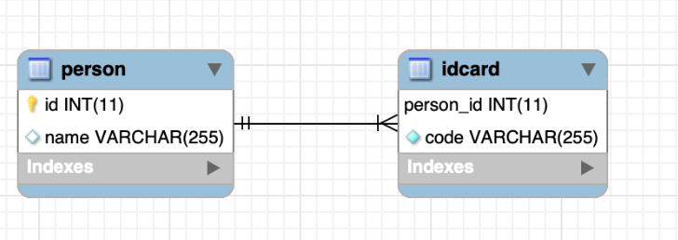

One to Many
In this mapping one object is mapped with more than one object
In one to many hibernate will create extra table to store foreign or primary key off both tables

import jakarta.persistence.*;
import java.util.List;

@Entity
public class Department {

@Id
@GeneratedValue(strategy = GenerationType.IDENTITY)
private int id;

private String name;

@OneToMany(mappedBy = "department", cascade = CascadeType.ALL)
private List<Employee> employees;

// getters & setters
}

import jakarta.persistence.*;

@Entity
public class Employee {

@Id
@GeneratedValue(strategy = GenerationType.IDENTITY)
private int id;

private String name;

@ManyToOne
@JoinColumn(name = "department_id")
private Department department;

// getters & setters
}
🔹 Table Structure
➤ department
| id (PK) | name |
➤ employee
| id (PK) | name | department_id (FK) |
department_id → references department(id)

🔥 Key Points (Exam Ready)
- @OneToMany → One parent, many children
- mappedBy → used on inverse side
- @ManyToOne → owning side
- Foreign key is always on Many side

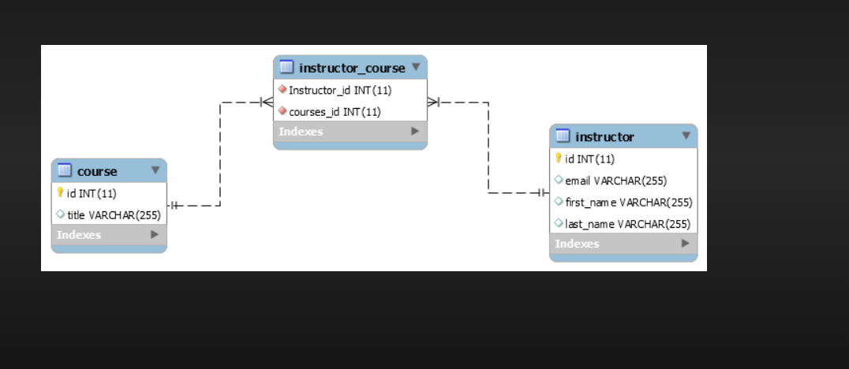

Many to One
In mto mapping many objects or more than one objects is mapped with only one object
In mto mapping hibernate wil create extra column by using @ManytoOne annotation
Many-to-One mapping means many objects of one entity are associated with one object of another entity.
👉 Example: Many Employees belong to one Department.
- Multiple rows in Employee → refer to one Department
- Foreign key is stored on the many side
import jakarta.persistence.*;

@Entity
public class Department {

@Id
@GeneratedValue(strategy = GenerationType.IDENTITY)
private int id;

private String name;

// getters & setters
}
import jakarta.persistence.*;

@Entity
public class Employee {

@Id
@GeneratedValue(strategy = GenerationType.IDENTITY)
private int id;

private String name;

@ManyToOne
@JoinColumn(name = "department_id")
private Department department;

// getters & setters
}

🗄️ Table Structure
➤ department
| id (PK) | name |
➤ employee
| id (PK) | name | department_id (FK) |

🔥 Key Points (Exam-Ready)
- @ManyToOne → used on many side
- @JoinColumn → creates foreign key
- Foreign key always exists on many side
- No mappedBy needed in many-to-one

Foreign key is always stored on the Many side
(Except One-to-One where it can be in either table)
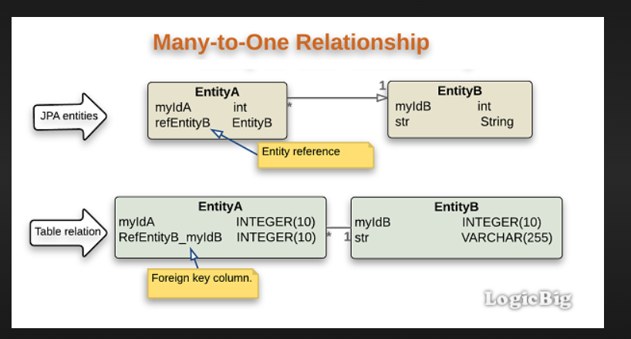

Many to Many mapping
In mtm more objects is mapped with more objects

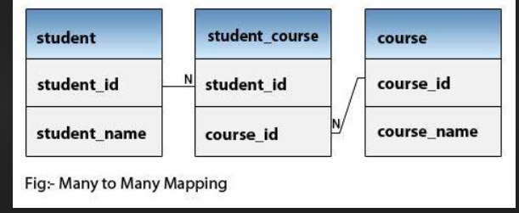

St1 sub1

St2 sub2

Bidirectional one to one
In this mapping one object is only mapped with only one object and we can access data from both the entities.

✅ Table: aadhaar
Column Name | Data Type | Constraints
id | INT | PRIMARY KEY, AUTO_INCREMENT
aadhaar_number | VARCHAR(20) | UNIQUE, NOT NULL

✅ Table: person
Column Name | Data Type | Constraints
id | INT | PRIMARY KEY, AUTO_INCREMENT
name | VARCHAR(100) | NOT NULL
aadhaar_id | INT | UNIQUE, FOREIGN KEY

import jakarta.persistence.*;

@Entity
public class Person {

@Id
@GeneratedValue(strategy = GenerationType.IDENTITY)
private int id;

private String name;

@OneToOne(cascade = CascadeType.ALL)
@JoinColumn(name = "aadhaar_id", unique = true)
private Aadhaar aadhaar;

// getters & setters
}

import jakarta.persistence.*;

@Entity
public class Aadhaar {

@Id
@GeneratedValue(strategy = GenerationType.IDENTITY)
private int id;

private String aadhaarNumber;

@OneToOne(mappedBy = "aadhaar")
private Person person;

// getters & setters
}

🔹 3️⃣ Table Structure
➤ person
| id (PK) | name | aadhaar_id (FK, UNIQUE) |
➤ aadhaar
| id (PK) | aadhaar_number |

🔥 Important Exam Points
- @JoinColumn → defines foreign key
- mappedBy → used on inverse side
- unique = true → ensures 1:1
- Owning side = class with @JoinColumn

Many to many Bidirectional
import jakarta.persistence.*;
import java.util.Set;

@Entity
public class Student {

@Id
@GeneratedValue(strategy = GenerationType.IDENTITY)
private int id;

private String name;

@ManyToMany
@JoinTable(
name = "student_course",
joinColumns = @JoinColumn(name = "student_id"),
inverseJoinColumns = @JoinColumn(name = "course_id")
)
private Set<Course> courses;

// getters & setters
}

import jakarta.persistence.*;
import java.util.Set;

@Entity
public class Course {

@Id
@GeneratedValue(strategy = GenerationType.IDENTITY)
private int id;

private String title;

@ManyToMany(mappedBy = "courses")
private Set<Student> students;

// getters & setters
}

Student student_course Course
--------- ---------------- ----------
id (PK) ───────▶ student_id (FK)
course_id (FK) ◀─────── id (PK)
name title

Example: Student ↔ Course

✅ 1️⃣ Table: student
Column Name | Data Type | Constraints
id | INT | PRIMARY KEY, AUTO_INCREMENT
name | VARCHAR(100) | NOT NULL

✅ 2️⃣ Table: course
Column Name | Data Type | Constraints
id | INT | PRIMARY KEY, AUTO_INCREMENT
title | VARCHAR(100) | NOT NULL

✅ 3️⃣ Table: student_course (Join Table)
Column Name | Data Type | Constraints
student_id | INT | FOREIGN KEY
course_id | INT | FOREIGN KEY

🔗 Constraints Definition
PRIMARY KEY (student_id, course_id)

FOREIGN KEY (student_id) REFERENCES student(id)

FOREIGN KEY (course_id) REFERENCES course(id)

🔥 Why Composite Primary Key?
- Prevents duplicate entries
(Same student cannot enroll in same course twice)
- Maintains proper Many-to-Many relationship

📘 Final Structure Summary
student (1) student_course course (1)
------------- ---------------- -------------
id (PK) ────▶ student_id (FK)
course_id (FK) ◀─── id (PK)
name title

Persistence.xml

It is xml file which contains database config i.e. information needed for jdbc connection
We will mention fully qualified classname of the driver url username password of DB in property tag

persistence.xml is a configuration file used in JPA (Java Persistence API).
It contains:
- Database connection details
- JPA provider configuration (like Hibernate)
- Entity class information
- Other properties related to persistence
It is used to create the EntityManagerFactory.

src/main/resources/META-INF/persistence.xml

✅ EntityManagerFactory
📦 Package
jakarta.persistence
Import:
import jakarta.persistence.EntityManagerFactory;
It is part of Jakarta Persistence (JPA).

✅ What is EntityManagerFactory?
- It is an interface
- Present in jakarta.persistence package
- Used to create EntityManager objects
- It is heavyweight
- Thread-safe
- Should be created only once per application

✅ Method Signature
public static EntityManagerFactory createEntityManagerFactory(String persistenceUnitName)
✔ It is a static method
✔ It returns an EntityManagerFactory
✔ It takes the persistence unit name from persistence.xml
This method belongs to:
jakarta.persistence.Persistence
So yes ✔ Persistence is a helper class.

✅ What Does createEntityManagerFactory() Do?
When we call:
EntityManagerFactory emf =
Persistence.createEntityManagerFactory("my-persistence-unit");
It:
- Reads persistence.xml
- Finds:
<persistence-unit name="my-persistence-unit">
- Loads configuration:
  - JDBC URL
  - Username
  - Password
  - Driver class
  - JPA provider (usually Hibernate)
- Loads JDBC driver automatically
- Creates database connection pool
- Prepares ORM mappings
- Returns implementation object of EntityManagerFactory

✅ Important Correction (JDBC Part)
You wrote:
It is used to do two steps of JDBC config:
i) load
ii) create connection between Java and JDBC driver
Let’s correct it properly:
In JDBC, we manually:
1️⃣ Load driver
Class.forName("com.mysql.cj.jdbc.Driver");
2️⃣ Create connection
DriverManager.getConnection(url, username, password);
But in JPA, we DO NOT manually do this.
All details like:
- URL
- Username
- Password
- Driver
are defined inside persistence.xml, and createEntityManagerFactory() handles it internally.

✅ Sample persistence.xml
<persistence xmlns="https://jakarta.ee/xml/ns/persistence"
version="3.0">
<persistence-unit name="my-persistence-unit">
<provider>org.hibernate.jpa.HibernatePersistenceProvider</provider>
<properties>
<property name="jakarta.persistence.jdbc.url"
value="jdbc:mysql://localhost:3306/test"/>
<property name="jakarta.persistence.jdbc.user"
value="root"/>
<property name="jakarta.persistence.jdbc.password"
value="root"/>
<property name="jakarta.persistence.jdbc.driver"
value="com.mysql.cj.jdbc.Driver"/>
<property name="hibernate.hbm2ddl.auto"
value="update"/>
</properties>
</persistence-unit>
</persistence>

✅ EntityManager
📦 Package
import jakarta.persistence.EntityManager;

✅ What is EntityManager?
- It is an interface
- Present in jakarta.persistence
- Used to perform CRUD operations
- Provides built-in methods:
  - persist()
  - find()
  - merge()
  - remove()
  - createQuery()
  - createNamedQuery()

✅ How to Create EntityManager?
We create it using EntityManagerFactory:
EntityManager em = emf.createEntityManager();
So flow is:
Persistence class
↓
createEntityManagerFactory()
↓
EntityManagerFactory
↓
createEntityManager()
↓
EntityManager

✅ Full Example Code
import jakarta.persistence.EntityManager;
import jakarta.persistence.EntityManagerFactory;
import jakarta.persistence.Persistence;
public class Main {
public static void main(String[] args) {
EntityManagerFactory emf =
Persistence.createEntityManagerFactory("my-persistence-unit");
EntityManager em = emf.createEntityManager();
em.getTransaction().begin();
// CRUD operation example
// em.persist(entity);
em.getTransaction().commit();
em.close();
emf.close();
}
}

✅ Interview-Ready Explanation (Short Version)
EntityManagerFactory is an interface in jakarta.persistence package.
It is used to create EntityManager objects.
We create its implementation object using Persistence class and its static method createEntityManagerFactory(), which reads configuration from persistence.xml.
It loads JDBC properties like URL, username, password, and driver, initializes the JPA provider (like Hibernate), and prepares database connections.
EntityManager is used to perform CRUD operations and is created using emf.createEntityManager().

✅ Inbuilt Methods of EntityManager (EM)
EntityManager is an interface in:
jakarta.persistence
Import:
import jakarta.persistence.EntityManager;

✅ 1️⃣ Save (Insert)
❌ Not save()
❌ Not persist(obj) in JDBC
✔ Correct JPA method:
persist(Object entity)
Example:
em.persist(student);
👉 Makes entity managed
👉 Inserts into DB when transaction commits

✅ 2️⃣ Delete
❌ Not delete()
✔ Correct method:
remove(Object entity)
Example:
em.remove(student);
👉 Entity must be in managed state

✅ 3️⃣ Update
✔ Correct method:
merge(Object entity)
Example:
em.merge(student);
👉 Used for updating detached objects
👉 Returns managed entity
Important:
merge() returns an object:
Student updated = em.merge(student);

✅ 4️⃣ Fetch (Read)
❌ Not get() (that is Hibernate Session method)
✔ Correct JPA method:
find(Class<T> entityClass, Object primaryKey)
Example:
Student student = em.find(Student.class, 1);
👉 Fetches by primary key

✅ 5️⃣ Query Methods
em.createQuery("JPQL query");
em.createNamedQuery("name");
em.createNativeQuery("SQL query");

✅ Methods of Transaction
We get transaction from EntityManager:
EntityTransaction tx = em.getTransaction();
Import:
import jakarta.persistence.EntityTransaction;

Transaction Methods
Method | Purpose
begin() | Start transaction
commit() | Save changes permanently
rollback() | Cancel changes
isActive() | Check if active

Example
EntityManagerFactory emf =
Persistence.createEntityManagerFactory("my-persistence-unit");
EntityManager em = emf.createEntityManager();
EntityTransaction tx = em.getTransaction();
tx.begin();
Student student = new Student("Sanvi", 22);
em.persist(student);
tx.commit();
em.close();
emf.close();

✅ Corrected Version of Your Notes (Clean Version)
Save → persist(object)
Delete → remove(object)
Update → merge(object)
Fetch → find(ClassName.class, primaryKey)
Transaction Methods →
begin()
commit()
rollback()
isActive()

🔥 Important Interview Point
Hibernate Session methods:
- save()
- update()
- delete()
- get()
JPA EntityManager methods:
- persist()
- merge()
- remove()
- find()

Cache in Hibernate
Cache is one of the key features of Hibernate ORM.
It helps reduce the number of database queries and improves application performance.
When Hibernate fetches data, it stores it temporarily in memory. If the same data is requested again, it returns it from cache instead of hitting the database.

Types of Cache in Hibernate
1️⃣ First-Level Cache (L1 Cache)
🔹 Key Points:
- Enabled by default
- Cannot be disabled
- Managed by EntityManager (or Session in native Hibernate)
- Scope: Per EntityManager / Session
- Stored in memory
🔹 How it Works:
For every EntityManager, Hibernate creates a separate first-level cache.
Example:
Student s1 = em.find(Student.class, 1);
Student s2 = em.find(Student.class, 1);
👉 Only one SQL query will be executed.
The second time, Hibernate returns the object from the first-level cache.
But if you create a new EntityManager:
EntityManager em2 = emf.createEntityManager();
Student s3 = em2.find(Student.class, 1);
👉 It will hit the database again because each EntityManager has its own L1 cache.
1st level cache is specific to a single entity manager if we use another entity manager it will not have the data cache by the first one

2️⃣ Second-Level Cache (L2 Cache)
🔹 Key Points:
- Not enabled by default
- Must be configured manually
- Shared across multiple EntityManagers
- Works at SessionFactory level
🔹 Scope:
Application-wide (shared cache)
🔹 Popular Cache Providers:
- EhCache
- Infinispan
- Hazelcast
- Redis
When L2 cache is enabled:
- First request → DB hit
- Next request (even from different EntityManager) → fetched from L2 cache

Interview-Friendly Definition
Hibernate cache is a mechanism that stores frequently accessed data in memory to reduce database hits and improve performance. Hibernate provides two types of caching: first-level cache (default, per session) and second-level cache (optional, shared across sessions).

Quick Comparison Table
Feature | First-Level Cache | Second-Level Cache
Default | Yes | No
Scope | Per EntityManager | SessionFactory / Application
Can Disable? | No | Yes
Shared? | No | Yes
Configuration Needed? | No | Yes

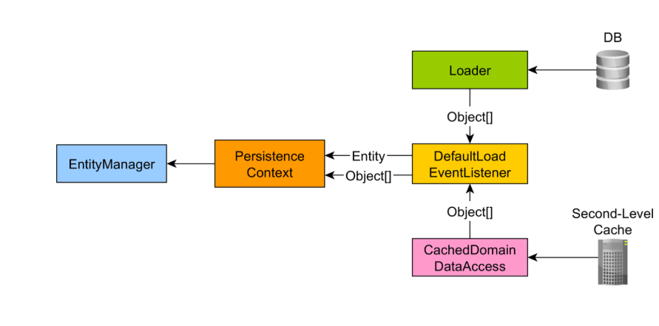

1st level caching
Entity manager factory DB

ee
cache

Scope of Second-Level Cache
👉 For every EntityManagerFactory, one L2 cache is created.
👉 All EntityManagers created from that EMF share the same cache.

Second-level cache in Hibernate is an optional cache that must be explicitly enabled. It works at the EntityManagerFactory level and is shared across multiple sessions. To use it, we annotate entities with @Cacheable and @Cache, and configure a cache provider like Ehcache or Redis.

2nd level caching is used to store data across different entity manager
Unlike 1st level cache which is related to one entity manager 2nd level cache cache allowing sharing caching of cache data between different entity manager
Data fetched by and em can be stored in the 2nd level cache
If another em requests the same data it will be served from the cache instead of the db
This helps to increase the performance and reduce the number of queries across whole application

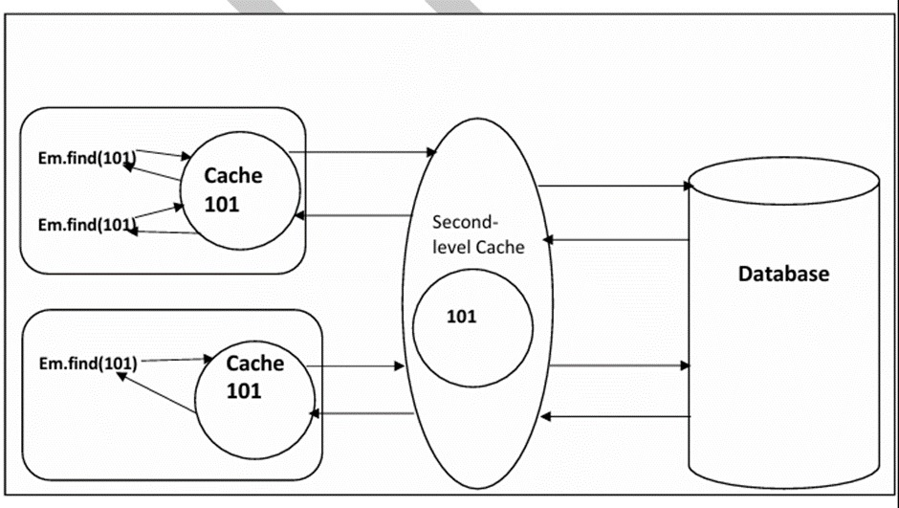

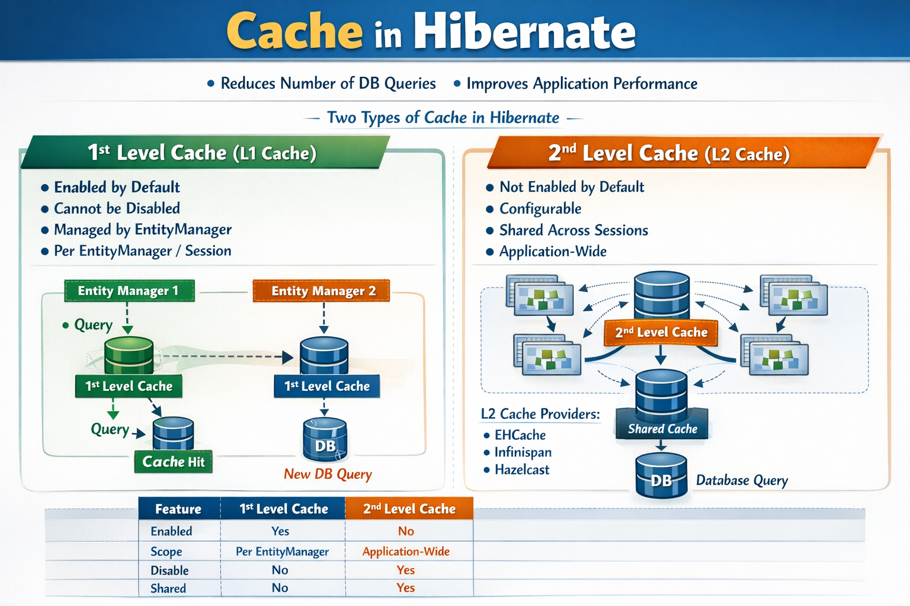

Hibernate lifecycle

Garbage

Pojo class

Persist(obj)
Remove(obj)

persistence
Persist(obj)
Merge(obj) detach(obj) garbage

Transient state ---
in transieent state if we do any modification then this modification will not be affecting any db
if we are not moving the pojo from transient to moving then it will be destroyed
persistence state---
we will use persist(obj)---to move from ts to persistence state

java--middleware—servlets (spring using it internally)
spring ---what why -how

soc---separation of concern
rigid coupling

Spring Core

Excellent 👍
Now we’ll learn Spring Core from absolute zero, in deep detail, using:
- ✅ WHAT
- ✅ WHY
- ✅ HOW
- ✅ Real-life example
- ✅ End summary paragraph after every topic
We’ll move step-by-step like building a house foundation.

🌱 1️⃣ What is Spring?
✅ WHAT
Spring Framework is a lightweight, open-source Java framework used to build enterprise applications.
It provides infrastructure support so developers can focus on business logic instead of object creation, configuration, and wiring.
It is modular. Core modules include:
- spring-core
- spring-beans
- spring-context
- spring-expression

❓ WHY Spring Was Created
Before Spring:
- Developers manually created objects using new
- Code was tightly coupled
- Testing was difficult
- Large XML configurations were common
- Enterprise Java (EJB) was heavy and complex
Spring was created to:
- Simplify enterprise development
- Reduce boilerplate code
- Promote loose coupling
- Improve testability
- Provide modular architecture

⚙ HOW Spring Solves This
Spring introduces:
- IoC (Inversion of Control)
- Dependency Injection
- Bean management
- Central container

🏠 Real-Life Example
Imagine building a house.
Without Spring:
You hire plumber, electrician, carpenter yourself.
You manage everything manually.
With Spring:
You hire a construction company.
They manage all workers and coordinate everything.
Spring = Construction Company
Your classes = Workers

📝 Summary Paragraph
Spring is a lightweight Java framework designed to simplify enterprise application development by managing object creation, configuration, and dependencies. It removes tight coupling and complex configurations by introducing IoC and Dependency Injection, allowing developers to focus only on business logic.

🔁 2️⃣ Inversion of Control (IoC)
✅ WHAT
Inversion of Control means:
Control of object creation is transferred from the programmer to the Spring container.
Normally, you control object creation.
With Spring, the container controls it.

❓ WHY IoC is Needed
Without IoC:
Service service = new Service();
If Service needs Repository:
Repository repo = new Repository();
Service service = new Service(repo);
Now:
- Service depends directly on Repository
- Changing Repository affects Service
- Hard to test
IoC removes this direct control.

⚙ HOW IoC Works
Spring provides a container:
ApplicationContext context =
new AnnotationConfigApplicationContext(AppConfig.class);
The container:
- Reads configuration
- Creates objects
- Injects dependencies
- Stores them
- Provides them when needed
You just ask:
Service service = context.getBean(Service.class);

🏢 Real-Life Example
Think of a hotel.
Without IoC:
You cook your own food, clean your room, manage everything.
With IoC:
Hotel provides:
- Room
- Food
- Cleaning
You don’t manage resources — hotel does.
Spring Container = Hotel
Your classes = Guests

📝 Summary Paragraph
Inversion of Control shifts the responsibility of object creation and management from the developer to the Spring container. This reduces tight coupling, improves flexibility, and makes applications easier to maintain and test.

💉 3️⃣ Dependency Injection (DI)
✅ WHAT
Dependency Injection is:
The process of injecting required objects into another object.
If Class A needs Class B,
Spring provides B to A.

❓ WHY DI is Important
Without DI:
class Car {
Engine engine = new Engine();
}
Car directly creates Engine.
This is tight coupling.
With DI:
class Car {
private Engine engine;

public Car(Engine engine) {
this.engine = engine;
}
}
Now Car does not create Engine.
Spring injects Engine.

⚙ HOW DI Works
Three types:
1️⃣ Constructor Injection (Best)
@Component
class Car {

private Engine engine;

public Car(Engine engine) {
this.engine = engine;
}
}
Spring:
- Creates Engine
- Injects into Car constructor

2️⃣ Setter Injection
@Autowired
public void setEngine(Engine engine) {
this.engine = engine;
}

3️⃣ Field Injection
@Autowired
private Engine engine;
(Not recommended for production)

🚗 Real-Life Example
Think of a car factory.
Car needs:
- Engine
- Wheels
- Seats
Car does NOT manufacture engine itself.
Factory assembles parts and gives ready car.
Spring = Factory
Car = Your class
Engine = Dependency

📝 Summary Paragraph
Dependency Injection allows Spring to provide required dependencies to a class instead of the class creating them itself. This promotes loose coupling, easier testing, and better maintainability. Constructor injection is preferred because it ensures immutability and completeness of objects.

🫘 4️⃣ Spring Bean
✅ WHAT
A Bean is:
An object that is created and managed by Spring container.

❓ WHY Beans?
Because Spring needs:
- To manage lifecycle
- To inject dependencies
- To apply AOP
- To manage scope

⚙ HOW to Create Beans
Using @Component
@Component
class Employee {}
Using @Bean
@Bean
public Employee employee() {
return new Employee();
}

🏪 Real-Life Example
Think of a warehouse.
Warehouse stores ready products.
When needed, it gives products.
Spring container = Warehouse
Beans = Products

📝 Summary Paragraph
A Spring Bean is any object managed by the Spring container. Beans are created, configured, and maintained by Spring, allowing lifecycle management, dependency injection, and scope control.

🔄 5️⃣ Bean Lifecycle
✅ WHAT
Bean lifecycle = complete journey of a bean.

🔁 Steps
- Container starts
- Bean instantiated
- Dependencies injected
- Initialization methods
- Bean ready
- Destroy method called

🏭 Real-Life Example
Think of a restaurant dish:
- Order placed
- Ingredients prepared
- Cooking
- Plating
- Served
- Clean-up
Bean lifecycle works similarly.

📝 Summary Paragraph
The bean lifecycle defines how Spring creates, initializes, manages, and destroys beans. Understanding lifecycle phases helps developers control initialization and cleanup logic effectively.

📦 6️⃣ Bean Scope
✅ WHAT
Scope defines how many instances of a bean exist.

Types
Scope | Meaning
singleton | One object (default)
prototype | New object every request
request | Per HTTP request
session | Per HTTP session

🏨 Real-Life Example
Singleton:
One manager in hotel.
Prototype:
Every guest gets new toothbrush.

📝 Summary Paragraph
Bean scope determines the lifecycle and number of bean instances within the container. Singleton creates one shared instance, while prototype creates new instances on demand.

🏗 7️⃣ Spring Container
Two main containers:
- BeanFactory (basic)
- ApplicationContext (advanced)
We mostly use ApplicationContext.
It supports:
- Events
- AOP
- Internationalization
- Eager loading

🏢 Real-Life Example
BeanFactory = Small shop
ApplicationContext = Shopping mall
Mall has more facilities.

📝 Summary Paragraph
The Spring container is responsible for managing beans and dependencies. ApplicationContext is the most commonly used container due to its advanced enterprise-level features.

🎯 FINAL BIG PICTURE
Spring Core revolves around:
- IoC
- DI
- Beans
- Container
- Lifecycle
- Scope
Everything in Spring Boot, Spring MVC, and Spring Data is built on these core concepts.

Spring Boot
It is framework built on top of spring
Used to build restful services
To remove boilerplate
It has embedded tomcat server
All starter dependencies
Rest
It is representational state transfer
The web service which is build using rest called restful web service
---- using json---is used to communicate now before it was xml
Json
Datatypes---string number Boolean null
Example—
GET /students/101
response

{
"id": 101,
"name": "Sanvi"
}
Request & Response Table
Operation | Method | URL | JSON Request | JSON Response
Get Student | GET | /students/101 | ❌ Not Required | { "id":101, "name":"Sanvi", "course":"Java" }
Add Student | POST | /students | { "id":102, "name":"Rahul", "course":"Spring" } | Same JSON returned
Update Student | PUT | /students/102 | { "name":"Rahul Sharma" } | Updated JSON
Delete Student | DELETE | /students/102 | ❌ Not Required | "Student deleted successfully"

Bean Factory

application Context (ioc di)

web application Context

Spring Security
Spring security helps in order to protect our web application api from unauthorized access ,hackers.
Authorization
Authentication
Architecture
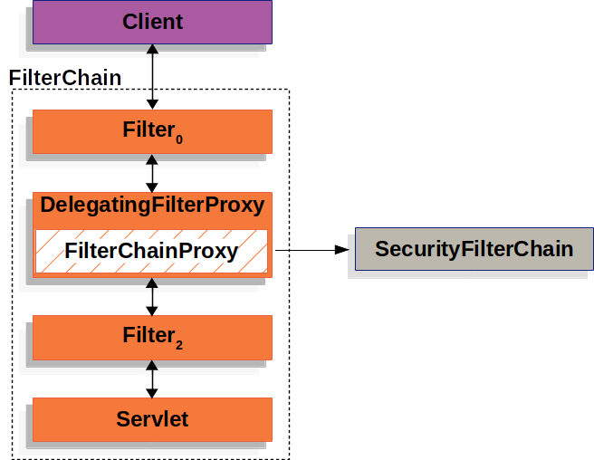

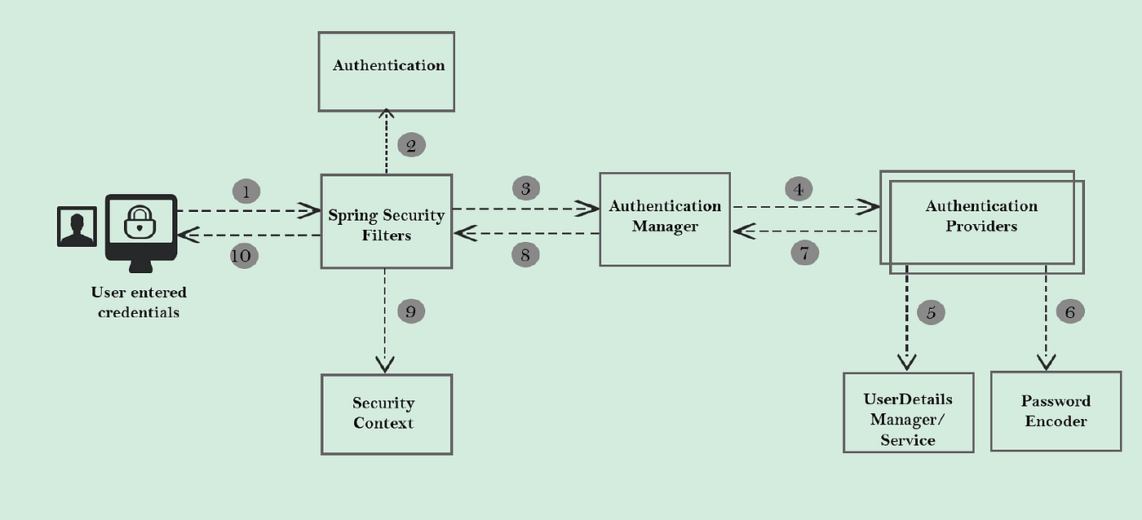

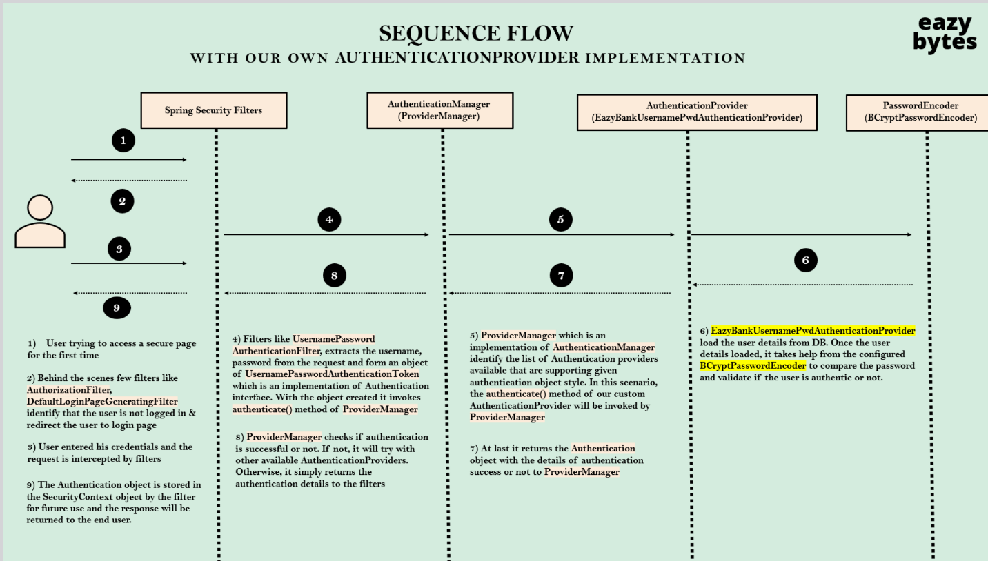

In 6th its daoauthenticationprovider invokes the method loaduserbyusername() of inmemoryuserdetailsmanager to load the user details from memory. Once the user details loaded it takes help from default password encoder implementing compare to password and validate the user authenticate or not

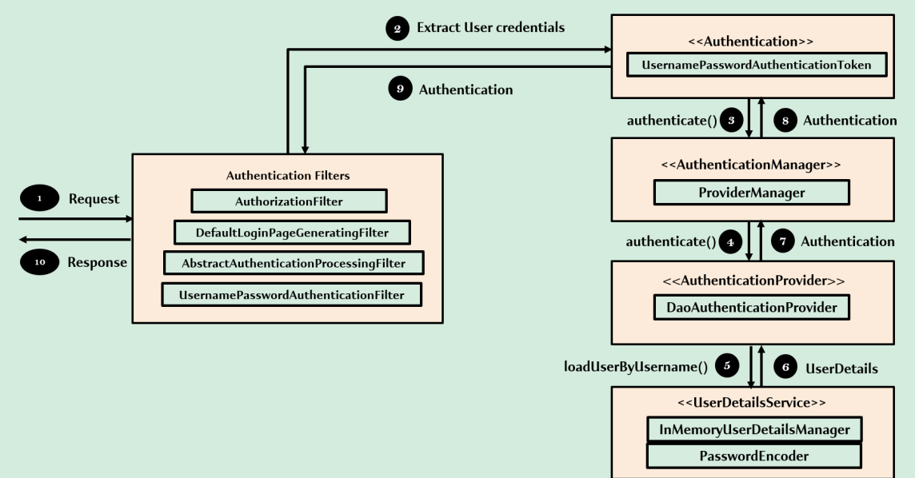

Ldap udm
Jdbc udm

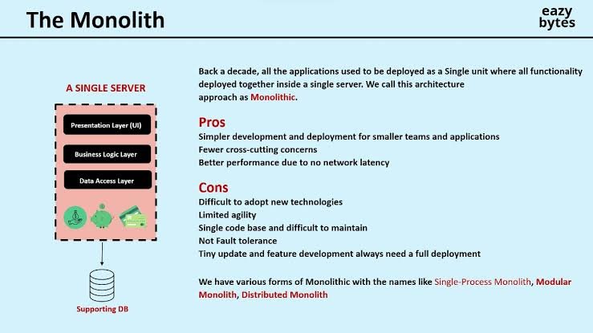

🧠 What is RabbitMQ (Queue Processing)?
RabbitMQ is a message broker that lets one system send data (messages) and another system process them later.
👉 Instead of calling another service directly (synchronous), you send a message to a queue and move on.

🔁 Basic Flow (Producer → Queue → Consumer)
1. Producer (Sender System)
- Sends a message (e.g., order details)
- Doesn’t wait for processing
- Message goes to RabbitMQ
2. Queue (Buffer)
- Stores messages safely
- Handles spikes in traffic
- Ensures messages are not lost
3. Consumer (Receiver System)
- Picks messages from the queue
- Processes them when ready

📦 Example (Real-life)
Imagine an e-commerce app:
Without Queue:
- User places order → payment → email → inventory update
- If email fails → whole process fails ❌
With RabbitMQ:
- Order service → sends message to queue
- Email service → processes later
- Inventory service → processes independently
✔ Faster
✔ More reliable
✔ Loosely coupled systems

⚙️ Key Components in RabbitMQ
1. Producer
Sends messages.
2. Exchange
- Receives messages from producer
- Decides which queue to send to
Types:
- Direct
- Fanout
- Topic
- Headers
3. Queue
- Stores messages until consumed
4. Consumer
- Processes messages

🔄 Message Lifecycle
- Producer sends message → Exchange
- Exchange routes → Queue
- Queue stores message
- Consumer reads message
- Consumer acknowledges (ACK)
👉 If no ACK → message can be retried

💡 Why Use RabbitMQ?
✅ 1. Asynchronous Processing
- No waiting → faster response
✅ 2. Decoupling
- Systems don’t depend on each other
✅ 3. Scalability
- Add more consumers to process faster
✅ 4. Reliability
- Messages can be persisted

🧱 Typical Use Cases
- Order processing
- Email/SMS sending
- Payment processing
- Logging systems
- Microservices communication

🛠️ Simple Flow Diagram (Text)
[Producer Service]
↓
Exchange
↓
Queue
↓
[Consumer Service]

🧪 Example (Spring Boot + RabbitMQ)
1. Send Message (Producer)
@Autowired
private RabbitTemplate rabbitTemplate;

public void sendMessage(String msg) {
rabbitTemplate.convertAndSend("exchange", "routingKey", msg);
}

2. Receive Message (Consumer)
@RabbitListener(queues = "myQueue")
public void receiveMessage(String message) {
System.out.println("Received: " + message);
}

⚠️ Important Concepts
🔁 Acknowledgment (ACK)
- Confirms message processed
- Prevents data loss
🔄 Retry Mechanism
- Failed messages can be retried
💾 Persistence
- Messages survive server restart
⚖️ Load Balancing
- Multiple consumers share work

🚀 In One Line
👉 RabbitMQ lets one system store work (messages) and another system process it later safely and efficiently.

Producer
It is a component which creates the msg as well as sends msg to the queue
consumer
it receives and process msg from the queue

rabbit mq
rmq is a msg broker that helps different application to send and receive msg via queue

exchange
it is a component in rmq that distinct the msg from the user and routes them to the queue

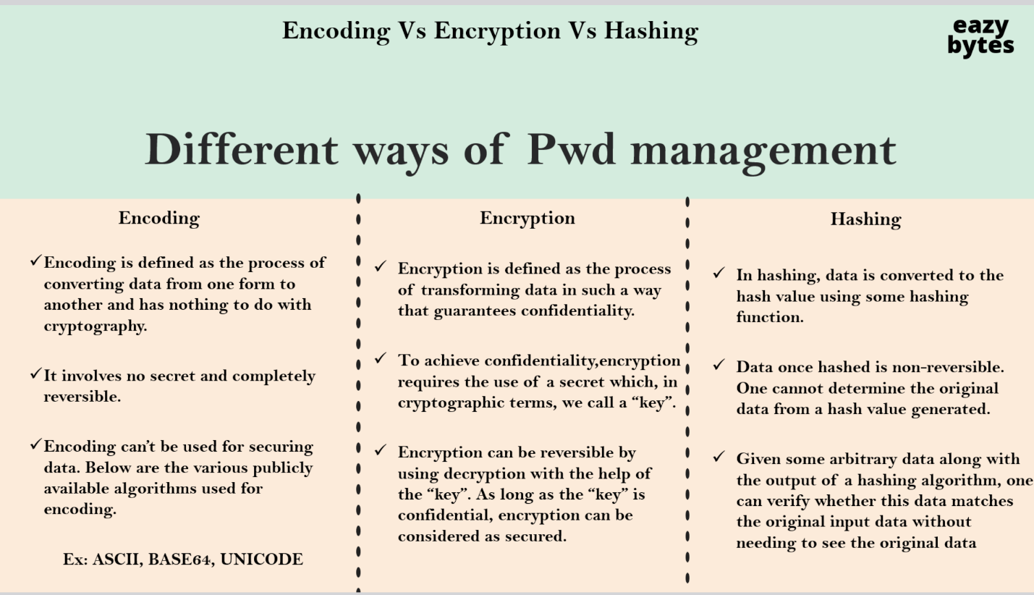

Idempotency
How to create idempotent api?
How idempotent api can be idempotent?

