**Cab Booking Web App**

Name - Sanya Sharma (2110996018)

Email – [rakshit6018.be21@chitkara.edu.in](mailto:rakshit6018.be21@chitkara.edu.in)

GitHub - <https://github.com/SANYA12SHARMA/2110996018_Scaler_Assignment>

**Home Page:**

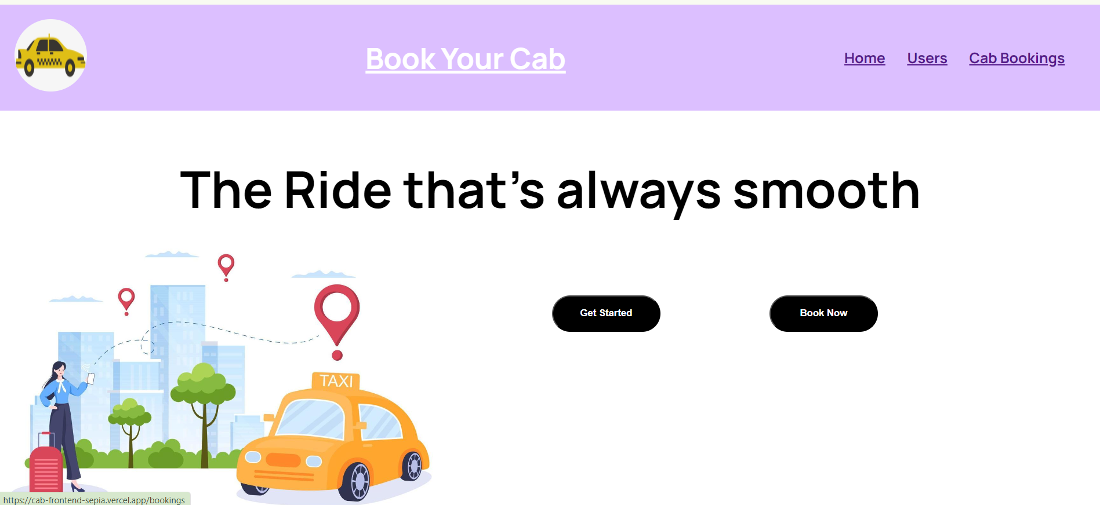

**Bookings by Users:**

* All the users are visible to the admin view.
* The data loads on runtime on any change in the website booking process.
* As soon as the booking is done the data is updated automatically.

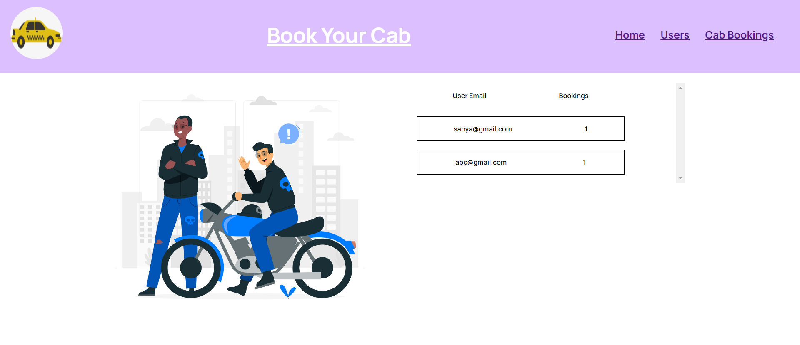

**Cab Bookings:**

* All the cabs are visible to the admin view.
* The data loads on runtime on any change in the website booking process.
* As soon as the booking is done the data is updated automatically

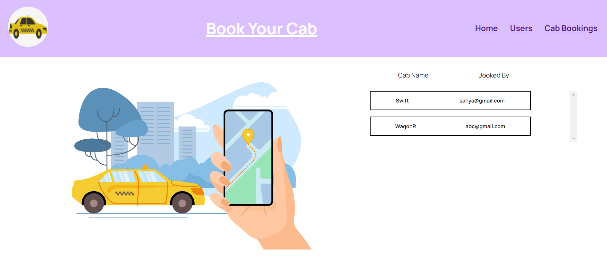

**Booking Page:**

* 5 different types of cabs available to the user to choose from.
* User just need to enter their email id, pick up point and drop point.
* As soon as the user clicks the check cost button ,it provides the desired price for each cab.

