**Cab System**

**Description:**

Create a web application for a cab system where users can enter the source and destination and they will be provided with the shortest time and estimated cost.

**Requirements:**

* The system should be able to manage cab booking
* The below provided is the time taken between different destinations. For e.g. from A to B the time taken is 5 min, similarly from D to F the time taken is 20 min. 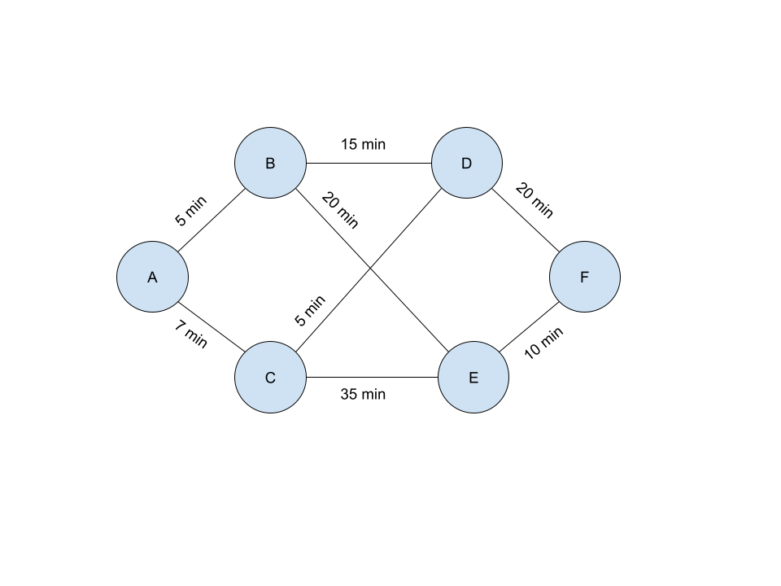
* The user should be able to book a cab by providing the user's email, source, and destination
* The system should be able to calculate the shortest possible time from source to destination. E.g. There are multiple ways from A to D, but the shortest route will be via C.
* There are a total of 5 cabs with different pricing. (Price/minute)
  + No cab should have an overlapping start and end time
* The system should provide the estimated cost depending on the cab chosen and the time taken to reach the destination.
* The system should be able to track the cab booking
* Users should be able to view and edit the cabs and their pricing.

*Note:*

* No need to develop login/signup pages, just make an assumption that only admins will be accessing it and just try to cover the basic requirements part with this assumption.
* Create your app’s frontend as a SPA.
* Create a proper ReadME file describing the functioning of your project

*Good to have:*

* Responsive design
* The system should be able to send email notifications to the user's email id at the time of booking

**Submitting:**

Upload your code on GitHub or any similar service and send us the link.

Make sure that the repository is marked public.

Also, you can deploy your app using AWS/Heroku or any other service and send us a link.

**Evaluation Criteria:**

Both the backend and frontend should meet all Basic functionality is working. (i.e. Mentioned in the Requirements Section)

Database schema.

Code Modularity.

Code quality.