SAC ALM Analytics Hands-on

In this exercise, you will build a SAC story to report on your ERP data load.

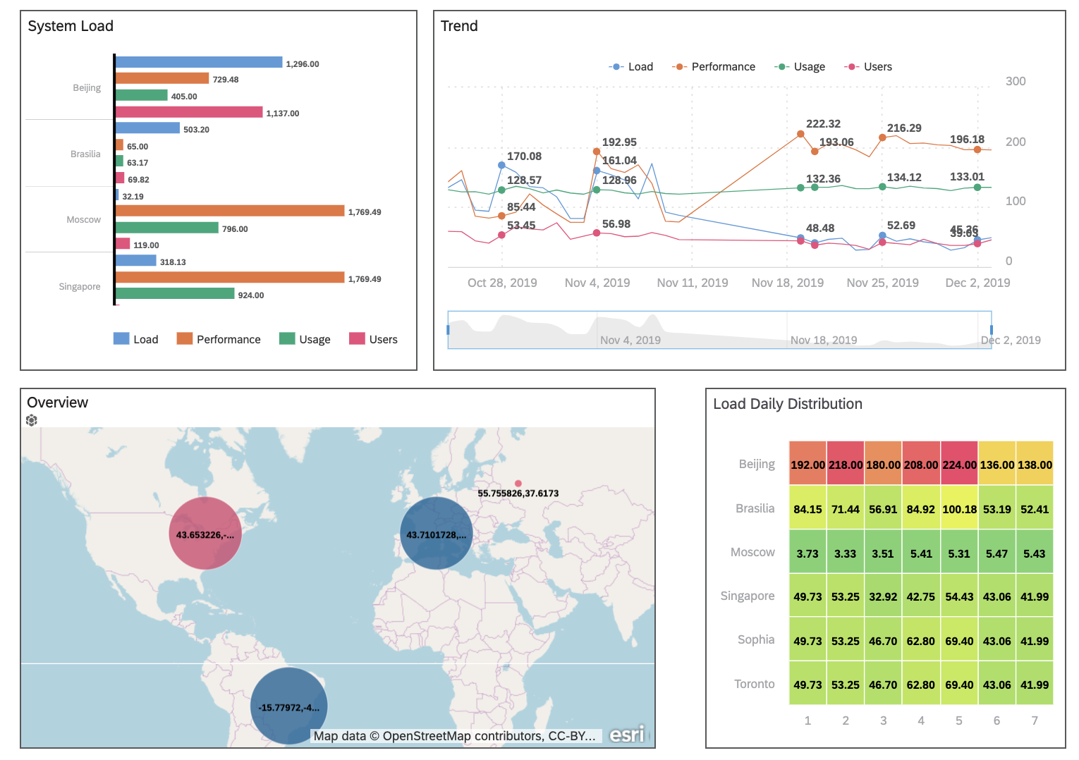

The data source is constructed in Focused Insights for the [www.sapsolutionmanagerdemo.com](http://www.sapsolutionmanagerdemo.com)

<https://www.sapsolutionmanagerdemo.com/sap/bc/ui5_ui5/stdf/occ_dash/index.html?configId=65>

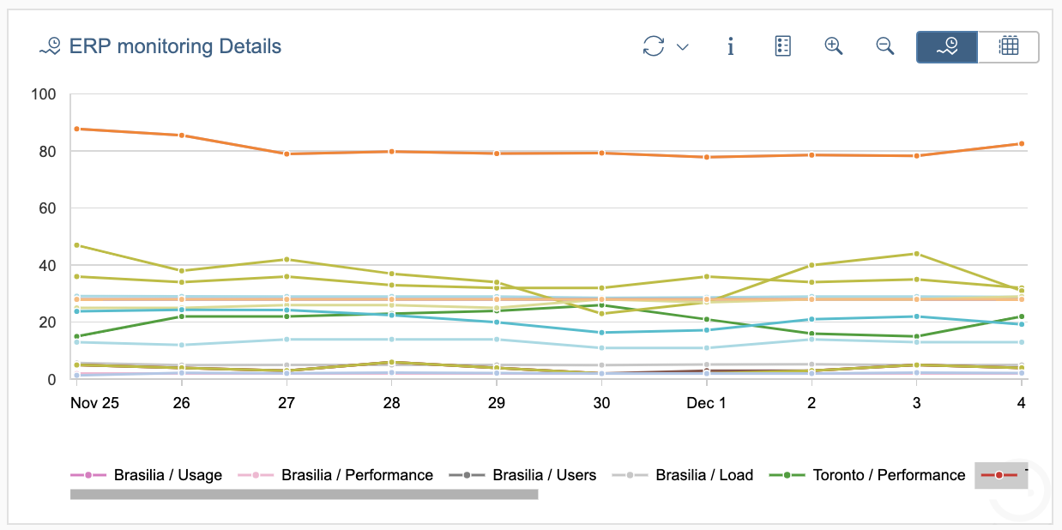

SAC ALM Analytics Hands-on 1

Ex 1: Create your first chart 3

1.1 Connect to the SAC Tenant 3

1.2 Create your story 3

1.3 Bar chart 4

Ex 2: Add a Trend Chart 8

1.4 Time series chart 8

Ex 3: Add a Distribution Chart 10

1.5 Heatmap chart 10

Ex 4: Add a Geo Map 12

1.6 Geo map with Bubble Chart 12

# Ex 1: Create your first chart

### Connect to the SAC Tenant

<https://fi-analytics-test.eu10.sapanalytics.cloud/sap/fpa/ui/app.html#;view_id=home>

### Create your story

|  |  |
| --- | --- |
| From the main menu select:   * Create * Story |  |
| Select the **Canvas** Page |  |
| Save your story |  |
| Name it:  techED_{***GROUPID***} |  |

### Bar chart

<https://fi-analytics-test.eu10.sapanalytics.cloud/sap/fpa/ui/app.html#;view_id=home>

|  |  |
| --- | --- |
| From the main menu select  **Browse**, **Files** |  |
| Select your story |  |
| Press the **Edit** button |  |
| Press the **Insert** button |  |
| A pop-up for model selection is displayed |  |
| Navigate to the **Public/Models** folder:  **FIDS_ERPMONITORING_832_IMPORT** |  |
| An empty chart is displayed. |  |
| Check the Designer view. |  |
| Select *Measure*, *Load*, *Usage*, *Users*. |  |
| Check Results |  |
| Change **Color** Palette |  |
| Check Result |  |
| Add the **Group** Dimension from the Dimension Listbox. |  |
| Select the **Styling** menu |  |
| Change **Border** |  |
| Select **Background Color** |  |
| Select **Legend** |  |
| Change the chart title to **System Load** |  |
| Check Result |  |
| Save **Story** |  |

# Ex 2: Add a Trend Chart

### Time series chart

|  |  |
| --- | --- |
| Select Insert Chart |  |
| In the designer tab, select a **Trend** Chart of time series |  |
| Add Measure with the “**Add Measure**” button |  |
| Select *Measure*, *Load*, *Usage*, *Users*. |  |
| Add **Timestamp** Dimension. |  |
| Select **Timestamp** in the **Time** dimenstion. |  |
| Change the title chart to “**Trend**”.  Change Border.  Check Result |  |
| Save the Story |  |

# Ex 3: Add a Distribution Chart

### Heatmap chart

|  |  |
| --- | --- |
| Select Insert Chart |  |
| Add a distribution chart by choosing the **Heat Map** chart |  |
| Select WeekDay for Dimensions for **X-Axis** |  |
| Select Group for Dimensions for **Y-Axis** |  |
| Select Load for the **Color** Dimension. |  |
| Change Title to **Load Daily distribution**.  Change **Border** chart**.** |  |
| Save Story |  |

# Ex 4: Add a Geo Map

### Geo map with Bubble Chart

|  |  |
| --- | --- |
| Select Insert Chart **Geo Map**. |  |
| Change Title to **Overview** |  |
| Add **Map Layer** in the **Builder** Tab  Select the “**Add Layer**” button. |  |
| Select model |  |
| Choose the Geo-localized model from the **Public / Folders**  **FIDS_ERPMONITORING_DS__832** |  |
| Select **Location** Dimension |  |
| Select **Bubble Color** to **Performance**.  Select **Bubble Size** to **Load** |  |
| Press OK to exit the **Layer** Tab |  |
| Change the **base Layer**  Change Border |  |
| Check Result |  |
| Save Story |  |

Congratulations.