SAP Concur App Center Listing Form

Overview
Please complete the following form to populate your App Center listing and return to your Certification Project Manager or PlatformCertification@sap.com. Please plan for a 1-2 week lead time to accommodate any edits required.

Be sure to review the App Center Partner Marketing Toolkit for brand guidelines and other tips.

Listing updates: Any requests for updates to your App Center listing, as well as any translations into other languages, require a new form to be submitted. Please send to your Certification Project Manager.

Collateral (brochures, videos, etc.): Any partner collateral materials you would like to include in your App Center listing must be reviewed by SAP Concur prior to posting. Please review the App Center Partner Marketing Toolkit for tips and brand guidelines.

Listing Language
What is the language that the following details are written in? If you want to make your listing available in multiple languages, please provide a separate listing form for each language.
Listing Type
User Connection or Enterprise
Listing Name
Company and/or specific product name.
Limit: 32 characters including spaces
Headline
Short heading describing the application.
Limit: 100 characters including spaces (shorter recommended)
Short Description
Will act as an introduction to your application and entice the reader to learn more. Briefly explain what the integration with SAP Concur solutions does.
Limit: 180 characters including spaces
Long Description
Longer description of the application and integration with SAP Concur solutions. This will appear in the details tab of your application. You can include rich text formatting - bold, italic, bullets, and hyperlinks.
Limit: 2500 characters including spaces
Partner’s Listing URL
URL to partner website. Required for Enterprise Application partners, the linked page must mention the partnership/integration.
Brochure or Datasheet URL
Required for Enterprise Application partners. Speaks to SAP Concur integration. Content hosted on partner website. For recommendations, visit the Marketing Content Best Practices section of the App Center Partner Marketing Toolkit. Must comply with SAP Concur Brand Guidelines.
Demo Video URL
Recommended, but not required. Ideally, the video speaks to the application and integration with SAP Concur solutions.
Additional Content
You may provide up to 5 additional pieces of content to link on your listing (optional). Please provide your suggested name as well as the URL.
Link Name | URL

Lead/Inquiry Report Email Address
Required for Enterprise Applications, but not applicable for User Connections. Lead inquires will be sent to this email address. More details are available here.
Lead/Inquiry IT Set Up
Provide your IT team the following details to place SAP Concur on the safe sender list. Leads will be sent from the Marketo marketing automation tool.
To ensure receipt of all leads, provide your IT team the following details to allowlist the Concur IP address and place SAP Concur on the safe sender list.
- Email From Address: concur@​info.​sap.​com
- From Sender: Concur App Center Referral
- Subject: AppCenter Inquiry Submission
- Domain: info.sap.com, .sap.com
- IP Address: 192.28.144.41

Partner Name
Partner Support URL or Email
A support email or partner-hosted page that has all your contact information for product support.
Partner Privacy Policy URL
Provide a link to the privacy policy page on your website.
Partner Terms and Conditions URL
Provide a link to the Terms and Conditions page on your website
Connect Landing Page URL
URL provided must include sign in/up or sign up flows, URL must be in production and certified prior to the app launch date. Be sure to review and follow the UX Guidelines (Enterprise / User Connection).
Connection Workflow
One Time Password Flow unless otherwise specified.
Mobile App Center
Submit these details and accompanying images (see image section) in order to be listed in the “Connect to Apps” section of Concur Mobile. Currently only for User Connection apps/Apps for Me.
- iOS App Store URL: (URL that takes user to the mobile page to begin the connection process. Example: https://www.partnerapp.com/concur/redirect)
- Android Package ID and App Launch URL and Parameters: (URL that opens the app once installed on the user's mobile device. Example: me.partnername.android)
- Any additional parameters for either mobile platform.

Keywords
Used for key word search in the App Center. Include any common words that may be used to search for or find your listing, separated by commas. Please do not include competitors’ brand names.
App works with these SAP Concur offerings
Must highlight at least one.
- Expense - Standard
- Expense - Professional
- Invoice - Standard
- Invoice - Professional
- Travel - Standard
- Travel - Professional
- Travel Request – Professional
- Concur TripLink
Listing Category
Highlight your integration’s functional role. You may select 1-3 of the most applicable categories.
- Air & Hotel
- Cars & Trains
  - Rides
  - Mileage
  - Parking
- Food
- Other Expenses
- Card Integrations
- Compliance
- Duty of Care
- Sustainability
- IT Solutions
- Finance & HR
  - Client Billing
  - Audit
  - Payment Providers
  - Tax Management
- ERP Integrations
  - Financial Integration Program
  - Microsoft Dynamics
  - Sage
  - Oracle
  - SAP
  - QuickBooks
  - Other
Global Capabilities
Please read the definitions below carefully and highlight the appropriate countries with a note of the capabilities you support today. See example.
- Availability: What countries is your app available in? (App must be fully functional)
- Language Support: What languages is your app translated into? (Must include translation for the listing content and any other marketing assets you utilize for the app)
- Local Presence: What countries do you have local support in? (Physical presence, offices) Please provide the address and contact number for each.

Examples:
- United States – Availability/Language/Local
- France – Availability/Language

If a specific country you support is not listed below, please include it separately.
North America  Canada  Mexico  United States of America | Latin America  Argentina  Bolivia  Brazil  Chile  Colombia  Ecuador  Paraguay  Peru  Uruguay  Venezuela | Europe, Middle East, & Africa  Afghanistan  Armenia  Austria  Belgium  Croatia  Czech Republic  Denmark  Egypt  Ethiopia  Finland  France  Germany  Greece  Greenland  Hungary  Iceland  Iran  Iraq  Ireland  Israel  Italy  Jordan  Kenya  Netherlands  Norway  Pakistan  Poland  Portugal  Russia  South Africa  Spain  Sweden  Switzerland  Turkey  Ukraine  United Arab Emirates  United Kingdom | Asia Pacific  Australia  Bangladesh  Cambodia  China  Fiji  Guam  Hong Kong  India  Indonesia  Japan  Korea, South (Republic of Korea)  Malaysia  Myanmar  Nepal  New Zealand  Palestine  Singapore  Taiwan  Thailand  Vietnam

Localization
On this page, you will find a list of SAP Concur-supported languages. If your application is available in a country where one of the following languages is spoken, you may translate your listing into that language. Use this form, and insert translations for the short description, long description, and insert links to any localized landing pages. For example, if your listing is available in France, we recommend that you translate the listing to French.

We recommend that all the assets that your listing links to are also localized, including the Support link.

We understand that there is a cost associated with localization. To bring that cost down, consider abbreviating the length of your listing to include only the key points about the integration with SAP Concur solutions and your application.

SAP Concur-supported languages

Images
Please submit the images below for approval:
- App Icon: (Required) Partner app icon with a logo or icon image, 600x600px / 700 KB / jpg or png / no white or transparent backgrounds
- High Resolution App Logo: Print quality logo to be used in future marketing activities. High resolution, eps or ai format
- App Screenshots (Max 5):
  - Web: Recommended aspect ratio 4:3 or 16:9. Maximum width 1176 / max 700 KB / jpg or png
  - Mobile: 9:16 ratio, 640x1138 px / max 700 KB / jpg or png

If you plan to be listing in the Mobile App Center, please submit these required images (User Connections/Apps for Me only at this time):
- Small Image (Icon): 300x300px, jpg or png format
- Large Image: 600x600px, jpg or png format
- Screenshots (Max 6): 920x1742px, jpg or png format
- Featured App Image: 1080x576px, jpg or png format

Note: Please avoid images with very fine or small text in them as these high-resolution images will be scaled down for use on lower resolution devices.

Example App Center Listing
Summary View

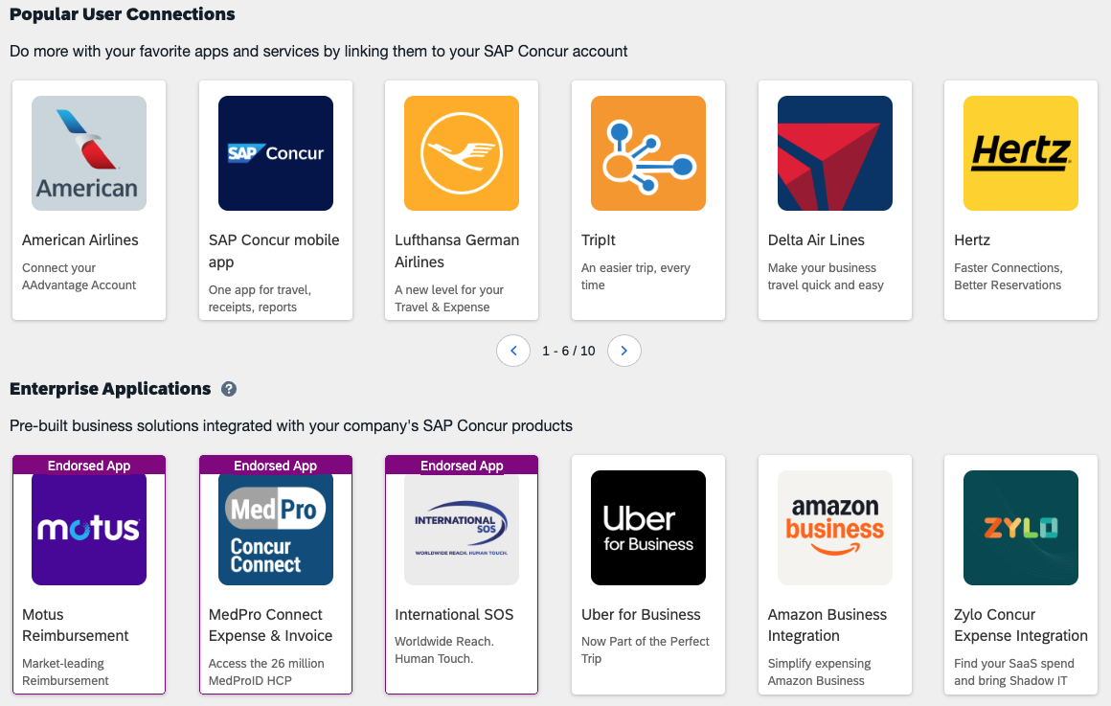
Short descript. shows when hovering over icons
Listing Name
600x600 px App Icon
Headline

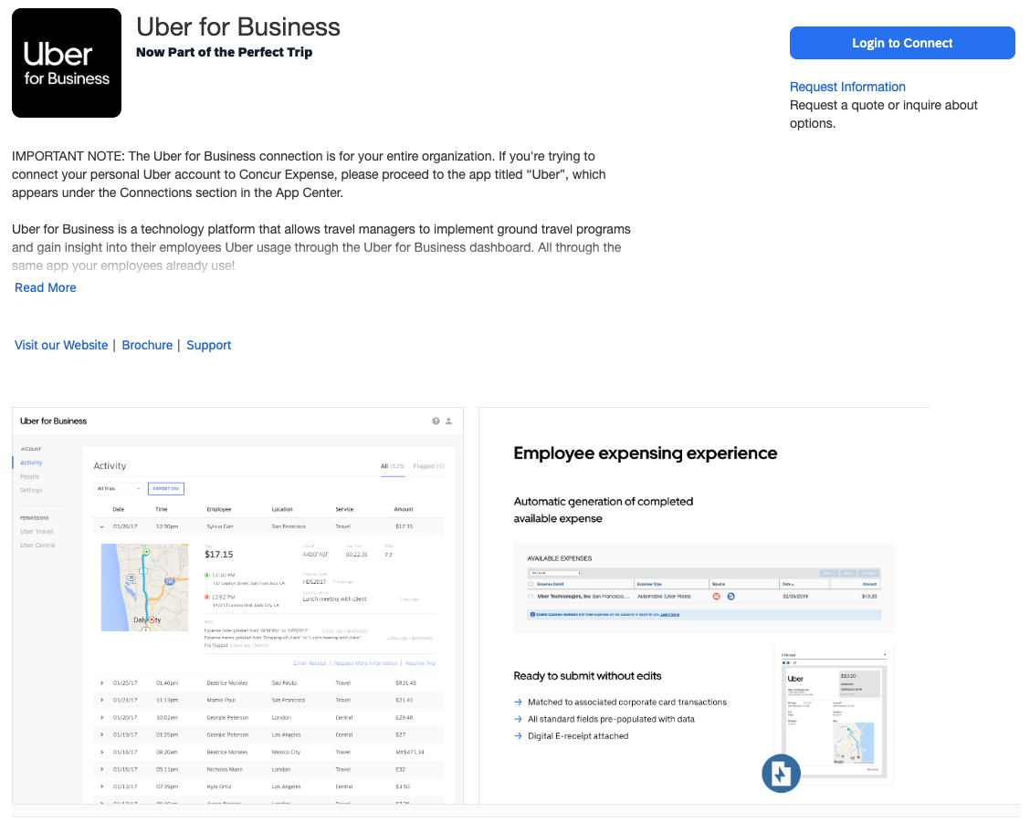
Additional support info/resources appear here when provided
Partner’s Listing URL
Long Description
Headline
App
Icon
Inquire Link
Listing Name
Screenshots

