Error Screenshots

App deployed successfully on BTP manually
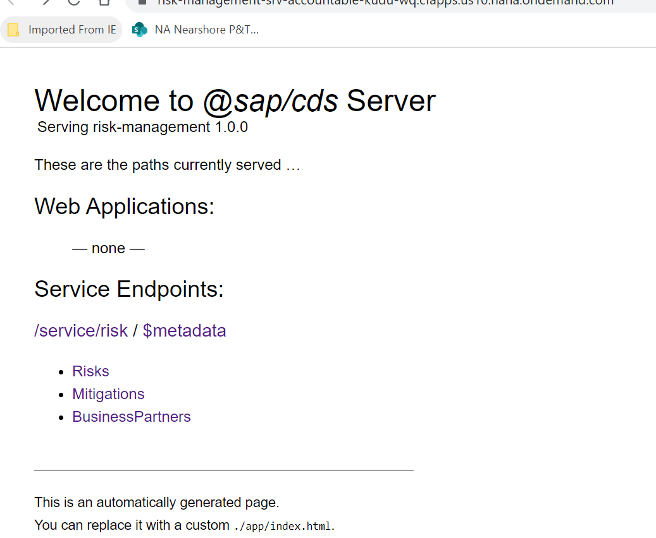
When clicked on Business partner or any other link

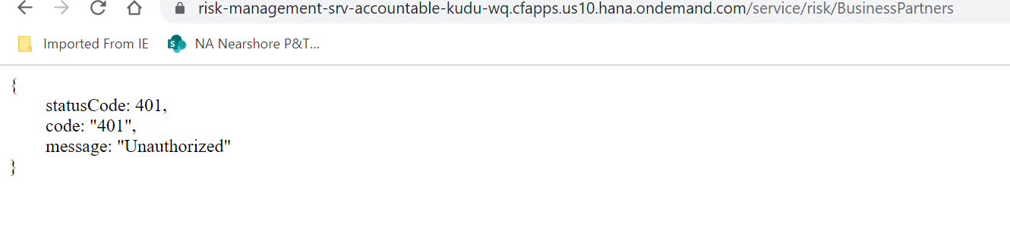
Same error when connection checked at connectivity-destination.
