If you are teaching the CLD900_20 and the SAP Gateway Demo ES5 System is not reachable/available, we implemented for Instructor Led Trainings a Workaround.

1. Log On to your SAP BTP Integration Suite
2. Click on Configure 🡺 APIs

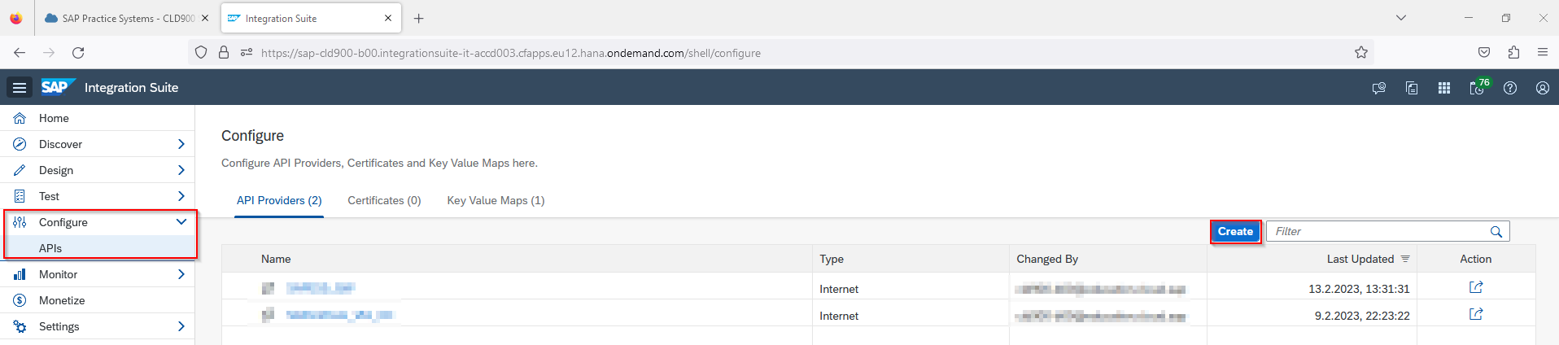

1. Click on Create
2. Type in the following:

|  |  |
| --- | --- |
| **Overview** | |
| Name | *saponprem_via_cc* |
| Description | *Workaround* |
| **Connection** | |
| Type | *Internet* |
| Host | *sklawonn.test.apimanagement.eu10.hana.ondemand.com* |
| Port | *443* |
| Use SSL | *unflagged* |
| **Catalog Service Settings** | |
| Path Prefix |  |
| Service Collection URL | *V1/GWSAMPLE_BASIC* |
| Authentication type | *None* |

The API Provider should look like this!

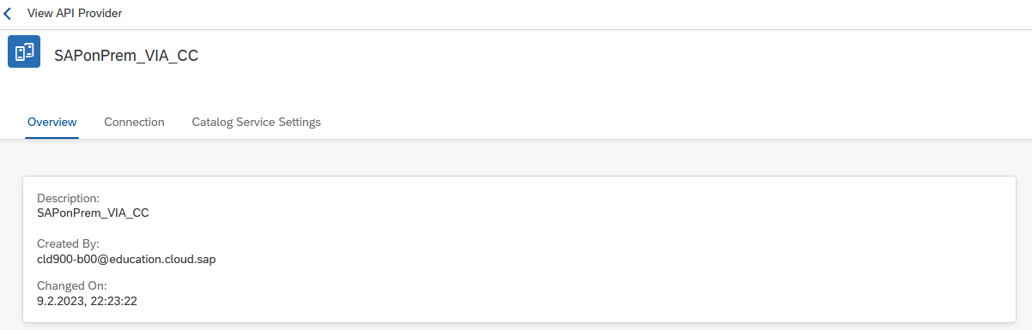

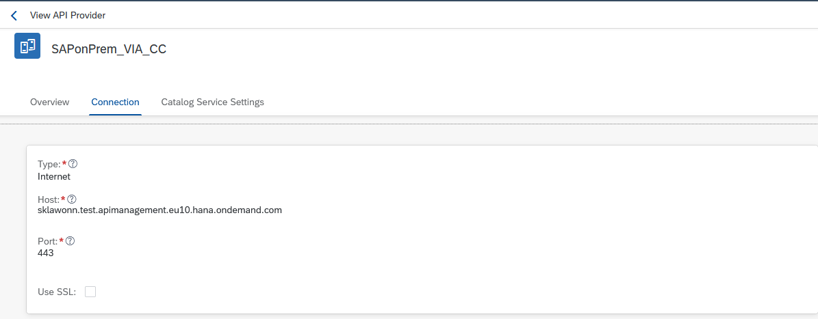

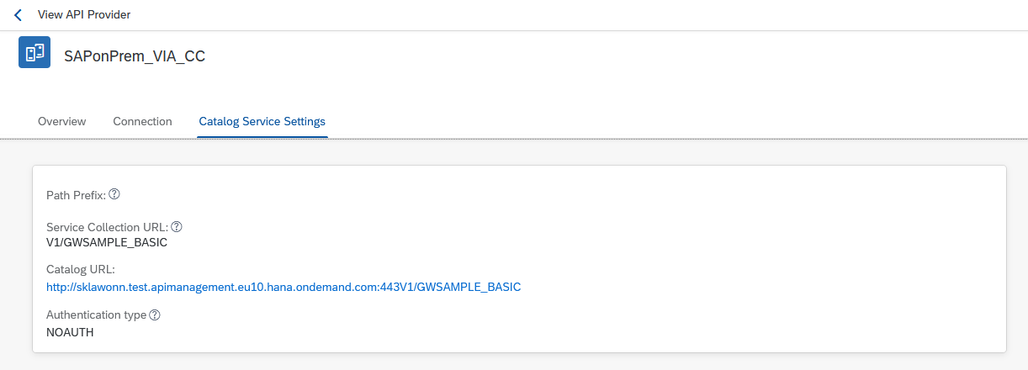

1. Go to Design 🡺 APIs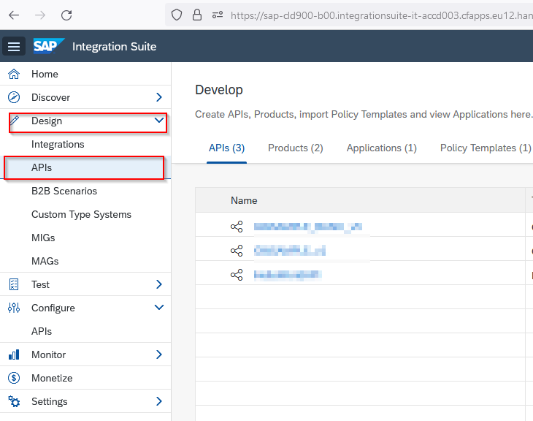
2. Click on Create
3. Type in following:

|  |  |
| --- | --- |
| **Create API** | |
| Choose | *URL* |
| URL | *https://sklawonn.test.apimanagement.eu10.hana.ondemand.com:443/v1/GWSAMPLE_BASIC* |
| **API Details** | |
| Name | *GWSAMPLE_on_CC_v1* |
| Title | *GWSAMPLE_on_CC_v1* |
| API State | *Active* |
| Host Alias | *api-cld900-XXX.apimanagement.eu12.hana.ondemand.com*  *(it gets self generated)* |
| Version | *V1* |
| Service_Type | *REST* |

1. Go through the Wizard step by step
2. Click on Deploy

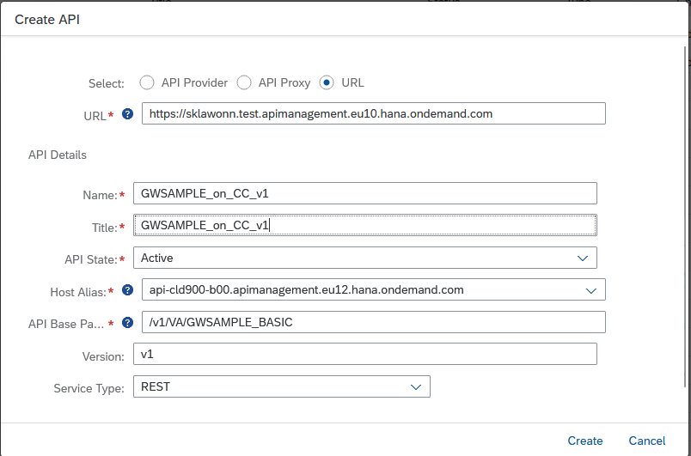

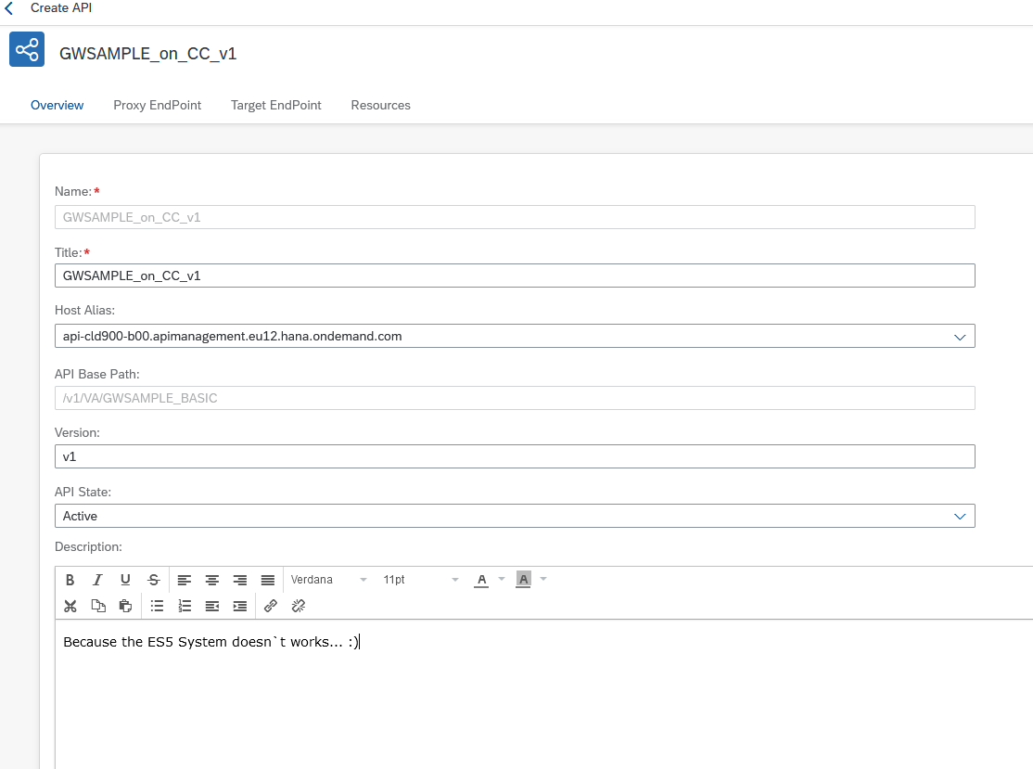

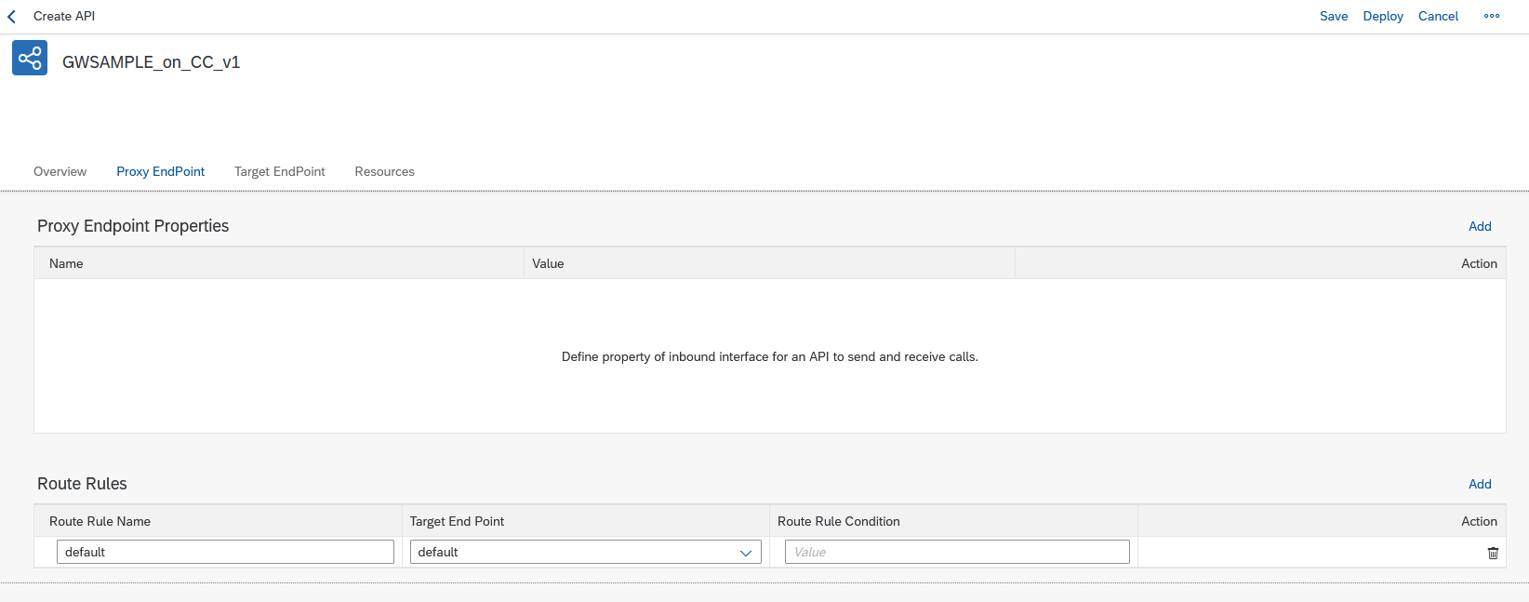

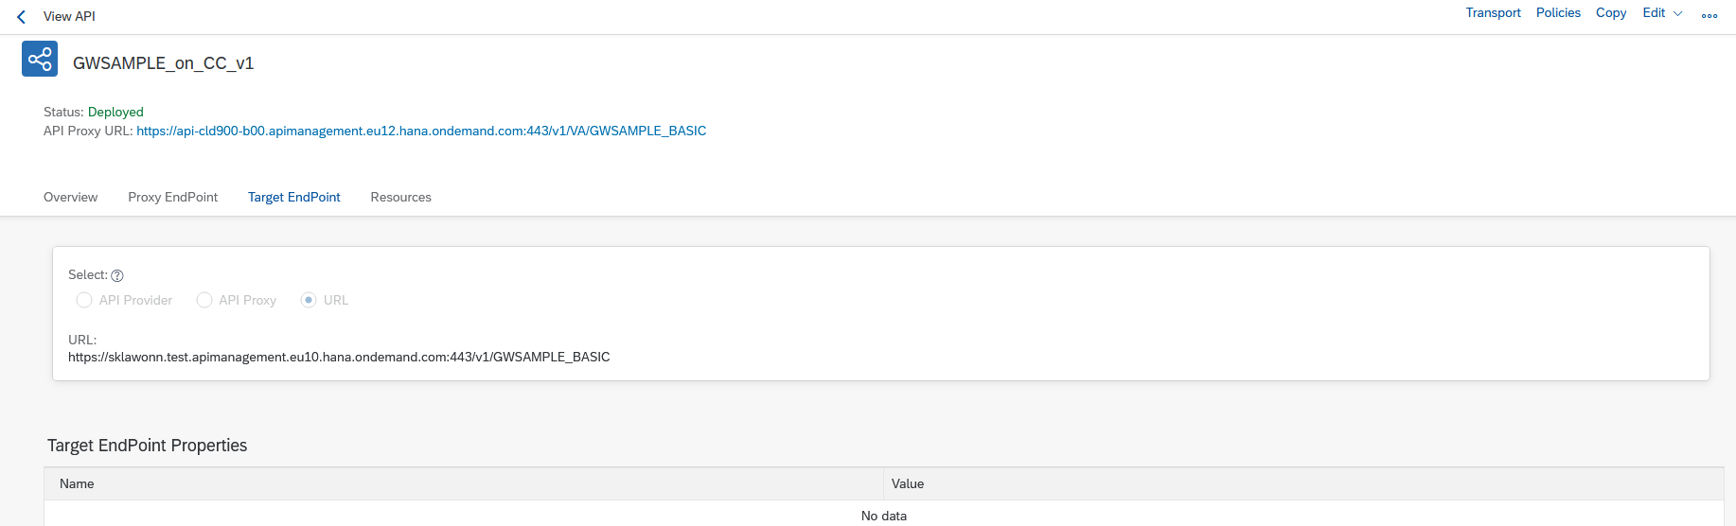

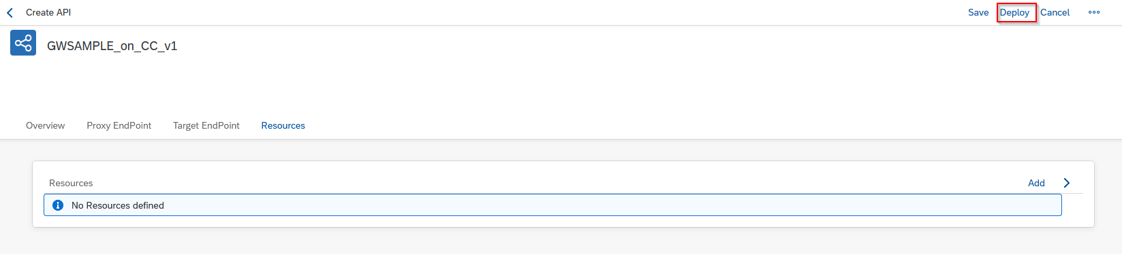

You should identify that you can`t get some resources out of the box. That is not an Issue, it is because of no Metadata transfer.

1. Go in to the Edit in API Designer modus

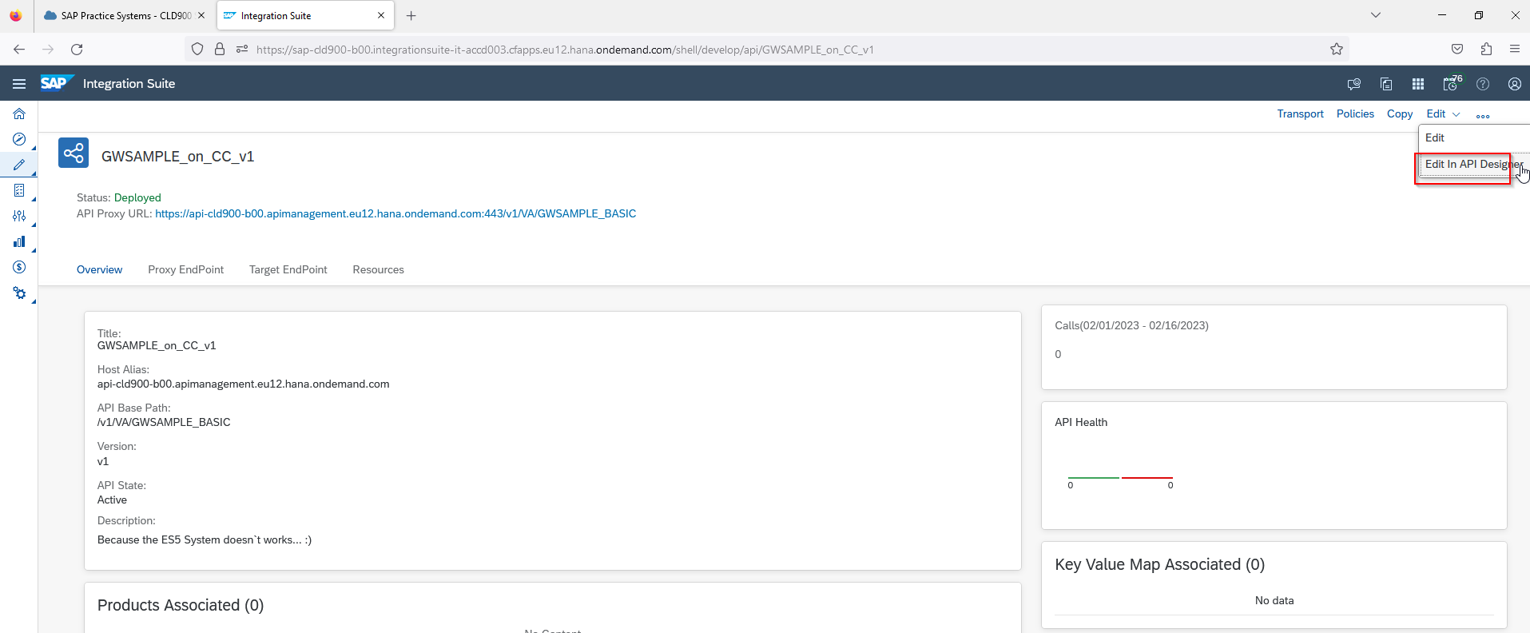

1. You should see that there aren`t some Resources in this API

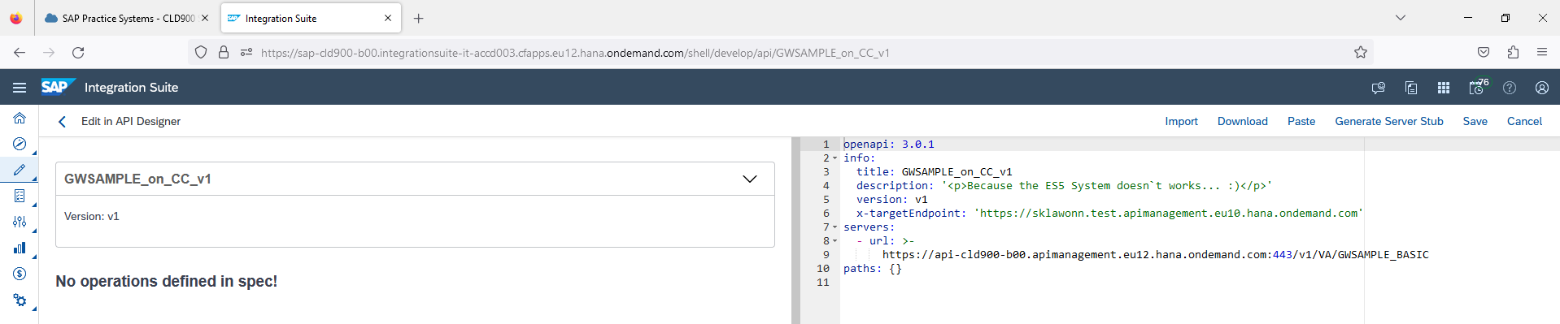

1. Add the the following OpenAPI Code which you can get from the OpenAPI_API_designer textfile which is placed in an external Github 🡺 [SAP-samples/integration-suite-learning-journey: Template for the learning journey "Developing with SAP Integration Suite". (github.com)](https://github.com/SAP-samples/integration-suite-learning-journey)

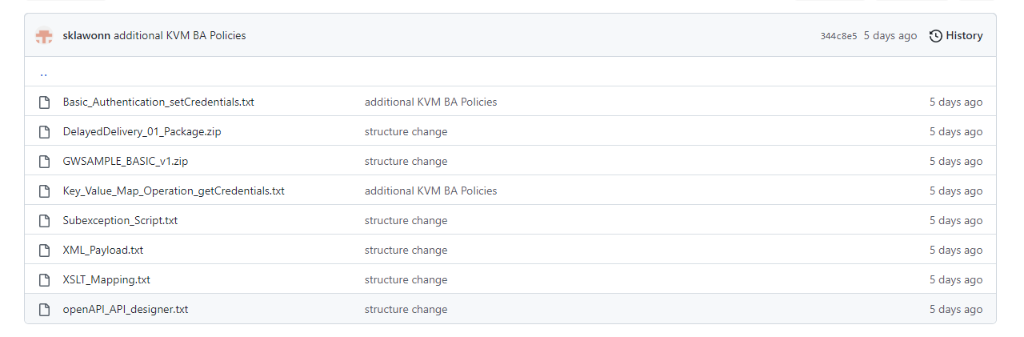

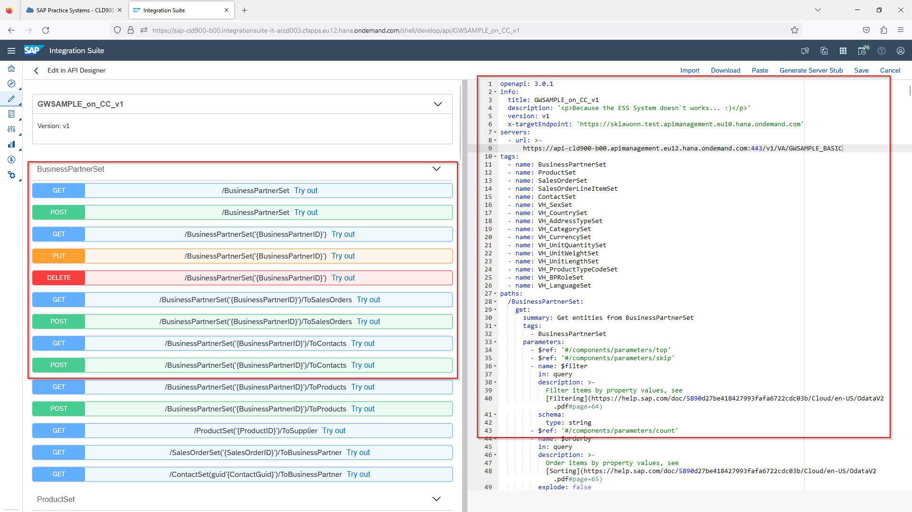

1. Click on Save
2. Now you should see the resources and test it via “try out”

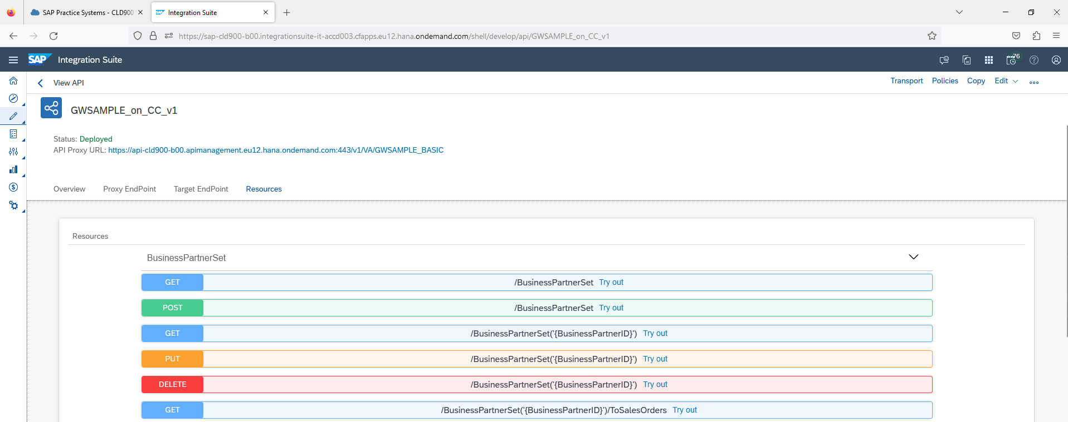

The students are now able to do the same steps “implementing the API proxy” which works instead of the ES5 System.

Please