**Installing Python and Required Libraries**

## **1.Download and Install Python**

## For Windows:

1. Go to <https://www.python.org/downloads/> and download Python version 3.7 or higher.
2. To install Python, select the "Add python.exe to PATH" checkbox and choose "Install Now".

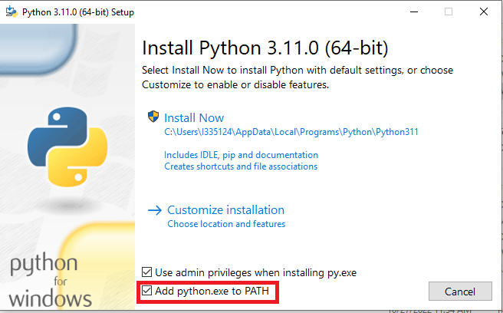

1. Check whether Python has been successfully installed by opening Command Prompt (cmd.exe) and entering the command "python --version". The system will display the installed Python version.

## 

## For Linux:

1. Go to <https://www.python.org/downloads/source/> and download Python version 3.7 or higher.
2. In the terminal, input the following commands sequentially as a superuser.

# tar -zxvf Python-3.9.0.tgz

# cd Python-3.9.0

# ./configure

# make && make install

1. Input the command "python3 --version".



## **2.Installing progressbar**

To run the File Splitter program, you will need to install the progress bar library for Python.

Note: pip is the recommended installer. If pip3 is not installed in your machine, you need to install pip3 before proceeding with this step.

For more information, see:

https://packaging.python.org/en/latest/tutorials/installing-packages/#use-pip-for-installing.

## For Windows:

Input the command "pip install progressbar"

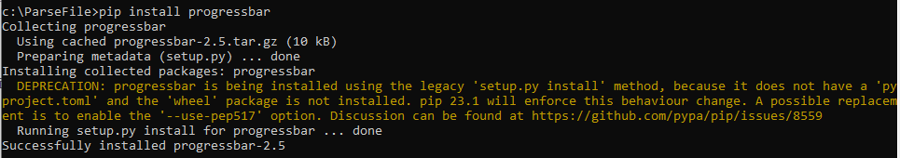

## For Linux:

Input the command "pip3 install progressbar"

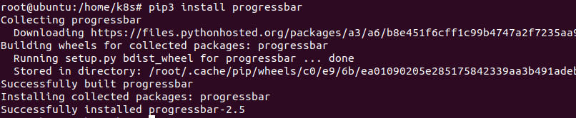

## **3. Run the Program Using cmd.py**

## For Windows:

Run the File Splitter program by using command "python cmd.py".

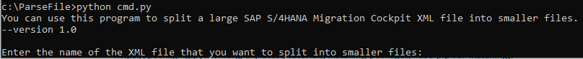

## For Linux:

Run the File Splitter program by using command "python3 cmd.py"

