**Installation**

## **1.Setup Python3 environment**

## For Windows:

1. Go to the website <https://www.python.org/downloads/>, and download the released Python environment (version 3.7 or above).
2. Installing.

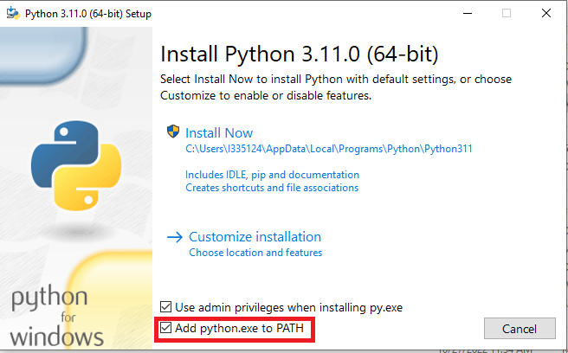

Tick ‘Add python.exe to PATH’ and then choose ‘Install Now’.

1. Run cmd.exe and input command ‘python --version’ to check if Python is successfully installed or not.

## 

## For Linux:

1. Go to the website <https://www.python.org/downloads/source/>, and download the released Python environment (version 3.7 or above).
2. Input the commands one by one in terminal as below (superuser mode).

# tar -zxvf Python-3.9.0.tgz

# cd Python-3.9.0

# ./configure

# make && make install

1. Input command ‘python3 --version’.



## **2.Installing progressbar**

## For Windows:

Input the command ‘pip install progressbar’

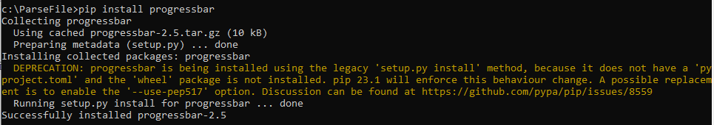

## For Linux:

Input the command ‘pip3 install progressbar’

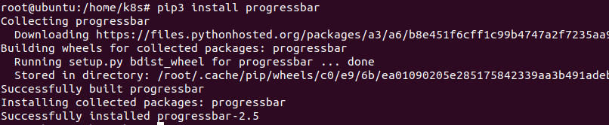

Note: If you do not install pip3, you should install pip3 firstly(Refer to https://packaging.python.org/en/latest/tutorials/installing-packages/#use-pip-for-installing).

## **3. Run cmd.py**

## For Windows:

Input command ‘python cmd.py’

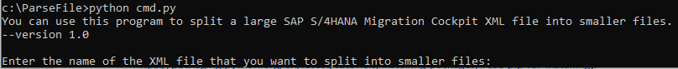

## For Linux:

Input command ‘python3 cmd.py’

