*Nielsen - Procurement Process User Experience Assistant*

Business Scenario Design Document

INTERNAL



Table of ContentS

1 USe case Description 3

2 Business Context 7

2.1 Business Objectives and Expected Benefits 7

2.2 Major Business Pain Points (to achieve business objective) 8

2.3 Key Financial Performance Indicators (KPIs) 8

3 Functional and Process Design 9

3.1 Master Data 9

3.2 Related Systems (being replaced or Interfaced with) 9

3.3 Major Data Sources for Integration 9

3.4 Policy and Compliance 10

3.5 Process Scope 10

# USe case Description

Link to the solution:

[**PR AI Agent**](https://nielsen-agent.cfapps.eu10.hana.ondemand.com/)

**Main Expectations and Validation Criteria:**

* **Simplify Purchase Requisition Creation:**  
  Streamline the process of creating a purchase requisition to encourage greater adoption of the standard procurement process within Ariba.
  + The chatbot’s primary objective is to simplify procurement by guiding buyers step-by-step through the process.
* **Prevent Costly Mistakes Early in the Process:**
  + Ensure the existence of a valid agreement (contract, quote, or other documentation) with the vendor to avoid unexpected issues at the time of payment.
  + Support accurate commodity code selection based on the item being procured.
  + Recommend preferred vendors with committed spend agreements to help buyers benefit from discounted rates.
* **Improve Vendor Contract Visibility for Accountants:**  
  Enable better tracking and accessibility of vendor contract terms and conditions by extracting key information for use by the accounting team.

The procurement process optimization powered by SAP AI enables non-expert BU users to be guided through the procurement process with prompts in natural language processing. Ai4U chatbot can assist with creating a purchase requisition with anomaly detection capabilities, supplier relationship management optimization.

Ai4U chatbot can also assist in assessing vendor contracts, extract and compare characteristics like payment terms, guaranteed spend consumption, cancelation policies and more as per below:

* Provide a new experience to support AP users navigating the current decentralized procurement model
* Create space and time with Ai4U chatbot tant to execute the AP transformation roadmap e.g. replace TAP, implement category management, explore supply chain financing as part of the process, enforce the process and improve the process
* Improve awareness and tracking of contract commitments - i.e. ensure we communicate the commitments made so we can make sure we track them continuously and avoid the need for renegotiation of commitments which is time consuming and occasionally costly
* Provide guidance for selecting the right type of service in order that the tax is calculated correctly - i.e. the location and type of good/service is correct
* Reduce POs going through corrections (currently 13% go through corrections once or more and these are the highest spend items)
* Track cancellation terms as sometimes we miss the deadlines and end up having to pay even when we cancel a contract

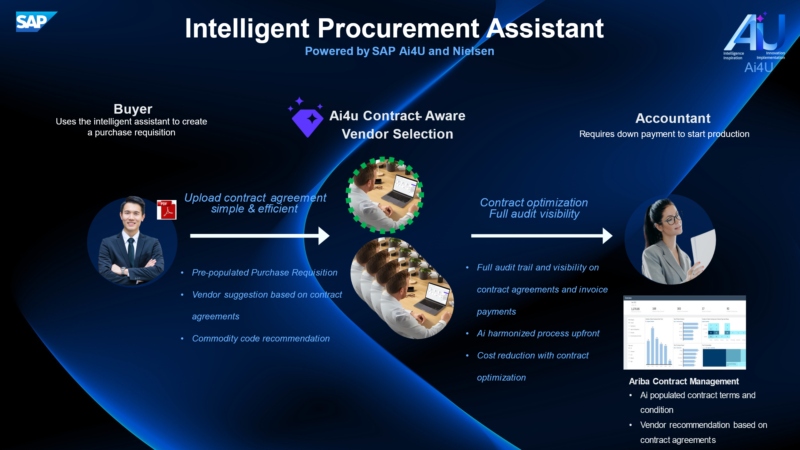

Ai4U chatbot can be used to carry out these tasks:

* **Use Case1:**
* Guide BU users to create a purchase requisition from catalog or non-catalog material or service items
* Determine if a catalog exists, if a vendor has been engaged, and if an agreement is in place
* The chatbot will first check for catalog items and then move to agreements if no catalog item is found
* Assist in selecting the right material category/commodity code based on goods/services requested
* Show a list of materials for purchase from existing Nielsen catalogs
* Show a list of sources of suppliers from the identified vendor master
* Based on the list of conditions extracted from previous vendor agreements, the chatbot checks if the required item is available from a vendor with a guaranteed spend agreement in progress. If so the chatbot should recommend this vendor to the buyer. The buyer can still choose to select another vendor.
* Step by step approach [here](https://sap.sharepoint.com/:w:/r/teams/BTPAIASC/Shared%20Documents/01.%20Customers/Nielsen/Breakdown%20of%20buying%20assistant%20logic.docx?d=w2283e2f759d74b77a154e1343a0be2d7&csf=1&web=1&e=Jeyj0g)

As per diagram below:

[Nielsen Assisted Buying.pdf](https://sap.sharepoint.com/:b:/r/teams/BTPAIASC/Shared%20Documents/01.%20Customers/Nielsen/Nielsen%20Assisted%20Buying%20(3).pdf?csf=1&web=1&e=pMLSnx)

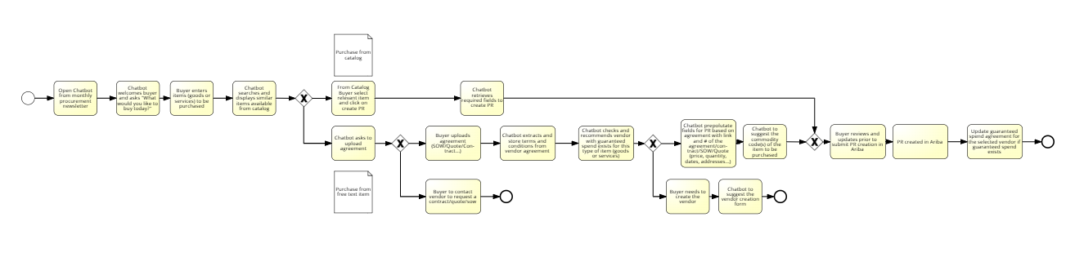

* **Use Case2:**
* The AI model should search in uploaded Supplier Contract Agreement (payment terms, discounts, guaranteed spend, cancelation policies) and additional information to prepopulate purchase requisition in Ariba.

Main information to be retrieved from the vendor agreement upload and prepolutated in the chatbot for PR creation:

* + Free-text material name
  + Material group (commodity code to be determined based on free text field and vendor contract item description)
  + Delivery date
  + Quantity
  + “Ship to” or “address”

Main terms and conditions to be extracted from the vendor agreement uploaded:

* + "Payment terms",
  + "Guaranteed spend",
  + "Discounts",
  + "Cancellation policy",
  + "Validity period",
  + "Quantity",
  + "Price",

Other additional fields nice to have:

* + "Purchase Requisition Number" (auto-generated),
  + "Supplier ID (Business Partner)",
  + "Creation Date",
  + "Document Type" (not available from vendor agreement),
  + "Item Number" (it would be the vendor item number but still good to have)
  + "Material/Service ID or Free Text Name",
  + "Quantity",
  + "Price",
  + "Currency",
  + "Delivery Date or Service Period (Start/End)",
  + "Source of Supply",
  + "Plant ID", (not from the vendor agreement)
  + "Material Group", (commodity code to be determined based on free text field and vendor contract item description)
  + "Contract Reference",
  + "Status",
  + "Tax Code",
  + "Vendor / Counterparty",
  + "Signed by (Nielsen)", (not needed)
  + "Signed by (Vendor)", (not needed)
* Record and track results in a table
* Extract the guaranteed spend information from the vendor agreements (pdf, sow, quote, etc...) and track the consumption against these guaranteed spend. if Nielsen has an agreement with a vendor to buy 1000 units of X, Nielsen wants to route the buyer towards this vendor until the minimun guaranteed spend is met, to get the best purchase price. Part of the dashboard from Andrii should contains the guaranteed spend agreement and actual consumption vs minimumn guaranteed spend.
* Nielsen Finance teams should have access to the recorded data via a dashboard.

**Minimum Guaranteed Spend Logic** –

Here some additional details about the Minimum Guaranteed Spend process:

Simple example:

|  |  |  |  |  |  |
| --- | --- | --- | --- | --- | --- |
| Item | Vendor | Guaranteed spend agreement | Actual consumption | Price | Discount |
| itemA | Vendor1 | 1000 | 900 | 100 | 5% |
| itemA | Vendor2 | n/a | n/a | 98 | n/a |

Buyer enters item (goods or services) to be purchased in the chatbot –

* Chatbot to checks if item available from catalog
  + Chatbot checks if **exact exact** item exists from multiple vendors (dataset to be created to reproduce this scenario)
  + Chatbot checks if/which vendors have valid (date and consumption) Guaranteed spend agreement
  + Chatbot to suggest the Vendor with a valid (date and consumption) agreement and provide explanation + apply discount on price
  + When PR created against this vendor, the consumed quantity is to be updated in the dataset.

| **Use Case** | **Important Notes** | **Sample Requests** |
| --- | --- | --- |
| **Use Case1** |  |  |
| Create purchase requisition with material items | Create a purchase requisition with material items with the following details:   * Material name * Delivery date * Quantity * *Optional*: Source of supply   Ai4U Chatbot can help you create a purchase requisition by means of a guided procedure, during which you will be asked to provide the material name, the source of supply, the delivery date, and the quantity of the material item. | Create purchase requisition.  Add material items. |
| Create purchase requisition with service items | Create a purchase requisition with service items with the following details:   * Service name * Service start date * Service end date * Quantity * *Optional*: Source of supply   Ai4U Chatbot can help you create a purchase requisition by means of a guided procedure, during which you will be asked to provide the service name, the source of supply, the service start date, the service end date, and the quantity of the service item. | Create purchase requisition.  Add service items. |
| Create purchase requisition with free-text material items | Create a purchase requisition with free-text material items with the following details:   * Free-text material name * Plant ID * Material group * Delivery date * Quantity * *Optional*: Source of supply   Ai4U Chatbot can help you create a purchase requisition with free-text material items by means of a guided procedure. When asking Ai4U Chatbot to show a non-existing material, you can choose to create a free-text material item. If you have chosen to add a source of supply, you will be asked to provide the plant ID and material group/commodity code. After having chosen a supplier, you will be asked to provide the delivery date and and the quantity of the free-text material item. | Create purchase requisition.  Show materials. |
| Create purchase requisition with free-text service items | Create a purchase requisition with free-text service items with the following details:   * Free-text service name * Plant ID * Material group * Service start date * Service end date * Quantity * *Optional*: Source of supply   Ai4U Chatbot can help you create a purchase requisition with free-text service items by means of a guided procedure. When asking Ai4U Chatbot to show a non-existing material, you can choose to create a free-text service item. If you have chosen to add a source of supply, you will be asked to provide the plant ID and material group. After having chosen a supplier, you will be asked to provide the service start date, the service end date, and the quantity of the service item. | Create purchase requisition.  Show materials. |
| **Use case2** |  |  |
| Search in Supplier Contract Agreement | Search payment terms from the contract agreement or SOW or Quote files and save results in a table. The payment terms have been defaulted to 90days in the system S/4HANA.  Search for guarantee spend agreements from the PDF contracts/SOW/Quote and keep track of what is been consumed. Route PR towards this vendor if actual spend is below guaranteed spend or find alternative vendor.  Search for cancellation policy to ensure to not miss the deadline which is often costly.  Search for discount pricing from the agreement contract to track and optimize the conditions. |  |
| Record and track results | Record variables from vendor contracts into a table. |  |
| Provide recommendations | Provide recommendations to contract with vendors to get better agreements if doesn’t exist already.  Compare list of supplier agreements provided with vendor from chatbot and suggest to the user to request a quote to the vendor to have official agreements, payment terms, discounts, cancellation policies, guaranteed spend agreements. |  |

# Business Context

## Business Objectives and Expected Benefits

Describe the business objective and expected benefits. These are the measurable improvements that will be delivered by business requirements. These are drawn from the value case produced in the Discover phase.

|  |  |  |  |  |
| --- | --- | --- | --- | --- |
| Business Objectives and Expected Benefits | | | | |
| Business Objectives | Process Change  (Key Business Requirement) | Value Owner | Business Case KPI (financial) | Target Benefit |
| Provide a new experience to support AP users navigating the current decentralized procurement model |  |  |  |  |
| Create space and time with the Assistant to execute the AP transformation roadmap e.g. replace TAP, implement category management, explore supply chain financing as part of the process, enforce the process and improve the process |  |  |  |  |
| Improve awareness and tracking of contract commitments - i.e. ensure we communicate the commitments made so we can make sure we track them continuously and avoid the need for renegotiation of commitments which is time consuming and occasionally costly |  |  |  |  |
| Provide guidance for selecting the right type of service in order that the tax is calculated correctly - i.e. the location and type of good/service is correct |  |  |  |  |
| Reduce POs going through corrections (currently 13% go through corrections once or more and these are the highest spend items) |  |  |  |  |
| Track cancellation terms as sometimes we miss the deadlines and end up having to pay even when we cancel a contract |  |  |  |  |
|  |  |  |  |  |

## Major Business Pain Points (to achieve business objective)

Provide a high-level list of pain points based on business scenario and solution mapping in Discover phase.

|  |  |  |  |
| --- | --- | --- | --- |
| Major Pain Points from weaknesses analysis | | | |
| Pain Point ID | Pain Point Description | Impact on Business | Contact |
| 1 | Decentralized Procurement render user autonomous with opportunity for optimization of the procurement process | Guided procurement process |  |
| 2 | Lack of awareness of the contract terms and conditions | Clear visibility on the term and conditions of the vendor agreements |  |

## Key Financial Performance Indicators (KPIs)

List the KPIs

|  |  |
| --- | --- |
| Key Performance indicators | |
| KPI Name | Assist non-expert users through the procurement process |
| Owner |  |
| Definition |  |
| Calculation |  |
| Drill Down Capabilities |  |
| Supporting SAP Solution Components |  |
| Planned Data Source |  |
| Reporting Method |  |
| Frequency |  |
| Used by |  |

# Functional and Process Design

## Master Data

List master data elements needed to support his business scenario/business area. Note any unique customer requirements.

|  |  |  |  |
| --- | --- | --- | --- |
| Master Data | | | |
| Data Object | Description | SAP Object | Unique Requirements |
| Vendor master data | List of vendor master from SAP |  |  |
| Vendor Catalogs | List of catalogs available for Nielsen |  |  |
| Commodity codes | List of commodity codes |  |  |

1. S/4 and Ariba API
2. Body of contracts PDFs and how they are represented in the system
3. Guided procurement procedures
4. Vendor master for terms
5. Commitments (sum up existing spend to show how we are tracking) and report on it quarterly z_table for commitments and a report on this - ML prediction on historic versus current to project achievement
6. List of vendors and categories
7. SAP to create a Signavio flow based on the procurement procedure if required
8. IAS (access) in BTP for SSO - maintains the permissions in Joule

## Related Systems (being replaced or Interfaced with)

List the system(s) currently used to enable this business scenario/business area. Indicate which ones will be decommissioned and which ones will have interfaces.

|  |  |  |  |
| --- | --- | --- | --- |
| Related Systems | | | |
| System | Role | Impact | Interfaces |
| S/4HANA ERP System | End to end ERP | Replaced by SAP | None |
|  |  |  |  |
|  |  |  |  |
|  |  |  |  |

## Major Data Sources for Integration

List the data conversion requirements and the source systems.

|  |  |  |  |
| --- | --- | --- | --- |
| Data Sources | | | |
| System | Source Data Object | Volume | Approach |
| S/4HANA ERP System | End to end ERP | Replaced by SAP | None |
|  |  |  |  |
|  |  |  |  |
|  |  |  |  |

## Policy and Compliance

List company policies and compliance requirements. For example, SOX, GDPR and Segregation of Duty considerations.

## Process Scope

List the business processes or scope items. Indicate whether they are in or out of scope of this business scenario/business area. Identify the proposed SAP Solution(s). Reference SAP Best Practices and SAP Model Company.

|  |  |  |  |  |
| --- | --- | --- | --- | --- |
| Process Scope | | | | |
| ID | Process Name | Description | In Scope | SAP Solution |
|  | Procurement | Create a purchase order assisted by Ai4U chatbot | Y | BTP |
|  |  |  |  |  |
|  |  |  |  |  |
|  |  |  |  |  |
|  |  |  |  |  |
|  |  |  |  |  |