Below is the definition of custom RFC module-

RFC module name – Z_TEST_COMPLEX_TT_EXP

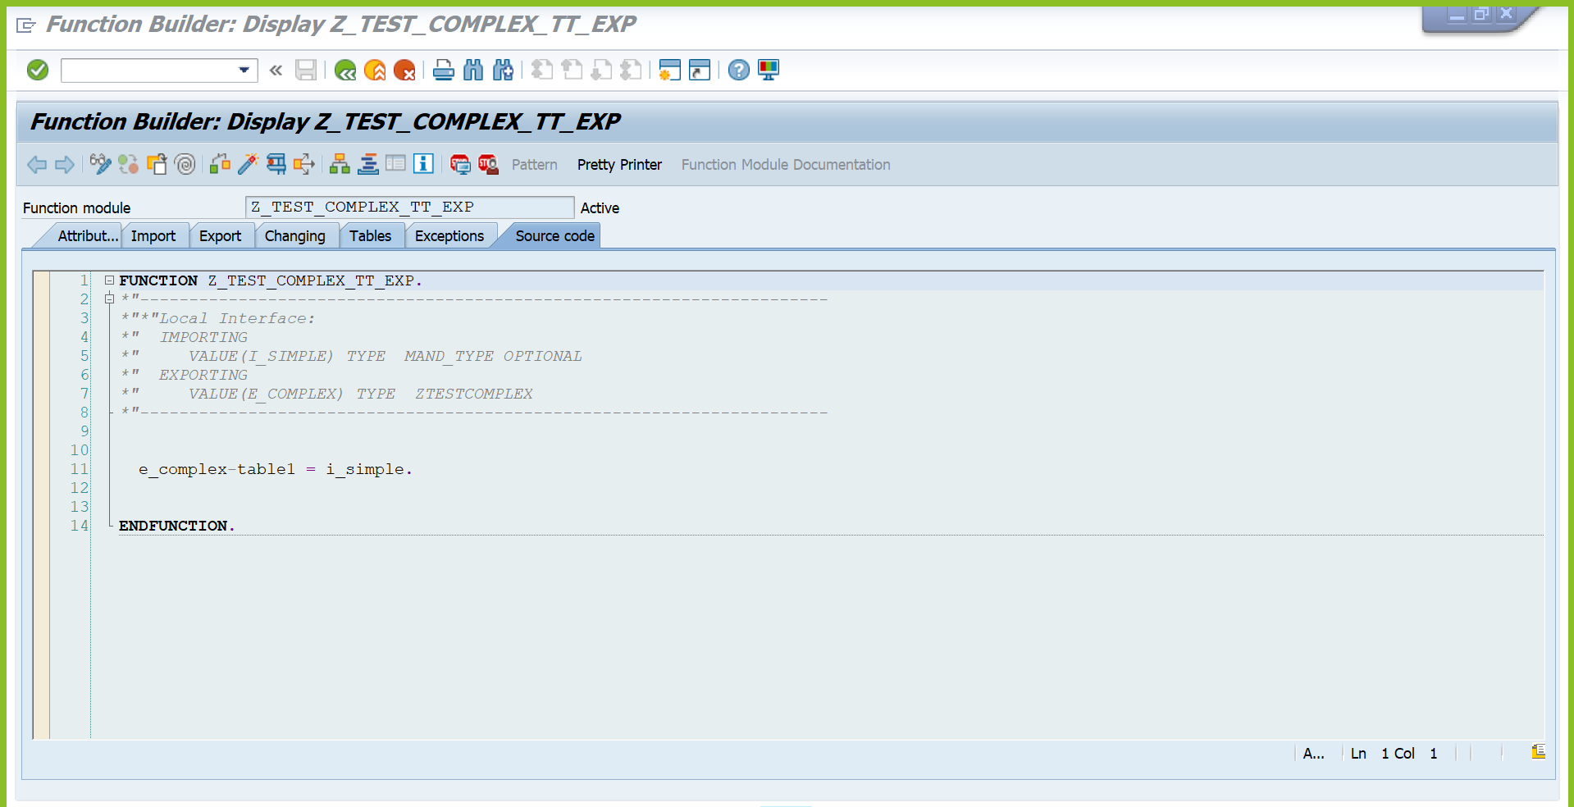

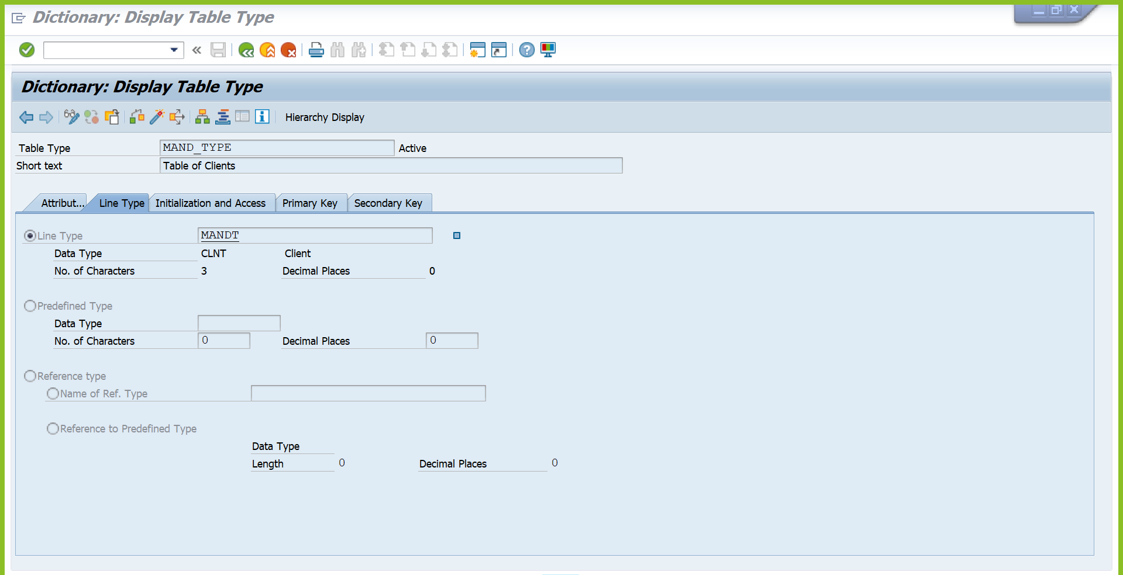

Please find the Trace level (RFC_TRACE = 4) for NW RFC SDK. I am trying to fetch the metadata for Z_TEST_COMPLEX_TT_EXP using a thirdparty https://github.com/SAP/gorfc GetFunctionDescription method.

