Introduction

The SAP Sailing Race Manager app has been designed to allow race committees and regatta organizers to simplify the operation and communication of starting, running and finishing sailing races. Its real time capability allows for the easy communication of race scheduling and status to be shared with interested parties via the internet. The status of racing can be made available online to allow organizers, fans, spectators and media to keep track of racing.

The SAP Sailing Race Manager app is a key part of the SAP Sailing Analytics system whether for tracked racing via GSM/GPS tracker, mobile phone (SAP Sail InSight) or untracked racing and allows competitors to utilise the SAP Sailing Analytics providing post-race analysis tools to review their performance and optimise strategies.

The SAP Sailing Buoy Pinger mobile app allows mark layers to be able to locate the positions of racing marks on a race course utilising an Android phone automatically communicating the

information to the SAP Sailing Analytics system and intern the Race Committee - for the benefit of the SAP Sail InSight app this also negates the need for a dedicated tracker for racing marks. The SAP Sailing Buoy Pinger app connects to the SAP Sailing Analytics solution and allows regatta managers to track the geographical position of their race marks.

Equipment Required

## SAP Sailing Race Manager app

* Fully charged Android tablet or smart phone
* Internet connection via Wi-Fi

or cellular connection (Sim Card)

## SAP Sailing Buoy Pinger app

* Fully charged Android smart phone or tablet
* Internet connection via Wi-Fi

or cellular connection (Sim Card)

How to Use

The SAP Sailing Race Manager app will be downloaded and installed onto the devices provided by SAP. Should you want to use your own device you can download this app from the Google Play Store searching for the **SAP Sailing Race Manager app** and **SAP Sailing Buoy Pinger.**

1. Locate the downloaded app on your device and launch the application by clicking on the SAP Sailing Race Manager icon.

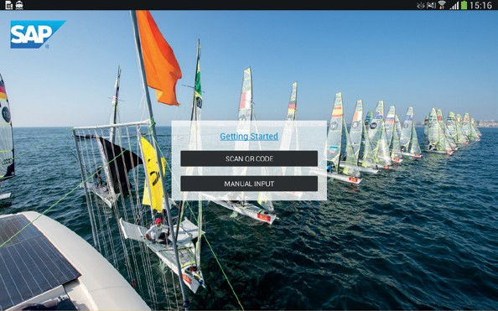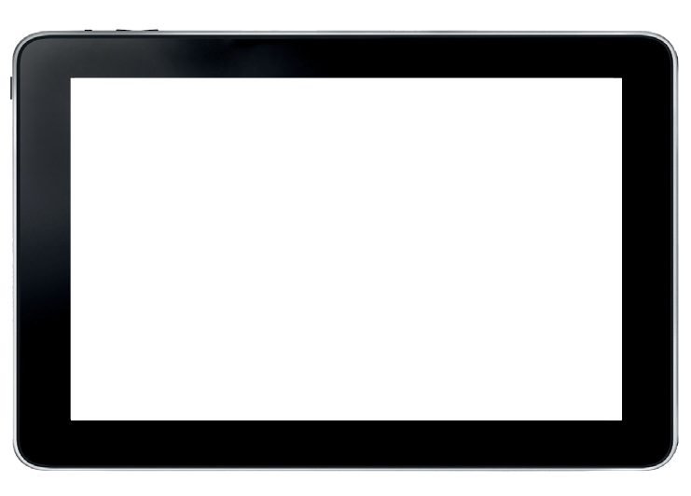

**2. Start:** Scan QR Code or enter login details provided by regatta to proceed.

1. Select event: Select your event from the alphabetical list and search for the Area/race course/fleet you will

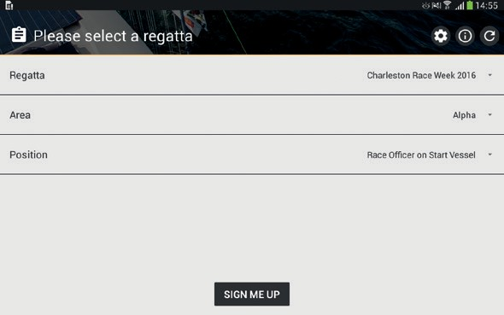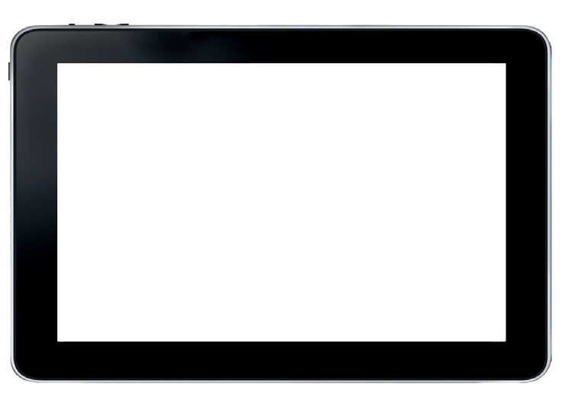

be operating on. Finally select which position you are in (On Committee Boat,

Shore Control etc.) then click on “Sign Me Up”.

1. Races List: To view all the races you manage, open the Race List Menu - this is accessed by swiping from the left hand side of the screen or by tapping on the menu in the upper left corner. This shows

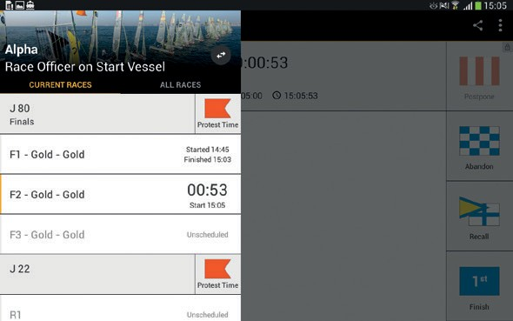

the current races, just running, scheduled or about to finish races. If you need to access another race, switch to

the 'All Races' tab.

1. Select start time: Set planned start time and date of the start of your race. Numerical input is possible with a double-click or long-press. Confirm with “Set Start Time”. For the first race of the

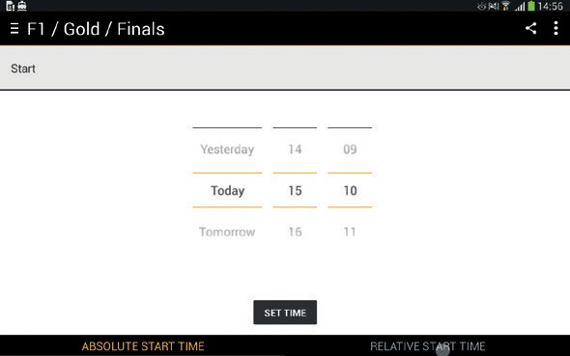

day this can be done in the morning hours before the race with the expected start time. The time can still be refined and adjusted at any later point in time before the start to the exact start time.

1. Setup Overview: Check start time, Adjust Count Down Procedure and course where required, Input Wind Speed and direction if available. Confirm with “Confirm Setup”.

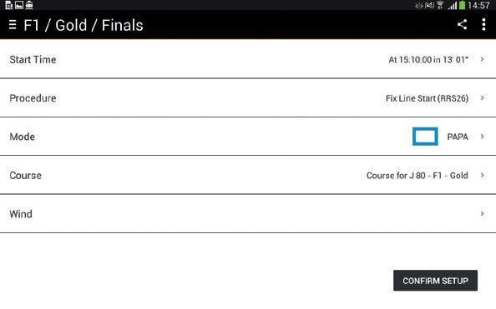

1. Wind: At select events SAP wind units will automatically report the wind to the SAP Sailing Analytics system; however it is also beneficial to have manual wind entered

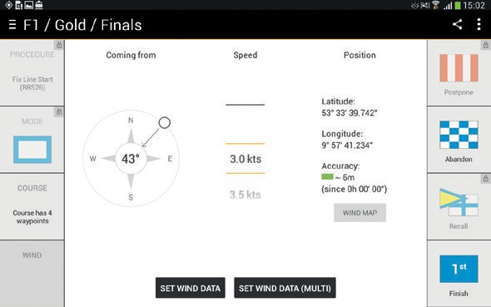

to increase the data captured.

1. Current race: Tap buttons to adjust Individually. (Tap the button a second time to return to current race)

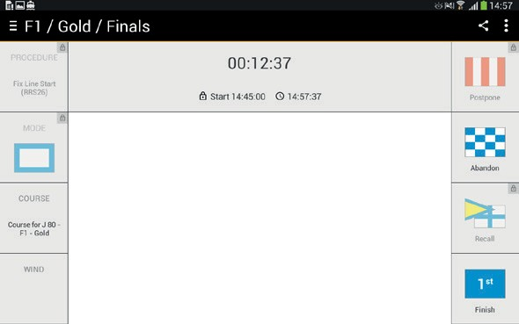

Top: Start time,

Left: Race setup and wind, Right: race flag history.

Click on buttons to adjust individually.

1. Adjust Start Time: The start time can be adjusted from your original time

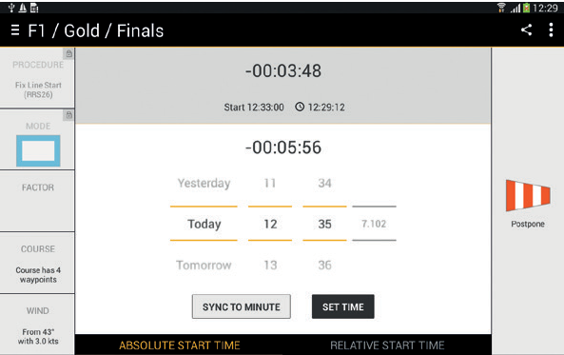

inputted in step 5, this can be done via the sync button, for example, press the Sync button at the 5 minute preparatory signal.

1. Start Line/Course Geometry:

The geometry of the start line and course can be viewed in the SAP Sailing Race Manager by clicking on the 'Wind Map' button. The bottom graph will also show wind angle and speed for events using SAP wind unit.

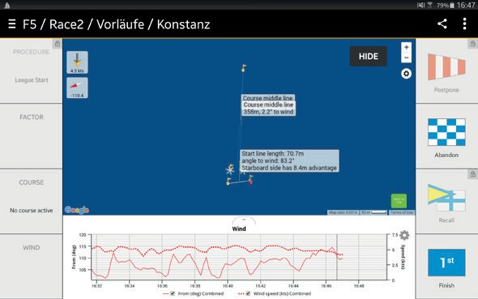

1. End current race: Set time when first boat crossed the line.

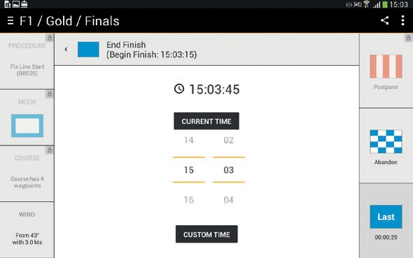

1. “End Finish” Ends the race for good, once all competitors have finished the race and the race is complete input the 'End Finish' time and press 'End Finish'.

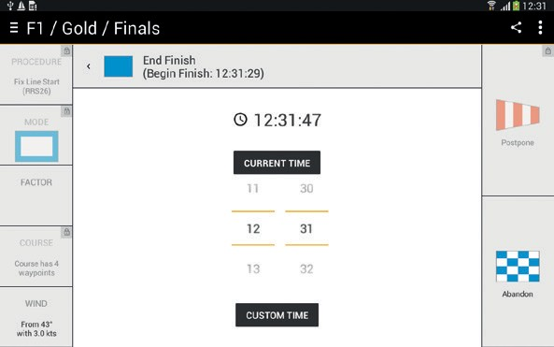

1. Result entry: When supported by SAP at your event, you may edit ranks, scores and penalties during and after the finishing phase, this feature is accessible via the 'Tracking edit list' button in the bottom left hand side.

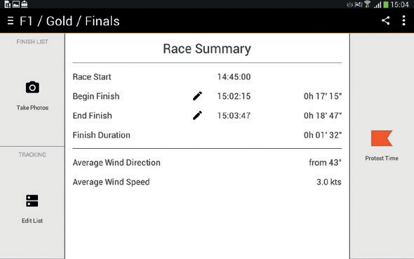

1. Tracked List: A tracked list

of competitors will be shown, this can be filtered by Sail ID or name and will show preliminary finisher list based on tracked boats.

18. Exiting App: Tap on the menu button in the top left corner and tap the standby button.

1. Clicking on the pen icon will allow the ability to input finish times for competitors to assist with handicap

calculations, swiping the entry to the left will remove it from the list again.

Notes

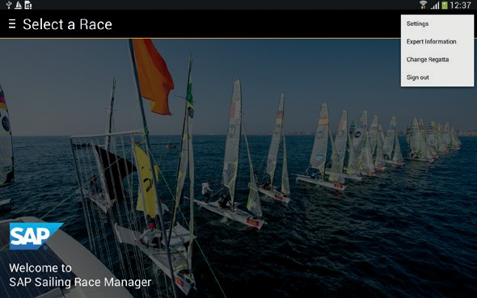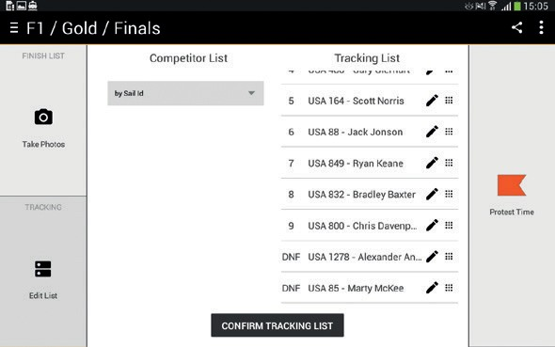

* Most editable fields can also be controlled via the tablets keyboard
* Signal/connection indicator (top right) shows the current status

*(Red: information waiting for transmission. White: all information transmitted)*

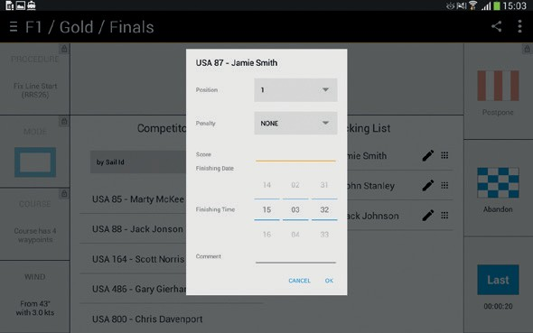

FAQ’s

1. Race Summary: Shows race details and allows an option to take a photo of a hand written finisher sheet and send to Race Control. The next race can then be selected from the sidebar

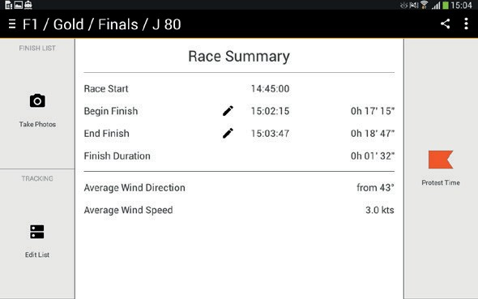

1. Take Photo: This feature is accessible via the 'Take Photos' button on the left hand side. Use the camera button at the bottom of the screen to take one or more pictures. Unwanted pictures may be deleted by clicking the recycle bin icon. Use 'Send Photos' to send those pictures to the race control.

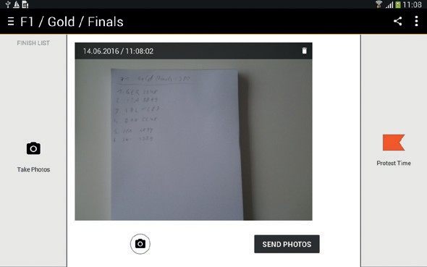

* Can I run this on my ipad or iphone? Unfortunately at this stage only Android devices are supported.
* I don’t have internet on my Committee boat how can I work this? 2 options, either have a person in the club house input the information which you could communicate to them by phone or radio or insert a sim card into your device.
* What happens if I do not input the wind? The SAP Sailing Analytics requires as much accurate wind information as possible to allow an accurate digital representation of the racing to be created for the sailors – this also helps SAP accurately determine the live leaderboard - whilst it’s not a necessity

it is appreciated if Race Committee’s comply.

* What if a race time goes wrong or is abandoned? Go back to the menu using menu button in the top right, select your race again and start the procedure.
* For more information: [www.sapsailing.com](http://www.sapsailing.com/)