**Technical Document for Budget**

Table of Contents

**1.** **PROCESS FLOW – SAP B1 “TO-BE” BUDGET UPLAOD PROCESS** 2

• **Budget for Account** 2

• **Budget for Procurement Plan** 3

**2.** **Excel file format** 4

**3.** **UDO** 5

• **Basic Setup** 5

• **Budget Import Screen** 6

• **Budget Transfer** 6

**4.** **Implementation Note** 7

# **PROCESS FLOW – SAP B1 “TO-BE” BUDGET UPLAOD PROCESS**

# **Budget for Account**



# **Budget for Procurement Plan**



# **Excel file format**

* + - * **Excel file format for Account Budget upload**

|  |  |  |  |  |  |  |  |  |  |
| --- | --- | --- | --- | --- | --- | --- | --- | --- | --- |
| Year | Branch Name Code | cost center Code | Account Code | Debit | Credit | Value(Month1) | Value(Month2) | Value(Month3) | Value(Month4) |
|  |  |  |  |  |  |  |  |  |  |

|  |  |  |  |  |  |  |  |
| --- | --- | --- | --- | --- | --- | --- | --- |
| Value(Month5) | Value(Month6) | Value(Month7) | Value(Month8) | Value(Month9) | Value(Month10) | Value(Month11) | Value(Month12) |
|  |  |  |  |  |  |  |  |

|  |
| --- |
| Value(Year) |
|  |

Above is the format of excel file, client will update the budget details for ledger as mentioned in above format.

* + - * **Excel file format for Procurement Plan Budget upload**

|  |  |  |  |  |  |  |  |  |  |
| --- | --- | --- | --- | --- | --- | --- | --- | --- | --- |
| Year | Branch Name Code | cost center Code | Project | Item Code | Quantity | Unit Price | Total Year Amount | Value(Month1) | Value(Month2) |
|  |  |  |  |  |  |  |  |  |  |

|  |  |  |  |  |  |  |  |
| --- | --- | --- | --- | --- | --- | --- | --- |
| Value(Month3) | Value(Month4) | Value(Month5) | Value(Month6) | Value(Month7) | Value(Month8) | Value(Month9) | Value(Month10) |
|  |  |  |  |  |  |  |  |

|  |  |
| --- | --- |
| Value(Month11) | Value(Month12) |
|  |  |

Above is the format of excel file, client will update the budget details for item as mentioned in above format.

# **UDO**

## **Basic Setup**

|  |  |
| --- | --- |
| Ledger |  |
| Branch Name Code | Check Box |
| cost center Code1 | Check Box |
| cost center Code2 | Check Box |
| cost center Code3 | Check Box |
| cost center Code4 | Check Box |
| cost center Code5 | Check Box |

|  |  |
| --- | --- |
| Item |  |
| Branch Name Code | Check Box |
| cost center Code1 | Check Box |
| cost center Code2 | Check Box |
| cost center Code3 | Check Box |
| cost center Code4 | Check Box |
| cost center Code5 | Check Box |
| Project | Check Box |
| Qty/Value | Drop Down |
| Budget for sale | Yes/No |
| Budget for Purchase | Yes/No |

We need to develop setup form as per mention above. So we can tag mandatory field here for validation.

## **Budget Import Screen**

|  |  |
| --- | --- |
| Budget Import screen |  |
|  |  |
| Ledger | Browse Button |
| Item | Browse Button |
|  |  |
|  | Import |

Above is the Budget import form that we need to be develop in SAPB1. User can select correct option for upload the budget in SAPB1.

## **Budget Transfer**

|  |  |  |  |  |  |
| --- | --- | --- | --- | --- | --- |
| Doc No | Budget Transfer /Additional Budget |  | Doc Date |  |  |
| Year | Branch Name Code | cost center Code | Account Code | Debit | Credit |
|  |  |  |  |  |  |
| 2020 | Bhairava | Sales | 230987 | 10000 |  |
| 2020 | kathmandu | sales | 230987 |  | 10000 |

|  |  |  |  |  |  |
| --- | --- | --- | --- | --- | --- |
| Doc No |  |  | Doc Date |  |  |
| Year | Branch Name Code | cost center Code | Account Code | Debit | Credit |
| 2020 | Bhairava | Sales | 230987 | 10000 |  |
| 2020 | Bhairava | maintenance | 230998 |  | 10000 |

Develop one form as per above screen for Budget transfer. Client would transfer budget from one branch to another branch, one ledger to another ledger.

We need to update above information in another document, so we would be able to maintain log for additional budget changes in main budget.

# **Implementation Note**

* + - * Excel file format for Account Budget upload –
        1. Develop one UDO in SAPB1 to save information
        2. Accumulate value and update in SAPB1 budget Document

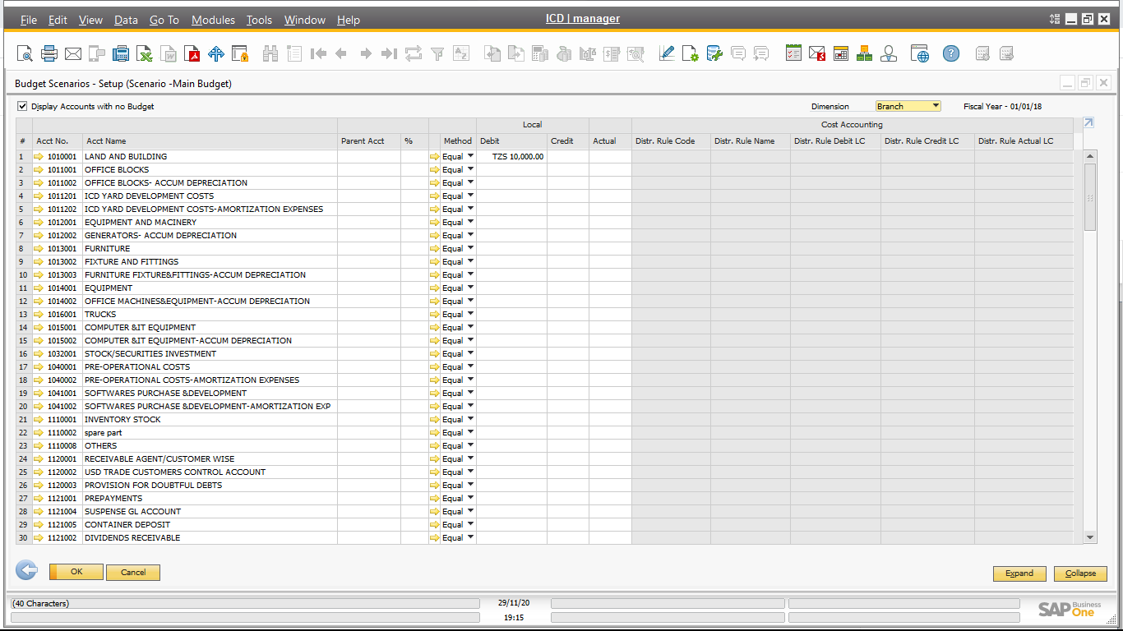

* + - * Excel file format for Procurement Plan Budget upload –
        1. Develop one UDO in SAPB1 to save information
        2. Accumulate value and update in one master UDO budget Document, that would be cost center wise, project wise
        3. Validate procurement plan value with ledger budget value. Accumulate all the same item’s stock account ledger value and then validate with budget ledger value.
      * Budget Transfer – It would be 2 types
        1. Transfer from one ledger or department to another ledger or department

Budget Type🡪 Budget Transfer /Additional Budget

Doc no🡪automatic generate (branch wise)

Doc Date🡪Date

Year🡪text(year)

Branch Name🡪 CFL from branch list

Cost Center🡪 CFL from cost center

Account Code🡪 CFL from chart of account

Credit 🡪text- value

Debit🡪 text- value

Note: - credit and debit value should be same

* + - * 1. It would be additional budget from initial budget

Budget Type🡪 Budget Transfer /Additional Budget

Doc no🡪automatic generate (branch wise)

Doc Date🡪Date

Year🡪text(year)

Branch Name🡪 CFL from branch list

Cost Center🡪 CFL from cost center

Account Code🡪 CFL from chart of account

Credit 🡪text- value

Debit🡪 text- value

Note: - credit and debit value will be different

SELECT T0."ItemCode", T0."ItemName", T3."WhsCode", T3."WhsName" FROM OITM T0 INNER JOIN OITB T1 ON T0."ItmsGrpCod" = T1."ItmsGrpCod" INNER JOIN OITW T2 ON T0."ItemCode" = T2."ItemCode" INNER JOIN OWHS T3 ON T2."WhsCode" = T3."WhsCode" WHERE T1."ItmsGrpNam" ='Trading' and T3."U_Category" in ('Main Tank') ORDER BY T0."ItemCode"

ITN@neo10sap

SAP Qty Query

SELECT T0."InQty"-, T0."OutQty" FROM OINM T0 WHERE T0."Warehouse" ='' and T0."ItemCode" ='' and T0."DocDate" >''

Diff

CalQty-SAPQty

Old TT nume – Inactive truct List

New Form –

Truck Rout change

Branch,

Truck Num,

Row

Existing Route , New Route

Truck Owner/Transporter change

Branch,

Truck Num,

Row

Current Owner , Current Transporater

TT Punishment

Truck Num, Current Owner , Current Transporate,Branch

Row

Status,

From Date ,To Date ,

Callibaretoo

Inventry Transfer –

Stock transfer-