E-R DIAGRAM FOR STOCK MAINTENANCE SYSTEM
  - Step-by-Step Entity-Relationship Data Modeling with Cardinality
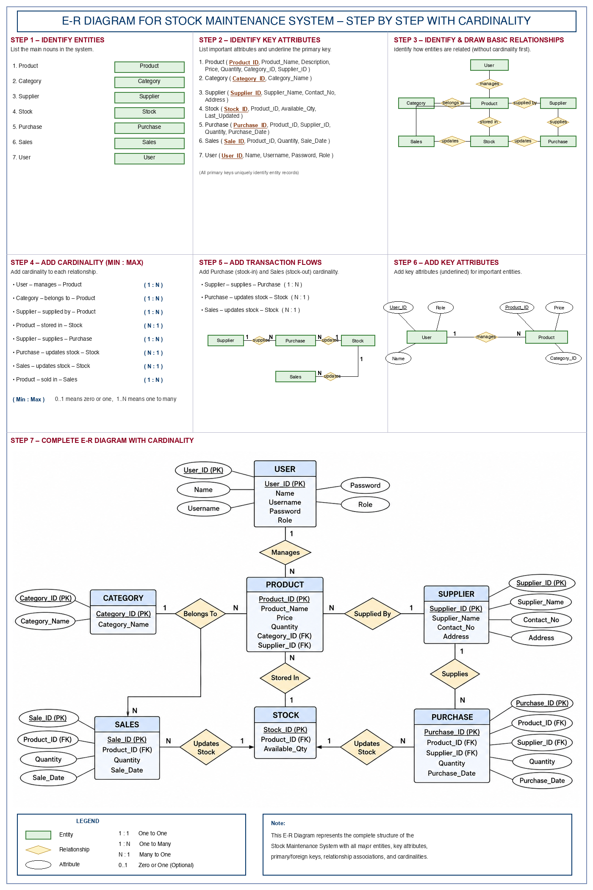
All-in-One Step-by-Step E-R Diagram Infographic

STEP 1 – IDENTIFY ENTITIES
Instruction: List the main nouns in the system.
1. Product: Merchandise and inventory items stored, purchased, and sold.
2. Category: Classification group or department for organizing products.
3. Supplier: External vendor profile delivering replenishment supplies.
4. Stock: Real-time warehouse balance record and timestamp.
5. Purchase (Stock In): Inward procurement transaction from suppliers.
6. Sales (Stock Out): Outward customer fulfillment transaction.
7. User: System operators (Admin / Staff) with access control.
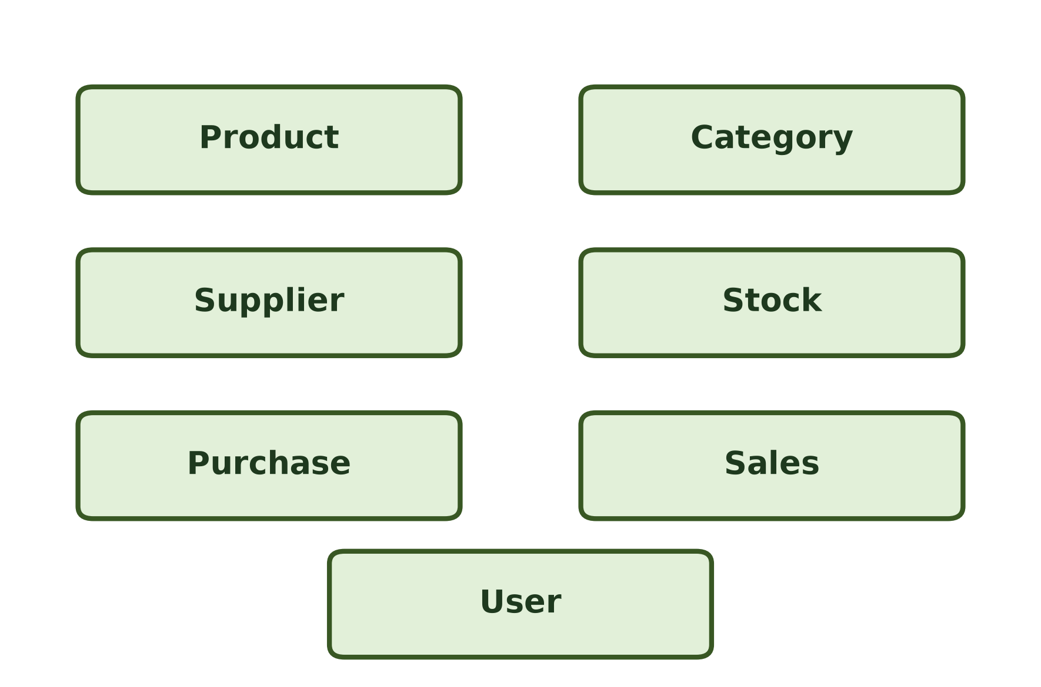
Figure 1: Identified Entities in Stock Maintenance System

STEP 2 – IDENTIFY KEY ATTRIBUTES FOR EACH ENTITY
Instruction: List important attributes and underline the primary key.
1. Product ( Product_ID, Product_Name, Description, Price, Quantity, Category_ID [FK], Supplier_ID [FK] )
2. Category ( Category_ID, Category_Name )
3. Supplier ( Supplier_ID, Supplier_Name, Contact_Number, Email, Address )
4. Stock ( Stock_ID, Product_ID [FK], Available_Quantity, Last_Updated )
5. Purchase (Stock In) ( Purchase_ID, Product_ID [FK], Supplier_ID [FK], Quantity, Purchase_Date )
6. Sales (Stock Out) ( Sale_ID, Product_ID [FK], Quantity, Sale_Date )
7. User ( User_ID, Name, Username, Password, Role )

Attribute Data Dictionary
Entity | Primary Key (PK) | Foreign Key (FK) | Other Attributes | Description
Product | Product_ID | Category_ID, Supplier_ID | Product_Name, Description, Price, Quantity | Master details and specifications of inventory products.
Category | Category_ID | None | Category_Name | Classifies items into distinct product families.
Supplier | Supplier_ID | None | Supplier_Name, Contact_Number, Email, Address | Vendor profile and contact details for procurement.
Stock | Stock_ID | Product_ID | Available_Quantity, Last_Updated | Warehouse physical stock level and timestamp.
Purchase | Purchase_ID | Product_ID, Supplier_ID | Quantity, Purchase_Date | Inward stock arrivals (stock-in) from suppliers.
Sales | Sale_ID | Product_ID | Quantity, Sale_Date | Outward product sales (stock-out) to customers.
User | User_ID | None | Name, Username, Password, Role | Operator credentials and access roles (Admin/Staff).

STEP 3 – IDENTIFY AND DRAW BASIC RELATIONSHIPS
Instruction: Identify how entities are related and draw relationships with attributes (without cardinality first).
• User – [Manages] – Product: Authenticated users manage product catalog.
• Category – [Belongs To] – Product: Products belong to distinct categories.
• Supplier – [Supplied By] – Product: Products are provided by registered suppliers.
• Product – [Stored In] – Stock: Products are held in physical stock records.
• Supplier – [Supplies] – Purchase: Suppliers deliver purchase orders.
• Purchase – [Updates Stock] – Stock: Purchases increment available stock.
• Sales – [Updates Stock] – Stock: Sales deduct available stock.
• Product – [Sold In] – Sales: Products are sold in sales orders.
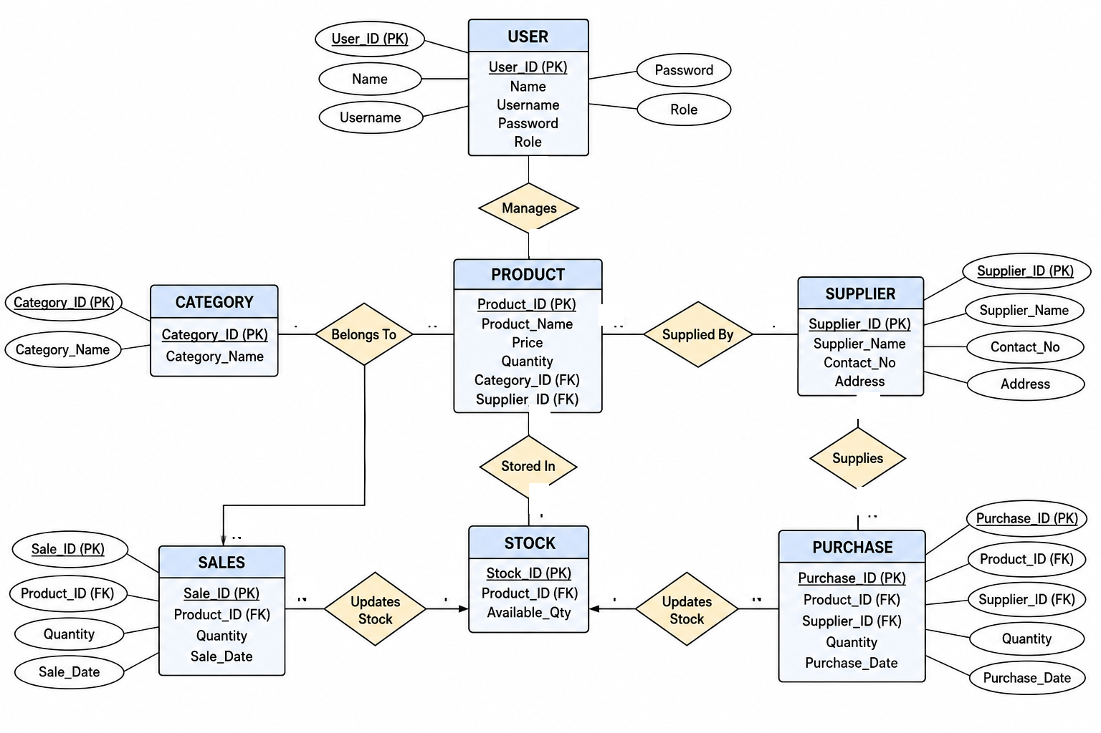
Figure 2: Basic Relationships Diagram for Stock Maintenance System (without cardinality)

STEP 4 – ADD CARDINALITY (MIN : MAX)
Instruction: Add cardinality to each relationship.
• User – manages – Product ( 1 : N ) : One user manages many products (1 : N).
• Category – belongs to – Product ( 1 : N ) : One category contains many products (1 : N).
• Supplier – supplied by – Product ( 1 : N ) : One supplier supplies many products (1 : N).
• Product – stored in – Stock ( N : 1 ) : Products are tracked in stock (N : 1).
• Supplier – supplies – Purchase ( 1 : N ) : One supplier fulfills many purchases (1 : N).
• Purchase – updates stock – Stock ( N : 1 ) : Many purchases increment stock (N : 1).
• Sales – updates stock – Stock ( N : 1 ) : Many sales deduct stock (N : 1).
• Product – sold in – Sales ( 1 : N ) : One product sold in many sales (1 : N).
Relationship Name | Entity 1 | Entity 2 | Cardinality Ratio | Participation (Min : Max) | Description
Manages | User | Product | 1 : N | (1, N) : (1, 1) | 1 User manages N Products
Belongs To | Category | Product | 1 : N | (1, N) : (1, 1) | 1 Category contains N Products
Supplied By | Supplier | Product | 1 : N | (1, N) : (1, 1) | 1 Supplier supplies N Products
Stored In | Product | Stock | N : 1 | (1, 1) : (1, 1) | Products tracked in Stock records
Supplies | Supplier | Purchase | 1 : N | (1, N) : (1, 1) | 1 Supplier delivers N Purchases
Updates Stock (In) | Purchase | Stock | N : 1 | (0, N) : (1, 1) | Many Purchases increment Stock
Updates Stock (Out) | Sales | Stock | N : 1 | (0, N) : (1, 1) | Many Sales deduct Stock
Sold In | Product | Sales | 1 : N | (0, N) : (1, 1) | 1 Product sold in N Sales orders

STEP 7 – COMPLETE E-R DIAGRAM WITH CARDINALITY
Instruction: Construct the comprehensive Entity-Relationship Diagram integrating all entities, attributes, primary keys, foreign keys, relationships, and cardinality constraints.
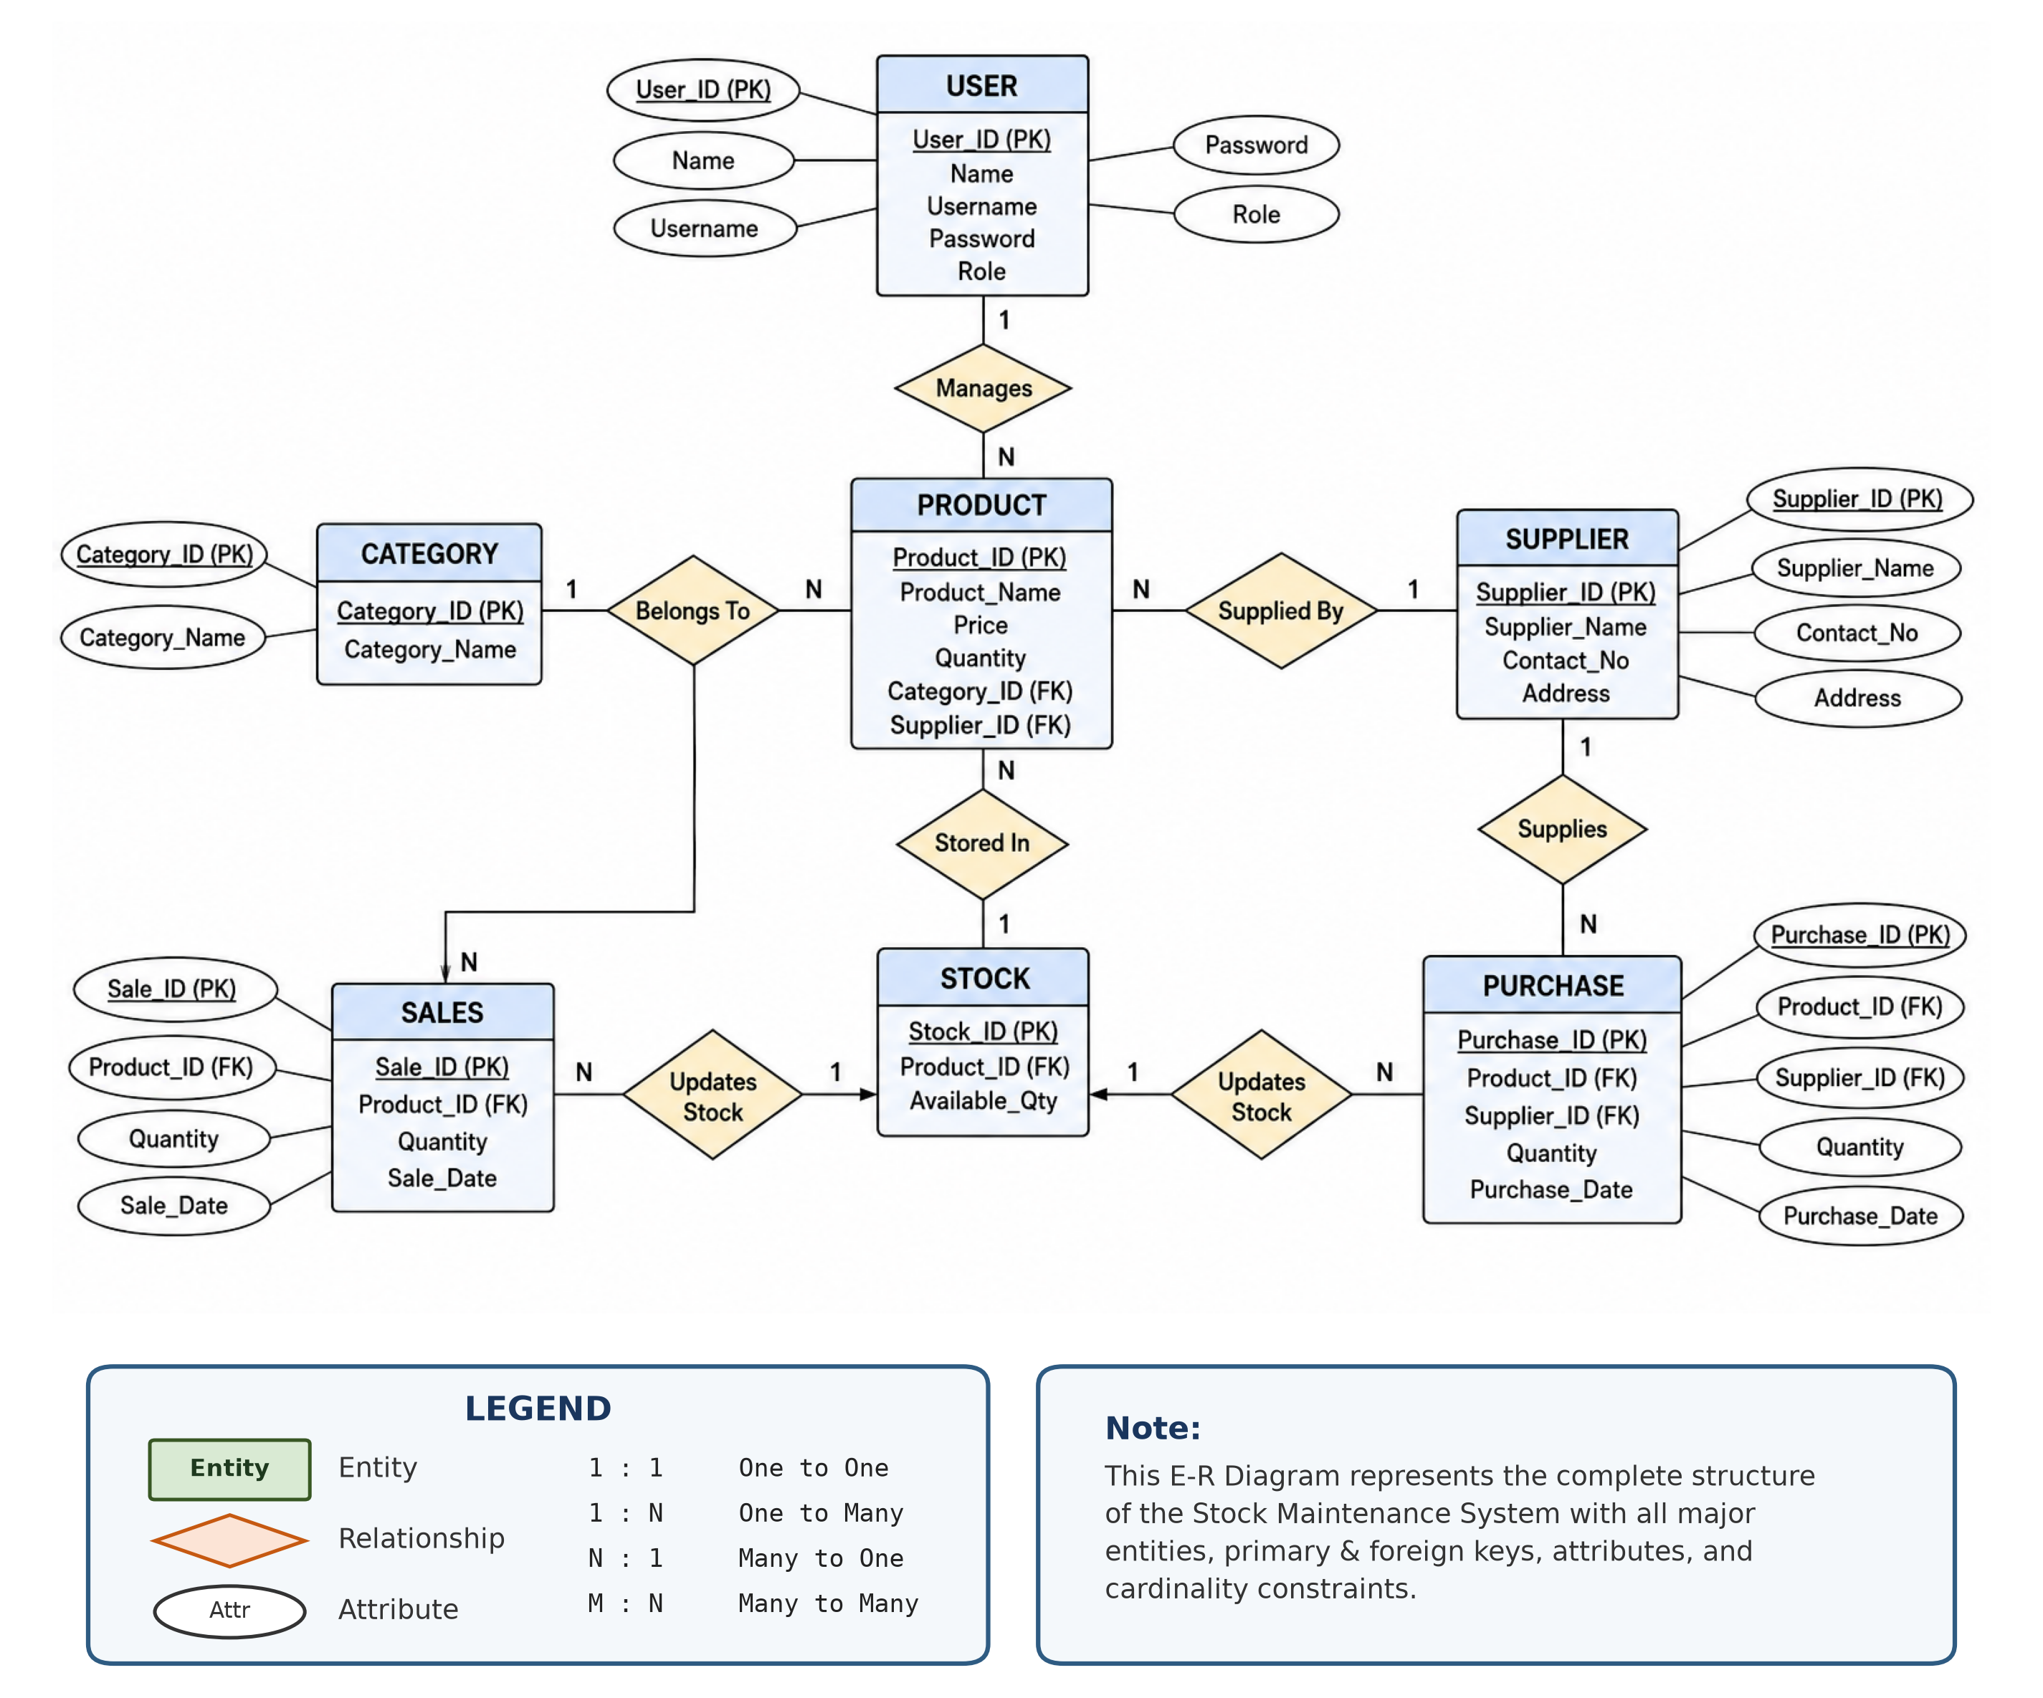
Figure 3: Complete E-R Diagram for Stock Maintenance System with Cardinality, Attributes, and Keys

