STOCK MAINTENANCE SYSTEM
  - Requirements Analysis & Step-by-Step E-R Diagram Design with Cardinality

AIM
To formulate the requirements specification and design a comprehensive step-by-step Entity-Relationship (E-R) data model with cardinality constraints for a Stock Maintenance System.

PROBLEM STATEMENT
Many retail, wholesale, and manufacturing businesses encounter severe operational hurdles when managing inventory manually or through disconnected spreadsheets. Manual inventory management frequently leads to inaccurate stock records, unexpected stockouts, excessive overstocking, delayed order processing, and substantial financial losses. Without a synchronized tracking system, business managers lack real-time visibility into current product levels, supplier fulfillment history, and sales patterns. An automated Stock Maintenance System is required to centralize inventory data, eliminate human errors, automate stock-in and stock-out calculations, and optimize overall warehouse efficiency.

SYSTEM DESCRIPTION
A Stock Maintenance System is a mission-critical database application developed to systematically track and regulate inventory movement throughout its entire lifecycle. The system provides real-time visibility over products, stock balances, vendor supplies, and customer sales transactions.
Key functional capabilities of the system include:
• Real-Time Stock Tracking: Continuously computes and monitors available stock levels for every item in inventory.
• Automated Stock Updates: Automatically increments stock when purchase orders (stock-in) are received and decrements stock when sales orders (stock-out) are fulfilled.
• Low-Stock Alerting: Flags products that fall below safety thresholds to trigger prompt vendor replenishment.
• Supplier & Catalog Management: Maintains comprehensive supplier directories, product categories, and unit pricing.
• Role-Based Access Control: Secures operations through role-specific access privileges for Administrators and Staff members.
• Audit Trail & Reporting: Generates detailed analytical reports on purchase expenditures, sales revenue, and inventory turnover.

RAPID THROWAWAY PROTOTYPE
A Rapid Throwaway Prototype is an exploratory software engineering model built swiftly during the early design phases to elucidate ambiguous requirements and validate user workflows. After stakeholders evaluate the prototype and provide feedback, the temporary model is discarded, and the final production system is engineered from the ground up based on confirmed specifications.
This prototyping approach is especially beneficial when resolving uncertainties regarding:
• Product catalog structure and categorization schemes.
• Stock addition (purchases) and stock deduction (sales) transaction workflows.
• Supplier directory and procurement record requirements.
• Inventory balance visualization and real-time availability metrics.
• Low-stock alert rules and automatic replenishment triggers.
• User roles and permissions for Administrator and Staff user accounts.
• Report formats and audit history tracking requirements.

STEP 1 – IDENTIFY ENTITIES
Instruction: List the main nouns (entities) representing core real-world objects, actors, and transaction concepts in the system.
In the Stock Maintenance System, the following 7 primary entities have been identified:
1. Product: Represents individual items or merchandise stored, cataloged, purchased, and sold in the business.
2. Category: Represents the classification or department under which various products are organized (e.g., Electronics, Hardware, Apparel).
3. Supplier: Represents external vendors, manufacturers, or distributors who supply goods to the inventory.
4. Stock: Represents physical warehouse inventory holding records, tracking available quantities and timestamped updates.
5. Purchase (Stock In): Represents inward procurement transactions where products are received from suppliers to replenish stock.
6. Sales (Stock Out): Represents outward customer transactions where products are sold and deducted from stock.
7. User: Represents system operators (Administrators and Staff members) who manage product catalogs, record sales, and monitor stock.
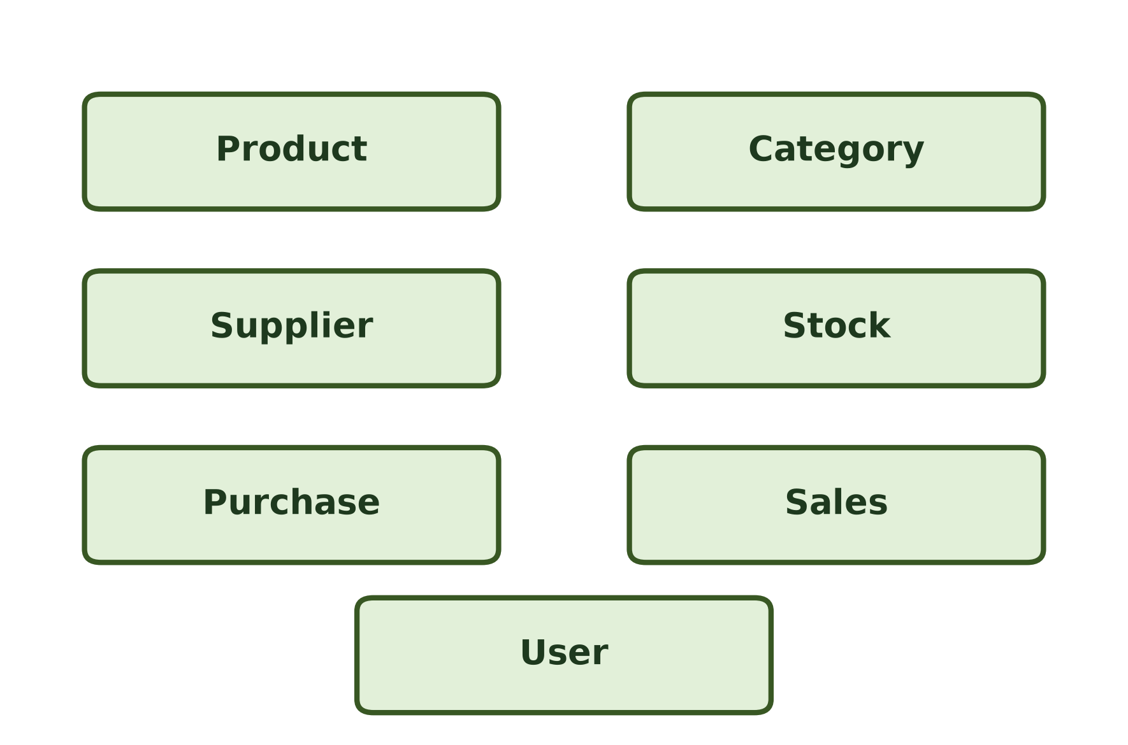
Figure 1: Identified Entities in Stock Maintenance System

STEP 2 – IDENTIFY KEY ATTRIBUTES FOR EACH ENTITY
Instruction: List all important attributes for each entity and underline the Primary Key (PK). Note Foreign Keys (FK) for referential integrity.
1. Product ( Product_ID, Product_Name, Description, Price, Quantity, Category_ID [FK], Supplier_ID [FK] )
2. Category ( Category_ID, Category_Name )
3. Supplier ( Supplier_ID, Supplier_Name, Contact_Number, Email, Address )
4. Stock ( Stock_ID, Product_ID [FK], Available_Quantity, Last_Updated )
5. Purchase (Stock In) ( Purchase_ID, Product_ID [FK], Supplier_ID [FK], Quantity, Purchase_Date )
6. Sales (Stock Out) ( Sale_ID, Product_ID [FK], Quantity, Sale_Date )
7. User ( User_ID, Name, Username, Password, Role )

Comprehensive Attribute Data Dictionary
Entity | Primary Key (PK) | Foreign Key (FK) | Other Attributes | Description
Product | Product_ID | Category_ID, Supplier_ID | Product_Name, Description, Price, Quantity | Holds master details and specifications of inventory products.
Category | Category_ID | None | Category_Name | Classifies items into distinct product families or departments.
Supplier | Supplier_ID | None | Supplier_Name, Contact_Number, Email, Address | Maintains vendor profiles and communication details for procurement.
Stock | Stock_ID | Product_ID | Available_Quantity, Last_Updated | Tracks real-time warehouse physical stock levels and timestamp.
Purchase | Purchase_ID | Product_ID, Supplier_ID | Quantity, Purchase_Date | Logs inward stock arrivals (stock-in) acquired from suppliers.
Sales | Sale_ID | Product_ID | Quantity, Sale_Date | Logs outward product sales (stock-out) distributed to customers.
User | User_ID | None | Name, Username, Password, Role | Stores credentials and permission levels (Admin/Staff) for operators.

STEP 3 – IDENTIFY AND DRAW BASIC RELATIONSHIPS
Instruction: Identify how entities interact and establish associations across the system. Draw relationships with all identified entities and key attributes (without cardinality first).
The fundamental business relationships connecting the entities and their attributes are identified as follows:
• User – [Manages] – Product: Authenticated users (Admin or Staff) manage product information, update prices, and edit descriptions in the catalog.
• Category – [Belongs To] – Product: Each product is categorized under a designated product category to enable systematic catalog browsing.
• Supplier – [Supplied By] – Product: Products are sourced from specific registered suppliers who provide items to the business.
• Product – [Stored In] – Stock: Products are stored in warehouse inventory, where available quantities are tracked by stock records.
• Supplier – [Supplies] – Purchase: Suppliers fulfill purchase orders and deliver batches of goods to the organization.
• Purchase – [Updates Stock] – Stock: Inward purchase transactions increase and update the available quantity of products in stock.
• Sales – [Updates Stock] – Stock: Outward sales transactions reduce and update the available quantity of products in stock.
• Product – [Sold In] – Sales: Products are referenced and sold in customer sales transactions.
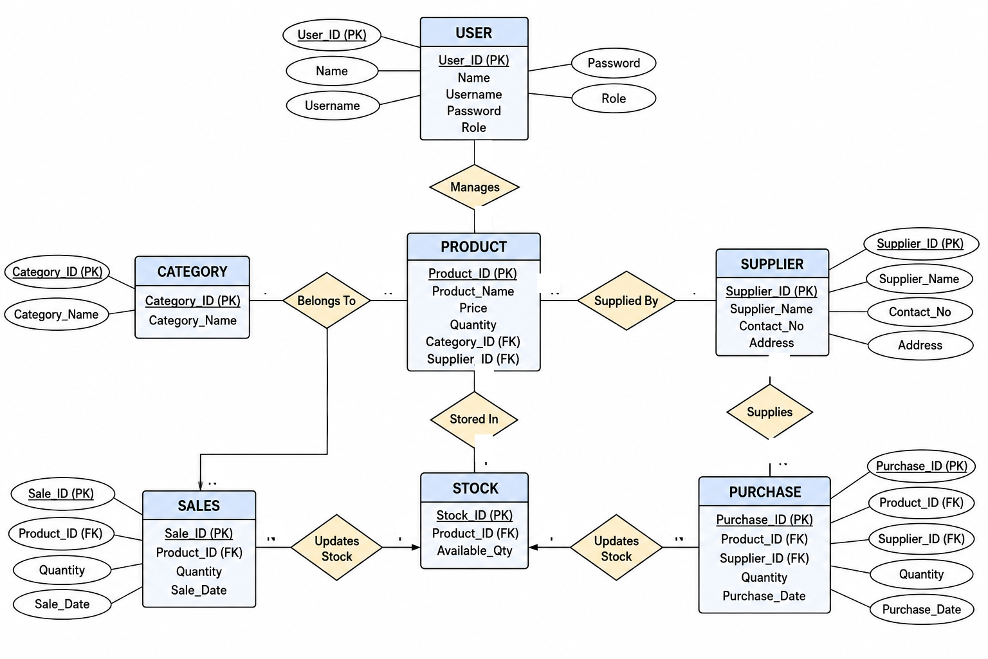
Figure 2: Basic Relationships Diagram for Stock Maintenance System with Entities, Attributes, and Relationships (without cardinality)

STEP 4 – ADD CARDINALITY (MIN : MAX)
Instruction: Add cardinality ratios and minimum:maximum participation constraints to each relationship in the schema.
Cardinality defines the numerical mapping constraints between participating entity instances. Below are the detailed cardinality rules for all relationships:
• User – manages – Product ( 1 : N ) : One user (admin/staff) can manage many products (1 : N). Each product is managed within the system (1 : 1). Participation: User (1 : N), Product (1 : 1).
• Category – belongs to – Product ( 1 : N ) : One category can contain multiple products (1 : N). Each product belongs to exactly one category (1 : 1). Participation: Category (1 : N), Product (1 : 1).
• Supplier – supplied by – Product ( 1 : N ) : One supplier can supply many products (1 : N). Each product is associated with a primary supplier (1 : 1). Participation: Supplier (1 : N), Product (1 : 1).
• Product – stored in – Stock ( N : 1 / 1 : 1 ) : Products are tracked in stock. Each product maintains an active inventory stock record. Participation: Product (1 : 1), Stock (1 : 1).
• Supplier – supplies – Purchase ( 1 : N ) : One supplier can fulfill many purchase transactions over time (1 : N). Each purchase transaction is supplied by one supplier (1 : 1). Participation: Supplier (1 : N), Purchase (1 : 1).
• Purchase – updates stock – Stock ( N : 1 ) : Many purchase transactions update the available quantity of stock over time (N : 1). Each purchase transaction updates the corresponding stock record. Participation: Purchase (0..N : 1), Stock (1 : 1).
• Sales – updates stock – Stock ( N : 1 ) : Many sales transactions deduct and update the available quantity in stock (N : 1). Participation: Sales (0..N : 1), Stock (1 : 1).
• Product – sold in – Sales ( 1 : N ) : One product can be sold across multiple sales transactions (1 : N). Each sales transaction record references the product sold. Participation: Product (0..N : 1), Sales (1 : 1).

Summary of Relationship Cardinality Constraints
Relationship Name | Entity 1 | Entity 2 | Cardinality Ratio | Participation (Min : Max) | Description
Manages | User | Product | 1 : N | (1, N) : (1, 1) | 1 User manages N Products
Belongs To | Category | Product | 1 : N | (1, N) : (1, 1) | 1 Category contains N Products
Supplied By | Supplier | Product | 1 : N | (1, N) : (1, 1) | 1 Supplier supplies N Products
Stored In | Product | Stock | N : 1 | (1, 1) : (1, 1) | Products tracked in Stock records
Supplies | Supplier | Purchase | 1 : N | (1, N) : (1, 1) | 1 Supplier delivers N Purchases
Updates Stock (In) | Purchase | Stock | N : 1 | (0, N) : (1, 1) | Many Purchases increment Stock
Updates Stock (Out) | Sales | Stock | N : 1 | (0, N) : (1, 1) | Many Sales deduct Stock
Sold In | Product | Sales | 1 : N | (0, N) : (1, 1) | 1 Product sold in N Sales orders

Cardinality Notation Rules
• 1 : 1 (One-to-One): An entity in A is associated with at most one entity in B, and vice versa.
• 1 : N (One-to-Many): An entity in A is associated with any number (zero or more) of entities in B.
• N : 1 (Many-to-One): Multiple entities in A are associated with a single entity in B.
• M : N (Many-to-Many): Multiple entities in A are associated with multiple entities in B.
• 0..1: Optional single participation (zero or one instance).
• 1..N: Mandatory multiple participation (at least one, up to many).

STEP 7 – COMPLETE E-R DIAGRAM WITH CARDINALITY
Instruction: Construct the comprehensive Entity-Relationship Diagram integrating all entities, attributes, primary keys, foreign keys, relationships, and cardinality constraints.
The complete E-R diagram for the Stock Maintenance System depicts the full schema structure, attribute associations, referential relationships, and cardinality notations (1, N, M):
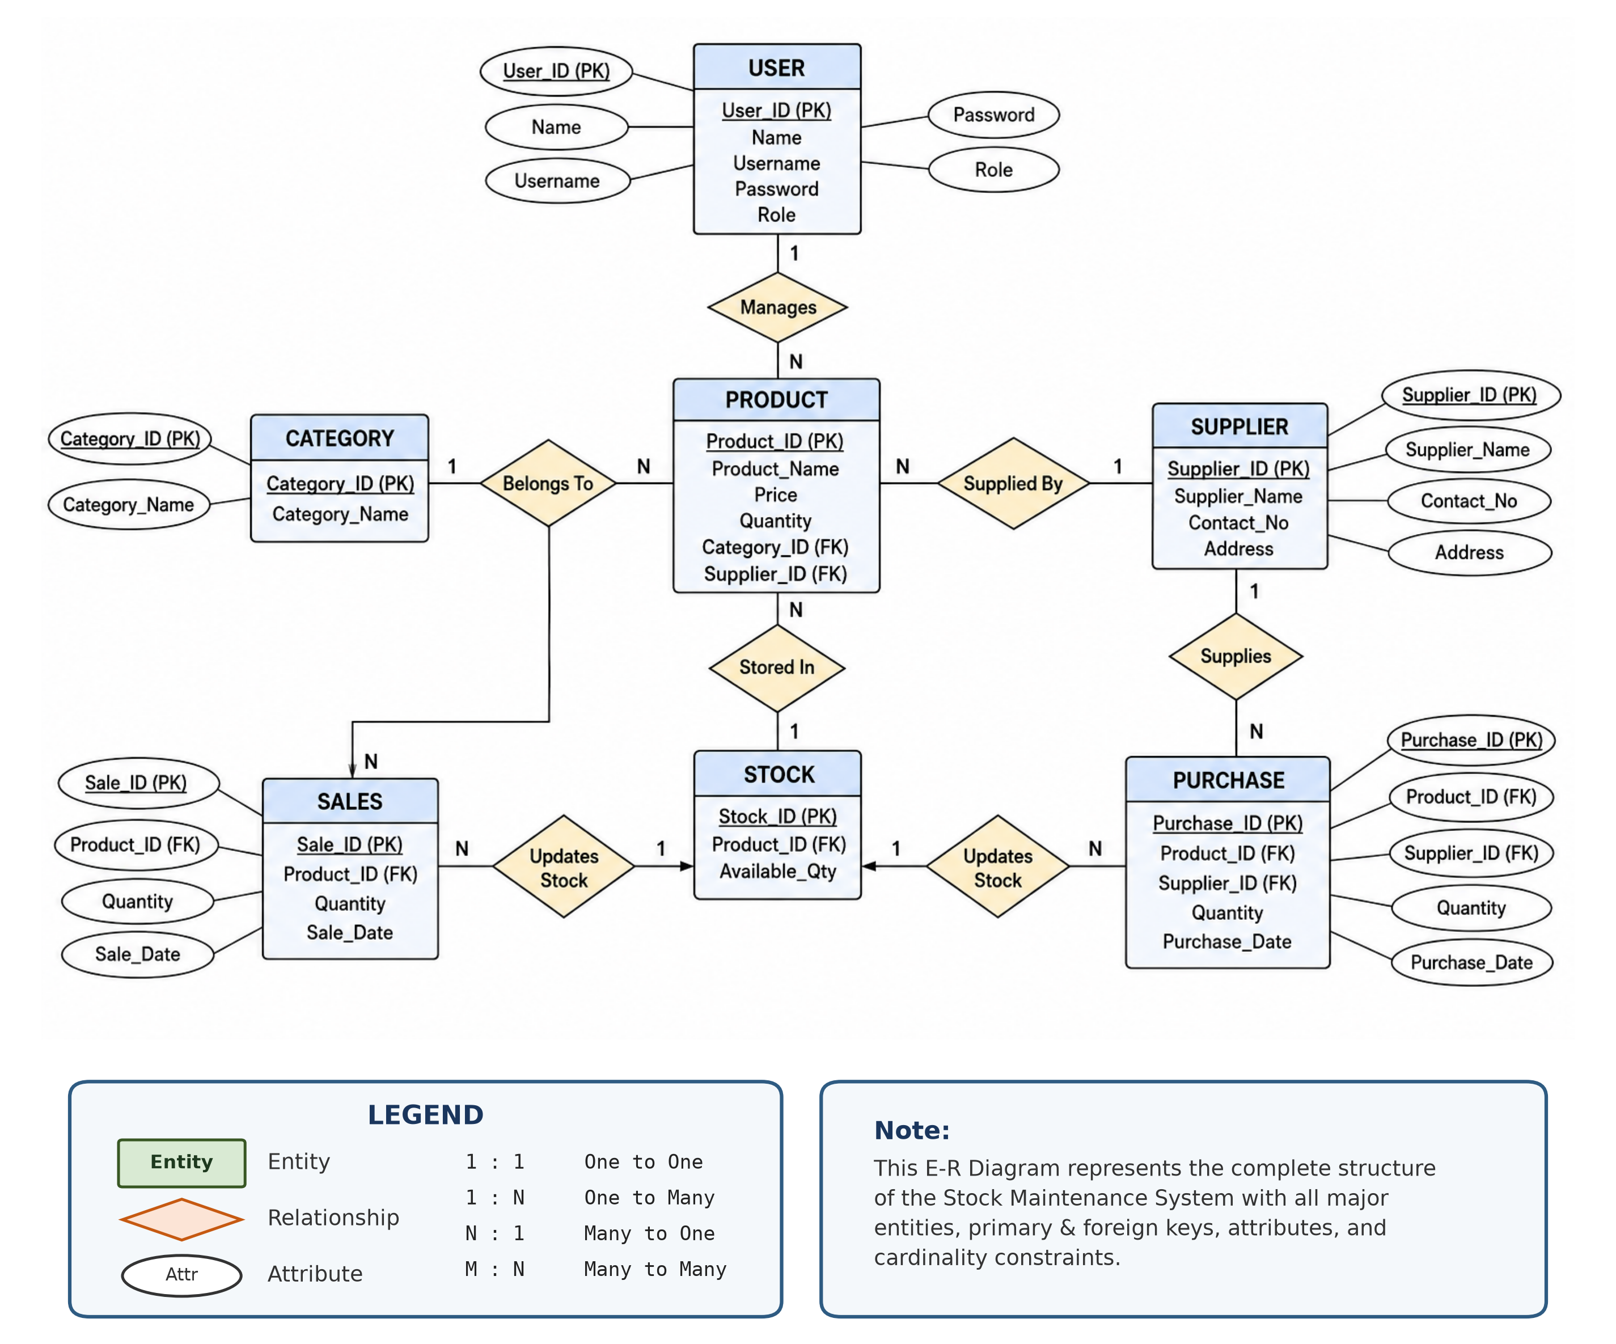
Figure 3: Complete E-R Diagram for Stock Maintenance System with Cardinality, Attributes, and Keys

Architectural & Database Integrity Summary
• Entity Structure: The system consists of 7 well-defined entities: User, Product, Category, Supplier, Stock, Purchase, and Sales.
• Key Definitions: Each entity possesses a designated Primary Key (PK) underlined in the diagram to uniquely identify records, along with Foreign Keys (FK) establishing referential connections.
• Bidirectional Inventory Balance: Physical stock tracking is maintained by Stock, which dynamically receives additions from Purchase (stock-in) and deductions from Sales (stock-out).
• Referential Integrity: Foreign key constraints between Product-Category, Product-Supplier, Purchase-Supplier, Purchase-Stock, and Sales-Stock prevent orphaned records and ensure robust transaction consistency.
• Operational Security: Role-based credentials in the User entity enforce strict separation of administrative privileges and inventory staff workflows.

