

**NATIONAL UNIVERSITY OF COMPUTER AND EMERGING SCIENCES**



|  |  |
| --- | --- |
| **Course Code** | **EE402** |
| **Course Name** | **Digital Image Processing** |
| **Course Instructor** | **Dr. M. Hashim Yaseen** |

Group Members

|  |  |
| --- | --- |
| **ROLL NO** | **NAME** |
| **17F-8005** | **Sameer Ahmar** |
| **17F-8035** | **Shahroze Kamran Sahotra** |

***-FAST SCHOOL OF COMPUTING-***

**Question No. 1: Hessian Matrix**

**Numerical Question done on separate Sheet attached with Report.**

**Question No. 6: Eigen values**

**Numerical Question done on separate Sheet attached with Report.**

**Question No. 3: Mean Filters**

Consider the following images where left image is the result of using an arithmetic mean filter of size 3 × 3 and the other image is the result of using a geometric mean filter of the same size. Explain the followings:

1. **Why the image obtained with geometric mean filtering is less blurred.**

Geometric mean filter achieves smoothing as comparable to Arithmetic Mean Filter but the image obtained with geometric mean filtering is less blurred because in geometric mean filtering the image loses image details.

1. **Why the black components in the right image are thicker?**

Geometric mean filter works better with gaussian noise and retains better image detail than arithmetic mean filter that’s why black components are showing thicker.

As there is gaussian noise present in image so its prominent dark regions.

**Question No. 4: Contra-Harmonic Filter**

1. **Explain why the filter is effective in eliminating pepper noise when 𝑄 is positive.**

The contra harmonic filter is in eliminating the sudden occurrences of pepper noise on an image when Q is positive more effectively than other filters. Also it is also used to blur dark areas.

1. **Explain why the filter is effective in eliminating salt noise when 𝑄 is negative.**

The contra harmonic filter is effective in eliminating the sudden occurrences of salt noise on an image when Q is negative more effectively. Also, it is also used to blur light regions.

1. **Explain why the filter gives poor results when the wrong polarity is chosen for 𝑄.**

If the polarity for Q is chosen wrong for examples if we invert the polarity the noise pixels will become more prominent causing increase in noise in image.

1. **Discuss the behavior of the filter when 𝑄 = −1.**

When Q=-1 is used in Contra-Harmonic Filter it acts as Harmonic Mean Filter. So, it can be used to remove Gaussian Noise and also be used to preserve edge boundaries better than arithmetic mean filter. It becomes good for removing positive outliers.

1. **Discuss (for positive and negative 𝑄) the behavior of the filter in areas of constant intensity levels.**

Positive and negative values of Q don’t have any influence in areas of constant intensity levels.

**Question No. 2: Filters**

1. **A Geometric Mean Filter.**

**3*3**

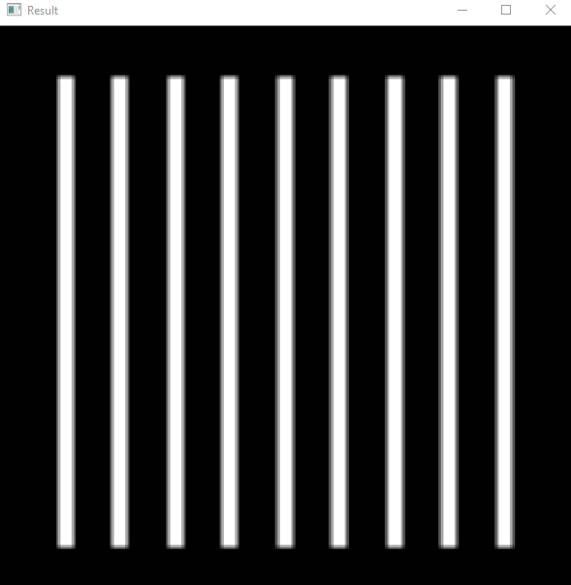

**5*5**

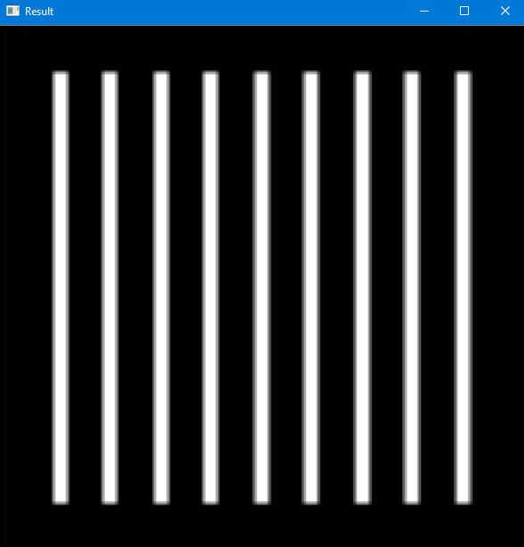

1. **A Harmonic Mean Filter**

**3*3**

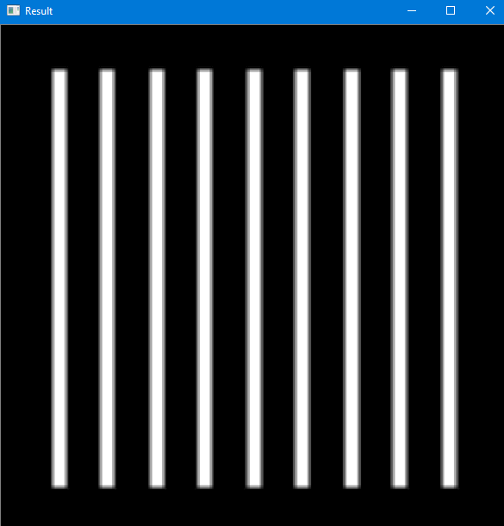

**5*5**

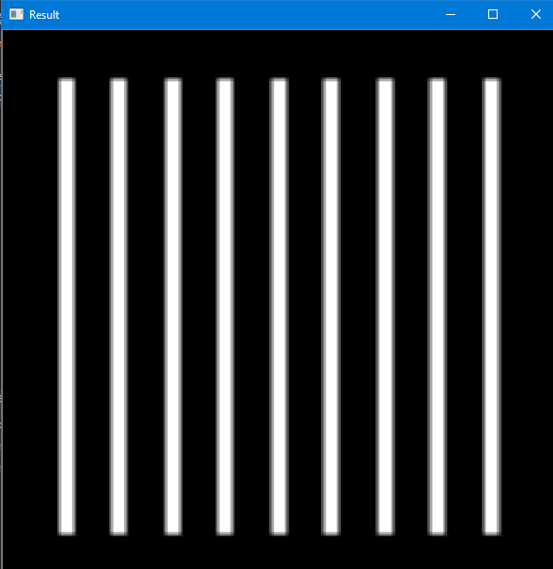

1. **A Contra-Harmonic mean filter with 𝑄 = 1**

**3*3**

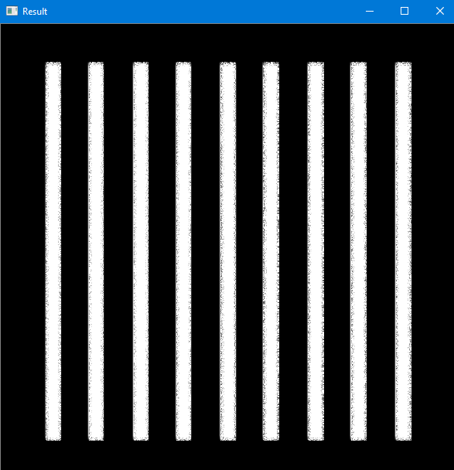

**5*5**

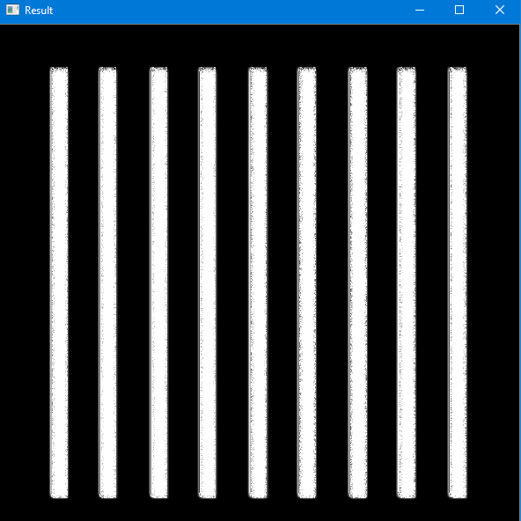

1. **A Contra-Harmonic mean filter with 𝑄 = −1**

**3*3**

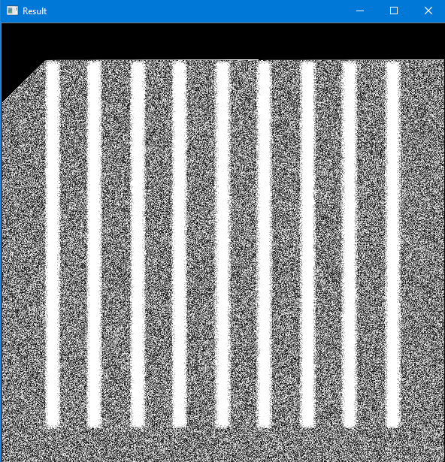

**5*5**

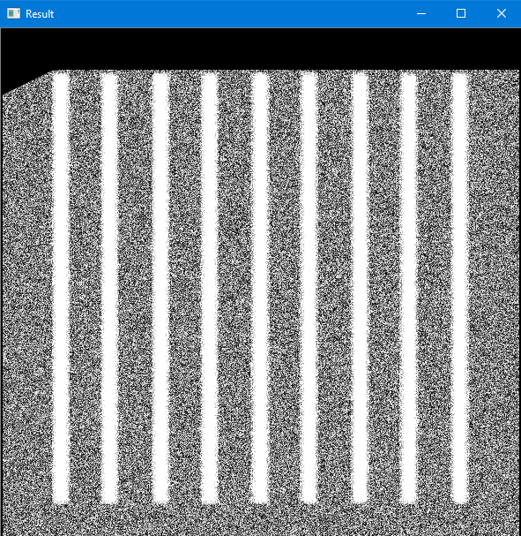

1. **Adaptive median filter**

**3*3**

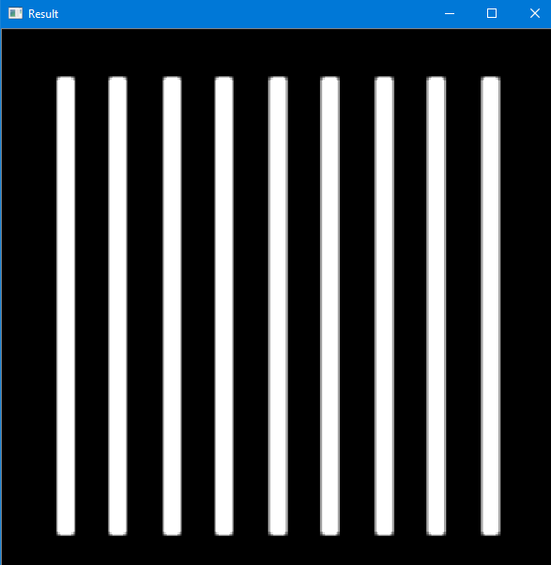

**5*5**

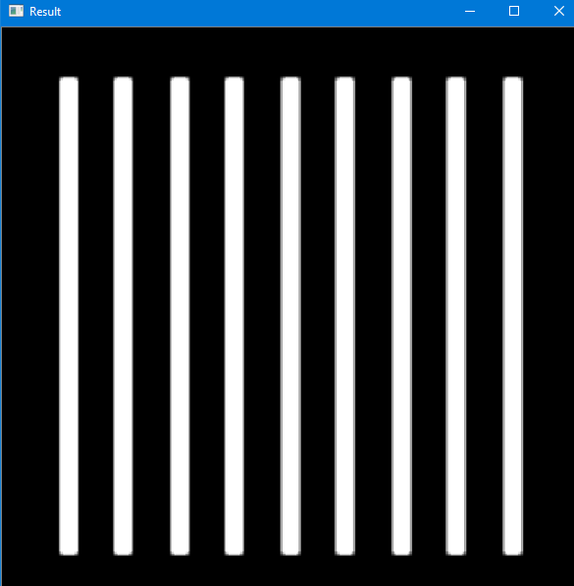

**Question No. 5:**