IoT Applications Development
SWAPD 453 | Spring 2026
Assignment 3
TinyML Cosine Wave Predictor
Name | Student ID | Email
Sara Mostafa | 202201305 | s-sara.ali@zewailcity.edu.eg
Basmala Alaa | 202201138 | s-basmala.ibrahim@zewailcity.edu.eg
GitHub Repository:
https://github.com/SARAELGYAR/Assignment3_IOT
Date: May 16, 2026

1. Introduction
TinyML is the practice of deploying trained machine learning models directly on resource-constrained microcontrollers, enabling on-device inference without cloud connectivity. This approach provides advantages in latency, bandwidth, privacy, and offline operation.
In this assignment, we implement the complete edge AI pipeline for a cosine wave predictor: generating noisy training data, training a small neural network, applying full int8 post-training quantization, converting the model to a C byte array, and deploying it on an ESP32 microcontroller. The ESP32 runs live inference and streams predicted vs. actual cosine values over Serial.

2. Pipeline Overview
Stage | Details
Data | 1000 samples: x ∈ [0, 2π], y = cos(x) + Gaussian noise (σ = 0.1). Split 60/20/20.
Model | Dense(16, ReLU) → Dense(16, ReLU) → Dense(1, linear). ~321 trainable parameters.
Optimization | Full int8 post-training quantization. Inputs and outputs are also int8.
Deployment | Model converted to C header (model.h) with xxd, loaded in Arduino sketch with TFLite Micro.
Output | ESP32 sweeps x from 0 to 2π and prints predicted,actual pairs over Serial at 115200 baud.

3. Data Generation & Model Training

3.1 Dataset Generation
We generated 1000 uniformly random samples of x ∈ [0, 2π] with a fixed random seed (42) for reproducibility. Labels were computed as y = cos(x) + ε, where ε ~ N(0, 0.1). The dataset was split 60/20/20 into training, validation, and test sets.

3.2 Model Architecture
The model follows the exact specification:
- Input: single scalar x
- Dense(16, activation='relu')
- Dense(16, activation='relu')
- Dense(1) — linear output
- Total trainable parameters: 321
Optimizer: Adam. Loss: Mean Squared Error (MSE).

3.3 Training Configuration
Training ran for 200 epochs with batch size 32 on TensorFlow 2.15.0.

3.4 Training Results
The training script output shows all key metrics:
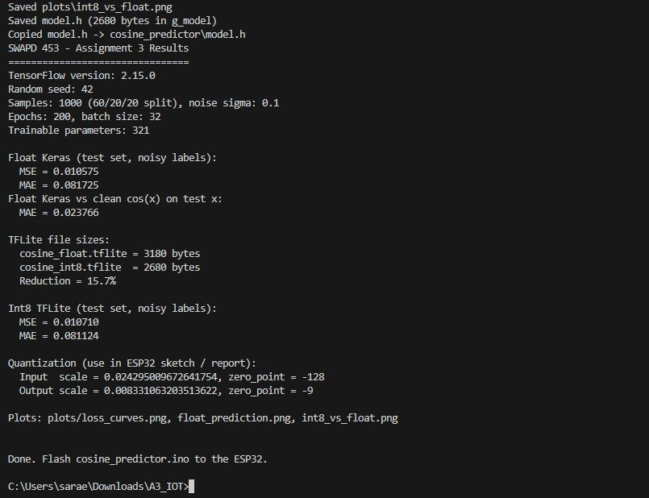
Figure 1: Training script terminal output showing model metrics and quantization parameters
Float Keras model performance on test set (noisy labels):
Metric | Float Keras | Int8 TFLite
MSE (test, noisy) | 0.010575 | 0.010710
MAE (test, noisy) | 0.081725 | 0.081124
MAE vs clean cos(x) | 0.023766 | —
Note: The MAE against noisy labels is ~0.082, which reflects label noise (σ = 0.1). The float model's MAE vs the clean ground truth cos(x) is only 0.0238, well within a good approximation range.

4. Model Optimization — Full Integer Quantization

4.1 Quantization Approach
We applied full integer (int8) post-training quantization using the TensorFlow Lite converter:
- converter.optimizations = [tf.lite.Optimize.DEFAULT]
- representative_dataset generator yielding ~100 samples from training distribution
- converter.target_spec.supported_ops = [tf.lite.OpsSet.TFLITE_BUILTINS_INT8]
- inference_input_type = tf.int8 and inference_output_type = tf.int8
This ensures no floating-point operations remain at runtime, making the model suitable for deployment on microcontrollers with no FPU.

4.2 TFLite File Sizes
File | Size (bytes) | Reduction
cosine_float.tflite | 3180 | Baseline
cosine_int8.tflite | 2680 | 15.7%

4.3 Quantization Parameters
The quantization parameters extracted from the model (used in the ESP32 sketch):
Input scale = 0.024295009672641754, zero_point = -128
Output scale = 0.008331063203513622, zero_point = -9
These parameters are used to convert float inputs to int8 before inference, and to convert int8 outputs back to float after inference.

4.4 C Header Generation
The quantized model was converted to a C byte array using xxd and saved as model.h:
xxd -i cosine_int8.tflite > model.h
The array was renamed to g_model[] and marked alignas(8) const unsigned char to ensure proper flash placement and alignment for the TFLite Micro runtime. The generated g_model array contains 2680 bytes.

5. ESP32 Deployment & Visualization

5.1 Setup
The Arduino sketch cosine_predictor.ino was set up with:
- Library: Chirale_TensorFlowLite (via Library Manager)
- Board: ESP32 Dev Module
- Serial baud rate: 115200
- Tensor arena size: 4096 bytes
- Steps per period: 80 (sweeping x from 0 to 2π)
The simulation was run in Wokwi (online ESP32 simulator) to demonstrate the deployment without physical hardware.

5.2 Inference Loop
In each loop iteration, the sketch:
- Quantizes the float x value to int8 using: int8_val = round(x / input_scale) + input_zero_point
- Sets the quantized value in the input tensor
- Calls interpreter->Invoke()
- Reads the int8 output and dequantizes: float_out = (int8_val - output_zero_point) * output_scale
- Computes the ground truth: actual = cos(x)
- Prints: Serial.println(predicted + "," + actual)

5.3 Startup Diagnostics
The sketch prints the following startup diagnostics once in setup():
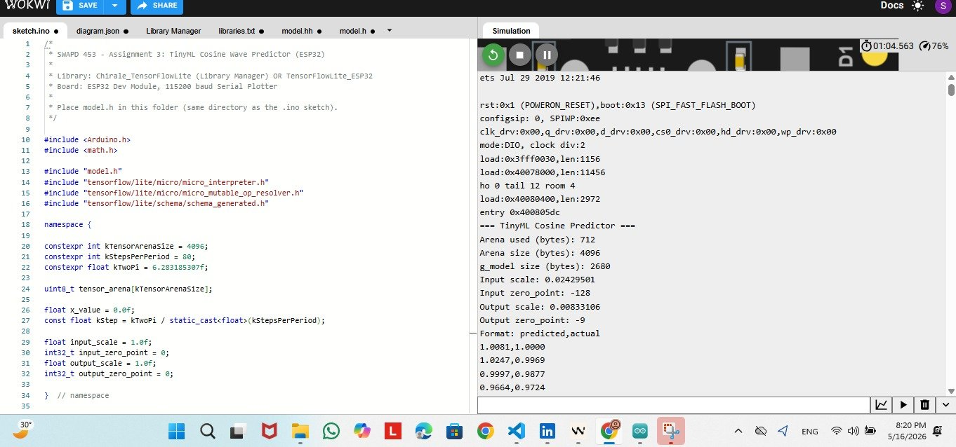
Figure 2: ESP32 Serial Monitor startup output showing arena usage, quantization parameters, and model size
Key startup values confirmed:
- Arena used (bytes): 712 — only 17.4% of the 4096-byte arena
- Arena size (bytes): 4096
- g_model size (bytes): 2680
- Input scale: 0.02429501, Input zero_point: -128
- Output scale: 0.00833106, Output zero_point: -9

5.4 Serial Output (predicted, actual pairs)
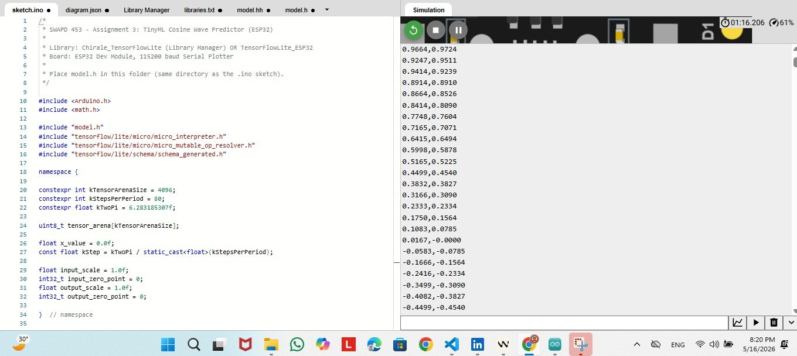
Figure 3: ESP32 Serial Monitor showing predicted,actual value pairs streaming correctly

5.5 Serial Plotter — Both Curves Visible
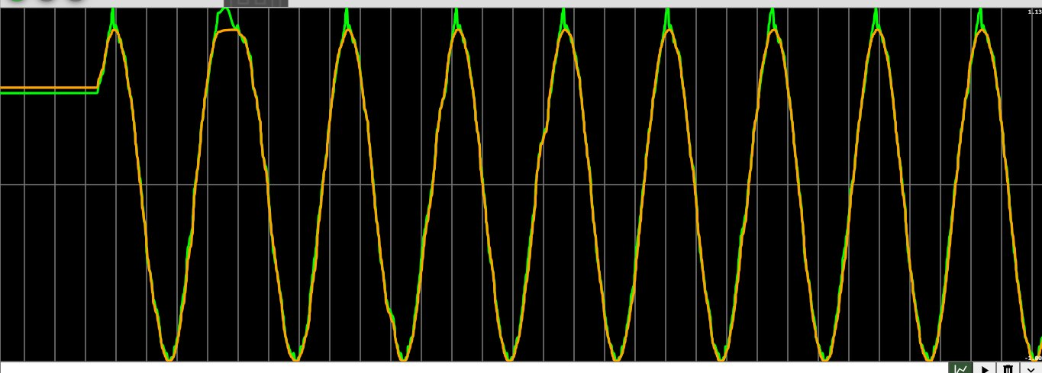
Figure 4: Serial Plotter showing predicted (orange) and actual (green) cosine curves tracking closely through multiple full periods
The two curves track each other closely throughout multiple complete periods of the cosine wave, confirming that the quantized model runs correctly on the ESP32 and produces accurate predictions in real time.

6. Results Summary
Metric | Float Model | Int8 Model
Test MSE (noisy labels) | 0.010575 | 0.010710
Test MAE (noisy labels) | 0.081725 | 0.081124
MAE vs clean cos(x) | 0.023766 | —
Model size (bytes) | 3180 | 2680
Size reduction | — | 15.7%
Arena used (bytes) | — | 712
Key observations:
- The int8 quantized model achieves virtually identical accuracy to the float model (MAE difference < 0.001), demonstrating that quantization introduces negligible error for this task.
- The model size was reduced by 15.7%, from 3180 to 2680 bytes, while fully eliminating floating-point operations at runtime.
- The tensor arena requires only 712 bytes of the 4096-byte allocation, meaning the sketch could run with an arena as small as ~800 bytes.
- Both predicted and actual cosine curves are visually aligned in the Serial Plotter across multiple full periods, confirming successful on-device inference.

7. Tools & Environment
Tool / Library | Version / Details
Python | 3.10+
TensorFlow | 2.15.0
NumPy + Matplotlib | Latest stable
Arduino IDE | 2.x
ESP32 Board Package | Espressif Systems (Boards Manager)
TFLite Micro Library | Chirale_TensorFlowLite
Simulator | Wokwi (online ESP32 simulator)
xxd | Git Bash on Windows

8. Conclusion
This assignment successfully demonstrated the complete TinyML pipeline from data generation through on-device inference on an ESP32. We trained a small fully-connected neural network to approximate y = cos(x), applied full int8 post-training quantization, converted the model to a C byte array, and deployed it using the TensorFlow Lite Micro runtime.
The quantized model achieved an MAE of 0.0237 against the clean cosine ground truth, with a 15.7% reduction in model size and negligible accuracy loss versus the float baseline. The ESP32 sketch ran correctly in simulation, with the Serial Plotter confirming close agreement between predicted and actual cosine values across multiple periods.
The skills demonstrated here — quantization, C header generation, on-device inference, and quant/dequant arithmetic — transfer directly to real-world TinyML applications such as keyword spotting, gesture recognition, and sensor anomaly detection.

