Table of Contents
1. Introduction 3
1.1 Why Object-Oriented Programming Is Suitable 3
1.2 Benefits of Classes and Objects in Healthcare Systems 3
2. Problem Statement 3
3. System Design 3
4. Class Descriptions 4
4.1 Patient Class 4
4.2 Doctor Class 5
4.3 How the Class Method Works 5
4.4 Object Interaction 5
5. Data Structure Used 5
5.1 Why a Dictionary Was Selected 5
5.2 Functions 6
6. Python Source Code 6
7. Program Execution and Output 9
7.1 Explanation of the Output 10
8. DPG Compliance 10
8.1 Open Source 10
8.2 Reusability 10
8.3 Privacy 10
8.4 Accessibility 10
9. Challenges and Solutions 11
10. Conclusion 11
References 11
Appendix A: README.md 12
Appendix B: GitHub Submission Guide 15
1. Create a GitHub repository 15
2. Upload project files 15
3. Create or edit README.md 15
4. Commit changes 15
5. Push to GitHub (command-line option) 15
6. Copy the repository link 15
7. Submit the assignment 15

1. Introduction
Access to accurate patient information is the foundation of good healthcare. In many clinics and health centres, especially in low-resource settings such as Sierra Leone, patient details are still written in paper registers. Paper records are slow to search, easy to lose or damage, difficult to update, and impossible to share quickly between staff. A patient who visits a different clinic may have to repeat their details, and a doctor may not know which patients are under their care.
This report presents a Patient Health Management System, a Python application that digitises the most basic tasks of a clinic: registering patients, storing doctor information, assigning doctors to patients, updating records, and displaying all records. The solution follows the Digital Public Goods (DPG) standards required by the assignment: it is open source, reusable, privacy-respecting and designed with accessibility in mind.

1.1 Why Object-Oriented Programming Is Suitable
Healthcare is naturally made of real-world entities: patients, doctors, appointments and records. Each entity has its own data (such as a name or specialization) and its own behaviour (such as being updated or displayed). Object-Oriented Programming (OOP) lets a programmer model these entities directly as classes, so the program mirrors the real world and is easier to understand, test and maintain.

1.2 Benefits of Classes and Objects in Healthcare Systems
- Organisation: all data and behaviour for a patient are kept together in one class rather than scattered across the program.
- Encapsulation: each class controls how its data is changed, which supports validation and protects data quality.
- Reusability: a class written once can create many objects and can be reused in other hospitals or projects.
- Scalability: new features, such as an Appointment class, can be added without rewriting existing code.
- Clarity: code such as patient.assign_doctor(doctor) reads like a real sentence, which helps new contributors.

2. Problem Statement
Small health facilities need a simple, low-cost way to manage patient and doctor information without expensive commercial software or constant internet access. The problem addressed by this project is the lack of a lightweight, open, and privacy-conscious record system that can be understood and adapted by students and local developers.
The system must therefore allow the following operations:
- Registering patients with a unique patient ID.
- Managing doctor information including identification number and specialization.
- Scheduling appointments in its simplest form by assigning a doctor to a patient, which links each patient to the clinician responsible for their care.
- Viewing patient records individually through display_info().
- Updating patient information through update_record().
- Displaying all patient records through display_all_patients().

3. System Design
The system is a console-based Python program organised into three layers: the entity classes (Patient and Doctor), the storage layer (a single dictionary named patients), and the interface functions (add_patient(), display_all_patients() and main()). The design keeps each responsibility separate so that, for example, the storage could later be replaced by a database without changing the classes.
Component | Responsibility
Doctor class | Holds doctor details and the number of patients assigned; can display and update its record.
Patient class | Holds patient details and a reference to a Doctor object; can display, update, validate and be assigned a doctor.
patients dictionary | The only data structure; maps Patient ID to Patient object for fast lookup.
add_patient() | Registers a patient and rejects duplicate IDs.
display_all_patients() | Loops through the dictionary and prints every record in a table.
main() | Demonstrates creation, assignment, update and display using the sample data.

Key design decisions were: (1) store the assigned doctor as an object reference, not as text, so that Patient and Doctor genuinely interact; (2) validate input inside the class that owns the data; and (3) store only the minimum personal information necessary, in line with the privacy principle of DPG.
Appointment scheduling is deliberately kept simple. In this version, assigning a doctor represents the first step of scheduling. A dedicated Appointment class with dates and times is identified as a future improvement because the assignment limits the solution to the two required classes and a single data structure.

4. Class Descriptions

4.1 Patient Class
The Patient class represents a person registered at the facility. It stores only the data required to identify and contact the patient and to link them to a doctor.
Attribute | Description
patient_id | Unique identifier (e.g. P001), used as the dictionary key.
patient_name | Full name of the patient.
age | Age in years.
contact_number | Phone number in international format (e.g. +23270000001).
assigned_doctor | A Doctor object, or None if no doctor has been assigned.
total_patients (class attribute) | Counts all Patient objects created.

Method | Description
__init__() | Constructor; sets the attributes and increases total_patients.
display_info() | Prints the patient's details and the assigned doctor's name and specialization.
assign_doctor(doctor) | Checks that the argument is a Doctor, links it to the patient, and updates the doctor's patient count.
update_record() | Updates only the supplied fields; validates the contact number before saving.
masked_contact() | Returns the contact number with the last four digits hidden.
create_default_patient() (@classmethod) | Factory method that builds a placeholder patient.
is_valid_contact() (@staticmethod) | Utility that checks a phone number's format without needing an object.

4.2 Doctor Class
The Doctor class represents a clinician who can be assigned to patients. It is intentionally small and independent, so it can be reused in any facility.
Attribute / Method | Description
doctor_id | Unique identifier (e.g. D101).
doctor_name | Name of the doctor.
specialization | Area of practice (e.g. Cardiology).
patient_count | Number of patients currently assigned (updated by Patient.assign_doctor()).
__init__() | Constructor; sets attributes and increases the class counter total_doctors.
display_info() | Prints the doctor's details.
update_record() | Changes the name and/or specialization.

4.3 How the Class Method Works
A class method is declared with the @classmethod decorator and receives the class itself (conventionally named cls) as its first argument instead of an individual object (self). The method create_default_patient() calls cls("P000", "Unknown Patient", 0, "+23200000000"), which is equivalent to Patient(...), and returns the new object. Because it creates a real Patient through the constructor, the shared counter total_patients is also incremented. This pattern is known as a factory method and is useful when a standard object must be created without repeating the same arguments.

4.4 Object Interaction
Interaction occurs when patient1.assign_doctor(doctor1) is called. The patient stores a reference to the doctor object, and the doctor's patient_count is increased. If the patient is later moved to another doctor, the old doctor's count is reduced. This shows that objects can cooperate by calling each other's data and methods, which is a core idea of OOP.

5. Data Structure Used
As required, the program uses only one data structure: a dictionary named patients. Each key is a Patient ID (a string such as "P001") and each value is the corresponding Patient object:
patients = {
"P001": patient1,
"P002": patient2
}

5.1 Why a Dictionary Was Selected
- Fast lookup: finding a patient by ID takes constant time on average, regardless of how many patients are stored. A list would need to be searched item by item.
- Unique keys: a dictionary cannot hold two entries with the same key, which matches the rule that every patient has one unique ID. add_patient() uses this to reject duplicates.
- Natural fit: real clinics identify patients by a reference number, so ID-to-record mapping is how the information is already used.
- Simplicity: dictionaries are built into Python, need no external libraries, and are easy for beginners to read.

5.2 Functions
add_patient(patient) checks whether patient.patient_id is already a key, and if not stores the object in the dictionary. display_all_patients() loops through patients.items() and prints each record, using masked contact numbers for privacy. Doctors are kept as individual objects (doctor1, doctor2) and referenced by patients, so no second data structure is introduced.

6. Python Source Code
The complete source code is shown below and is also provided as patient_health_system.py. It uses only the Python standard library and runs without modification on Python 3.8 or later.

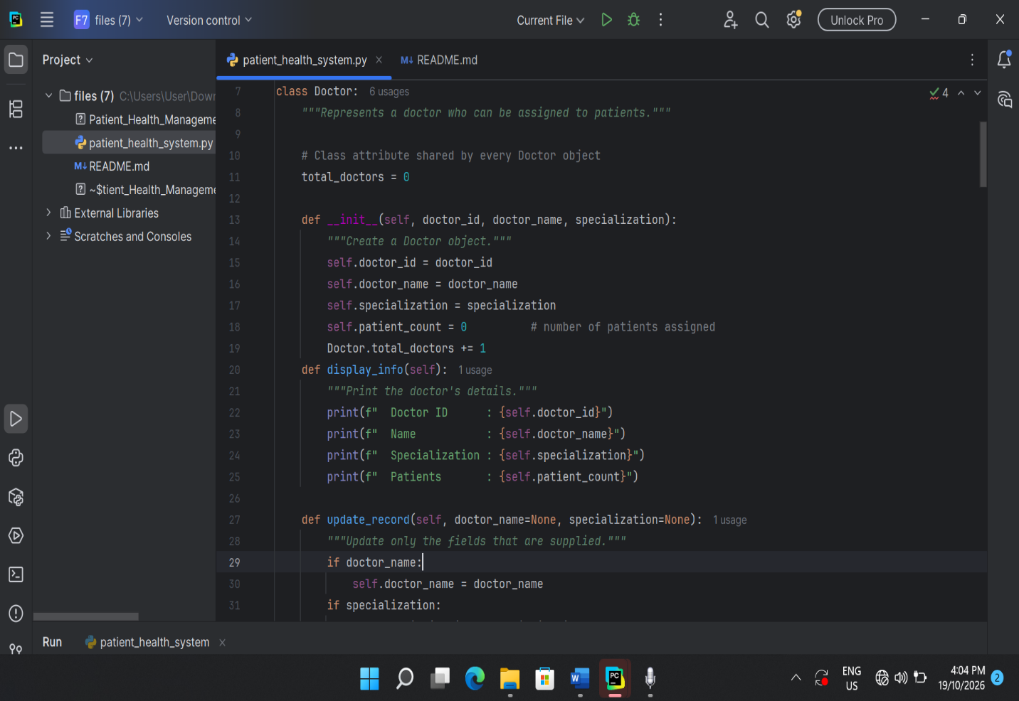

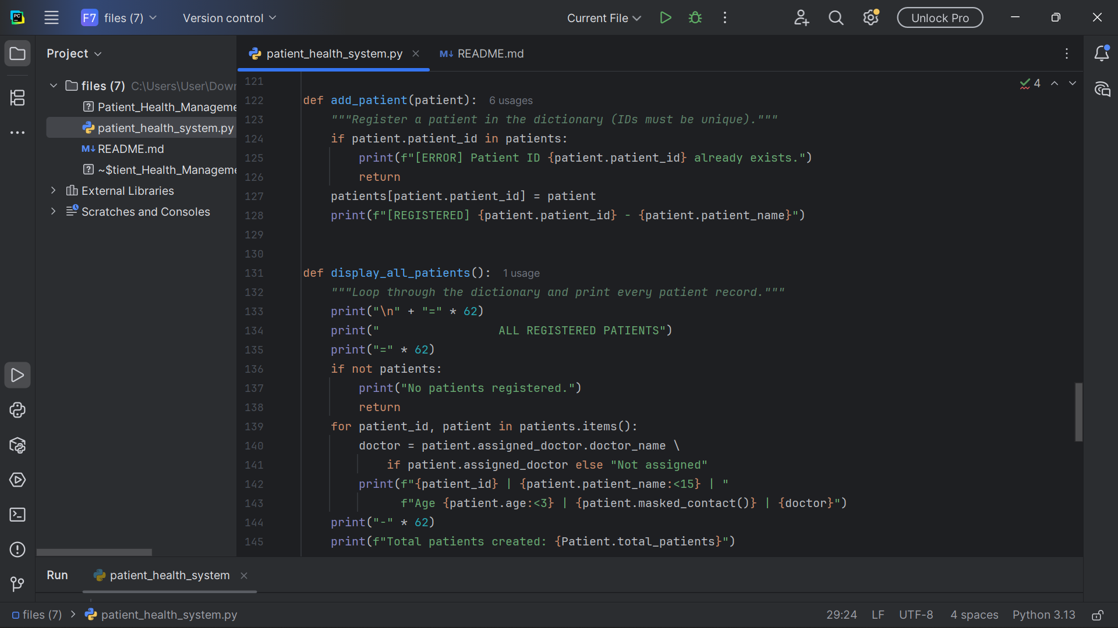

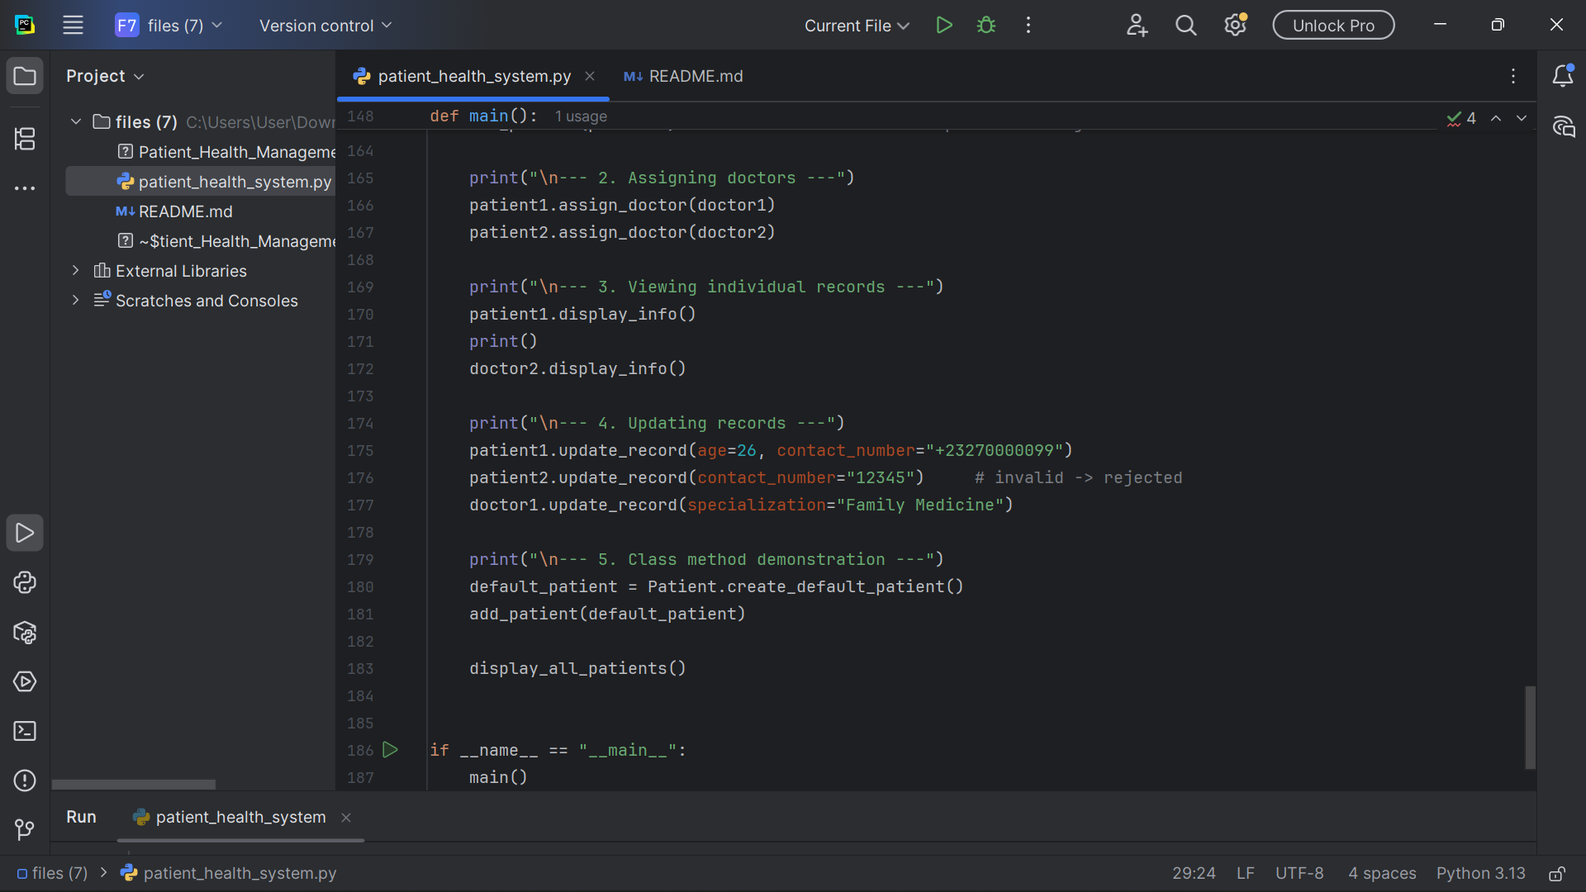

7. Program Execution and Output
The program was executed with the command python patient_health_system.py. The sample data from the assignment brief (patients John Kamara and Mariama Sesay; doctors Dr. Williams and Dr. Johnson) was used. The output below was produced by the program.

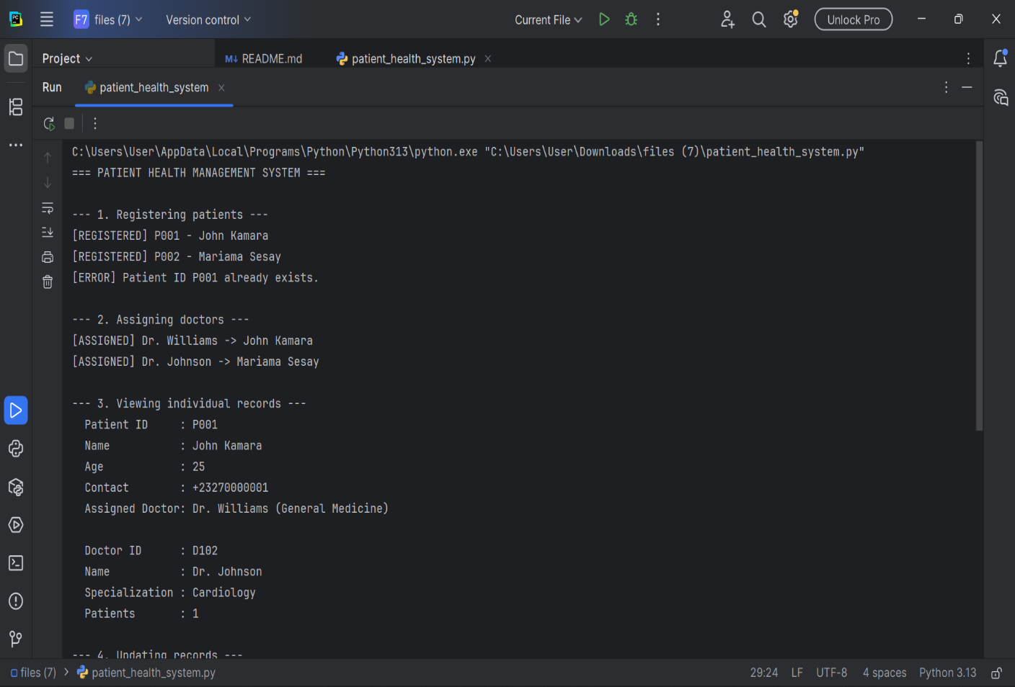

7.1 Explanation of the Output
- Step 1: two patients are registered; the duplicate registration of P001 is rejected.
- Step 2: each patient is linked to a doctor, demonstrating object interaction.
- Step 3: individual records are displayed; Dr. Johnson shows one assigned patient.
- Step 4: John Kamara's age and number are updated, an invalid number for Mariama is rejected, and Dr. Williams' specialization is changed.
- Step 5: the class method creates a default patient, and the final table shows all records with masked contact numbers and a counter of three patients.
Note: screenshots of the program running should be inserted here for the hardcopy submission, as required by the assignment brief.

8. DPG Compliance
Digital Public Goods are open-source software, data, standards and content that adhere to privacy and other applicable best practices and help attain the Sustainable Development Goals. The system applies the four principles required by the assignment.

8.1 Open Source
The project is hosted in a public GitHub repository under the MIT licence. Any hospital, clinic, student or developer may download, use, study, modify and redistribute the code at no cost, without vendor lock-in. Because it is written in plain Python with no external dependencies, organisations can adapt it without special tools or licences.

8.2 Reusability
The Patient and Doctor classes contain no facility-specific logic. A hospital can import them into a larger system, a clinic can use them as they are, and a community health centre can extend them (for example, by subclassing Patient to add antenatal data). The storage and display functions are separate from the classes, so the interface can change without affecting the core model.

8.3 Privacy
Privacy is protected by data minimisation: the system stores only an ID, name, age and contact number. It does not store home addresses, national ID numbers, biometric data, diagnoses or passwords. The contact number is masked in list views through masked_contact(), and input is validated so that bad data is not saved. For a real deployment, the design recommends encrypted storage and role-based access, which are listed as future improvements.

8.4 Accessibility
The system runs on low-cost computers, works offline, and has a simple text interface that does not require a mouse, graphics or the internet. Its clear structure makes it easy to extend with local-language messages, larger fonts, voice or SMS interfaces, and web or mobile front ends to serve diverse communities, including rural areas and users with limited digital literacy.
DPG Principle | How It Is Met
Open Source | Public GitHub repository, MIT licence, standard library only.
Reusability | Independent classes; storage and display separated from the model.
Privacy | Minimal data, masked contact numbers, input validation.
Accessibility | Offline, lightweight, plain interface, extendable to other languages and platforms.

9. Challenges and Solutions
Challenge | Solution
Using only one data structure while linking patients and doctors. | Patients are stored in one dictionary, and doctors are separate objects referenced by the patient's assigned_doctor attribute.
Preventing duplicate patient IDs. | add_patient() checks whether the ID is already a dictionary key before storing.
Keeping doctor patient counts accurate when reassigning. | assign_doctor() reduces the previous doctor's count before increasing the new one.
Protecting privacy while showing useful information. | Only minimal data is stored and contact numbers are masked in the summary table.
Preventing invalid data. | A static method validates phone numbers, and update_record() rejects invalid values.
Defining Doctor before Patient in the file. | Doctor is declared first so that Patient.assign_doctor() can check isinstance(doctor, Doctor).

10. Conclusion
This project shows how Object-Oriented Programming can be applied to a real healthcare problem. The Patient and Doctor classes model real entities, objects interact through assign_doctor(), a single dictionary provides fast and unique access to patient records, and instance, class and static methods each serve a clear purpose. The design follows DPG standards by being open source, reusable, privacy-respecting and accessible.
The system is intentionally simple, yet its structure is ready to grow. Future work could add an Appointment class, persistent encrypted storage, search functions, multilingual interfaces and a web front end. With these extensions the project could support real community health facilities while remaining free and open to everyone.

References
Digital Public Goods Alliance (2023) The Digital Public Goods Standard. Available at: https://digitalpublicgoods.net/standard/ (Accessed: October 2026).
Open Source Initiative (n.d.) The MIT License. Available at: https://opensource.org/license/mit (Accessed: October 2026).
Phillips, D. (2018) Python 3 Object-Oriented Programming. 3rd edn. Birmingham: Packt Publishing.
Python Software Foundation (n.d.) Python 3 Documentation: Classes. Available at: https://docs.python.org/3/tutorial/classes.html (Accessed: October 2026).
Python Software Foundation (n.d.) Python 3 Documentation: Dictionaries. Available at: https://docs.python.org/3/tutorial/datastructures.html#dictionaries (Accessed: October 2026).
van Rossum, G., Warsaw, B. and Coghlan, A. (2001) PEP 8 – Style Guide for Python Code. Available at: https://peps.python.org/pep-0008/ (Accessed: October 2026).
World Health Organization (2021) Global Strategy on Digital Health 2020–2025. Geneva:

