Asglory E-Commerce Project
Functional and UI Issues Identified
Testing performed on the Customer Storefront (Port 3000)
The following issues were identified while testing the Asglory E-Commerce Project by running the application on Port 3000. The findings cover functionality, navigation, currency handling, validation, responsiveness, checkout calculations, and authentication.

Detailed Issues

1. Currency Conversion Not Reflected on Product Prices
The application supports multiple currencies, including INR, USD, EUR, and GBP. However, when the currency is changed from INR to USD on the Home page, the product prices continue to display in the previously selected currency.
Expected: Product prices should automatically update according to the selected currency.

2. Product Search Not Returning Results
When searching for a product, the application displays “There is no match” regardless of the search term entered.
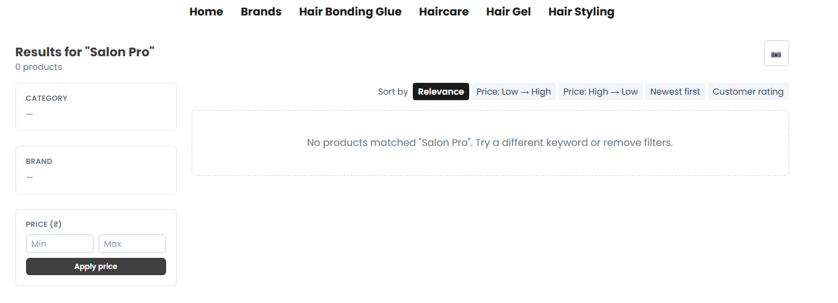
Expected: Relevant products should be displayed based on the entered search keyword.

3. Wishlist Page Returns 404 Error
When accessing the Wishlist page, the application returns a 404 Not Found error.
Expected: The Wishlist page should load successfully and display the user's saved products.

4. “View All” Displays No Products
Clicking “View All” on the Home page displays “No Products” instead of the available products.
Expected: The View All option should display the relevant product listing.

5. Professional Haircare and Styling Filters Not Working
The Strong Hold, Moisture, Shine, and Edge Control options under Professional Haircare and Styling are not functioning.
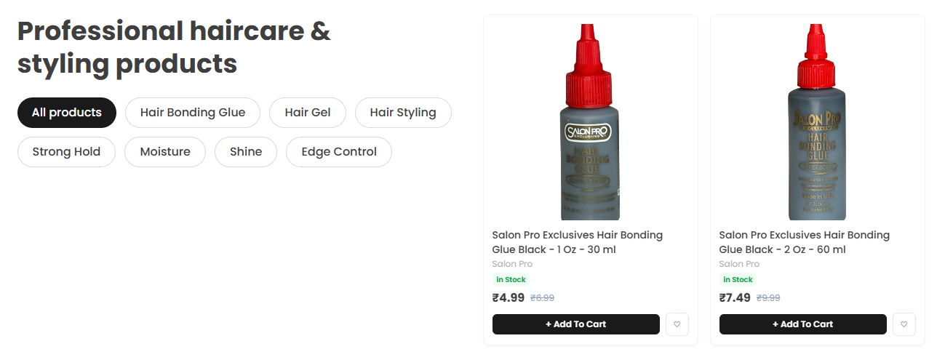
Expected: Selecting each option should display the corresponding products.

6. Subscription Form Validation and Network Error
The Name field in the Subscribe section is not marked as required. After entering the information, a “Network Error” message is displayed.
Expected: Proper validation should be applied and the subscription should be processed successfully.

7. Footer Links Redirect to the Home Page
Each footer link redirects to the Home page instead of its respective destination.

Expected: Each footer link should navigate to its corresponding page or section.

8. Pincode Validation Not Working Correctly
The pincode verification functionality on the Product View page does not validate the entered pincode correctly.
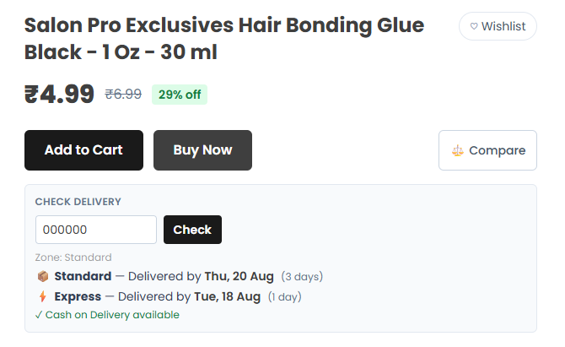
Expected: The system should accurately indicate delivery availability for the entered pincode.

9. Product Comparison Limited to Three Products
The Comparison page currently allows only three products to be compared.
Expected: The comparison limit should be increased or clearly defined according to business requirements.

10. Currency Not Updated on Comparison Page
Product prices on the Comparison page do not update when the selected currency is changed.
Expected: Comparison prices should reflect the selected currency.

11. Rating and Description Not Displayed in Comparison
After providing a product rating, the Rating and Description columns on the Comparison page remain empty.
Expected: Submitted ratings and product descriptions should be displayed correctly.

12. Suggested Product Prices Not Updated by Currency
Suggested products on the Product View page retain their original currency when the user changes currency.
Expected: Suggested product prices should reflect the currently selected currency.

13. Customer Reviews Section Has No Review Submission Page
The Home page contains a Customer Reviews section, but there is no accessible functionality for customers to submit reviews.

Expected: Customers should be able to submit reviews and ratings for eligible products.

14. Cart Page Does Not Automatically Refresh
Cart changes are not reflected automatically. A manual page refresh is required to display the current cart status.
Expected: Cart information should update automatically after changes.

15. Brand Product Listing Not Displayed
Selecting a brand on the Brands page does not display its associated products.
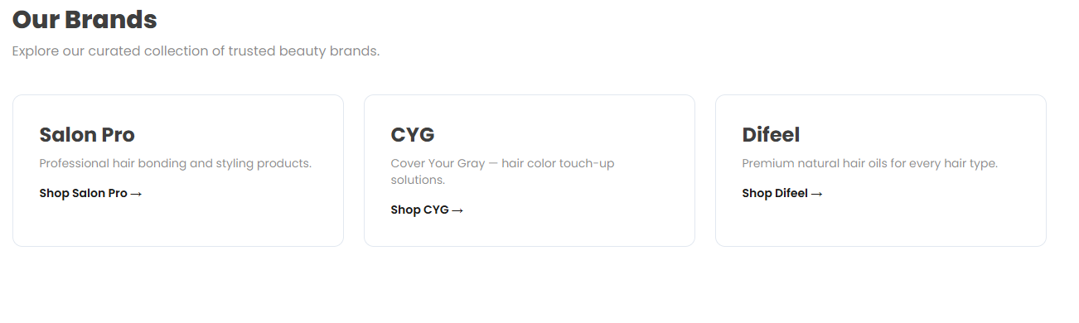
Expected: Selecting a brand should display the corresponding product catalog.

16. Mobile Number Validation Allows Invalid Input
The Address page allows submission when only 7 digits are entered in the mobile number field.
Expected: The field should enforce the required length and format.

17. “Set as Default” Address Option Not Working
The Set as Default option on the Address page does not function correctly.
Expected: The selected address should become the default address throughout the application.

18. “Mega Electronic Sale” Link Returns 404 Error
Clicking Mega Electronic Sale at the top of the website results in a 404 Not Found error.

Expected: The link should redirect to the appropriate promotional or product page.

19. Header Is Not Responsive
The website header does not adapt correctly to different screen sizes.

Expected: The header should be responsive across desktop, tablet, and mobile devices.

20. Navigation Menu Not Displayed on Smaller Screens
When the browser window is reduced, the navigation section is no longer visible.

Expected: Navigation should remain accessible through a responsive or hamburger menu.

21. Discount Coupon Not Reflected in Checkout Total
Applying a discount coupon on the Checkout page does not reduce the final order total.
Expected: A valid discount should be deducted from the order total.

22. Delivery Speed Cost Not Reflected in Total
Changing the selected delivery speed does not update the displayed total.
Expected: The applicable delivery charge should be dynamically reflected in the total.

23. GST Not Included in Checkout Submit Calculation
The checkout calculation does not include the applicable GST amount when the order is submitted.
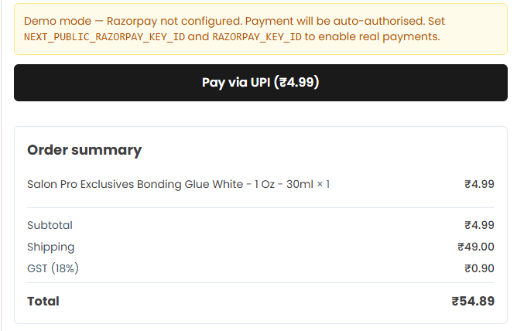
Expected: GST should be included in the checkout total before submission.

24. Payment Amount Includes Delivery Charges and GST
The Checkout page does not consistently reflect delivery charges and GST, although the payment process proceeds with these amounts included.
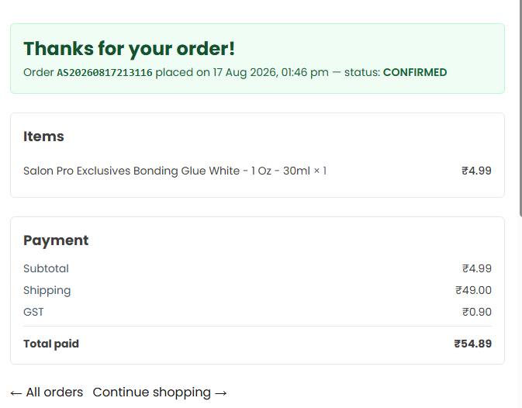
Expected: Checkout and payment totals should be consistent and show subtotal, discount, delivery charge, GST, and final payable amount.

25. Google and Apple Sign-In Not Working
Continue with Google and Continue with Apple are not functioning and display an alert/error message.
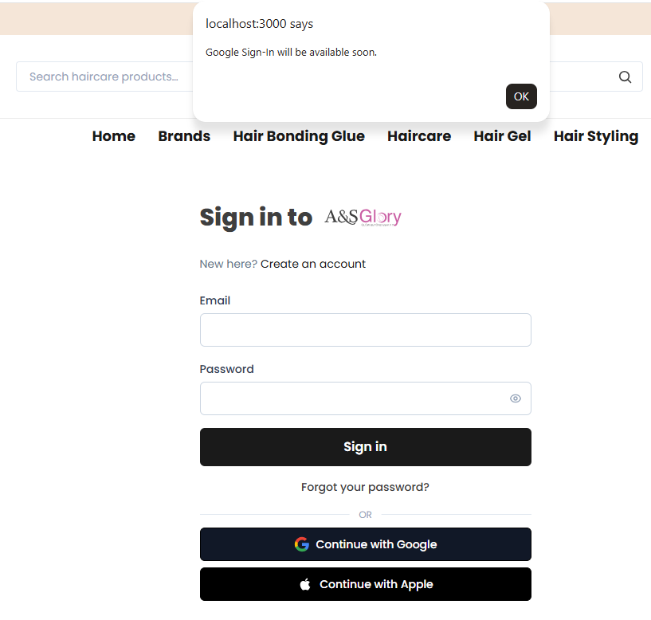
Expected: Both authentication options should successfully initiate their respective OAuth sign-in process.

Summary of Issues
No. | Module / Area | Issue Type
1 | Currency | Currency not updated on Home page
2 | Product Search | Search returns no matching products
3 | Wishlist | 404 error
4 | Home – View All | No products displayed
5 | Product Filters | Haircare filters not working
6 | Subscription | Validation and network error
7 | Footer Navigation | Links redirect to Home
8 | Product Details | Pincode validation issue
9 | Comparison | Limited to 3 products
10 | Comparison | Currency not updated
11 | Comparison | Rating and description not displayed
12 | Product Details | Suggested product currency not updated
13 | Customer Reviews | No review submission functionality
14 | Cart | Manual refresh required
15 | Brands | Products not displayed
16 | Address | Invalid mobile number accepted
17 | Address | Default address option not working
18 | Promotional Navigation | Mega Electronic Sale returns 404
19 | Header | Not responsive
20 | Navigation | Navigation unavailable on smaller screens
21 | Checkout | Coupon discount not reflected
22 | Checkout | Delivery charge not reflected
23 | Checkout | GST not reflected in checkout total
24 | Payment | Checkout and payment totals inconsistent
25 | Authentication | Google and Apple sign-in not working

