NAME: SARAN D

REG NO: 20MIC0148

COURSE: DATA WARE HOUSING AND DATA MINING

COURSE CODE: CSI3010

Slot: L51+L52

Experiment-2

Create an Employee Dataset in excel and store the file in .csv extension

Attributes Type Range of Values

Empid Nominal 1,2,…30

Name character ….

Designation ordinal Manager, Supervisor, Clerk, labour

Salary Numerical 6000, ….… 30,000

Experience Numerical 1,….12

Vaccinated binary yes/no

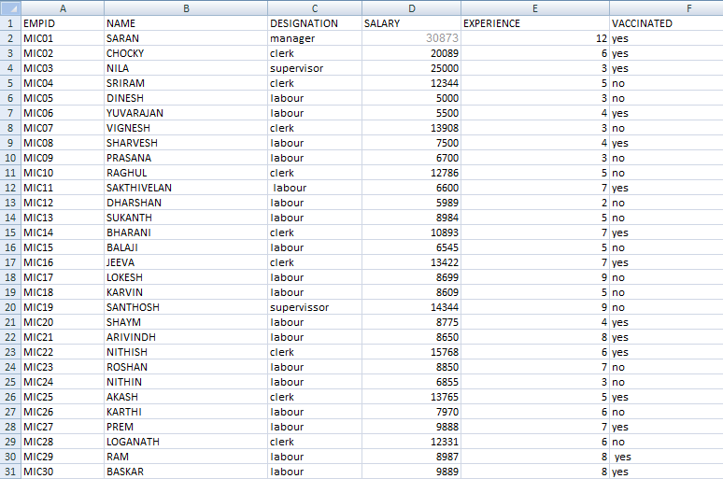

Section: 2

1.Get the dimensions, structure, attribute name, and attribute values of the dataset.

DIMENSIONS:

