* 1

#Importing library

import keras

from keras.models import Sequential

from keras.layers import Dense, Activation, Dropout, Flatten, Conv2D, MaxPooling2D

from keras.layers.normalization import BatchNormalization

import numpy as np

np.random.seed(1000)

#Instantiation

AlexNet = Sequential()

#1st Convolutional Layer

AlexNet.add(Conv2D(filters=96, input_shape=(32,32,3), kernel_size=(11,11), strides=(4,4), padding='same'))

AlexNet.add(BatchNormalization())

AlexNet.add(Activation('relu'))

AlexNet.add(MaxPooling2D(pool_size=(2,2), strides=(2,2), padding='same'))

#2nd Convolutional Layer

AlexNet.add(Conv2D(filters=256, kernel_size=(5, 5), strides=(1,1), padding='same'))

AlexNet.add(BatchNormalization())

AlexNet.add(Activation('relu'))

AlexNet.add(MaxPooling2D(pool_size=(2,2), strides=(2,2), padding='same'))

#3rd Convolutional Layer

AlexNet.add(Conv2D(filters=384, kernel_size=(3,3), strides=(1,1), padding='same'))

AlexNet.add(BatchNormalization())

AlexNet.add(Activation('relu'))

#4th Convolutional Layer

AlexNet.add(Conv2D(filters=384, kernel_size=(3,3), strides=(1,1), padding='same'))

AlexNet.add(BatchNormalization())

AlexNet.add(Activation('relu'))

#5th Convolutional Layer

AlexNet.add(Conv2D(filters=256, kernel_size=(3,3), strides=(1,1), padding='same'))

AlexNet.add(BatchNormalization())

AlexNet.add(Activation('relu'))

AlexNet.add(MaxPooling2D(pool_size=(2,2), strides=(2,2), padding='same'))

#Passing it to a Fully Connected layer

AlexNet.add(Flatten())

# 1st Fully Connected Layer

AlexNet.add(Dense(4096, input_shape=(32,32,3,)))

AlexNet.add(BatchNormalization())

AlexNet.add(Activation('relu'))

# Add Dropout to prevent overfitting

AlexNet.add(Dropout(0.4))

#2nd Fully Connected Layer

AlexNet.add(Dense(4096))

AlexNet.add(BatchNormalization())

AlexNet.add(Activation('relu'))

#Add Dropout

AlexNet.add(Dropout(0.4))

#3rd Fully Connected Layer

AlexNet.add(Dense(1000))

AlexNet.add(BatchNormalization())

AlexNet.add(Activation('relu'))

#Add Dropout

AlexNet.add(Dropout(0.4))

#Output Layer

AlexNet.add(Dense(10))

AlexNet.add(BatchNormalization())

AlexNet.add(Activation('softmax'))

#Model Summary

AlexNet.summary()

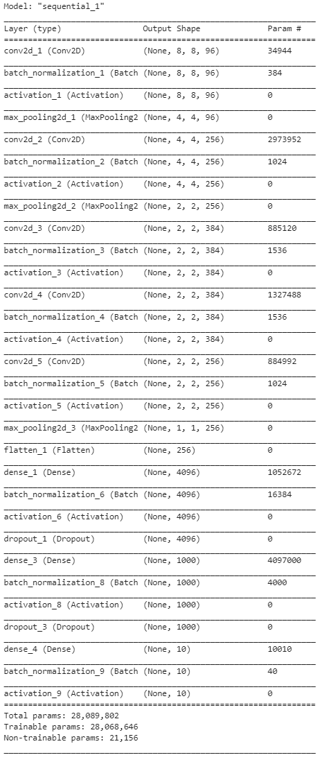

# Compiling the model

AlexNet.compile(loss = keras.losses.categorical_crossentropy, optimizer= 'adam', metrics=['accuracy'])

#Keras library for CIFAR dataset

from keras.datasets import cifar10

(x_train, y_train),(x_test, y_test)=cifar10.load_data()

#Train-validation-test split

from sklearn.model_selection import train_test_split

x_train,x_val,y_train,y_val=train_test_split(x_train,y_train,test_size=.3)

#Dimension of the CIFAR10 dataset

print((x_train.shape,y_train.shape))

print((x_val.shape,y_val.shape))

print((x_test.shape,y_test.shape))

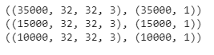

#Onehot Encoding the labels.

from sklearn.utils.multiclass import unique_labels

from keras.utils import to_categorical

#Since we have 10 classes we should expect the shape[1] of y_train,y_val and y_test to change from 1 to 10

y_train=to_categorical(y_train)

y_val=to_categorical(y_val)

y_test=to_categorical(y_test)

#Verifying the dimension after one hot encoding

print((x_train.shape,y_train.shape))

print((x_val.shape,y_val.shape))

print((x_test.shape,y_test.shape))

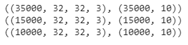

#Image Data Augmentation

from keras.preprocessing.image import ImageDataGenerator

train_generator = ImageDataGenerator(rotation_range=2, horizontal_flip=True,zoom_range=.1 )

val_generator = ImageDataGenerator(rotation_range=2, horizontal_flip=True,zoom_range=.1)

test_generator = ImageDataGenerator(rotation_range=2, horizontal_flip= True,zoom_range=.1)

#Fitting the augmentation defined above to the data

train_generator.fit(x_train)

val_generator.fit(x_val)

test_generator.fit(x_test)

#Defining the parameters

batch_size= 100

epochs=100

learn_rate=.001

Now, we will train our defined AlexNet model.

#Training the model

AlexNet.fit_generator(train_generator.flow(x_train, y_train, batch_size=batch_size), epochs = epochs, steps_per_epoch = x_train.shape[0]//batch_size, validation_data = val_generator.flow(x_val, y_val, batch_size=batch_size), validation_steps = 250, callbacks = [lrr], verbose=1)

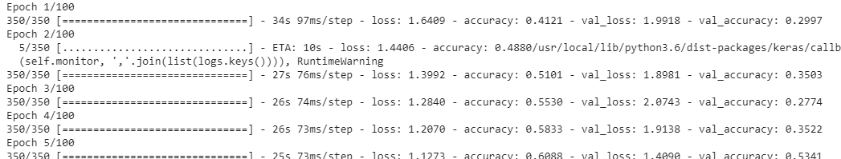 

#After successful training, we will visualize its performance.

import matplotlib.pyplot as plt

#Plotting the training and validation loss

f,ax=plt.subplots(2,1) #Creates 2 subplots under 1 column

#Assigning the first subplot to graph training loss and validation loss

ax[0].plot(AlexNet.history.history['loss'],color='b',label='Training Loss')

ax[0].plot(AlexNet.history.history['val_loss'],color='r',label='Validation Loss')

#Plotting the training accuracy and validation accuracy

ax[1].plot(AlexNet.history.history['accuracy'],color='b',label='Training  Accuracy')

ax[1].plot(AlexNet.history.history['val_accuracy'],color='r',label='Validation Accuracy')

plt.legend()

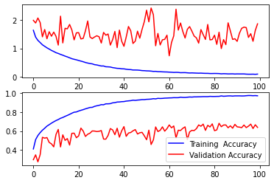

We will see the classification performance using a non-normalized and a normalized confusion matrices. For this purpose, first, we will define a function through which the confusion matrices will be plotted.

#Defining function for confusion matrix plot

def plot_confusion_matrix(y_true, y_pred, classes,

                         normalize=False,

                         title=None,

                         cmap=plt.cm.Blues):

   if not title:

       if normalize:

           title = 'Normalized confusion matrix'

       else:

           title = 'Confusion matrix, without normalization'

   # Compute confusion matrix

   cm = confusion_matrix(y_true, y_pred)

   if normalize:

       cm = cm.astype('float') / cm.sum(axis=1)[:, np.newaxis]

       print("Normalized confusion matrix")

   else:

       print('Confusion matrix, without normalization')

#Print Confusion matrix

   fig, ax = plt.subplots(figsize=(7,7))

   im = ax.imshow(cm, interpolation='nearest', cmap=cmap)

   ax.figure.colorbar(im, ax=ax)

   # We want to show all ticks...

   ax.set(xticks=np.arange(cm.shape[1]),

          yticks=np.arange(cm.shape[0]),

          xticklabels=classes, yticklabels=classes,

          title=title,

          ylabel='True label',

          xlabel='Predicted label')

   # Rotate the tick labels and set their alignment.

   plt.setp(ax.get_xticklabels(), rotation=45, ha="right",

            rotation_mode="anchor")

   # Loop over data dimensions and create text annotations.

   fmt = '.2f' if normalize else 'd'

   thresh = cm.max() / 2.

   for i in range(cm.shape[0]):

       for j in range(cm.shape[1]):

           ax.text(j, i, format(cm[i, j], fmt),

                   ha="center", va="center",

                   color="white" if cm[i, j] > thresh else "black")

   fig.tight_layout()

   return ax

np.set_printoptions(precision=2)

In the next step, we will predict the class labels for the test images using the trained AlexNet model.

#Making prediction

y_pred=AlexNet.predict_classes(x_test)

y_true=np.argmax(y_test,axis=1)

#Plotting the confusion matrix

from sklearn.metrics import confusion_matrix

confusion_mtx=confusion_matrix(y_true,y_pred)

class_names=['airplane', 'automobile', 'bird', 'cat', 'deer', 'dog', 'frog', 'horse', 'ship', 'truck']

# Plotting non-normalized confusion matrix

plot_confusion_matrix(y_true, y_pred, classes = class_names,title = 'Confusion matrix, without normalization')

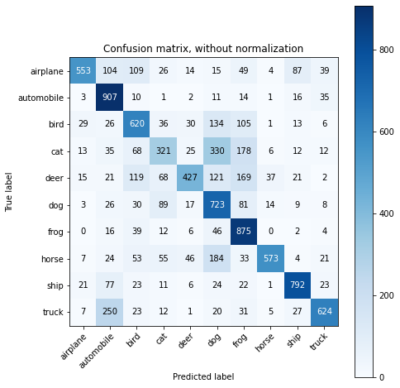

# Plotting normalized confusion matrix

plot_confusion_matrix(y_true, y_pred, classes=class_names, normalize=True, title='Normalized confusion matrix')

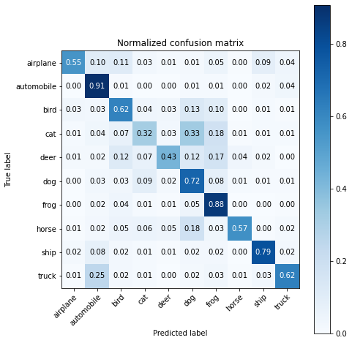

The average accuracy score in classifying the unseen test data will be obtained now.

#Classification accuracy

from sklearn.metrics import accuracy_score

acc_score = accuracy_score(y_true, y_pred)

print('Accuracy Score = ', acc_score)

alexnet accuracy score