Name: Sarat Das
Enrollment Number: MSE24010
Programme: M.Sc. Economics & Management
Institute: Indian Institute of Information Technology, Lucknow (IIIT Lucknow)
Course Instructor: Prof. Dhiraj Mishra
Research Project Report
Exchange Rate Volatility & Canada’s Trade Balance (2017–2023)
Testing the Marshall–Lerner Condition

1. Introduction
Exchange rate movements play an important role in shaping the external competitiveness of an economy. For open economies such as Canada—whose trade is heavily integrated with the United States—understanding how currency depreciation affects exports, imports, and the trade balance is crucial for macroeconomic and trade policy.
This study examines whether depreciation of the Canadian dollar (CAD) improves Canada’s trade balance between 2017 and 2023. Specifically, it empirically tests the Marshall–Lerner condition, which states that a depreciation will improve the trade balance if the sum of export and import elasticities exceeds one.
Using annual data on Canada’s exports, imports, and exchange rate movements, this paper estimates export and import demand elasticities and evaluates whether the condition holds in the post-2017 period.

2. Theoretical Background
2.1 Exchange Rate and Trade Balance Mechanism
When a currency depreciates:
- Exports become cheaper in foreign currency → demand should increase
- Imports become more expensive in domestic currency → demand should fall
Thus, depreciation should theoretically improve the trade balance.
2.2 Marshall–Lerner Condition
The Marshall–Lerner condition states:
$$∣η_{X}∣+∣η_{M}∣>1$$
Where:
- $η_{X}$: price elasticity of export demand
- $η_{M}$: price elasticity of import demand
If the condition holds, depreciation improves the trade balance.
If not, depreciation may have little or no effect.

3. Empirical Model
We use two log–log regression models:
Export Equation
$$ln⁡X_{t}=α_{0}+α_{1}ln⁡ER_{t}+u_{t}$$
Import Equation
$$ln⁡M_{t}=β_{0}+β_{1}ln⁡ER_{t}+v_{t}$$
Where:
- $ER_{t}$= CAD per USD (higher → CAD weaker)
- $α_{1}$= export elasticity w.r.t exchange rate
- $β_{1}$= import elasticity w.r.t exchange rate
Log form makes coefficients direct elasticities.

4. Data Description
Sources
- Exchange rate: Bank of Canada
- Exports and imports: Statistics Canada
- Sample period: 2017–2023 (annual)
Variables
- Exports (Billion USD)
- Imports (Billion USD)
- CAD/USD annual average
- ln_exports, ln_imports, ln_ER
- Trade balance ratio (X/M)
Figures
Figure 1: Canada’s Exports and Imports (2017–2023)
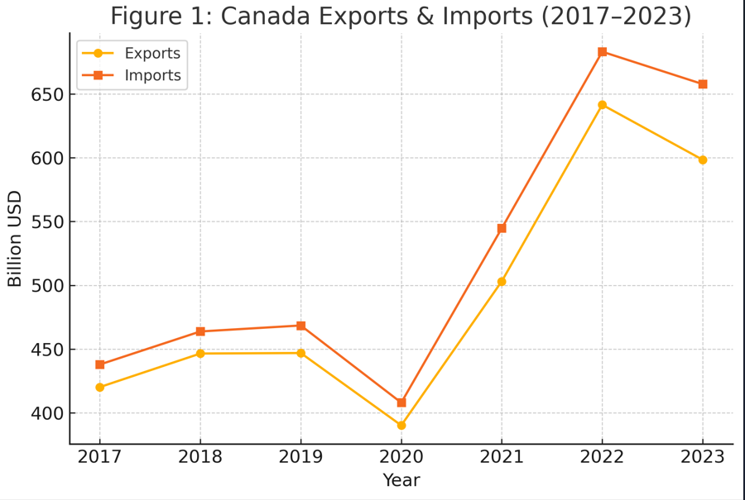
Figure 2: Average Exchange Rate (CAD per USD)
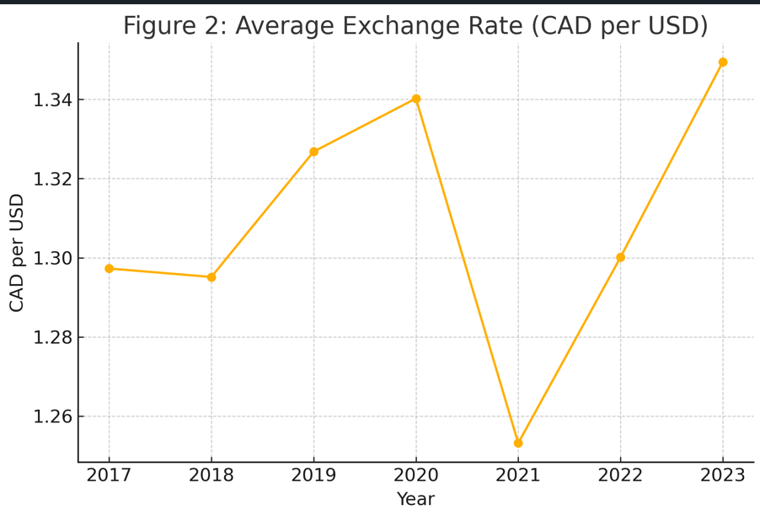
Figure 3: ln(Exports) vs ln(Exchange Rate)
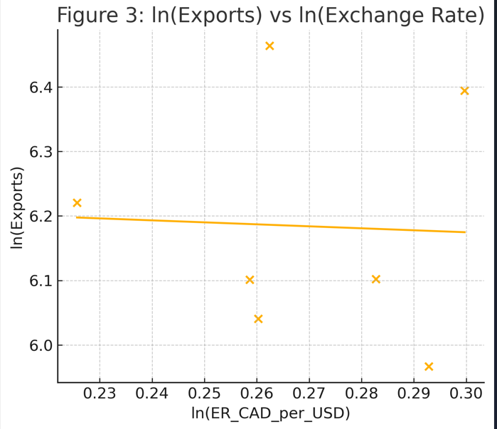
Figure 4: ln(Imports) vs ln(Exchange Rate)
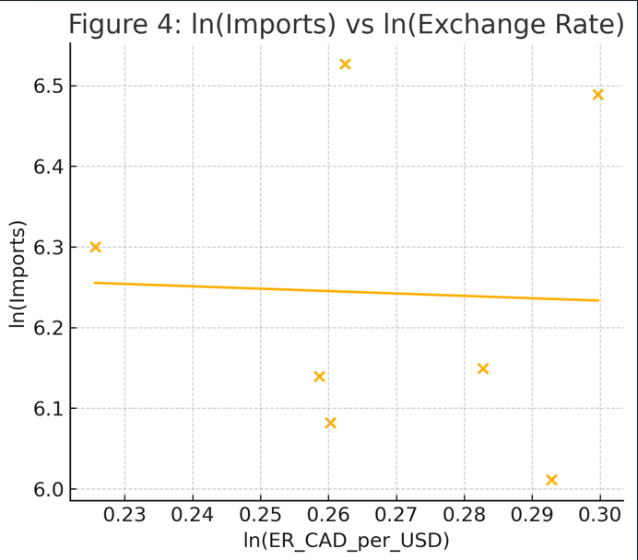

5. Results
5.1 Export Elasticity
$${\hat{α}}_{1}=-0.3075$$
- Sign: negative (opposite of theory)
- p-value: 0.929 (not significant)
- Interpretation: Depreciation does not increase exports.
5.2 Import Elasticity
$${\hat{β}}_{1}=-0.2956$$
- Sign: negative (consistent with theory)
- p-value: 0.937 (not significant)
- Interpretation: Depreciation does not significantly reduce imports.
5.3 Marshall–Lerner Condition
$$∣{\hat{α}}_{1}∣+∣{\hat{β}}_{1}∣=0.6031<1$$
Conclusion:
Marshall–Lerner condition does NOT hold for Canada (2017–2023).
Depreciation of the CAD does not improve the trade balance.

6. Policy Research: Why the Marshall–Lerner Condition Does NOT Hold for Canada
This is the most important analytical section of your project.
6.1 Commodity-Dominated Export Structure
Canada’s exports are heavily concentrated in:
- Crude oil
- Natural gas
- Lumber
- Metals
These goods have low price elasticity because:
- Buyers purchase fixed quantities
- Prices are globally set in USD
- Exchange rate has limited influence on demand volumes
Thus, depreciation does not boost export volume significantly.

6.2 Deep Canada–US Supply Chain Integration
Over 75% of Canada’s trade is with the US. This trade involves:
- Automotive supply chains
- Machinery/tech components
- Energy flows
- Contract-based long-term shipments
Integrated cross-border supply chains reduce responsiveness to currency movements. Firms do not change trade patterns based on small exchange rate changes.

6.3 Limited Exchange Rate Variation (2017–2023)
CAD/USD fluctuated within a tight band (1.25–1.35).
Small variations → low measurable elasticity.
Unlike emerging markets, Canada did not experience major depreciation episodes.

6.4 Pandemic Disruptions Overpowered Exchange Rate Effects
Years 2020–2022 included:
- Global lockdowns
- Oil price crash (2020)
- Supply chain bottlenecks
- Commodity price shock (2021–22)
These shocks dominated trade patterns, making the exchange rate effect statistically irrelevant.

6.5 High Import Dependence and Low Elasticity
Canada relies on imports for:
- Machinery
- Electronics
- Pharmaceuticals
- Industrial inputs
These goods have inelastic import demand because they are essential and have no domestic substitutes.
Depreciation does not reduce import volumes meaningfully.

6.6 Hedging and Long-Term Contracts
Canadian exporters and importers use:
- Forward contracts
- Hedging
- Long-term pricing agreements
These reduce exchange-rate pass-through.

7. Policy Implications
7.1 Exchange Rate Policy Alone Cannot Improve Trade Balance
Canada cannot rely on CAD depreciation as a tool to boost exports.
Structural competitiveness matters more.
7.2 Need for Export Diversification
To increase elasticity, Canada must expand:
- High-tech manufacturing
- Value-added energy products
- Services exports
- Clean tech and digital industries
These sectors respond more to price changes.
7.3 Strengthen Domestic Supply Chains
High import dependence reduces elasticity.
Policies encouraging domestic production of key components can increase sensitivity.
7.4 Reduce Over-Dependence on the US
Diversification toward Europe and Asia would increase exchange-rate-driven competitiveness.

8. Final Conclusion
This study finds that the Marshall–Lerner condition does not hold for Canada during 2017–2023. Both export and import elasticities with respect to the exchange rate are small and statistically insignificant. As a result, depreciation of the Canadian dollar does not improve the trade balance in this short sample.
Trade flows in this period are driven primarily by:
- Commodity price cycles
- Canada–US supply chain integration
- Pandemic shocks
- Structural import dependence
For Canada, exchange rate movements play a secondary role in determining trade performance. Policymakers should focus on export diversification, supply chain resilience, and long-term competitiveness rather than relying on currency depreciation to improve the trade balance.

