Outliers and Boxplots

OUTLIERS
Outliers are data points that significantly differ from other observations in a dataset. They can skew statistical analyses and distort interpretations of the data. Outliers can also arise due to various reasons such as measurement error, natural variability, or rare events.
Example:
- In a dataset of household incomes, a billionaire's income would be considered an outlier if most other incomes are in the middle or lower range.
- If most students score between 80% and 90% on an exam, a score of 99% would be considered an outlier.
- In a dataset of daily temperatures, an unusually high or low temperature that deviates significantly from the typical range for that location and time of year could be an outlier.

BOXPLOTS
Outliers can be detected using boxplots, which is a visual representation of the distribution of data. The points that fall beyond the whiskers of the boxplot are termed to be outliers.
A boxplot displays the median, quartiles, and potential outliers in the data.
- The box in the boxplot represents the interquartile range (IQR), which is the range between the first quartile (Q1 = 25th percentile) and the third quartile (Q3 = 75th percentile). The line inside the box represents the median (Q2 = 50th percentile).
- Q1 = (n + 1) × 1/4th value,
- Q2 = (n + 1) × 1/2 th value,
- Q3 = (n + 1) × 3/4 th value, where 'n' is the number of values in the dataset.
- Calculate the interquartile range (IQR) as follows: IQR = Q3 − Q1
- Points that fall below Q1 − 1.5×IQR or above Q3 + 1.5×IQR are considered outliers and are represented as individual points beyond the whiskers of the boxplot.
Boxplot Structure (labelled parts):
- Lower Whisker = Q1 − 1.5 × IQR
- Q1 (25th Percentile) — left edge of the box
- Median (Q2, 50th Percentile) — line inside the box
- Q3 (75th Percentile) — right edge of the box
- Upper Whisker = Q3 + 1.5 × IQR
- Points beyond either whisker are plotted individually and labelled as Outliers.
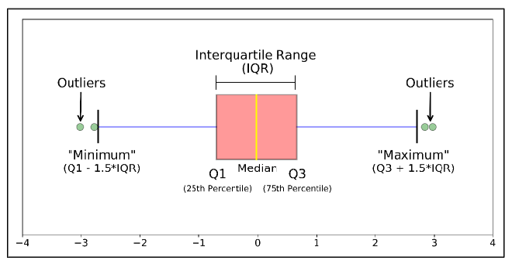

Worked Example
Let's consider the dataset:
30, 15, 29, 19, 150, 12, 20, 55, 22, 25, 26, 27, 17, 28, 35
To calculate the interquartile range (IQR), first find the quartiles Q1 and Q3, which represent the 25th and 75th percentiles, respectively.
- Arrange the dataset in ascending order:
12, 15, 17, 19, 20, 22, 25, 26, 27, 28, 29, 30, 33, 35, 150
- Calculate the median (Q2), which is the middle value of the dataset. Since the dataset contains an odd number of values, the median is the value at position (n + 1)/2 th, where 'n' is the number of values in the dataset.
- Find the median of the lower half of the dataset, which includes all values up to and including the median. This is the first quartile (Q1):
Q1 = Median of (12, 15, 17, 19, 20, 22, 25) = 19
- Find the median of the upper half of the dataset, which includes all values above the median. This is the third quartile (Q3):
Q3 = Median of (27, 28, 29, 30, 33, 35, 150) = 30
- Calculate the interquartile range (IQR) by subtracting Q1 from Q3.
IQR = Q3 − Q1 = 30 − 19 = 11
Now that we have the IQR, we can identify outliers using the 1.5×IQR rule. Any value below Q1 − 1.5×IQR or above Q3 + 1.5×IQR is considered an outlier.
Lower bound = Q1 − 1.5×IQR = 19 − 1.5×11 = 19 − 16.5 = 2.5
Upper bound = Q3 + 1.5×IQR = 30 + 1.5×11 = 30 + 16.5 = 46.5
Thus, in this dataset, the value 150 is above the upper bound of 46.5, so it is considered an outlier.

