Statistics for AI & Machine Learning

1. Introduction to Statistics
Statistics is the science of collecting, organizing, summarizing, analyzing, interpreting and presenting data. It converts raw data into meaningful information that helps in decision making.

Student Feedback Example
Student | Rating
S1 | 5
S2 | 4
S3 | 5
S4 | 4
S5 | 5
S6 | 3
S7 | 5
S8 | 4
S9 | 4
S10 | 5
Instead of looking at every student's rating separately, statistics summarizes the overall feedback using Mean, Median and Mode.

Why Statistics in AI & ML?
AI/ML Stage | Role of Statistics
Data Collection | Understand data
EDA | Summarize data
Data Cleaning | Handle missing values & outliers
Feature Engineering | Identify useful features
Model Evaluation | Measure performance

2. Types of Statistics

Descriptive Statistics
Descriptive Statistics summarizes and describes the existing dataset. Examples include Mean, Median, Mode, Variance and Standard Deviation.

Inferential Statistics
Inferential Statistics uses a sample to make conclusions or predictions about a larger population.
Descriptive | Inferential
Summarizes data | Predicts/Estimates
Uses available data | Uses sample
No prediction | Prediction
Used in EDA | Used in hypothesis testing

3. Measures of Central Tendency
Central Tendency identifies the centre of a dataset. The three measures are Mean, Median and Mode.

Mean
Mean is the average of all observations.
Formula: Mean = Sum of Values / Number of Values
Example Ratings: 5,4,5,3,4,5,4,5,2,4

Sum = 41, Number of Values = 10, Mean = 41/10 = 4.1

Median
Median is the middle value after arranging the data.

Sorted Ratings: 2,3,4,4,4,4,5,5,5,5
Median = (5th value + 6th value)/2 = (4+4)/2 = 4

Mode
Mode is the value occurring most frequently.
Rating | Frequency
2 | 1
3 | 1
4 | 4
5 | 4
The dataset is bimodal because both 4 and 5 occur most frequently.

Comparison
Measure | Purpose | Affected by Outliers
Mean | Average | Yes
Median | Middle | No
Mode | Most Frequent | No

Key Takeaways
- Statistics converts raw data into meaningful information.
- Descriptive Statistics summarizes existing data.
- Inferential Statistics uses samples to estimate populations.
- Mean, Median and Mode are measures of central tendency.

1. Measures of Dispersion
Measures of Dispersion describe how far the data values are spread from the centre. Two datasets may have the same mean but different spreads.
Dataset A | Dataset B
48,49,50,51,52 | 20,35,50,65,80
Both datasets have Mean = 50, but Dataset B has much greater variation.

Range
Range is the difference between the maximum and minimum values.
Formula:
Range = Maximum Value − Minimum Value
Example: Marks = 45, 55, 60, 72, 90
Range = 90 − 45 = 45

Standard Deviation
How far data points are away from mean
Standard Deviation is the square root of the variance. It is expressed in the same unit as the original data.
Interpretation:
• Small Standard Deviation → Data is consistent.
• Large Standard Deviation → Data varies greatly.
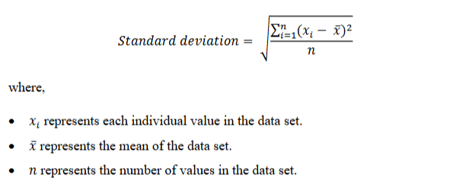
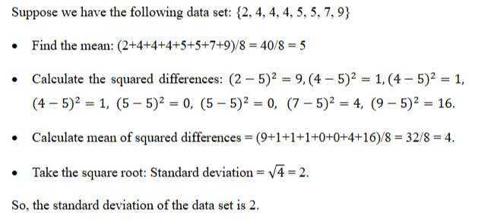

Variance
Variance measures how much the observations differ from the mean. A small variance indicates that values are close to the mean, while a large variance indicates that values are widely spread.
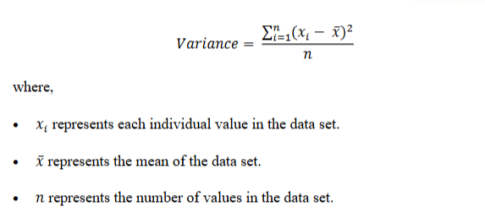
Steps:
1. Find the mean.
2. Subtract the mean from each value.
3. Square the differences.
4. Find the average of squared differences.

2. Measures of Shape
Measures of Shape describe the distribution pattern of the data.

Skewness
Skewness indicates whether the data is symmetric or tilted to one side.
Type | Shape | Example
Symmetric | Mean = Median = Mode | Exam marks follow a balanced pattern
Positive (Right) Skew | Tail extends to the right | Most salaries are low, few are very high
Negative (Left) Skew | Tail extends to the left | Most students score high, few score very low
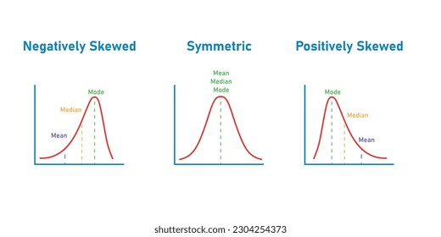

Kurtosis
Kurtosis measures the peakedness of a distribution.
Type | Description
Mesokurtic | Normal peak
Leptokurtic | Tall peak with heavy tails
Platykurtic | Flat peak with light tails

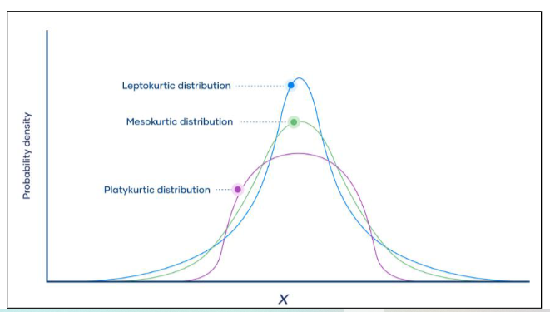

3. Outliers
An outlier is a value that is unusually different from the rest of the observations.
Example Data:
45, 48, 49, 50, 51, 52, 53, 300
Here, 300 is an outlier.
- Effects of Outliers:
- Increase or decrease the mean.
- Increase variance and standard deviation.
- Reduce model performance.
- May indicate data entry errors or rare events.

Detecting Outliers using IQR
Lower Limit = Q1 − 1.5 × IQR
Upper Limit = Q3 + 1.5 × IQR
Values outside these limits are considered outliers.

4. Box Plot
A Box Plot is a graphical representation used to identify the spread of data and detect outliers.
Components of a Box Plot:
Component | Meaning
Minimum | Smallest non-outlier value
Q1 | 25th Percentile
Median | 50th Percentile
Q3 | 75th Percentile
Maximum | Largest non-outlier value
Whiskers | Show data spread
Outliers | Displayed as individual points

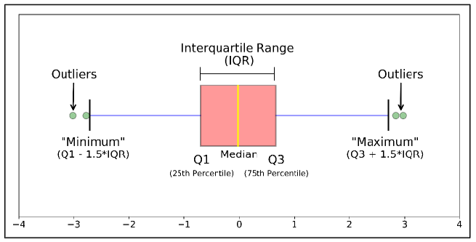

Step 1: Arrange the Data
12, 15, 17, 19, 20, 22, 25, 26, 27, 28, 29, 30, 33, 35, 150
Step 2: Find Q1
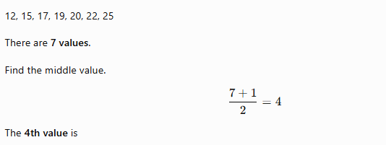
Q1 = 19

Step 3: Find Q3
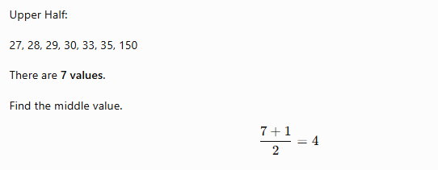
Q3 = 30
Step 4: Calculate IQR
IQR = Q3 − Q1
IQR = 30 − 19
IQR = 11
Step 5: Calculate Lower Limit
Lower Limit = Q1 − (1.5 × IQR)
Lower Limit = 19 − (1.5 × 11)
Lower Limit = 2.5
Step 6: Calculate Upper Limit
Upper Limit = Q3 + (1.5 × IQR)
Upper Limit = 30 + (1.5 × 11)
Upper Limit = 46.5
Step 7: Identify the Outlier
Any value less than 2.5 or greater than 46.5 is an outlier.
Therefore,
Outlier = 150

AI & ML Applications of Statistical Concepts
1. Variance → Measure Feature Variability
What is Variance?
Variance measures how much the values vary from one another.
If all values are nearly the same, the variance is low.
If values differ greatly, the variance is high.

Real-Life Example
Imagine a classroom where every student is 20 years old.
Can Age help predict student performance?
No.
Since everyone's age is almost identical, it provides very little information.
Now consider another classroom where students range from 18 to 35 years old.
Age now varies significantly and may become a useful feature for prediction.

AI & ML Application
During Feature Selection, Machine Learning algorithms look for features that contain useful information.
If a feature has very low variance, it often contributes very little to prediction.
Examples:
- Every employee has the same department.
- Every customer belongs to the same city.
- Every student has the same attendance.
Such features are usually removed before training.

Practical Examples
- Employee Age Prediction
- Student Placement Prediction
- Customer Churn Prediction
- Loan Approval System

2. Standard Deviation → Measure Data Consistency
What is Standard Deviation?
Standard Deviation measures how consistently the values are distributed around the average.
Small Standard Deviation
↓
Values are close together.
Large Standard Deviation
↓
Values are spread out.

Real-Life Example
Suppose two teachers conduct the same examination.
Teacher A
Almost every student scores around the same mark.
Students performed consistently.

Teacher B
Some students score extremely high while others score extremely low.
Student performance is highly inconsistent.

AI & ML Application
Many Machine Learning algorithms perform better when features are on a similar scale.
Standard Deviation helps identify features with very large spreads.
Such features are often standardized before training.

Practical Examples
- Exam Marks
- Product Ratings
- House Sizes
- Monthly Sales
- Medical Measurements

3. Skewness → Identify Data Distribution
What is Skewness?
Skewness measures whether data is balanced (symmetric) or tilted toward one side.

Positive (Right) Skew
Most observations are small.
A few observations are extremely large.
Example
Most employees earn regular salaries.
One CEO earns several crores.
The salary distribution becomes positively skewed.

Negative (Left) Skew
Most observations are high.
Only a few are very low.
Example
An easy examination where almost everyone scores above 90, but a few students score much lower.

AI & ML Application
Many Machine Learning algorithms assume data is approximately symmetric.
Highly skewed features may reduce model performance.
Data Scientists often apply transformations to reduce skewness.
Examples:
- Log Transformation
- Square Root Transformation
- Box-Cox Transformation

Practical Examples
- House Prices
- Customer Income
- Medical Expenses
- Stock Prices

4. Kurtosis → Understand Rare or Extreme Events
What is Kurtosis?
Kurtosis measures how peaked or flat a distribution is and indicates the presence of extreme values.

Real-Life Example
Imagine daily electricity consumption.
Most days show similar usage.
Suddenly one day, electricity usage becomes extremely high due to a large event.
This unusual observation creates a distribution with heavier tails.

AI & ML Application
Kurtosis helps identify rare but important events.
These events are valuable in many AI applications.
Examples include:
- Credit Card Fraud Detection
- Insurance Claim Analysis
- Cybersecurity Attack Detection
- Network Intrusion Detection

Practical Examples
- Fraud Transactions
- Insurance Claims
- Machine Failures
- Medical Emergencies

5. Outliers → Data Cleaning Before Model Training
What is an Outlier?
An outlier is an observation that is very different from the remaining data.
It may represent:
- Data entry error
- Measurement error
- Genuine rare event

Real-Life Example
Imagine entering a student's age.
Instead of typing 21, someone accidentally types 210.
This unusual value is an outlier.

Another example:
A hospital records a patient's body temperature as 150°C.
This is clearly an incorrect value.

AI & ML Application
Outliers can significantly affect Machine Learning models.
Therefore, Data Scientists first:
- Detect outliers
- Investigate the cause
- Remove or treat them if necessary

Practical Examples
- House Price Prediction
- Medical Diagnosis
- Sales Forecasting
- Loan Approval
- Manufacturing Quality Inspection

6. Box Plot → Exploratory Data Analysis (EDA)
What is a Box Plot?
A Box Plot is a visualization that helps us understand:
- Data spread
- Median
- Quartiles
- Outliers
It provides a quick summary of the distribution.

Real-Life Example
Suppose a teacher wants to understand students' exam performance.
Instead of reading hundreds of marks individually, the teacher uses a Box Plot.
Within seconds, the teacher can identify:
- Average performance
- Spread of marks
- Students with exceptionally high or low marks

Another example:
A hospital monitors patient waiting times.
One patient waits much longer than everyone else.
A Box Plot immediately highlights this unusual observation.

AI & ML Application
Box Plots are widely used during Exploratory Data Analysis (EDA).
Before training a Machine Learning model, Data Scientists use Box Plots to:
- Detect outliers
- Understand feature distributions
- Compare multiple features
- Decide whether data cleaning is required

Summary Table
Concept | AI & ML Application | Real-Life Example
Variance | Identify features with useful variability | Age of employees, attendance, customer income
Standard Deviation | Measure consistency and decide whether scaling is needed | Student marks, product ratings, monthly sales
Skewness | Detect asymmetric features and apply transformations | Salaries, house prices, medical expenses
Kurtosis | Identify rare or extreme events | Fraud transactions, insurance claims, cybersecurity alerts
Outliers | Detect abnormal values before model training | Incorrect age, impossible temperature, unusual house price
Box Plot | Visualize spread and detect outliers during EDA | Exam marks, hospital waiting times, manufacturing quality
Final Classroom Message
Statistics doesn't build the AI model directly. It helps us understand the data first. Good data understanding leads to better preprocessing, better feature engineering, and ultimately better Machine Learning models.

