SESSION 2: MACHINE LEARNING WORKFLOW
Data Collection, Preprocessing, Training, Testing and Prediction

1. Machine Learning Is a Complete Process
Machine Learning does not begin with selecting an algorithm. A successful project begins by understanding a real-world problem. Relevant data is then collected and studied. Raw data is cleaned and prepared. A portion of the data is used to train a model, while separate data is used to test the learned model. Only after suitable evaluation is the model used to make predictions on new data.
Consider this problem: Predict whether a student is placement-ready. A computer cannot answer this question without previous examples. We may collect aptitude score, coding score, attendance, communication score, project count, mock interview score, and the known placement-readiness result of previous students.
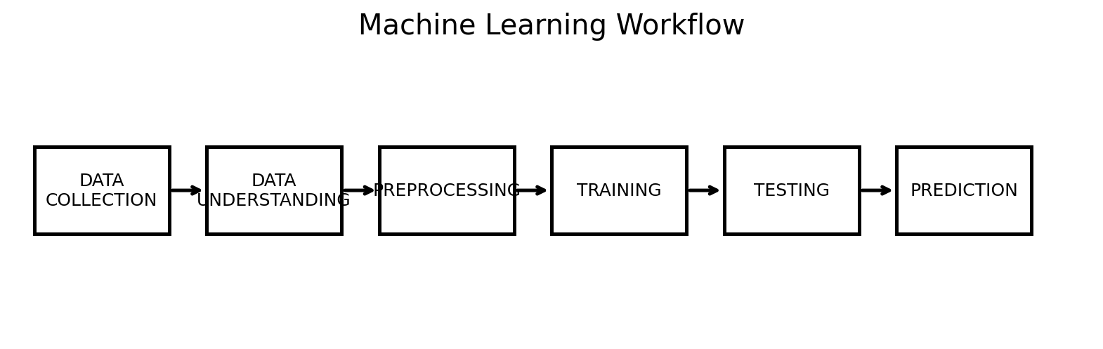
Data Collection → Data Understanding → Preprocessing → Training → Testing → Prediction

2. Running Example: Student Placement Readiness
Problem Statement: Build a Machine Learning system that predicts whether a student is placement-ready.
Aptitude | Coding | Attendance | Communication | Projects | Mock Interview | Placement Ready
82 | 90 | 92 | 80 | 3 | 85 | Yes
45 | 40 | 65 | 55 | 1 | 48 | No
76 | 80 | 88 | 78 | 2 | 81 | Yes
55 | 52 | 70 | 62 | 1 | 58 | No
88 | 92 | 95 | 86 | 4 | 90 | Yes

Aptitude, Coding, Attendance, Communication, Projects, and Mock Interview are input features. Placement Ready is the target or label. Because the target is a category, Yes or No, the task is classification. Because previous records contain known answers, the project uses supervised learning.

3. Problem Definition Before Data Collection
Data should be collected for a clear purpose. If the objective is vague, the team may collect irrelevant information or build a model whose result is not useful. Problem definition describes what must be predicted, what information may be available, who may use the result, and how success will be evaluated.

Placement Example
Objective: Predict student placement readiness.
Inputs: Aptitude, coding, attendance, communication, projects, and mock interview score.
Output: Placement Ready: Yes or No.
Learning Type: Supervised Learning.
Task Type: Classification.
Limitation: The prediction is an analytical support output and should not be treated as a final judgment about a student's future.

4. Data Collection

4.1 Meaning
Data collection is the process of gathering information required to solve a problem. Machine Learning algorithms learn from examples. Therefore, the quality, relevance, and coverage of collected data strongly influence the model.
If important information is absent, the model cannot automatically know it. If incorrect information repeatedly appears in the dataset, the model may learn misleading relationships. More data is not automatically better; useful data must be relevant and sufficiently representative.

4.2 Common Data Sources
CSV or Excel files: Student marks, attendance, surveys, sales, and reports.
Databases: Transactions, customers, application records, and operational information.
APIs: Information received from another software service.
Sensors and devices: Temperature, pressure, machine, movement, or IoT readings.
Application logs: User interactions and system events.
Forms and surveys: Feedback, ratings, and assessment responses.
Images, audio, and text: Photographs, documents, speech, emails, and reviews.

4.3 Structured and Unstructured Data
Type | Meaning | Examples
Structured | Organized with defined rows and columns. | CSV, Excel, database table
Unstructured | Does not naturally follow a simple table structure. | Text, images, audio, video
The placement dataset is structured. Each row represents one student and each column represents a defined student attribute.

5. Data Understanding
Before changing data, we must understand it. Data understanding means studying the structure, meaning, data type, and basic behaviour of every important variable.

Rows and Columns
A row normally represents one observation or record. In the placement dataset, one row represents one student. A column represents one variable, such as Coding Score or Attendance.

Features and Target
Features are input variables used by the model. The target or label is the output the supervised model must learn to predict.
FEATURES (X) → MACHINE LEARNING MODEL → TARGET PREDICTION (y)

Common Data Types
Numerical: Numbers such as score, salary, age, or attendance.
Categorical: Groups such as department, city, Yes, or No.
Text: Reviews, emails, sentences, or documents.
Date and Time: Joining date, transaction time, or timestamp.

6. Data Preprocessing
Data preprocessing converts raw data into a cleaner and more suitable form for analysis and model training. Real-world data may contain missing values, duplicates, inconsistent text, incorrect data types, invalid values, outliers, or categories that cannot directly be processed by some algorithms.

6.1 Missing Values
A missing value means information is unavailable for a particular record. For example, one student's coding score may be empty. Possible treatments include removing a record, filling a value using a suitable statistic, using domain knowledge, or applying an imputation method. The correct choice depends on why data is missing and how much is missing.

6.2 Duplicate Records
A duplicate occurs when the same record appears more than once. Duplicate observations can distort counts, averages, and learning patterns. However, a repeated-looking record may sometimes represent a valid separate event, so records should be investigated before deletion.

6.3 Inconsistent Categories
Values such as 'Yes', 'YES', and 'yes' may represent the same category. If left unchanged, software may treat them as different categories. Standardization makes the representation consistent.

6.4 Incorrect Data Types
A numerical score may be stored as text. A date may be stored as an ordinary string. Data types must be checked because mathematical operations and Machine Learning algorithms require suitable representations.

6.5 Invalid Values and Outliers
Attendance of 850% is probably an invalid value. An extremely high salary may be unusual but valid. An outlier is a value unusually far from other observations. Unusual values should be investigated rather than automatically deleted.

6.6 Encoding
Many algorithms require numerical input. Categories such as Yes/No or department names may need to be converted into numerical representations. This process is called encoding.

6.7 Feature Scaling
Features can have very different ranges. Attendance may range from 0 to 100 while salary may contain values in lakhs. Some algorithms are sensitive to differences in numerical scale. Scaling transforms values into a more comparable range.
Important: Preprocessing is not a fixed list of steps that must be applied blindly. The required steps depend on the dataset, problem, and selected algorithm.

7. Train-Test Split
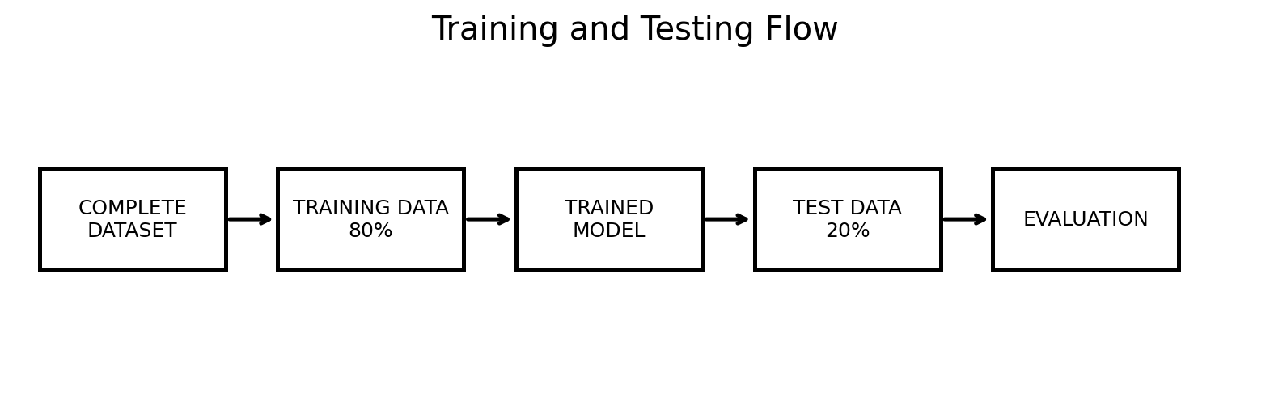

7.1 Training Data
Training data is used by the learning algorithm to identify patterns and adjust model parameters. The model sees these examples during learning.

7.2 Testing Data
Testing data is kept separate from training. After learning is complete, the trained model receives test features and produces predictions. These predictions are compared with the actual known test labels.

7.3 Why Split the Dataset?
Imagine a student receives the exact examination questions and answers before an exam. The student may memorize them. If the same questions are used for evaluation, the score may be excellent, but we do not know whether the student can answer new questions.
A model can similarly perform well on examples it has already seen. The purpose of testing is to examine whether learned patterns work on unseen examples. This ability is called generalization.

7.4 80-20 Example
A common introductory split is 80% training and 20% testing. If a dataset contains 1,000 records, approximately 800 may be used for training and 200 for testing. The exact ratio depends on the project and is not a universal rule.

8. Model Training
Training is the learning stage. The algorithm receives training features and known training labels. It uses a mathematical learning procedure to identify relationships and adjust internal parameters.
In the placement example, the algorithm studies previous students. It may learn relationships involving coding, aptitude, attendance, communication, project experience, and interview performance. The exact type of relationship learned depends on the selected algorithm.

Algorithm vs Model
Term | Meaning | Example
Algorithm | The learning method or procedure. | Decision Tree algorithm
Model | The learned result after an algorithm is trained on a particular dataset. | Trained placement decision tree
x_train + y_train → LEARNING ALGORITHM → TRAINED MODEL
The algorithm is the method. The model is the learned result. Calling model.fit() in many Machine Learning libraries starts the training process.

9. Testing and Evaluation
After training, the model receives test features. It predicts an output for each test observation. The predicted values are compared with the actual test labels.
x_test → TRAINED MODEL → PREDICTIONS → COMPARE WITH y_test
Student | Actual | Predicted
A | Yes | Yes
B | No | No
C | Yes | No
D | No | No
E | Yes | Yes
The model correctly predicts A, B, D, and E, but incorrectly predicts C. Evaluation metrics summarize this performance. Accuracy, precision, recall, F1-score, confusion matrix, and classification report will be studied in detail in later sessions.

Testing Is Not Training Again
The purpose of test data is independent evaluation. If we repeatedly change a model specifically until it performs perfectly on the final test set, the test set stops being a clean independent check.

10. Prediction or Inference
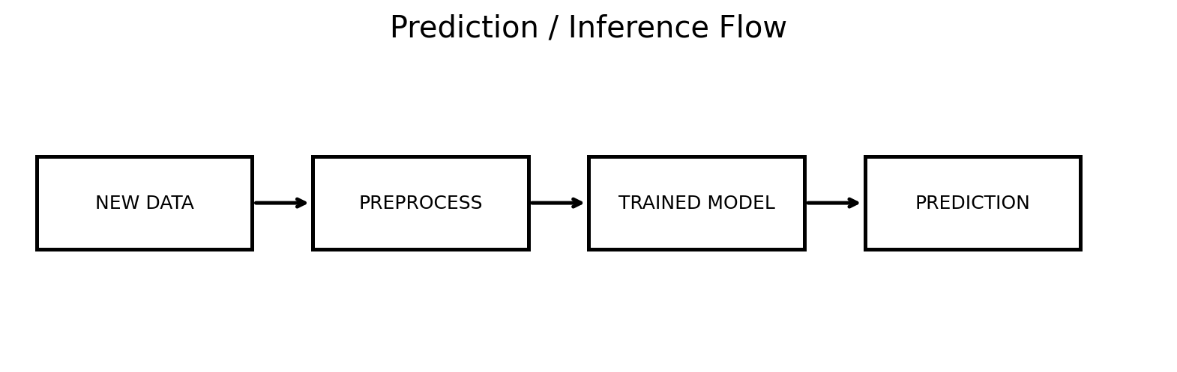
Prediction, also called inference in many AI systems, means using a trained model to produce an output for new input data.

New Student Example
Suppose a new student has Aptitude = 80, Coding = 84, Attendance = 91, Communication = 79, Projects = 3, and Mock Interview = 83. These values are prepared in the same required format and provided to the trained classification model. The model may predict Placement Ready = Yes.
A prediction is the model's estimated output. It is not automatically the actual future result. A Machine Learning model can make mistakes.

11. Complete Placement Workflow
1. Define Problem: Predict placement readiness.
2. Collect Data: Gather previous student features and known readiness labels.
3. Understand Data: Study rows, columns, types, features, target, and suspicious values.
4. Preprocess: Handle missing values, duplicates, inconsistent values, types, and required transformations.
5. Split Data: Create training and testing sets.
6. Train: Use training features and labels with a classification algorithm.
7. Test: Generate predictions for test examples.
8. Evaluate: Compare predictions with actual labels using suitable metrics.
9. Improve: Review data, features, model choice, and settings.
10. Predict: Give a new student's features to the trained model.
11. Monitor: Observe model performance if the model is used in a real system.

13. Common Misunderstandings
Collect any data and start training. Data must be relevant to a defined problem.
Replace every missing value with zero. Zero may have a real meaning. Treatment depends on the data.
Delete every outlier. Some unusual values are valid and important.
Use all data for training. Separate test data is needed for evaluation.
Training accuracy is enough. Performance on unseen data matters.
Algorithm and model mean the same thing. The algorithm is the method; the model is the learned result.
A prediction is always correct. A prediction is an estimate.
More features always improve a model. Irrelevant features may reduce model quality.
Every dataset needs identical preprocessing. Preprocessing depends on the problem and data.

17. Final Summary
- Machine Learning is an end-to-end process, not only model training.
- Problem definition guides the entire project.
- Data collection gathers relevant examples from suitable sources.
- Features are model inputs; the target is the output to predict.
- Data understanding examines structure, meaning, types, and quality.
- Preprocessing prepares raw data for analysis and learning.
- Training data is used to learn patterns; test data is used for evaluation.
- An algorithm is a learning method; a model is the learned result.
- Testing compares predictions with actual known test outputs.
- Prediction uses a trained model with new data.
- A prediction is an estimate and can be incorrect.
- The complete workflow connects problem definition, data, preprocessing, training, testing, evaluation, and prediction.

