TOPIC: COVARIANCE, CORRELATION AND CAUSATION
SECTION 1: INTRODUCTION
Statistics often deals with understanding how two variables relate to each other. For example, how does height relate to weight, or how does study time relate to exam marks. To understand these relationships, three important concepts are used: Covariance, Correlation, and Causation. These concepts help in understanding the direction, strength, and nature of relationships between variables.

SECTION 2: COVARIANCE
- Meaning of Covariance
Covariance measures how two numerical variables change together.
If one variable increase and the other also tends to increase, the covariance is positive.
If one variable increase while the other tends to decrease, the covariance is negative.
If the movement of the variables is unrelated, the covariance is close to zero.
Covariance only shows the direction of the relationship, not the strength.
- Interpretation of Covariance
Positive covariance: Both variables move in the same direction.
Negative covariance: Variables move in opposite directions.
Zero covariance: No meaningful linear relationship.
- Formula for Covariance
Covariance is calculated by finding how far values are from their mean and multiplying those deviations across variables, then taking the average of those products.
- Example Explanation
If students who study more hours generally get higher marks, the deviations of study hours and marks from their averages will often have the same sign. Their product will be positive, leading to a positive covariance.
If more social media usage results in less study time, the deviations have opposite signs and the covariance becomes negative.
- Limitations of Covariance
Covariance is not standardized.
It depends on the scale of measurement.
A high covariance value does not automatically mean a strong relationship.

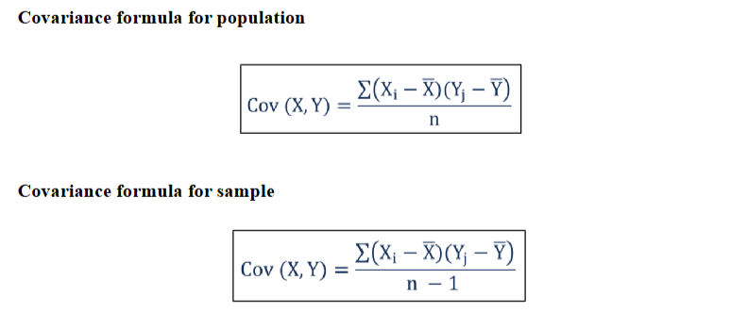

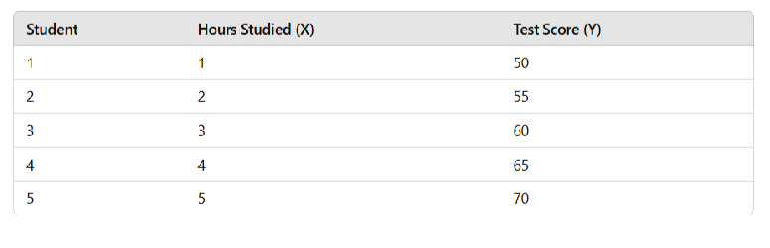

SECTION 3: CORRELATION
- Meaning of Correlation
Correlation is a standardized form of covariance.
It measures both the direction and the strength of a linear relationship between two variables.
Correlation value always lies between minus one and plus one.
- Why Correlation Is Used
Unlike covariance, correlation is scale-free.
It is easy to interpret.
A correlation of plus one means perfect positive relationship.
A correlation of minus one means perfect negative relationship.
A correlation of zero means no linear relationship.
- Formula for Correlation
Correlation is calculated by dividing the covariance by the product of the standard deviations of both variables.
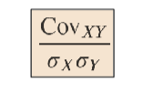
- Interpretation
Strong positive correlation: Values close to plus one.
Strong negative correlation: Values close to minus one.
Weak or no correlation: Values near zero.
- Example Explanation
If height and weight have correlation of 0.85, it shows a strong positive relationship.
If hours of gaming and study performance have correlation of minus 0.70, it shows a strong negative relationship.
If shoe size and intelligence have correlation near zero, it shows no meaningful relationship.
- Difference Between Covariance and Correlation
Covariance shows direction only, correlation shows both direction and strength.
Covariance has no fixed range, correlation is always between minus one and plus one.
Correlation is easier to interpret in practical scenarios.
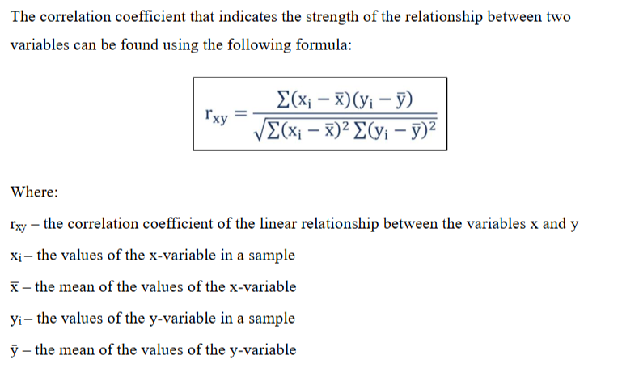

Aspect | Covariance | Correlation
Definition | Measures the direction of the relationship between two variables. | Measures both the strength and direction of the relationship between two variables.
Range | Can take any value from −∞ to +∞. | Always ranges between −1 and +1.
Scale | Depends on the units and scale of the variables, making comparisons difficult. | Standardized (unitless), making it easy to compare relationships across different datasets.
Units | Has units equal to the product of the units of (X) and (Y) (e.g., cm × kg). | Unitless (dimensionless) because it is standardized.
Usage | Used to determine whether two variables move in the same or opposite direction. | Used to measure both the direction and the strength of the relationship between two variables.

Aspect | Correlation | Correlation Coefficient
Definition | Correlation is a statistical concept that describes the relationship between two variables. It indicates whether the variables move together or in opposite directions. | A numerical measure that quantifies the strength and direction of the relationship between two variables.
Range | Correlation is a concept and does not have a numerical range. | The correlation coefficient always lies between −1 and +1.
Purpose | Used to describe whether two variables are related and the nature of their relationship (positive, negative, or no correlation). | Used to measure how strong the relationship is and whether it is positive or negative.
Value | Does not have a specific numerical value. It is a qualitative description of the relationship. | Has a specific numerical value, such as 0.85, −0.62, or 0.00.
Interpretation | Indicates only the type of relationship (positive, negative, or no relationship). | Indicates both the direction and the strength of the relationship.
Representation | Expressed as a general concept, e.g., positive correlation or negative correlation. | Represented by r (Pearson's correlation coefficient), where −1 ≤ r ≤ +1.
Example | "As temperature increases, ice cream sales also increase." This indicates a positive correlation. | If r = 0.92, it indicates a strong positive correlation. If r = −0.85, it indicates a strong negative correlation.

SECTION 4: CAUSATION
- Meaning of Causation
Causation means one variable produces an effect on another variable.
If X causes Y, then changing X will change Y.
Causation indicates a cause-effect relationship.
- Important Principle
Correlation does not imply causation.
Even if two variables show strong correlation, it does not mean one causes the other.
- Examples Where Correlation Exists but Causation Does Not
Example 1: Ice cream sales and number of drowning incidents may rise together during summer. They correlate, but one does not cause the other. Heat is a third factor.
Example 2: Number of movies actor acted and swimming pool deaths rise together in some years. Correlation exists but no causation.
Example 3: More phone usage and lower grades. There may be causation, or there may be other factors like lack of sleep, stress, or environment.
- Establishing Causation
To claim causation, additional evidence is required through proper methods:
Controlled experiments
Long-term observational studies
Eliminating confounding variables
Using causal inference models
Checking for logical and scientific explanation
- Key Indicators of Causation
Temporal order: Cause must occur before effect.
Consistency: Evidence must be consistent in repeated studies.
Plausibility: There should be a logical explanation.
Strength of association: Strong correlation helps, but not sufficient alone.

SECTION 5: COMPARISON SUMMARY
- Covariance
Measures direction of movement between variables.
No fixed range.
Difficult to interpret.
- Correlation
Standardized measure of linear relationship.
Range is minus one to plus one.
Shows strength and direction clearly.
- Causation
Indicates cause-effect.
Requires scientific or statistical proof.
Correlation alone is not enough.

SECTION 6: APPLICATIONS IN REAL WORLD
Finance: Understanding stock movements, portfolio diversification.
Economics: Studying relationships between inflation and unemployment.
Business: Relationship between marketing spend and sales.
Health: Relationship between exercise and blood pressure.
Machine Learning: Feature selection using correlation analysis.

Feature Intuition
1. What is Feature Intuition?
Feature Intuition is the process of understanding how each feature (input variable) influences the target variable before building a Machine Learning model.
It combines:
- Domain knowledge
- Business understanding
- Exploratory Data Analysis (EDA)
- Statistical analysis
Instead of blindly feeding all columns into a model, we first ask:
- Which features are important?
- Which features are irrelevant?
- Which features have the strongest impact?
- Which features move together?
- Which features may create duplicate information?

Definition
Feature Intuition is the ability to understand the importance, behavior, and relationship of each feature with the target variable before model training.

Why is Feature Intuition Important?
Suppose we have the following dataset.
Employee ID | Experience | Education | Salary
101 | 2 | B.Tech | 4 LPA
102 | 6 | M.Tech | 8 LPA
103 | 10 | MBA | 14 LPA
Question:
Should we use Employee ID for prediction?
Obviously, No.
Feature intuition helps us identify that Employee ID has no business relationship with Salary.

Benefits of Feature Intuition
Feature intuition helps us
- Select useful features
- Remove irrelevant features
- Improve model accuracy
- Reduce overfitting
- Reduce training time
- Improve model interpretability
- Create better engineered features

Types of Features
1. Important Features
Strongly influence the target variable.
Example
House Price Prediction
Feature | Importance
Area | High
Location | High
Bedrooms | Medium
Parking | Medium

2. Irrelevant Features
Have no meaningful relationship with the target.
Example
Predicting House Price
Feature
- Customer ID
Customer ID has no effect on house price.

3. Redundant Features
Two features contain almost the same information.
Example
Height (cm) | Height (m)
Both represent the same information.
Keeping both may introduce redundancy.

4. Derived Features
Created from existing features.
Example
Birth Year
↓
Age
Age is often more useful than Birth Year.

How to Develop Feature Intuition?
Step 1: Understand the Business Problem
Before looking at data,
understand
- What are we predicting?
- Who uses the prediction?
- Which factors logically affect the target?
Example
Predicting Employee Salary
Possible important features
- Experience
- Education
- Skills
- Company
Not important
- Employee ID

Step 2: Study Each Feature
Look at
- Data Type
- Missing Values
- Unique Values
- Distribution
- Outliers
Example
Age
Minimum = 22
Maximum = 65
Looks reasonable.

Step 3: Relationship with Target
Understand how the feature affects the target.
Example
Experience
↓
Salary
Usually
More Experience
↓
Higher Salary
Positive Relationship

Step 4: Correlation Analysis
For numerical variables
calculate
Correlation Matrix
Example
Feature | Salary Correlation
Experience | 0.91
Age | 0.62
Employee ID | 0.01

Experience has the strongest relationship.

Step 5: Visualization
Visualizations improve feature intuition.
Common plots
- Scatter Plot
- Box Plot
- Histogram
- Heatmap
- Pair Plot
- Count Plot
Example
Area vs House Price
Large Area
↓
Higher Price
Scatter plot clearly shows the trend.

Step 6: Domain Knowledge
Statistics alone is not enough.
Business knowledge is equally important.
Example
Medical Diagnosis
Feature
Blood Sugar
Domain experts know
Higher Blood Sugar
↓
Higher Diabetes Risk
Even before building the model.

Feature Intuition Example 1
House Price Prediction
Target
House Price
Features
Feature | Intuition
Area | Larger houses cost more
Location | Prime locations increase price
Bedrooms | More bedrooms usually increase price
Age of House | Older houses may be cheaper
Parking | Adds value

Feature Intuition Example 2
Employee Salary Prediction
Target
Salary
Feature | Intuition
Experience | Strong Positive
Education | Positive
Age | Moderate
Department | Depends on role
Employee ID | No effect

Feature Intuition Example 3
Customer Churn Prediction
Target
Will Customer Leave?
Feature | Intuition
Tenure | Longer customers less likely to leave
Monthly Charges | Higher charges may increase churn
Customer Support Calls | More complaints may increase churn
Gender | Usually weak predictor
Customer ID | No importance

Feature Intuition vs Correlation
Feature Intuition | Correlation
Based on business understanding | Based on statistics
Can identify important features before modeling | Measures numerical relationship
Can handle categorical and numerical features | Mainly for numerical variables
May identify useful features even with low correlation | Only measures linear relationship

Feature Intuition vs Feature Engineering
Feature Intuition | Feature Engineering
Understands existing features | Creates new features
Business understanding | Data transformation
Decides importance | Improves representation

Example
Feature Intuition
Experience is important.
Feature Engineering
Create
Experience Level
- Beginner
- Intermediate
- Expert

Feature Selection Using Intuition
Suppose we have
Feature | Keep?
Experience | ✅
Education | ✅
Skills | ✅
Employee ID | ❌
Passport Number | ❌
Phone Number | ❌

Real-Life Example
Loan Approval Prediction
Target
Loan Approved
Possible Features
Feature | Importance
Income | High
Credit Score | High
Existing Loan | High
Employment Type | Medium
House Ownership | Medium
Customer ID | No Importance
Without even training the model, we can predict which features are likely to be useful based on domain knowledge.

Common Mistakes
❌ Using every column in the dataset
❌ Keeping ID columns
❌ Ignoring business knowledge
❌ Keeping duplicate features
❌ Ignoring outliers and missing values
❌ Depending only on correlation

Summary
Feature Intuition is the process of understanding the importance, behavior, and relationship of each feature with the target variable before training a machine learning model. It combines business knowledge, domain expertise, exploratory data analysis, and statistical techniques to identify useful features, remove irrelevant ones, and build more accurate and interpretable models. It is one of the most important steps in successful machine learning projects.

