Probability for AI & Machine Learning

Probability
Probability is the chance of an event happening.
Probability tells us how likely something is to occur.
P(A) = Number of Favourable Outcomes / Total Number of Possible Outcomes
- 0 ≤ P(A) ≤ 1
- P(A)=0 → Impossible Event
- P(A)=1 → Certain Event
- P(A)+P(A')=1 → Complement Rule

Important Terminology
Term | Meaning | Example (Rolling a Die)
Experiment | An activity whose outcome is uncertain. | Rolling a six-sided die once.
Outcome | A single possible result of the experiment. | The die shows 4.
Sample Space (S) | The set of all possible outcomes. | S = {1, 2, 3, 4, 5, 6}
Event (E) | One or more outcomes of interest from the sample space. | Getting an even number, E = {2, 4, 6}
Favourable Outcome | Outcomes that satisfy the required event. | If the event is "getting an even number", the favourable outcomes are 2, 4, 6 (3 favourable outcomes).

Types of Events
Type | Description | Example
Impossible | Cannot happen | Rolling 7 on a die
Certain | Always happens | Rolling 1–6 on a die
Simple | Single outcome | Rolling a 4
Compound | Multiple outcomes | Rolling an even number
Independent | One event doesn't affect another | Coin toss & die roll
Dependent | One event affects another | Cards without replacement
Mutually Exclusive | Cannot occur together | Head and Tail in one toss
Exhaustive | All outcomes covered | {1,2,3,4,5,6}
Equally Likely | Same chance | Each face of a fair die

Complement Rule
Complement means 'NOT the event'.
Formula: P(A') = 1 − P(A)
Example: If P(Head)=1/2, then P(Tail)=1−1/2=1/2.

Addition Rule
For mutually exclusive events:
P(A ∪ B)=P(A)+P(B)
For non-mutually exclusive events:
P(A ∪ B)=P(A)+P(B)−P(A∩B)

Multiplication Rule
Independent Events: P(A∩B)=P(A)×P(B)
Dependent Events: P(A∩B)=P(A)×P(B|A)
Example: Head and then a 6 = 1/2 × 1/6 = 1/12

Conditional Probability
Probability of an event given another event has already occurred.
Example: Probability that a drawn card is a King given it is a Face Card.

Probability in AI & ML
Application | Usage
Spam Detection | Probability of spam
Weather | Chance of rain
Medical Diagnosis | Disease probability
Recommendation | Likelihood of liking a movie
Fraud Detection | Probability of fraud
Face Recognition | Identity prediction

Practice Questions
- Find the probability of getting a prime number on a die.

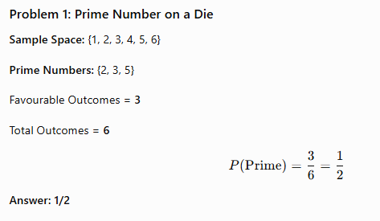
- Find the probability of drawing a black card.
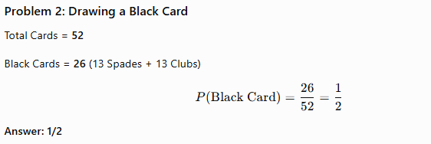

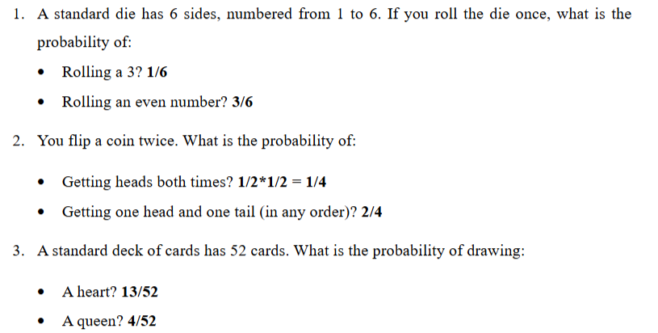

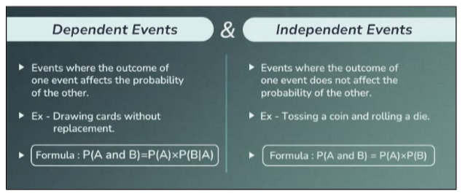

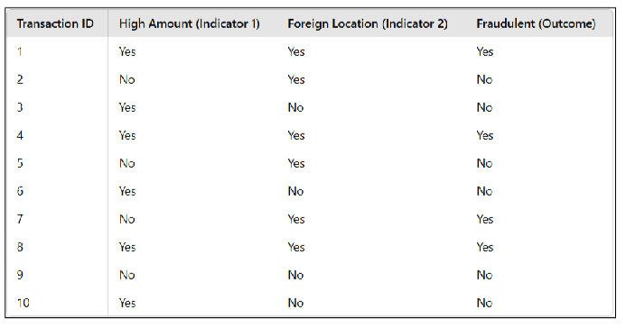

1. Joint Probability
Joint probability means the probability of two events happening together at the same time.
A = High Amount = Yes
B = Foreign Location = Yes

Transaction ID | High Amount | Foreign Location | Both?
1 | Yes | Yes | ✅
2 | No | Yes | ❌
3 | Yes | No | ❌
4 | Yes | Yes | ✅
5 | No | Yes | ❌
6 | Yes | No | ❌
7 | No | Yes | ❌
8 | Yes | Yes | ✅
9 | No | No | ❌
10 | Yes | No | ❌
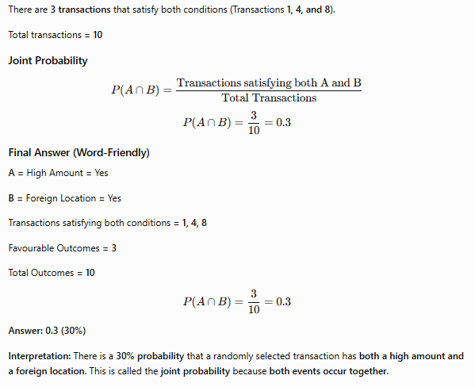

2. Marginal Probability
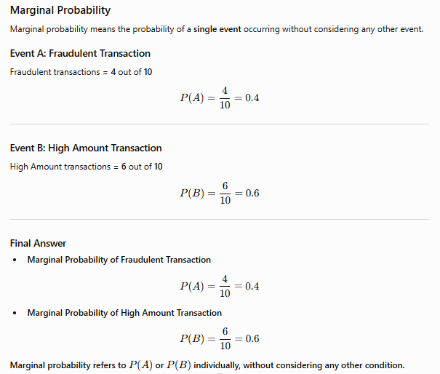

3. Conditional Probability
Conditional probability means the probability of an event occurring, given that another event has already happened.
Example:
Probability that a transaction has both (high amount & foreign location indicators) given that it is fraudulent:
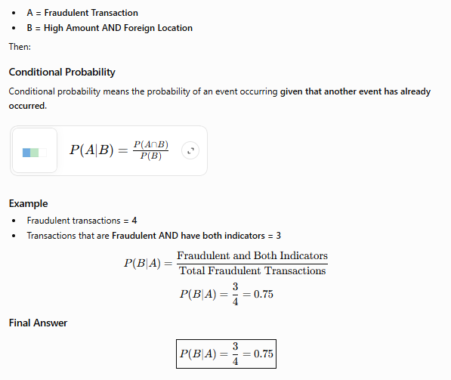
Interpretation:
If a transaction is already known to be fraudulent, there is a 75% probability that it has both a high amount and a foreign location.

Simple Summary Table
Type of Probability | Meaning | Example
Joint Probability | A and B happen together | (P(A \cap B)
Marginal Probability | Probability of A alone or B alone | (P(A) or P(B)
Conditional Probability | Probability of B given A | P(B | A)

Easy Memory Trick
Question | Type of Probability
What is the probability of A? | Marginal
What is the probability of A and B together? | Joint
What is the probability of A given B? | Conditional

