Document contains the steps to Disabling the Business event related to Customer Master:
Disable Business event: oracle.apps.ar.hz.OrgCustBO.update
- Navigate to the below path to disable the below business event for the particular subscription.
- Login with the user ‘SYSADMIN’.
workflow Administrator →Administrator workflow→Business Event
Search the event with name : oracle.apps.ar.hz.OrgCustBO.update

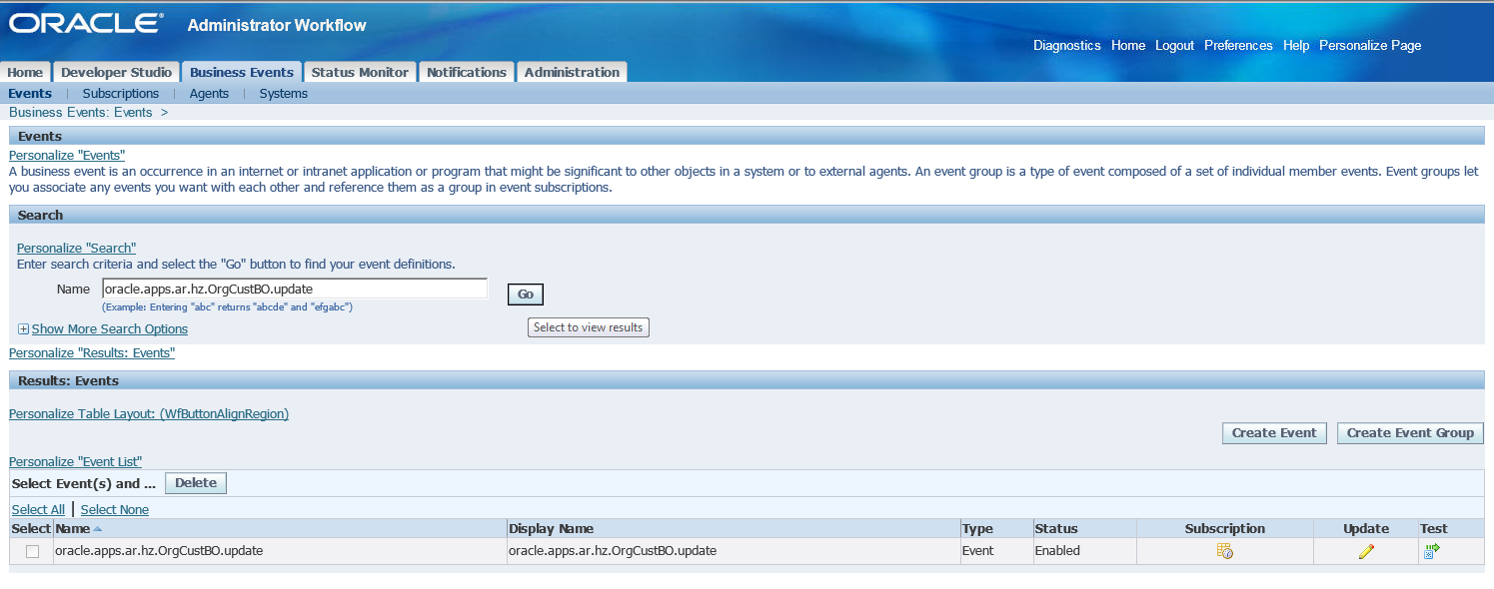
- Click on the subscription
N:B: Here System is FUNC as to provide screenshot, PROD will have different system.
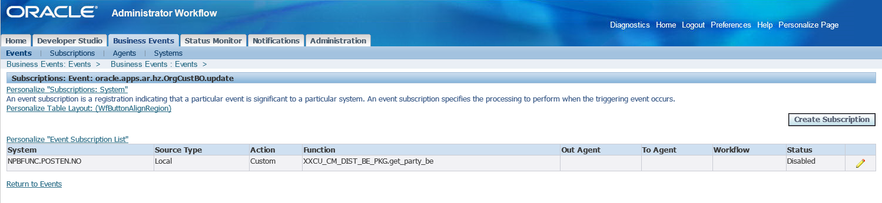
- Click on the Edit button to change the status of the Subscription only for the function ‘XXCU_CM_DIST_BE_PKG.get_party_be’. Change the status to ‘Disabled’.
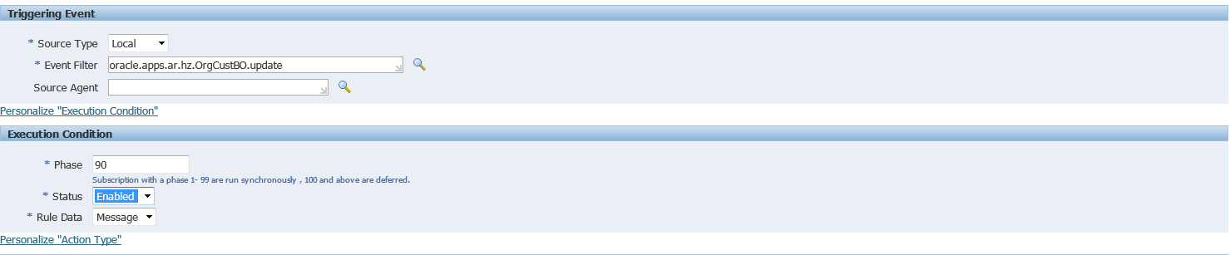

- Click on ’Next’ and then ’Apply’ to save the changes made.

Disable Business event : oracle.apps.ar.hz.PersonCustBO.update

- Navigate to the below path to Disable the below business event for the particular subscription.
- Login with the user ‘SYSADMIN’.
workflow Administrator →Administrator workflow→Business Event
Search the event with name : oracle.apps.ar.hz.PersonCustBO.update
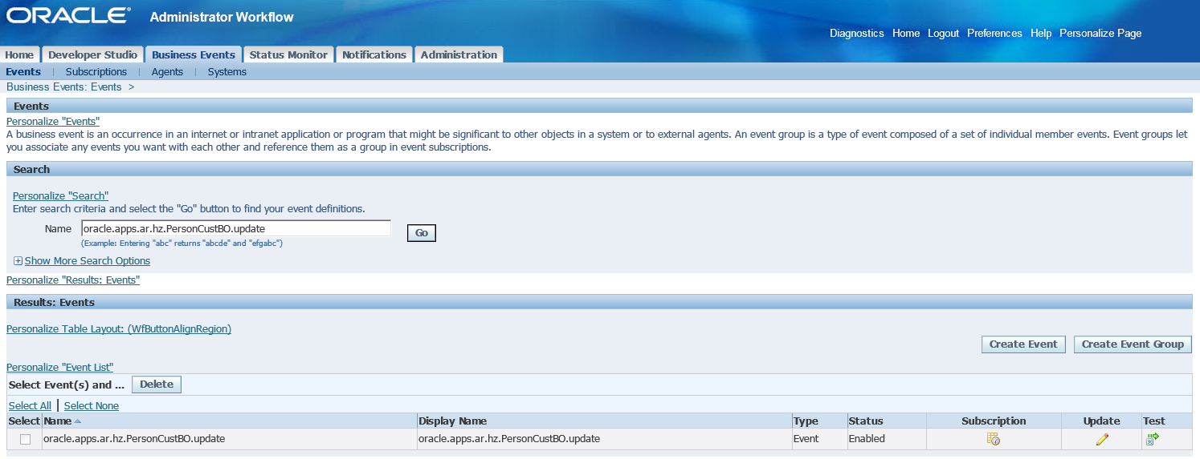

- Click on the subscription
N:B: Here System is FUNC as to provide screenshot, PROD will have different system.
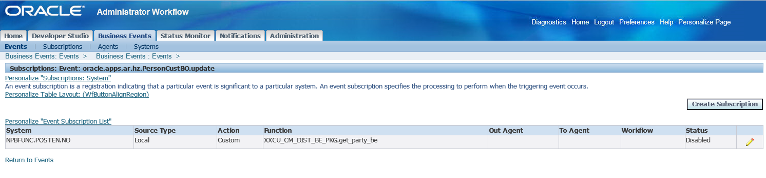
- Click on the Edit button to change the status of the Subscription only for the function ‘XXCU_CM_DIST_BE_PKG.get_party_be’. Change the status to ‘Disabled’.
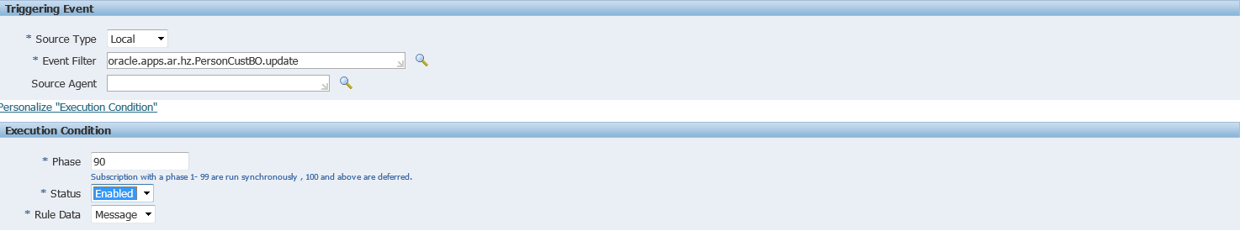
- Click on ’Next’ and then ’Apply’ to save the changes made.

Disable Business event: oracle.apps.ar.hz.CustAccount.create
- Navigate to the below path to Disable the below business event for the particular subscription.
- Login with the user ‘SYSADMIN’.
workflow Administrator →Administrator workflow→Business Event
Search the event with name : oracle.apps.ar.hz.CustAccount.create
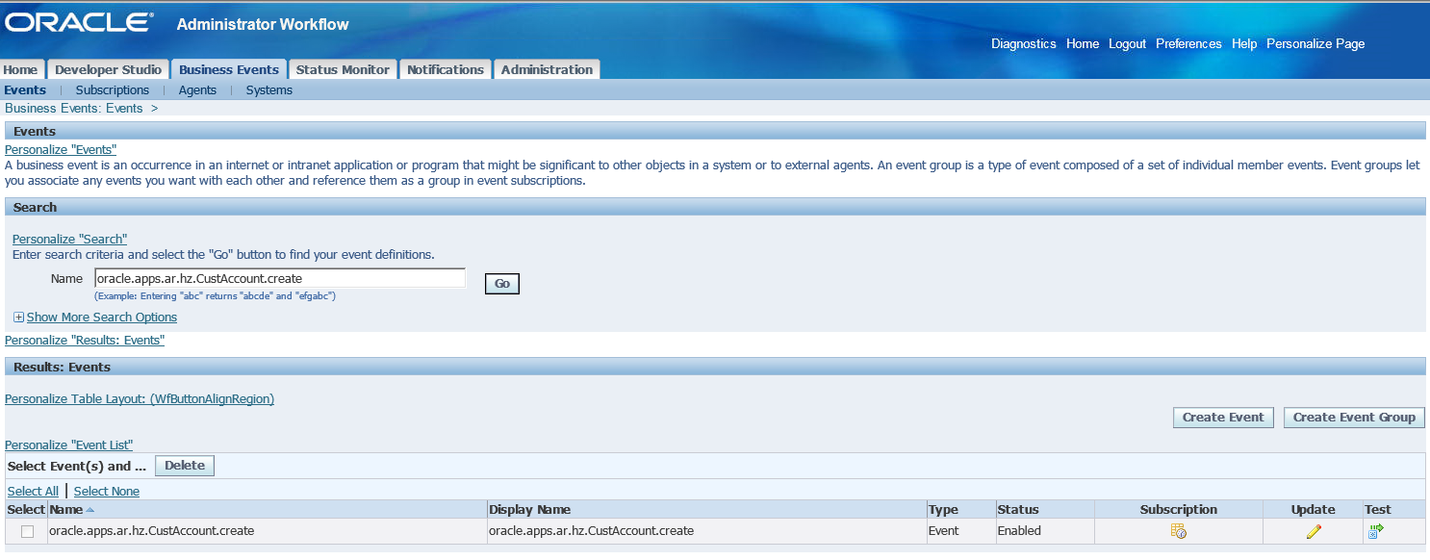

- Click on the subscription
N:B: Here System is FUNC as to provide screenshot, PROD will have different system.
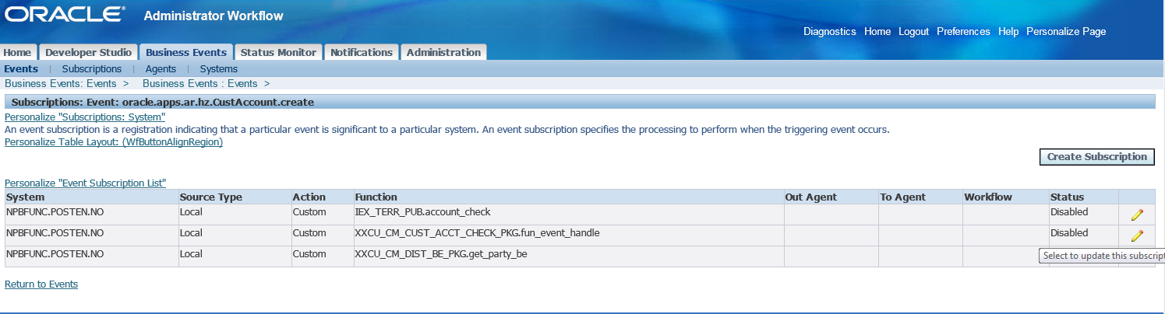
- Click on the Edit button to change the status of the Subscription only for the function ‘XXCU_CM_CUST_ACCT_CHECK_PKG.fun_event_handle’. Change the status to ’Disabled’.
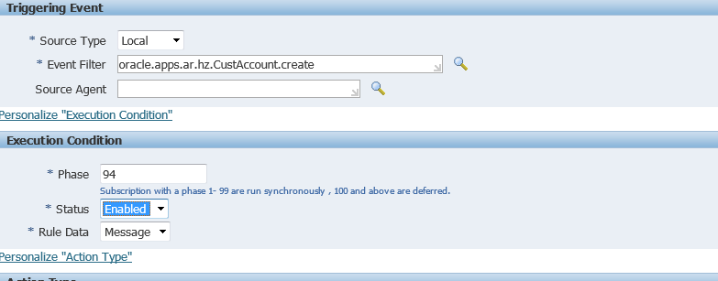
- Click on ’Next’ and then ’Apply’ to save the changes made.
Disable Business Event: xxcu.oracle.apps.ar.hz.origSystemRef.create
- Navigate to the below path to Disable the below business event for the particular subscription.
- Login with the user ‘SYSADMIN’.
workflow Administrator →Administrator workflow→Business Event
Search the event with name : xxcu.oracle.apps.ar.hz.origSystemRef.create
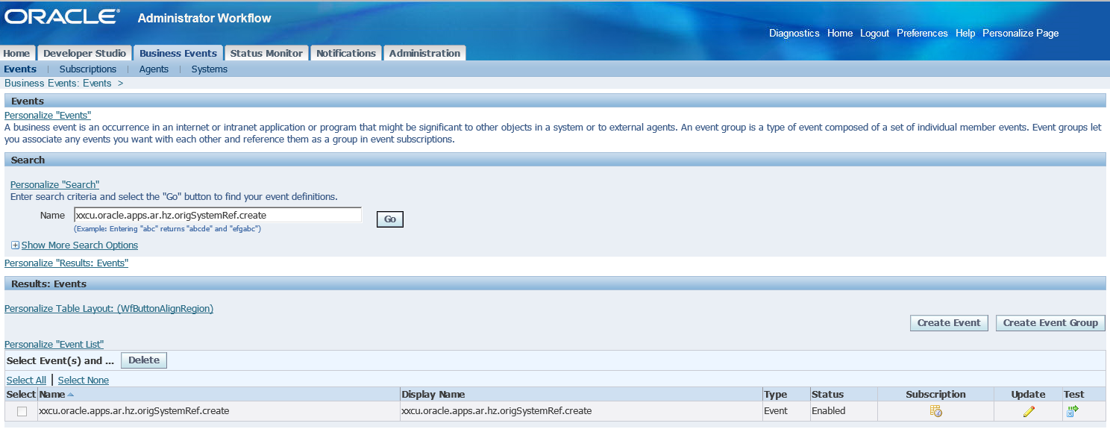

- Click on the subscription
N:B: Here System is FUNC as to provide screenshot, PROD will have different system.
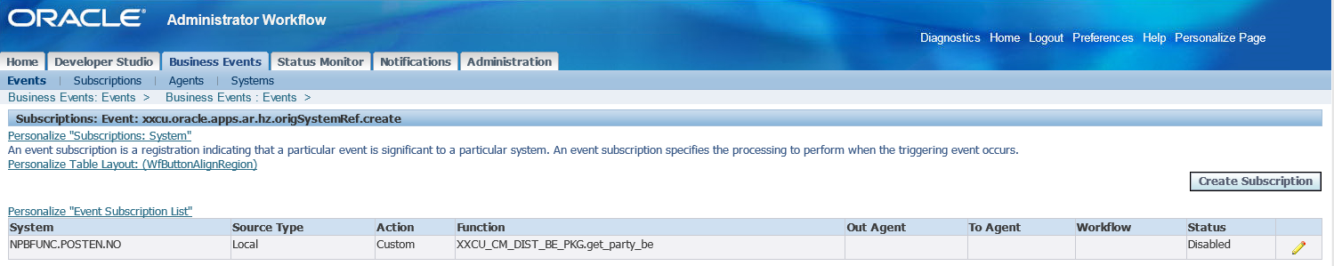
- Click on the Edit button to change the status of the Subscription only for the function ‘XXCU_CM_DIST_BE_PKG.get_party_be’. Change the status to ‘Disabled.
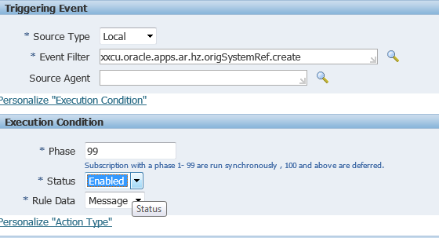
- Click on ’Next’ and then ’Apply’ to save the changes made.

Disable Business Event: oracle.apps.ar.hz.CustAccount.merge

- Navigate to the below path to Disable the below business event for the particular subscription.
- Login with the user ‘SYSADMIN’.
workflow Administrator →Administrator workflow→Business Event
Search the event with name : oracle.apps.ar.hz.CustAccount.merge
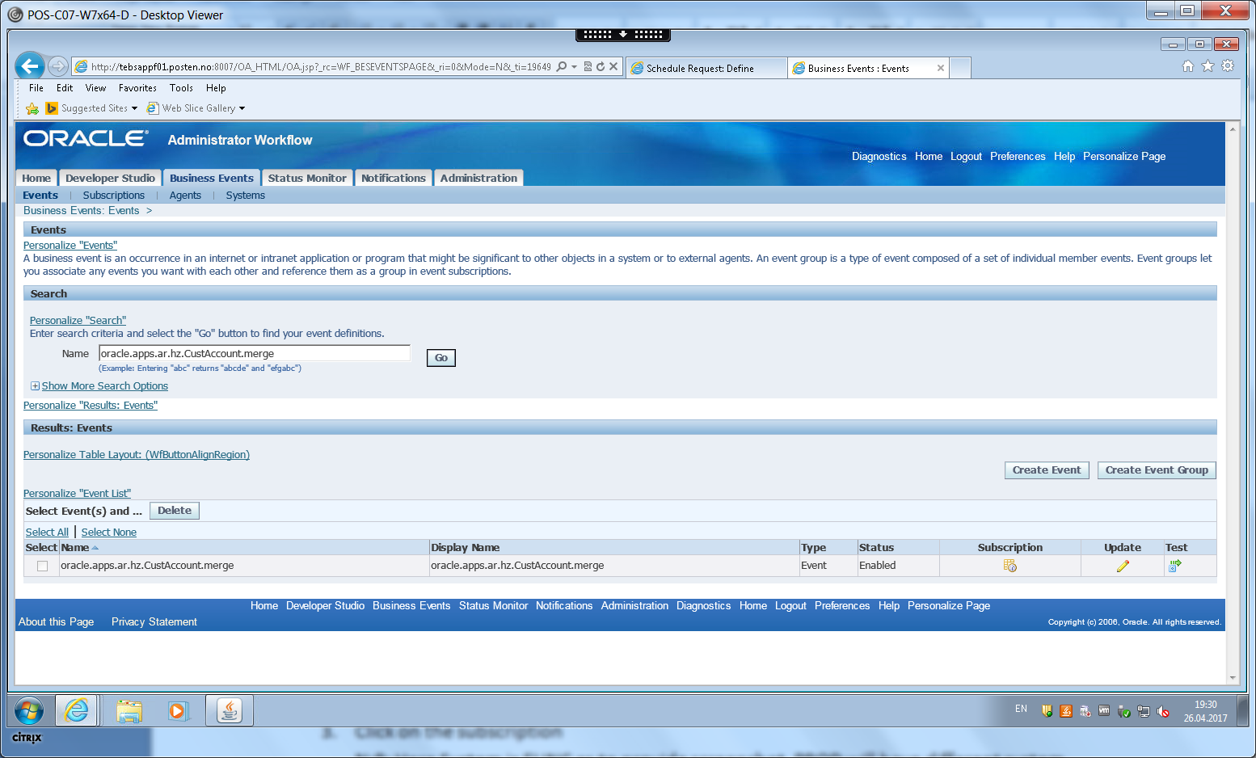

- Click on the subscription
N:B: Here System is FUNC as to provide screenshot, PROD will have different system.
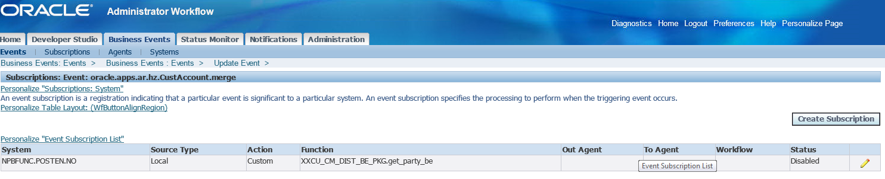
- Click on the Edit button to change the status of the Subscription only for the function ‘XXCU_CM_DIST_BE_PKG.get_party_be’. Change the status to ‘Disabled’.
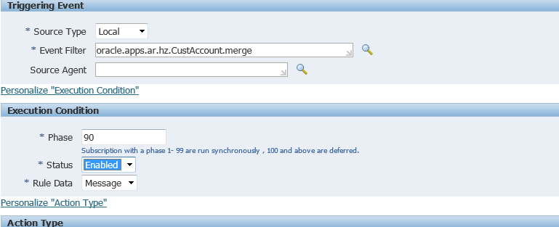
- Click on ’Next’ and then ’Apply’ to save the changes made.

Disable Business Event: oracle.apps.ar.hz.CustAcctSiteUse.create
- Navigate to the below path to Disable the below business event for the particular subscription.
- Login with the user ‘SYSADMIN’.
workflow Administrator →Administrator workflow→Business Event
Search the event with name : oracle.apps.ar.hz.CustAcctSiteUse.create
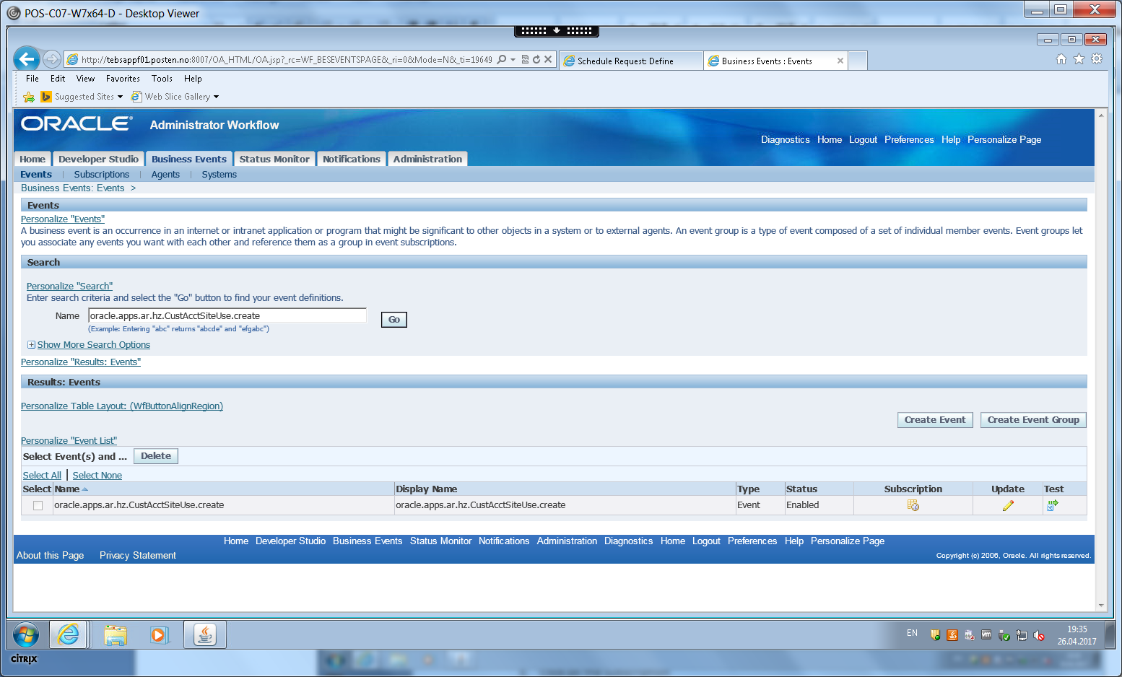

- Click on the subscription
N:B: Here System is FUNC as to provide screenshot, PROD will have different system.
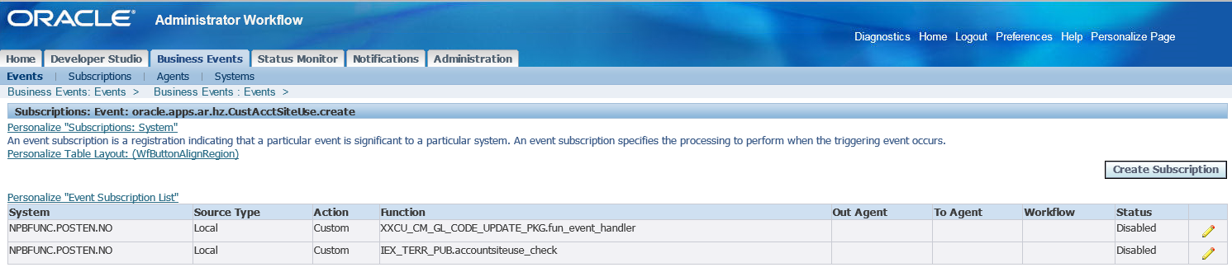
- Click on the Edit button to change the status of the Subscription only for the function ‘XXCU_CM_GL_CODE_UPDATE_PKG.fun_event_handler’. Change the status to ’Disabled’.
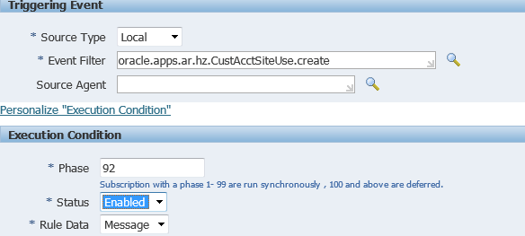
- Click on ’Next’ and then ’Apply’ to save the changes made.

