**Proyecto Redes III FTR Trenes C.A**

La empresa FTR Trenes, pide culminar el proyecto de la red de 3 de sus estaciones y su oficina principal. Para comenzar el proyecto se dio un Packet Tracer, donde se encuentran todos los avances de la red hasta al momento.

La dirección IP sobre la cual se trabajará es: 192.74.64.0/18

La topología a implementar se distribuye en 5 sectores importantes: la oficina principal, la estación central, la estación norte y la estación sur. Dicho esto, primero se realizará un VLSM MACRO para poder sacar las direcciones de red de cada sector, luego se hará los VLSM de cada subred, para dividir las direcciones de cada subsector.

La distribución de los hosts es de la siguiente manera:

|  |  |  |  |
| --- | --- | --- | --- |
| **Sector** | **Subsector** | **# Hosts** | **# Hosts 2^n** |
| Estación Central | Red Inalámbrica | 301 | 510 |
| Red de Oficinas de Seguridad | 8 | 14 |
| Red de Control de Trenes | 8 | 14 |
| Red de Boletería | 7 | 14 |
| Red de Atención al Cliente | 6 | 6 |
| Red de Granja de Servidores | 3 | 6 |
| Red dns/http | 2 | 2 |
| Red R2 con R3 | 2 | 2 |
| Red R2 con R6 | 2 | 2 |
| Red R2 con R4 | 2 | 2 |
| Red R2 con R7 | 2 | 2 |
| Red R2 con RD | 2 | 2 |
| **# Total de Hosts** |  | 343 | **576** |
| Estación Sur | Red Inalámbrica | 301 | 510 |
| Red de Boletería y Atención al Cliente | 12 | 14 |
| Red de Oficinas de Seguridad | 8 | 14 |
| Red de Control de Trenes | 8 | 14 |
| Red de Granja de Servidores | 3 | 6 |
| Red RS2 con R3 | 2 | 2 |
| Red RS2 con RS6 | 2 | 2 |
| Red RS2 con RS4 | 2 | 2 |
| Red RS2 con RS7 | 2 | 2 |
| **# Total de Hosts** |  | 340 | **566** |
| Estación Norte | Red Inalámbrica | 301 | 510 |
| Red de Boletería y Atención al Cliente | 12 | 14 |
| Red de Oficinas de Seguridad | 8 | 14 |
| Red de Control de Trenes | 8 | 14 |
| Red de Granja de Servidores | 3 | 6 |
| Red RN2 con R3 | 2 | 2 |
| Red RN2 con RN6 | 2 | 2 |
| Red RN2 con RN4 | 2 | 2 |
| Red RN2 con RN7 | 2 | 2 |
| **# Total de Hosts** |  | 340 | **566** |
| Oficina Principal | Red de Oficina Central | 11 | 14 |
| Red de Granja de Servidores | 4 | 6 |
| **# Total de Hosts** |  | 15 | **20** |
| Servicio ISP y FrameRelay | FrameRelay | 3 | 6 |
| ISP | 2 | 2 |
| **# Total de Hosts** |  | 5 | **8** |

**VLSM de la red.**

|  |  |  |  |  |  |  |
| --- | --- | --- | --- | --- | --- | --- |
| **Subneteo Macro.** | | | | | | |
| **Subred** | **# de host** | **Dirección de Red** | **Máscara** | **Primer Hosts** | **Ultimo host** | **Broadcast** |
| Estación Central | 1022 | 192.74.64.0 /22 | 255.255.255.0 | 192.74.64.1 | 192.74.67.254 | 192.74.67.255 |
| Estación Sur | 1022 | 192.74.68.0 /22 | 255.255.255.0 | 192.74.68.1 | 192.74.71.254 | 192.74.71.255 |
| Estación Norte | 1022 | 192.74.72.0 /22 | 255.255.255.0 | 192.74.72.1 | 192.74.75.254 | 192.74.75.255 |
| Oficina  Principal | 30 | 192.74.76.0 /27 | 255.255.255.224 | 192.74.76.1 | 192.74.76.30 | 192.74.76.31 |
| Servicio  ISP | 14 | 192.74.76.32 /28 | 255.255.255.240 | 192.74.76.33 | 192.74.76.46 | 192.74.76.47 |

|  |  |  |  |  |  |  |
| --- | --- | --- | --- | --- | --- | --- |
| **Subneteo Estación Central.** | | | | | | |
| **Subred** | **# de host** | **Dirección de Red** | **Máscara** | **Primer Hosts** | **Ultimo host** | **Broadcast** |
| Red Inalámbrica | 510 | 192.74.64.0 /23 | 255.255.254.0 | 192.74.64.1 | 192.74.65.254 | 192.74.65.255 |
| Red de Ofi. de Seguridad | 14 | 192.74.66.0 /28 | 255.255.255.240 | 192.74.66.1 | 192.74.66.14 | 192.74.66.15 |
| Red de Cont. de Trenes | 14 | 192.74.66.16 /28 | 255.255.255.240 | 192.74.66.17 | 192.74.66.30 | 192.74.66.31 |
| Red de  Boletería | 14 | 192.74.66.32 /28 | 255.255.255.240 | 192.74.66.33 | 192.74.66.46 | 192.74.66.47 |
| Red de Aten.  al Cliente | 6 | 192.74.66.48 /29 | 255.255.255.248 | 192.74.66.49 | 192.74.66.54 | 192.74.66.55 |
| Red de Granj.  de Serv. | 6 | 192.74.66.56 /29 | 255.255.255.248 | 192.74.66.57 | 192.74.66.62 | 192.74.66.63 |
| Red R2 con R3 | 2 | 192.74.66.64 /30 | 255.255.255.252 | 192.74.66.65 | 192.74.66.66 | 192.74.66.67 |
| Red R2 con R6 | 2 | 192.74.66.68 /30 | 255.255.255.252 | 192.74.66.69 | 192.74.66.70 | 192.74.66.71 |
| Red R2 con R4 | 2 | 192.74.66.72 /30 | 255.255.255.252 | 192.74.66.73 | 192.74.66.74 | 192.74.66.75 |
| Red R2 con R7 | 2 | 192.74.66.76 /30 | 255.255.255.252 | 192.74.66.77 | 192.74.66.78 | 192.74.66.79 |
| Red RS2 con RD | 2 | 192.74.66.80 /30 | 255.255.255.252 | 192.74.66.81 | 192.74.66.82 | 192.74.66.83 |
| Red dns/http | 2 | 192.74.66.84 /30 | 255.255.255.252 | 192.74.66.85 | 192.74.66.86 | 192.74.66.87 |

|  |  |  |  |  |  |  |
| --- | --- | --- | --- | --- | --- | --- |
| **Subneteo Estación Sur.** | | | | | | |
| **Subred** | **# de host** | **Dirección de Red** | **Máscara** | **Primer Hosts** | **Ultimo host** | **Broadcast** |
| Red Inalámbrica | 510 | 192.74.68.0 /23 | 255.255.254.0 | 192.74.68.1 | 192.74.69.254 | 192.74.69.255 |
| Red de Boletería y At. al Cliente | 14 | 192.74.70.0 /28 | 255.255.255.240 | 192.74.70.1 | 192.74.70.14 | 192.74.70.15 |
| Red de Ofi. de Seguridad | 14 | 192.74.70.16 /28 | 255.255.255.240 | 192.74.70.17 | 192.74.70.30 | 192.74.70.31 |
| Red de Cont. de Trenes | 14 | 192.74.70.32 /28 | 255.255.255.240 | 192.74.70.33 | 192.74.70.46 | 192.74.70.47 |
| Red de Granj.  de Serv. | 6 | 192.74.70.48 /29 | 255.255.255.248 | 192.74.70.49 | 192.74.70.54 | 192.74.70.55 |
| Red RS2 con R3 | 2 | 192.74.70.56 /30 | 255.255.255.252 | 192.74.70.57 | 192.74.70.58 | 192.74.70.59 |
| Red RS2 con RS6 | 2 | 192.74.70.60 /30 | 255.255.255.252 | 192.74.70.61 | 192.74.70.62 | 192.74.70.63 |
| Red RS2 con RS4 | 2 | 192.74.70.64 /30 | 255.255.255.252 | 192.74.70.65 | 192.74.70.66 | 192.74.70.67 |
| Red RS2 con RS7 | 2 | 192.74.70.68 /30 | 255.255.255.252 | 192.74.70.69 | 192.74.70.70 | 192.74.70.71 |

|  |  |  |  |  |  |  |
| --- | --- | --- | --- | --- | --- | --- |
| **Subneteo Estación Norte.** | | | | | | |
| **Subred** | **# de host** | **Dirección de Red** | **Máscara** | **Primer Hosts** | **Ultimo host** | **Broadcast** |
| Red Inalámbrica | 510 | 192.74.72.0 /23 | 255.255.254.0 | 192.74.72.1 | 192.74.73.254 | 192.74.73.255 |
| Red de Boletería y At. al Cliente | 14 | 192.74.74.0 /28 | 255.255.255.240 | 192.74.74.1 | 192.74.74.14 | 192.74.74.15 |
| Red de Ofi. de Seguridad | 14 | 192.74.74.16 /28 | 255.255.255.240 | 192.74.74.17 | 192.74.74.30 | 192.74.74.31 |
| Red de Cont. de Trenes | 14 | 192.74.74.32 /28 | 255.255.255.240 | 192.74.74.33 | 192.74.74.46 | 192.74.74.47 |
| Red de Granj.  de Serv. | 6 | 192.74.74.48 /29 | 255.255.255.248 | 192.74.74.49 | 192.74.74.54 | 192.74.74.55 |
| Red RN2 con  R3 | 2 | 192.74.74.56 /30 | 255.255.255.252 | 192.74.74.57 | 192.74.74.58 | 192.74.74.59 |
| Red RN2 con  RN6 | 2 | 192.74.74.60 /30 | 255.255.255.252 | 192.74.74.61 | 192.74.74.62 | 192.74.74.63 |
| Red RN2 con  RN4 | 2 | 192.74.74.64 /30 | 255.255.255.252 | 192.74.74.65 | 192.74.74.66 | 192.74.74.67 |
| Red RN2 con  RN7 | 2 | 192.74.74.68 /30 | 255.255.255.252 | 192.74.74.69 | 192.74.74.70 | 192.74.74.71 |

|  |  |  |  |  |  |  |
| --- | --- | --- | --- | --- | --- | --- |
| **Subneteo Oficina principal.** | | | | | | |
| **Subred** | **# de host** | **Dirección de Red** | **Máscara** | **Primer Hosts** | **Ultimo host** | **Broadcast** |
| Red Oficina  Central | 14 | 192.74.76.0 /28 | 255.255.255.240 | 192.74.76.1 | 192.74.76.14 | 192.74.76.15 |
| Red de Granj.  de Serv. | 6 | 192.74.76.16 /29 | 255.255.255.248 | 192.74.76.17 | 192.74.76.22 | 192.74.76.23 |

|  |  |  |  |  |  |  |
| --- | --- | --- | --- | --- | --- | --- |
| **Subneteo Servicio ISP y Frame Relay.** | | | | | | |
| **Subred** | **# de host** | **Dirección de Red** | **Máscara** | **Primer Hosts** | **Ultimo host** | **Broadcast** |
| FrameRelay | 6 | 192.74.76.32 /29 | 255.255.255.248 | 192.74.76.33 | 192.74.76.38 | 192.74.76.39 |
| ISP | 2 | 192.74.76.40 /30 | 255.255.255.252 | 192.74.76.41 | 192.74.76.42 | 192.74.76.43 |

**Tabla de expansión de dispositivos router e interfaces.**

|  |  |  |  |  |
| --- | --- | --- | --- | --- |
| **Equipo** | **Modelo** | **Módulo de expansión** | **# Total de puertos fastethernet** | **# Total de puertos seriales** |
| Router 0 | 2811 | 2 WIC-1T | 4 | 2 |
| NM-2FE2W |
| Router 1 | 2620XM | WIC-1T | 1 | 1 |
| Router 2 | 2621XM | 2 WIC-2T | 2 | 4 |
| Router 3 | Router PT | N/C | 6 | 2 |
| Router 4 | 2811 | WIC-1T | 2 | 1 |
| Router 6 | 2811 | WIC-1T | 4 | 1 |
| NM-2FE2W |
| Router 7 | 2620XM | WIC-1T | 2 | 1 |
| NM-1FE2W |
| RouterN2 | 2621XM | 2 WIC-2T | 3 | 4 |
| NM-1FE-FX |
| RouterN4 | 2811 | WIC-1T | 2 | 1 |
| RouterN6 | 2811 | WIC-1T | 4 | 1 |
| NM-1FE2W |
| RouterN7 | 2620XM | WIC-1T | 2 | 1 |
| 2 WIC-2T |
| RouterS2 | 2621XM | 2 WIC-2T | 3 | 4 |
| NM-1FE-FX |
| RouterS4 | 2811 | WIC-1T | 2 | 1 |
| RouterS6 | 2811 | WIC-1T | 4 | 1 |
| NM-2FE2W |
| RouterS7 | 2620XM | WIC-1T | 2 | 1 |
| NM-1FE2W |
| RouterRD | 2620XM | NM-2FE2W | 2 | 0 |

**Tabla de interconexión de routers.**

|  |  |  |  |  |
| --- | --- | --- | --- | --- |
| **Estación Central** | | | | |
| **Dispositivos** | **Interfaz** | **IP** | **Máscara** | **Tipo de Conexión** |
| Router RD | Fa0/0 | 192.74.66.82 | 255.255.255.252 | N/A |
| Fa1/0 | 192.74.66.85 | 255.255.255.252 | N/A |
| Router 2 | Se0/0 | 192.74.66.65 | 255.255.255.252 | DTE |
| Se0/2 | 192.74.66.69 | 255.255.255.252 | DCE |
| Se0/3 | 192.74.66.73 | 255.255.255.252 | DCE |
| Fa0/0 | 192.74.66.77 | 255.255.255.252 | N/A |
| Fa0/1 | 192.74.66.81 | 255.255.255.252 | N/A |
| Router 3 | Se2/0 | 192.74.66.66 | 255.255.255.252 | DCE |
| Se3/0 | 192.74.76.35 | 255.255.255.248 | DTE |
| Fa4/0 FIBRA | 192.74.74.58 | 255.255.255.252 | N/A |
| Fa5/0 FIBRA | 192.74.70.58 | 255.255.255.252 | N/A |
| Router 4 | Se0/3/0 | 192.74.66.74 | 255.255.255.252 | DTE |
| Fa0/0 | 192.74.66.1 | 255.255.255.240 | N/A |
| Fa0/1 | 192.74.66.57 | 255.255.255.248 | N/A |
| Router 6 | Se0/3/0 | 192.74.66.70 | 255.255.255.252 | DTE |
| Fa0/0 | 192.74.66.49 | 255.255.255.248 | N/A |
| Fa0/1 | 192.74.66.17 | 255.255.255.240 | N/A |
| Fa1/0 | 192.74.66.33 | 255.255.255.240 | N/A |
| Router 7 | Fa1/0 | 192.74.66.78 | 255.255.255.252 | N/A |
| Fa0/0 | 192.74.64.1 | 255.255.254.0 | N/A |

|  |  |  |  |  |
| --- | --- | --- | --- | --- |
| **Estacion Sur** | | | | |
| **Dispositivos** | **Interfaz** | **IP** | **Máscara** | **Tipo de Conexión** |
| Router S2 | Fa1/0 FIBRA | 192.74.70.57 | 255.255.255.252 | N/A |
| Se0/2 | 192.74.70.61 | 255.255.255.252 | DCE |
| Se0/3 | 192.74.70.65 | 255.255.255.252 | DCE |
| Fa0/0 | 192.74.70.69 | 255.255.255.252 | N/A |
| Router S4 | Se0/3/0 | 192.74.70.66 | 255.255.255.252 | DTE |
| Fa0/0 | 192.74.70.17 | 255.255.255.240 | N/A |
| Fa0/1 | 192.74.70.49 | 255.255.255.248 | N/A |
| Router S6 | Se0/3/0 | 192.74.70.62 | 255.255.255.252 | DTE |
| Fa0/0 | 192.74.70.1 | 255.255.255.240 | N/A |
| Fa0/1 | 192.74.70.33 | 255.255.255.240 | N/A |
| Router S7 | Fa1/0 | 192.74.70.70 | 255.255.255.252 | N/A |
| Fa0/0 | 192.74.68.1 | 255.255.254.0 | N/A |

|  |  |  |  |  |
| --- | --- | --- | --- | --- |
| **Estacion Norte** | | | | |
| Dispositivos | Interfaz | IP | Máscara | Tipo de Conexión |
| Router N2 | Fa1/0 FIBRA | 192.74.74.57 | 255.255.255.252 | N/A |
| Se0/2 | 192.74.74.61 | 255.255.255.252 | DCE |
| Se0/3 | 192.74.74.65 | 255.255.255.252 | DCE |
| Fa0/0 | 192.74.74.69 | 255.255.255.252 | N/A |
| Router N4 | Se0/3/0 | 192.74.74.66 | 255.255.255.252 | DTE |
| Fa0/0 | 192.74.74.17 | 255.255.255.240 | N/A |
| Fa0/1 | 192.74.74.49 | 255.255.255.248 | N/A |
| Router N6 | Se0/3/0 | 192.74.74.62 | 255.255.255.252 | DTE |
| Fa0/0 | 192.74.74.1 | 255.255.255.240 | N/A |
| Fa0/1 | 192.74.74.33 | 255.255.255.240 | N/A |
| Router N7 | Fa1/0 | 192.74.74.70 | 255.255.255.252 | N/A |
| Fa0/0 | 192.74.72.1 | 255.255.254.0 | N/A |

|  |  |  |  |  |
| --- | --- | --- | --- | --- |
| **Oficina Principal** | | | | |
| Dispositivos | Interfaz | IP | Máscara | Tipo de Conexión |
| Router 0 | Fa0/0 | 192.74.76.1 | 255.255.255.240 | N/A |
| Fa0/1 | 192.74.76.17 | 255.255.255.248 | N/A |
| Se0/2/0 | 192.74.76.34 | 255.255.255.248 | DTE |

|  |  |  |  |  |
| --- | --- | --- | --- | --- |
| **Servicio ISP** | | | | |
| **Dispositivos** | **Interfaz** | **IP** | **Máscara** | **Tipo de Conexión** |
| Router 1 | Fa0/0 | 192.74.76.41 | 255.255.255.252 | N/A |
| Se0/0 | 192.74.76.33 | 255.255.255.248 | DTE |

**Distribución de dispositivos por red.**

**WORD DE DIEGO EN DISCORD.**

**Tabla de servidores.**

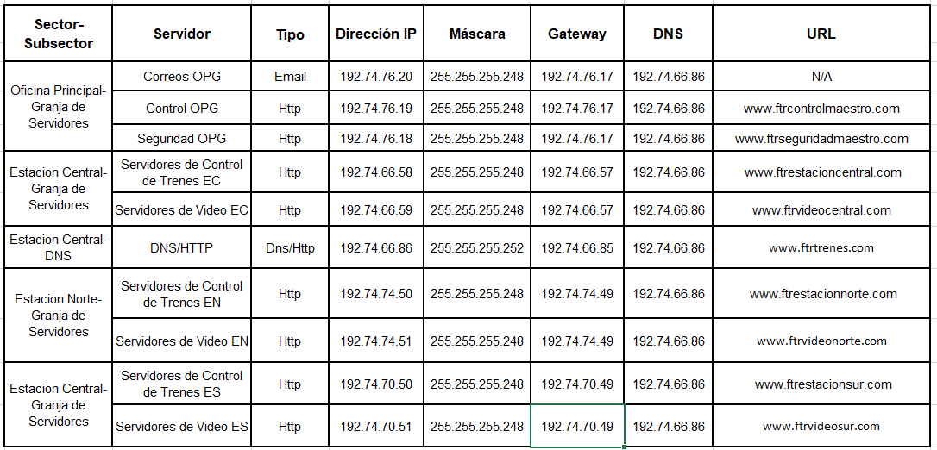

**Protocolo de enrutamiento.**

El protocolo de enrutamiento que se realizó fue el protocolo OSPF, ID del proceso 31, teniendo Estación Central y Oficina Principal como áreas de backbone ó área 0, Estación Sur como área 1 y Estación Norte como área 2.

**Convención de diseño para la telefonía.**

Para la distribución de la red telefónica implementamos una convención de diseño de la siguiente manera: **ABC**

**A:** Identifica el sector principal donde se encuentre el dispositivo.

* Estación central: 1
* Estación sur: 2
* Estación norte: 3
* Oficina principal: 4

**B:** Identifica el subsector en donde se encuentre el dispositivo.

* Control de trenes: 1
* Atención al cliente: 2
* Oficinas de seguridad: 3
* Oficina de control central: 4

**C:** Identifica el número particular del teléfono.

**Ejemplo ilustrativo:**

El sexto teléfono de control de trenes de la estación sur: **316**

**Tabla de asignación de números a dispositivos.**

|  |  |  |  |
| --- | --- | --- | --- |
| **Estación Central** | | | |
| **Nombre de Dispositivo** | **Subsector** | **Número** | **Red** |
| AnalogPhone1ECOS | Oficinas de seguridad | 131 | 192.74.66.0 /28 |
| AnalogPhone2ECOS | 132 |
| AnalogPhone3ECOS | 133 |
| IPPhone1ECAC | Atención al Cliente | 121 | 192.74.66.48 /29 |
| IPPhone2ECAC | 122 |
| IPPhone1ECCT | Control de Trenes | 113 | 192.74.66.16 /28 |
| IPPhone2ECCT | 112 |
| IPPhone3ECCT | 111 |

|  |  |  |  |
| --- | --- | --- | --- |
| **Estación Norte** | | | |
| **Nombre de Dispositivo** | **Subsector** | **Número** | **Red** |
| AnalogPhone1ENOS | Oficinas de seguridad | 333 | 192.74.74.16 /28 |
| AnalogPhone2ENOS | 331 |
| AnalogPhone3ENOS | 332 |
| IPPhone1ENAC | Atención al Cliente y Boletería | 321 | 192.74.74.0 /28 |
| IPPhone2ENAC | 322 |
| IPPhone1ENCT | Control de Trenes | 313 | 192.74.74.32 /28 |
| IPPhone2ENCT | 311 |
| IPPhone3ENCT | 312 |

|  |  |  |  |
| --- | --- | --- | --- |
| **Estación Sur** | | | |
| **Nombre de Dispositivo** | **Subsector** | **Número** | **Red** |
| AnalogPhone1ESOS | Oficinas de seguridad | 232 | 192.74.70.16 /28 |
| AnalogPhone2ESOS | 233 |
| AnalogPhone3ESOS | 231 |
| IPPhone1ESAC | Atención al Cliente y Boletería | 221 | 192.74.70.0 /28 |
| IPPhone2ESAC | 222 |
| IPPhone1ESCT | Control de Trenes | 211 | 192.74.70.32 /28 |
| IPPhone2ESCT | 212 |
| IPPhone3ESCT | 213 |

|  |  |  |  |
| --- | --- | --- | --- |
| **Oficina Principal** | | | |
| **Nombre de Dispositivo** | **Subsector** | **Número** | **Red** |
| IPPhone1OPC | Oficinas de Control Central | 443 | 192.74.76.0 /28 |
| IPPhone2OPC | 441 |
| IPPhone3OPC | 442 |
| IPPhone4OPC | 444 |

**Tabla de dial-peer.**

|  |  |  |
| --- | --- | --- |
| **Router extremo 1** | **Router extremo 2** | **ID de voice** |
| R0 | R4 | 1 |
| R0 | R6 | 2 |
| R0 | RN4 | 3 |
| R0 | RN6 | 4 |
| R0 | RS4 | 5 |
| R0 | RS6 | 6 |
| R4 | R6 | 7 |
| R4 | RN4 | 8 |
| R4 | RN6 | 9 |
| R4 | RS4 | 10 |
| R4 | RS6 | 11 |
| R6 | RN4 | 12 |
| R6 | RN6 | 13 |
| R6 | RS4 | 14 |
| R6 | RS6 | 15 |
| RN4 | RN6 | 16 |
| RN4 | RS4 | 17 |
| RN4 | RS6 | 18 |
| RN6 | RS4 | 19 |
| RN6 | RS6 | 20 |
| RS4 | RS6 | 21 |

**Configuración Frame-Relay.**

Se realizará entre el router 0, router 1 y router 3, por consiguiente, la conexión es de 3 seriales, por ende se debe configurar 2 DLCI por cada router y establecer la conexión entre ellos.

|  |  |  |
| --- | --- | --- |
| **Router** | **Puerto de conexión en el frame-relay** | **DLCI** |
| Router0 | Se1 | 200 |
| **210** |
| Router1 | Se0 | **100** |
| **110** |
| Router3 | Se3 | **300** |
| **310** |

**Tabla y configuración de correos.**

Los correos solamente estarán en las PC de los empleados del departamento de control y oficina central, bajo el dominio de @ftrcontrol.com

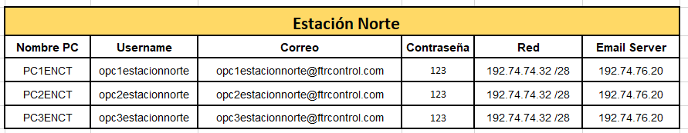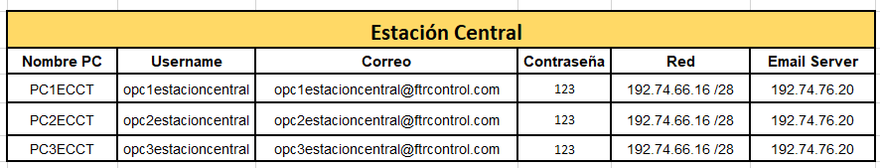

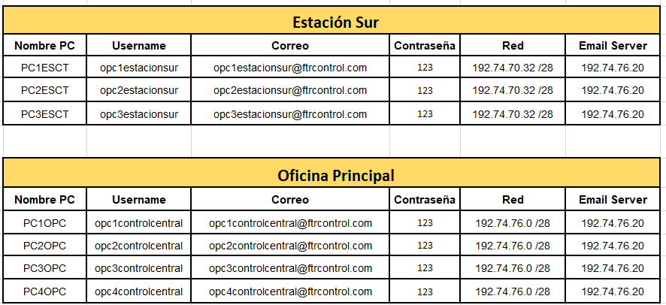

**Restricciones de redes inalámbricas.**