# Name :- Sarthak Pagar

# Roll No. :- 40

# Class :- TE (IT)

# Practical A1 :- Using a Network Simulator (e.g. packet tracer) Configure Router for…

a) Configure a router using router commands and Configure Routing Information Protocol (RIP).

b) Configure Access Control lists – Standard & Extended.

c) Network Address Translation: Static, Dynamic & PAT (Port Address Translation)

a) Configure a router using router commands and Configure Routing Information Protocol (RIP).

**Use below topology**

Requirements – two PC’s, three routers and two switches.

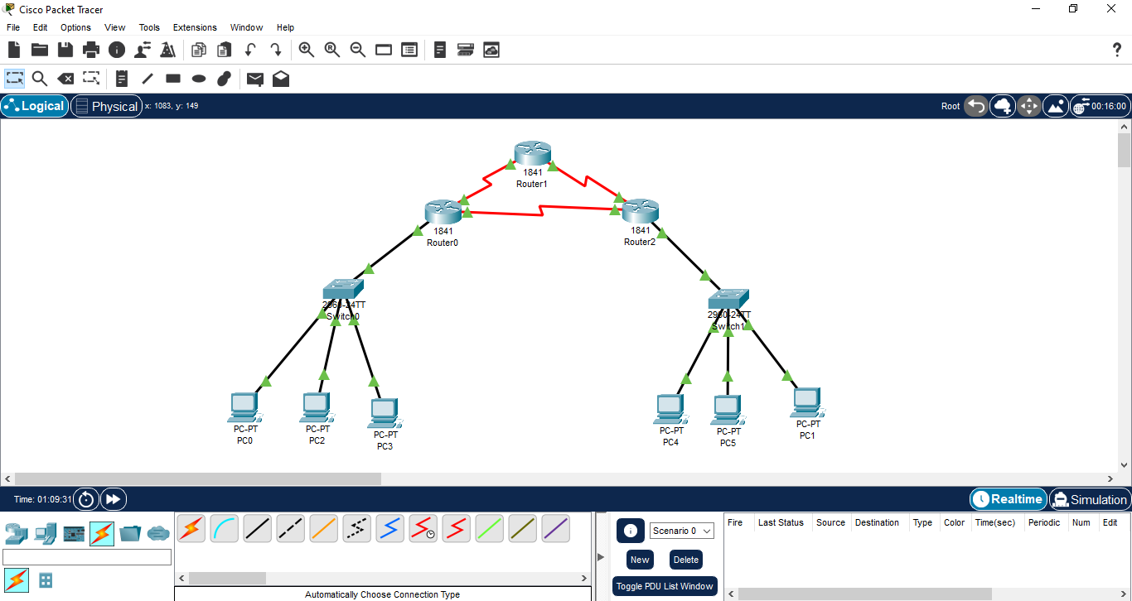

- Use serial DCE/DTE cable for connections between routers.

- Double click on router, switch OFF it. Drag HWIC-2T from the modules section on the left inside

the router. Switch the router ON.

Router0 (Serial0/0/0) → Router1 (Serial0/0/0)

Router1 (Serial0/0/1) → Router2 (Serial0/0/0)

Router2 (Serial0/0/1) → Router0 (Serial0/0/1)

- Router-to-Switch (Ethernet Links)

Use Copper Straight-Through cable to connect Router to Switch:

Switch0 (Fa0/1) → Router0 (Fa0/0)

Switch1 (Fa0/1) → Router1 (Fa0/0)

- For Switch to PC connection use Copper Straight-Through cable

Switch0 (Fa0/2) → PC0

Switch1 (Fa0/2) → PC1

**How to configure all devices**

1) PC0 – Double click on device

Go to Desktop, click on IP configuration

Fill: IP Address: 192.168.1.2

Subnet Mask: 255.255.255.0

Default Gateway: 192.168.1.1

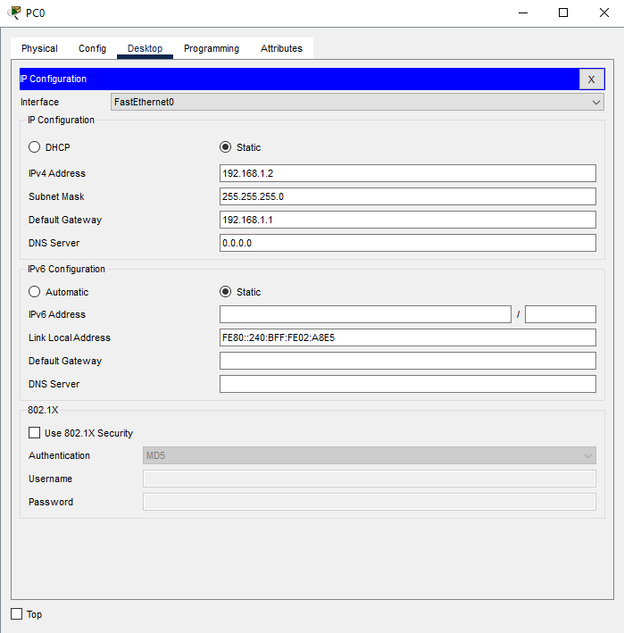

For PC1 : IP Address: 192.168.2.2

Subnet Mask: 255.255.255.0

Default Gateway: 192.168.2.1

2) Routers – Double click on Router0

Click on CLI

Type the below command one by one:

enable

configure terminal

hostname Router0

! Configure LAN interface (connects to Switch0)

interface FastEthernet0/0

ip address 192.168.1.1 255.255.255.0

no shutdown

exit

! Configure serial links (triangle topology)

interface Serial0/0/0

ip address 10.0.12.1 255.255.255.252

clock rate 64000 ! DCE side

no shutdown

exit

interface Serial0/0/1

ip address 10.0.13.1 255.255.255.252

clock rate 64000 ! DCE side

no shutdown

exit

For Router1 - ! Configure serial links only (no LAN)

interface Serial0/0/0

ip address 10.0.12.2 255.255.255.252

no shutdown ! No clock rate (DTE side)

exit

interface Serial0/0/1

ip address 10.0.23.1 255.255.255.252

clock rate 64000 ! DCE side to Router2

no shutdown

exit

For Router2 - ! Configure LAN interface (connects to Switch1)

interface FastEthernet0/0

ip address 192.168.2.1 255.255.255.0

no shutdown

exit

! Configure serial links

interface Serial0/0/0

ip address 10.0.23.2 255.255.255.252

no shutdown ! DTE side

exit

interface Serial0/0/1

ip address 10.0.13.2 255.255.255.252

no shutdown ! DTE side

exit

You will see like this.

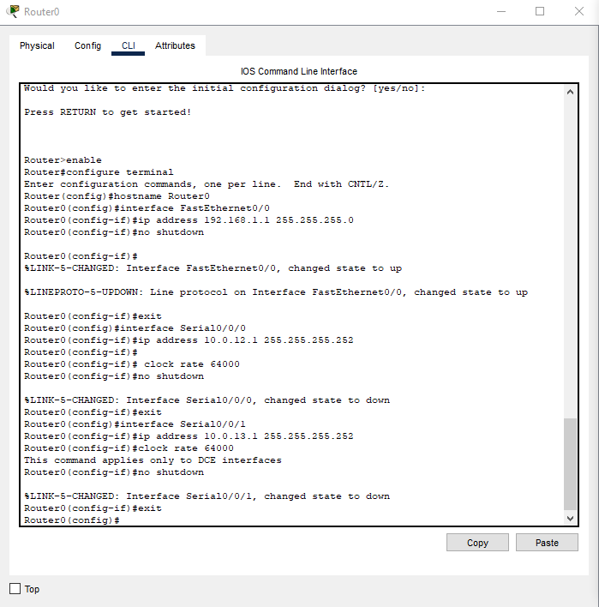

**RIP Configuration -**

For Router0 - ! RIP Configuration

router rip

version 2

network 192.168.1.0

network 10.0.12.0

network 10.0.13.0

no auto-summary

end

write memory ! Save configuration

For Router1 - router rip

version 2

network 10.0.12.0

network 10.0.23.0

no auto-summary

end

write memory

For Router2 - router rip

version 2

network 192.168.2.0

network 10.0.13.0

network 10.0.23.0

no auto-summary

end

write memory

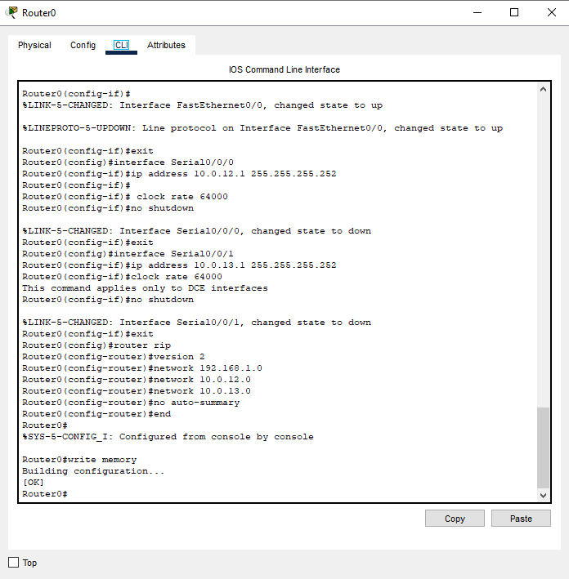

**Verification -**

Open PC0's Command Prompt: Click on PC0 → Desktop tab → Command Prompt.

Type - ping 192.168.2.2

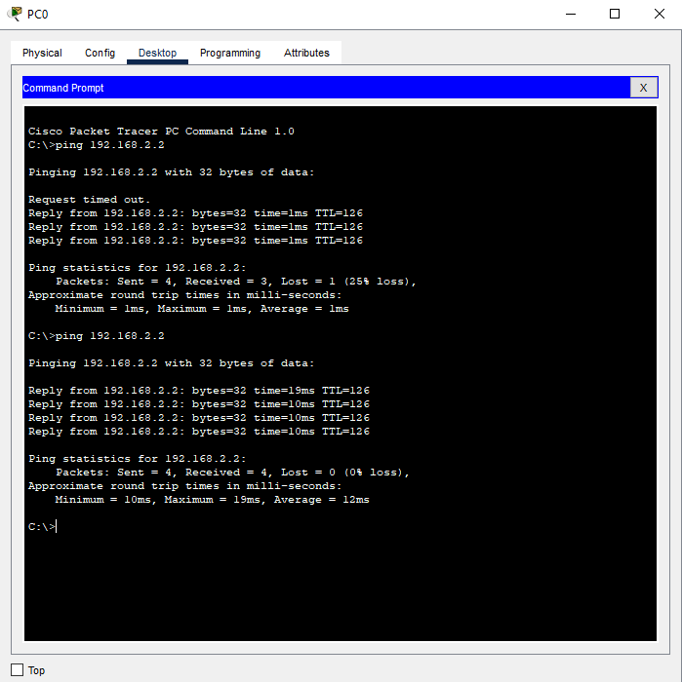

b) Configure Access Control lists – Standard & Extended.

**Use the same topology as used in above practical.**

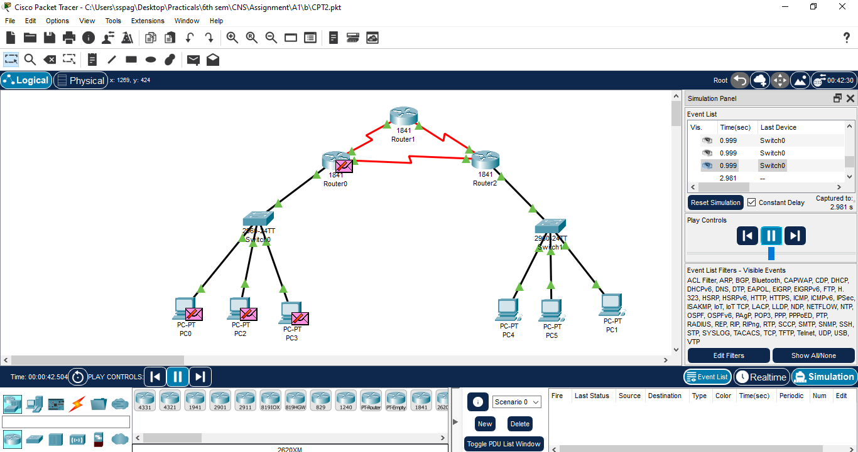

**Standard ACL:-**

For Router0 – Double click and navigate to CLI

enable

configure terminal

access-list 1 deny host 192.168.1.2 ! Create ACL to block PC0's IP

access-list 1 permit any

interface FastEthernet0/0 ! Apply ACL inbound on the LAN interface

ip access-group 1 in

end

write memory

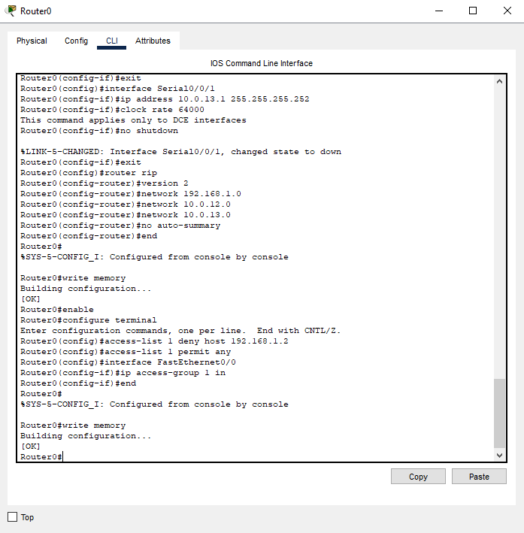

**Verification -**

From PC0, ping 192.168.1.1 → Should fail.

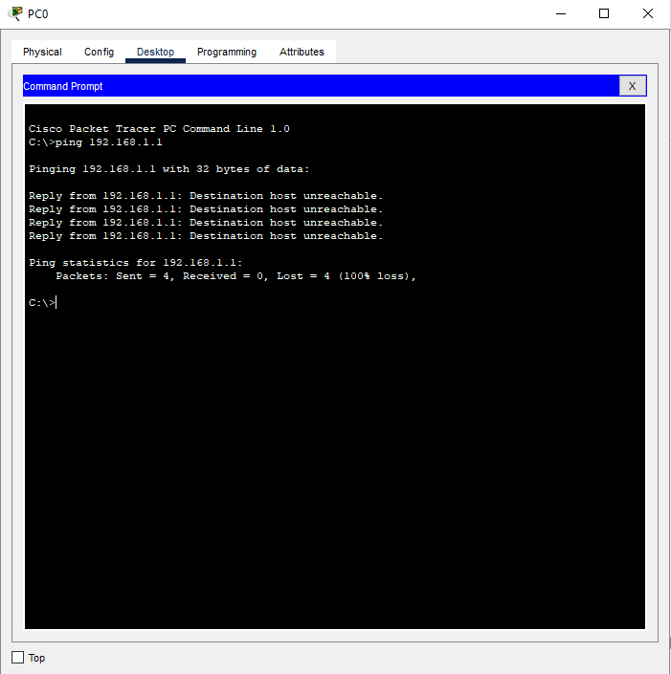

From PC1, ping 192.168.1.1 → Should succeed.

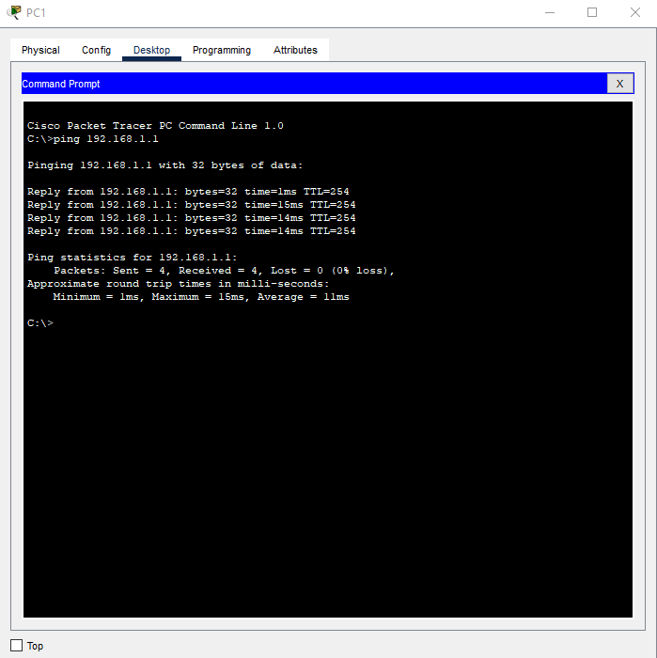

**Extended ACL:-**

For Router0 – Double click and navigate to CLI

enable

configure terminal

! Create ACL to block Telnet/HTTP from 192.168.1.0/24

access-list 101 deny tcp 192.168.1.0 0.0.0.255 any eq 23

access-list 101 deny tcp 192.168.1.0 0.0.0.255 any eq 80

access-list 101 permit ip any any

! Apply ACL inbound on the LAN interface

interface FastEthernet0/0

ip access-group 101 in

end

write memory

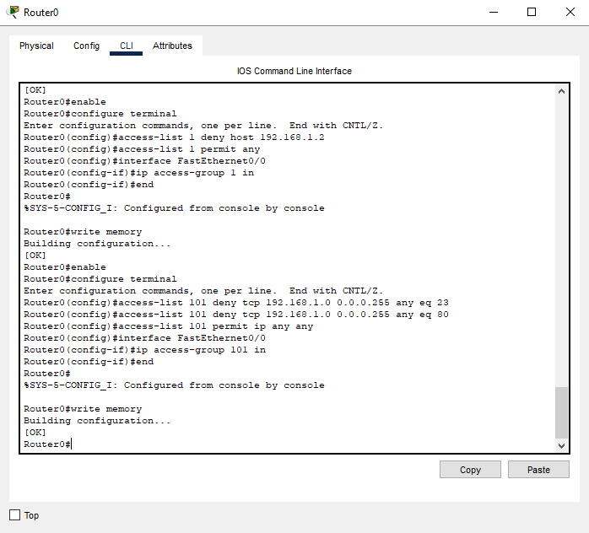

**Verification -**

Test Telnet Block:

From PC0, Open Command Prompt and try to telnet to Router2

Type - telnet 192.168.2.1

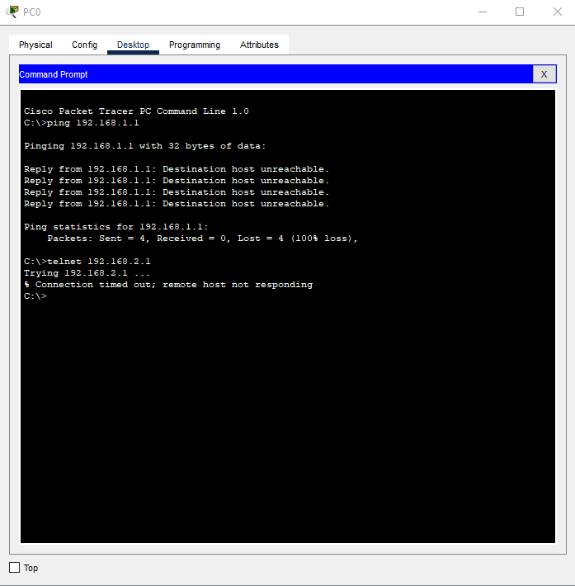

Test HTTP Block:

From PC0, go to Desktop open a web browser and enter http://192.168.2.2 → Should fail.

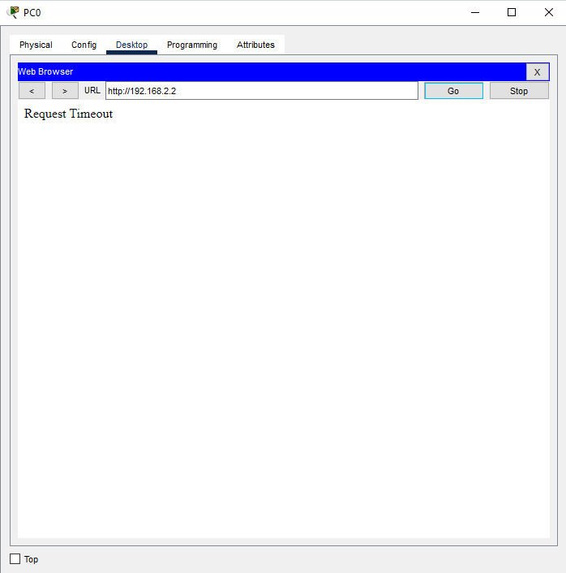

Configure an HTTP server on PC1 (Desktop tab → HTTP Server).

enter http://192.168.2.2

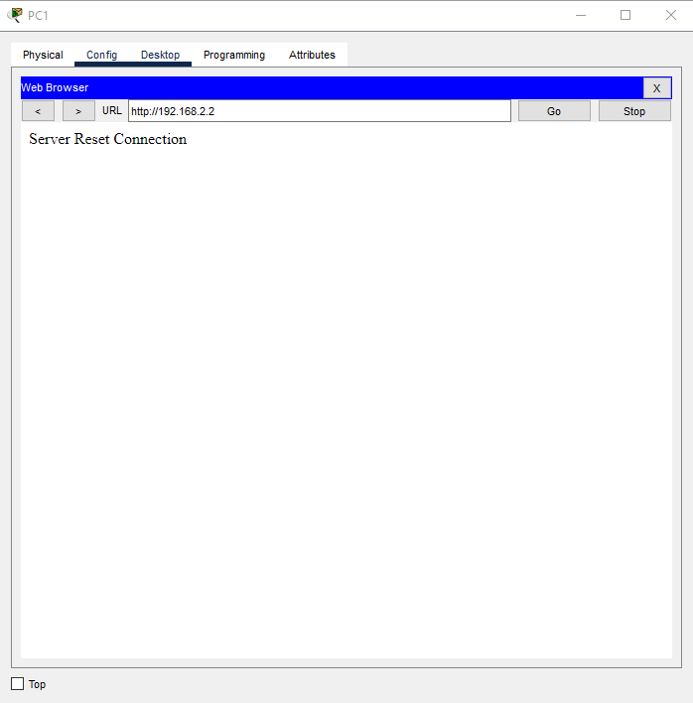

c) Network Address Translation: Static, Dynamic & PAT (Port Address Translation)

**Use the same topology as used in above practical**

just delete switch1 and its PC'c, delete all PC's except pc0 and pc1, connect pc1 with switch0.

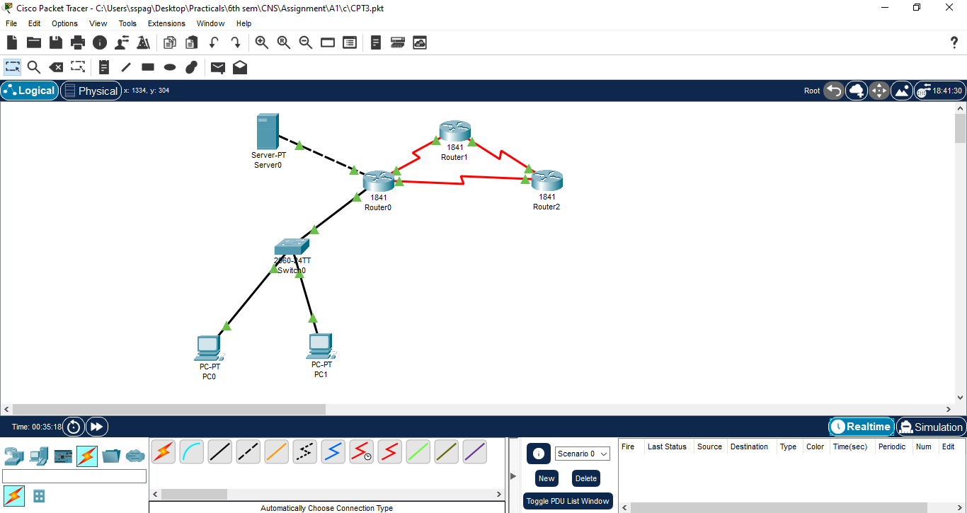

Requirements – three routers, one server0, one switch and 2 PC’s.

Join the Server0 and Router0 with a copper cross over cable.

**How to configure -**

1) Server0 – Double click on the server

Go to the Desktop tab

Click on IP configuration

Type: IP: 203.0.113.2

Subnet: 255.255.255.252

Gateway: 203.0.113.1

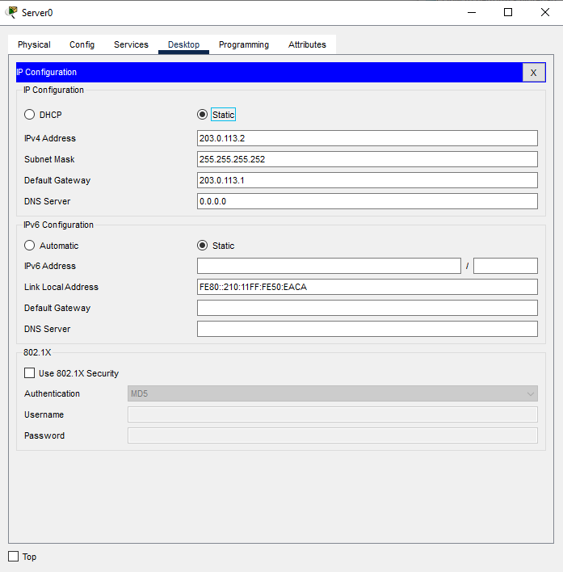

2) PC1 – Double click on it

Go to Desktop tab

Click on IP configuration

Type: IP: 192.168.1.3

Subnet Mask: 255.255.255.0

Default Gateway: 192.168.1.1

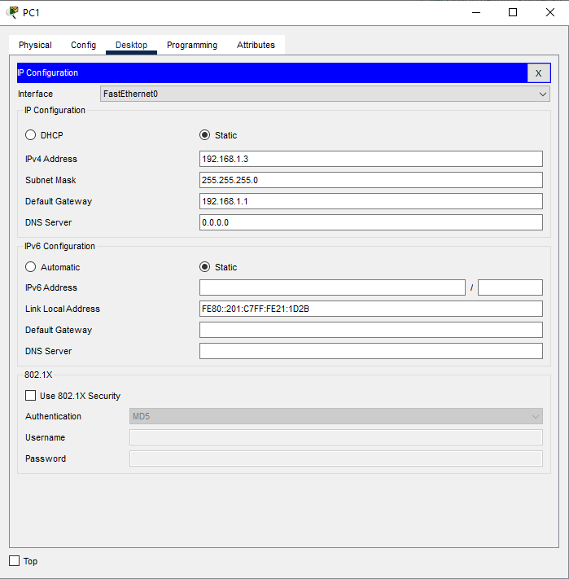

3) Router0 – Double click on it

Go to CLI section

Type: enable

configure terminal

! Interfaces

interface FastEthernet0/0

ip nat inside

exit

interface FastEthernet0/1

ip address 203.0.113.1 255.255.255.252

no shutdown

ip nat outside

exit

! NAT Rules

ip nat inside source static 192.168.1.5 203.0.113.10

ip nat pool PUBLIC_POOL 203.0.113.11 203.0.113.20 netmask 255.255.255.0

access-list 1 permit 192.168.1.0 0.0.0.255

ip nat inside source list 1 pool PUBLIC_POOL

ip nat inside source list 1 interface FastEthernet0/1 overload

! Routing

ip route 0.0.0.0 0.0.0.0 FastEthernet0/1

end

write memory

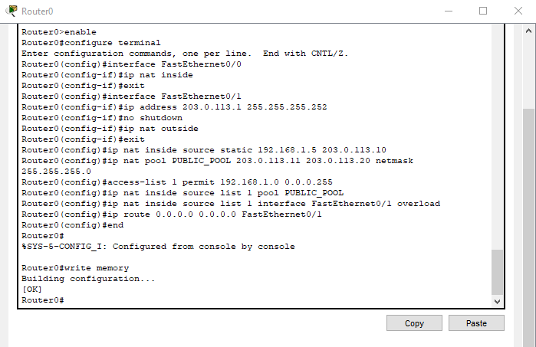

**Verification -**

Static NAT:-

From Command Prompt of Server0, give command

Type - ping 203.0.113.10 # Should reach 192.168.1.5

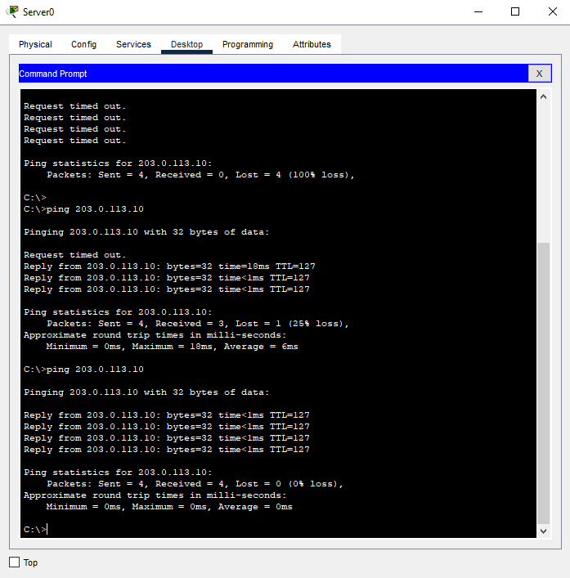

On Router0: Open CLI and Type - show ip nat translations

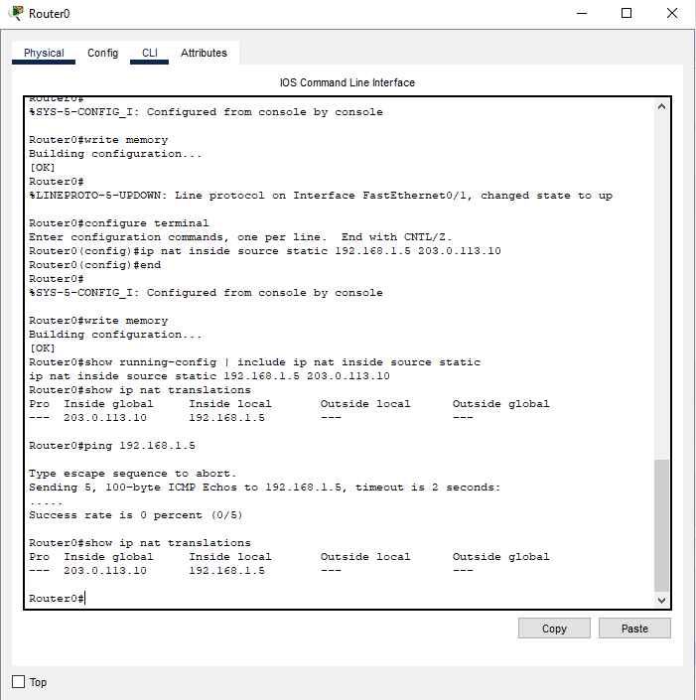

Dynamic NAT:-

From PC0 (192.168.1.2): Open Command Prompt and Type

[C:\](../../../../../../../)> ping 203.0.113.2

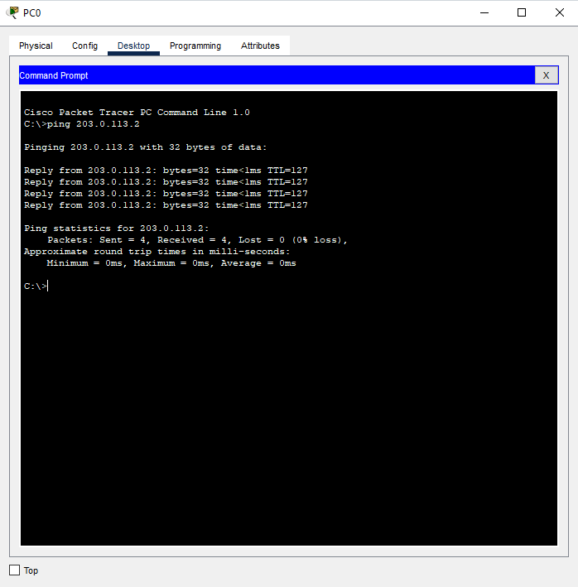

On Router0: Open CLI and Type - show ip nat translations

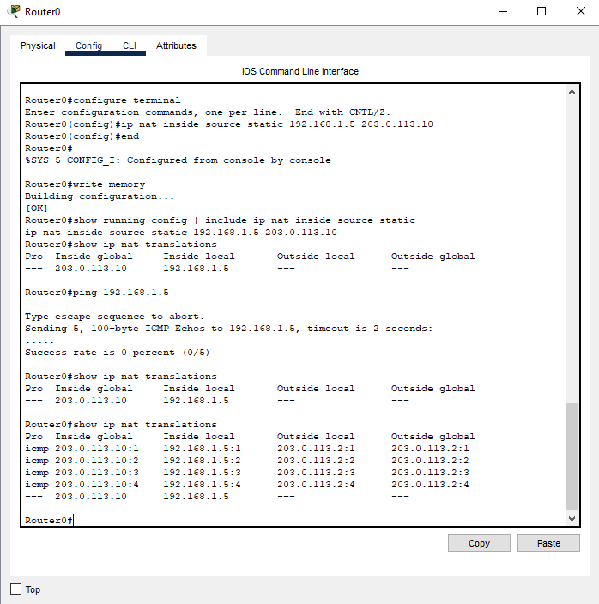

PAT:-

From PC0 and PC1 simultaneously: Open Command Prompt and run

Type - ping 203.0.113.2

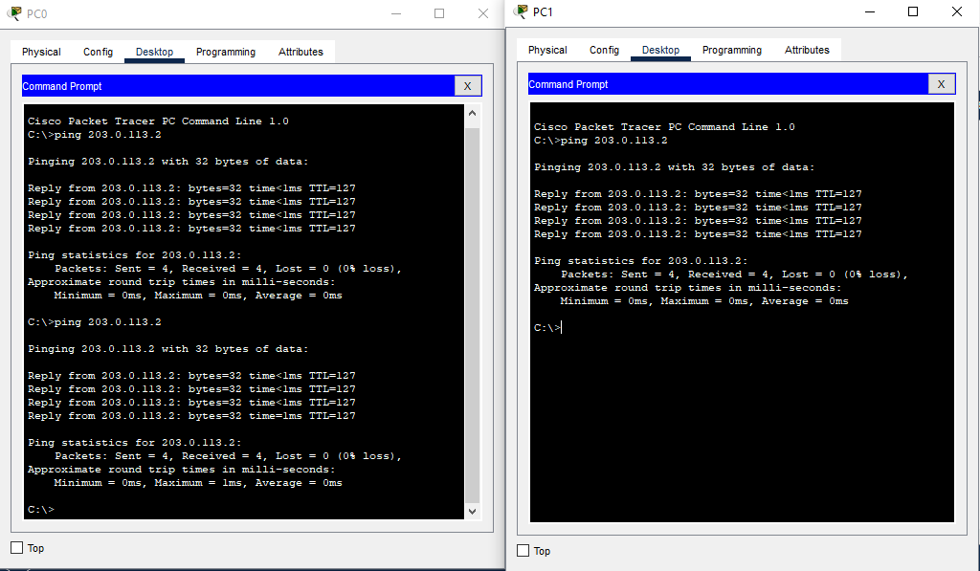

On Router0: Open CLI and Type - show ip nat translations

