# Name :- Sarthak Pagar

# Roll No. :- 40

# Class :- TE (IT)

# Practical A2 :- Using a Network Simulator (e.g. packet tracer) Configure Routing Protocols,

a) Configure EIGRP – Explore Neighbor-ship Requirements and Conditions, its K Values Metrics Assignment and Calculation.

b) OSPF – Explore Neighbor-ship Condition and Requirement, Neighbor-ship states, OSPF MetricCost Calculation.

c) WLAN with static IP addressing and DHCP with MAC security and filters.

a) Configure EIGRP – Explore Neighbor-ship Requirements and Conditions, its K Values Metrics Assignment and Calculation.

**Use below topology -**

Requirements - one PC0 device, four Router and a Server.

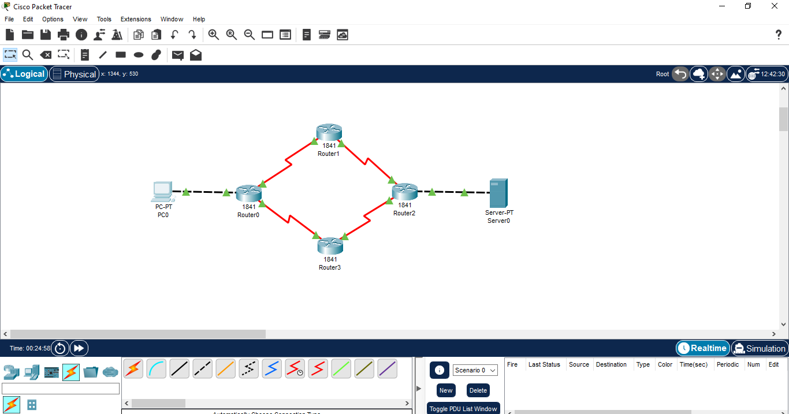

Configure PC0 with - IP Address: 192.168.1.10

Subnet Mask: 255.255.255.0

Default Gateway: 192.168.1.1

Configure Server0 with - IP Address: 192.168.2.10

Subnet Mask: 255.255.255.0

Default Gateway: 192.168.2.1

Configure all the Routers with their interface and eigrp

**How to configure all devices**

1) PC0 – Double click on device

Go to Desktop, click on IP configuration

Fill: IP Address: 192.168.1.10

Subnet Mask: 255.255.255.0

Default Gateway: 192.168.1.1

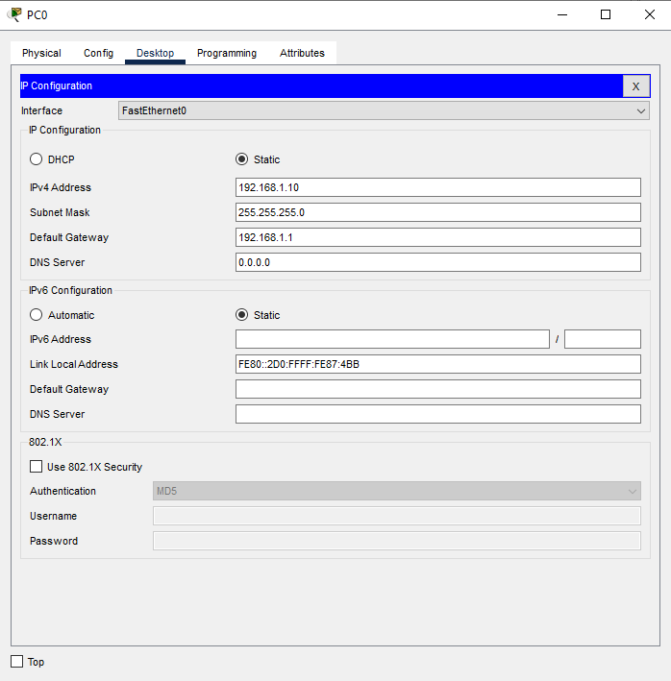

2) Server0 – Double click on server

Go to Desktop, click IP configuration

Fill: IP Address: 192.168.2.10

Subnet Mask: 255.255.255.0

Default Gateway: 192.168.2.1

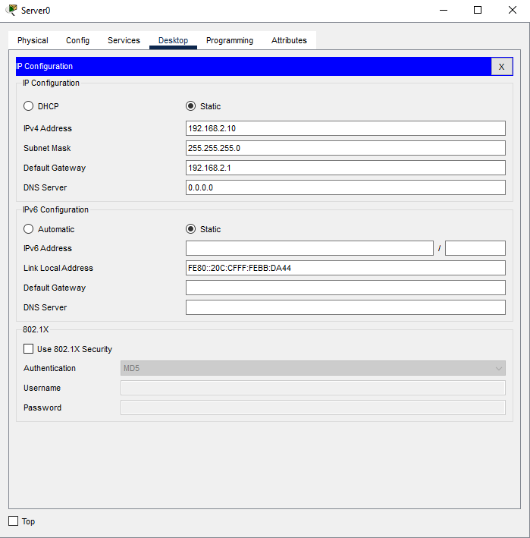

3) Routers – Switch OFF the router

Drag HWIC-2T from the modules section on the left

Power ON the router

Navigate to CLI and configure it

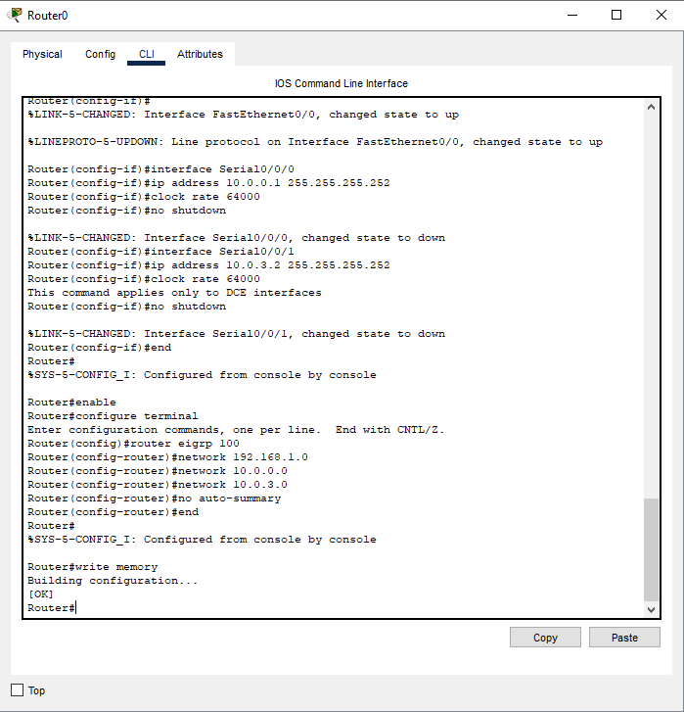

**Verify EIGRP Configuration**

Double click on router1, select CLI.

Use commands on any router - show ip eigrp neighbors

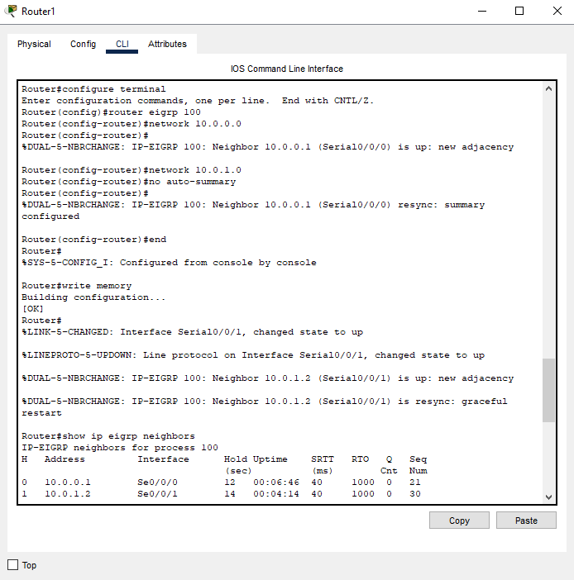

Check EIGRP Topology Table - show ip eigrp topology

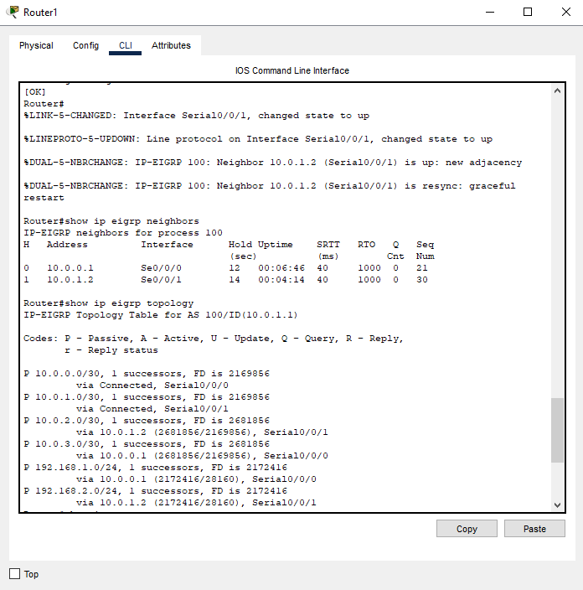

Check Routing Table - show ip route

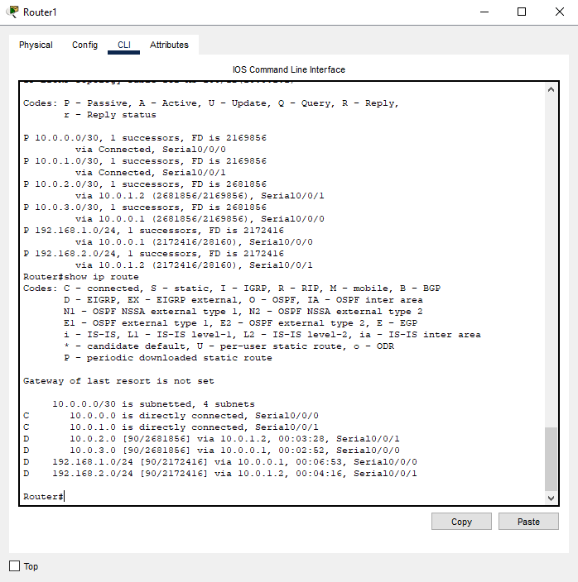

**Testing**

From PC0, open Command Prompt

Ping Server0 - ping 192.168.2.10

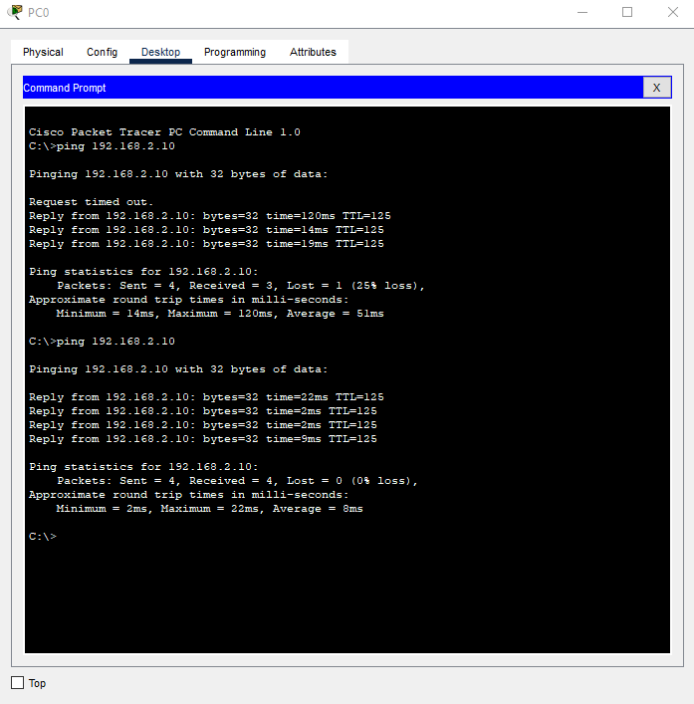

**K Values Metrics Assignment and Calculation**

Double click on Router3 and select CLI.

View Current K Values - show ip protocols

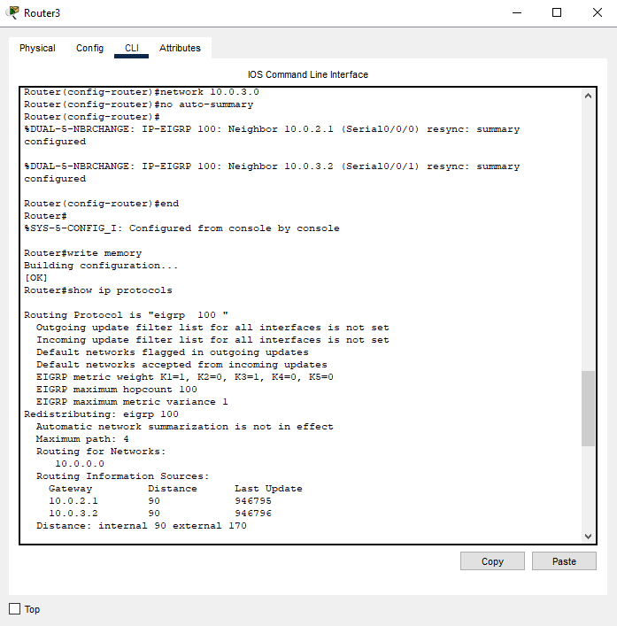

View Detailed Metric Components - show interface Serial0/0/0

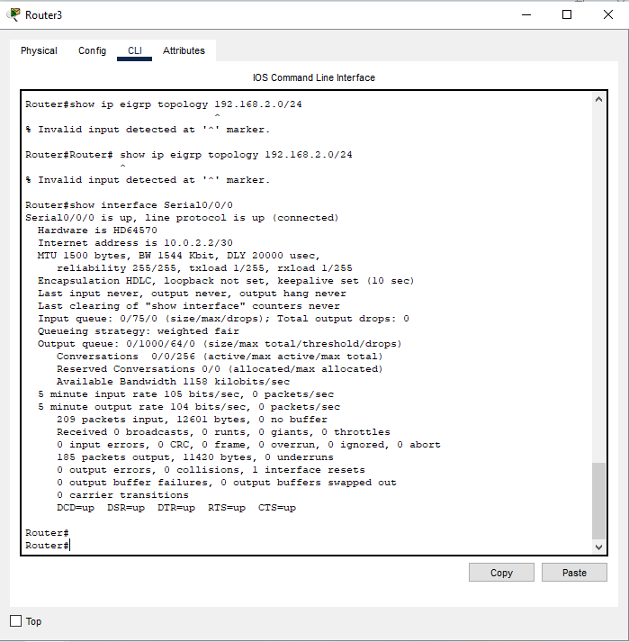

Double click on Router0 and select CLI

View EIGRP Metric Calculation - show ip eigrp topology 192.168.2.0 255.255.255.0

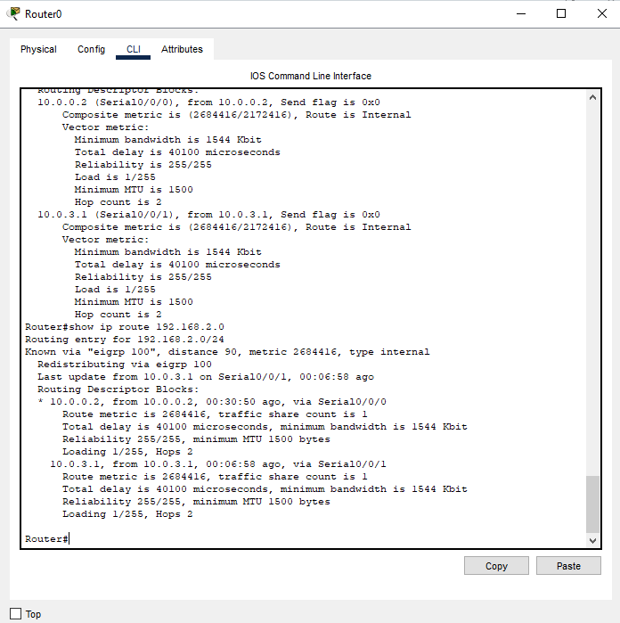

The metric calculation from your output:

Bandwidth term: 10^7/1544 = 6476

Delay term: 40100/10 = 4010

Composite metric: (6476 + 4010) * 256 = 2684416

**Verification**

On PC0's command prompt - ping 192.168.2.10

tracert 192.168.2.10

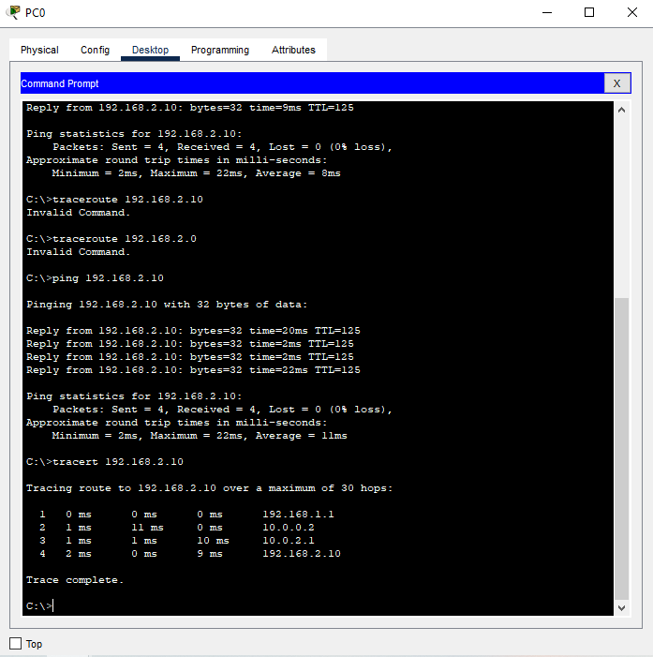

b) OSPF – Explore Neighbor-ship Condition and Requirement, Neighbor-ship states, OSPF MetricCost Calculation.

**Use the same topology used above** -

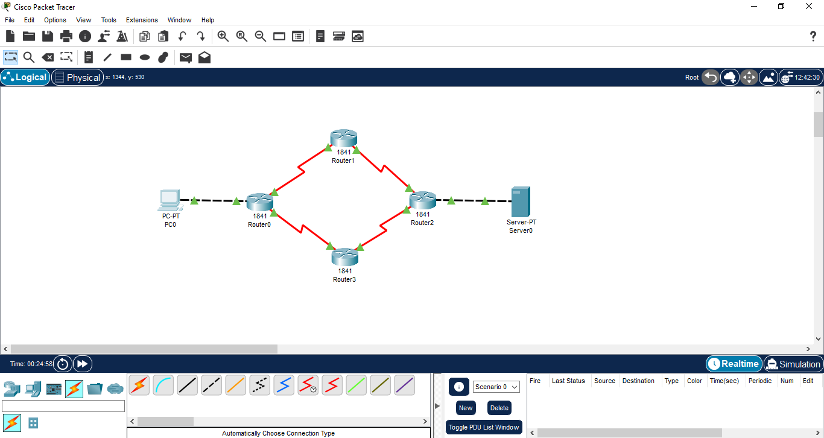

**Remove the EIGRP configuration from all routers**

Open all Router’s CLI and enter this commands

To remove use - enable

configure terminal

no router eigrp 100

end

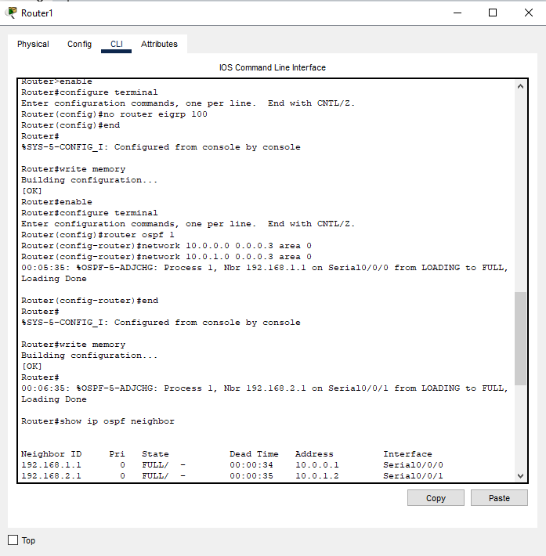

Configure OSPF on All Routers.

Verify OSPF Neighbor Relationships - show ip ospf neighbor

**OSPF Metric (Cost) Calculation**

Open any Router and select CLI

Verify OSPF Neighbor Relationships - show ip ospf neighbor

Check interface costs - show ip ospf interface

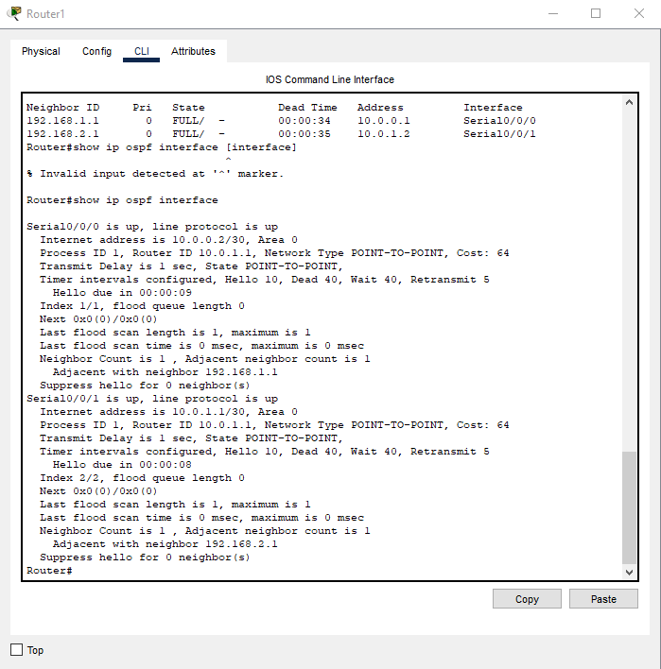

Cost = 100,000 Kbps / 1544 Kbps = 64

**Verify OSPF Operation**

Check routing table - show ip route ospf

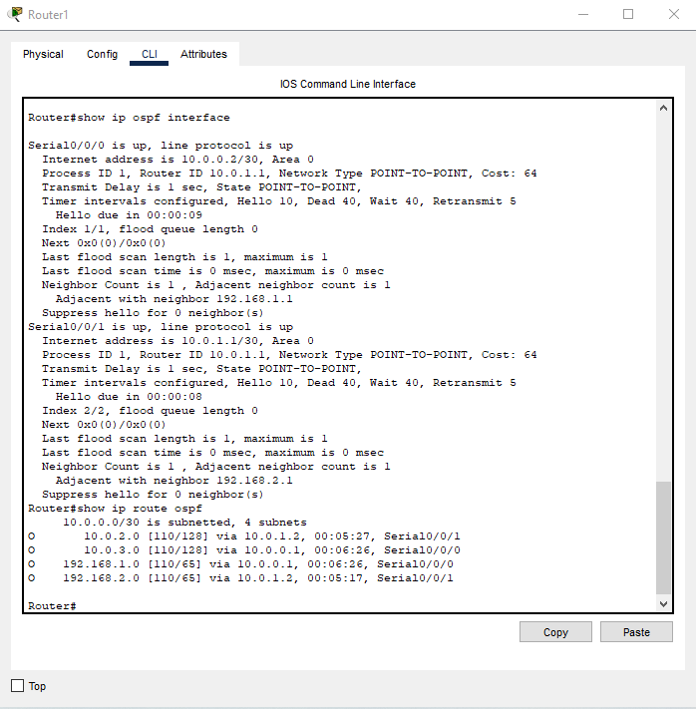

**Verify connectivity from PC0:**

Open command prompt - ping 192.168.2.10

tracert 192.168.2.10

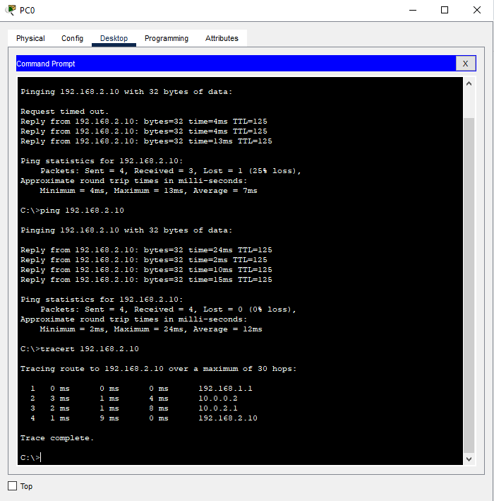

c) WLAN with static IP addressing and DHCP with MAC security and filters.

**Use below topology -**

Requirements – one WRT300N wireless router0 and three PC’s.

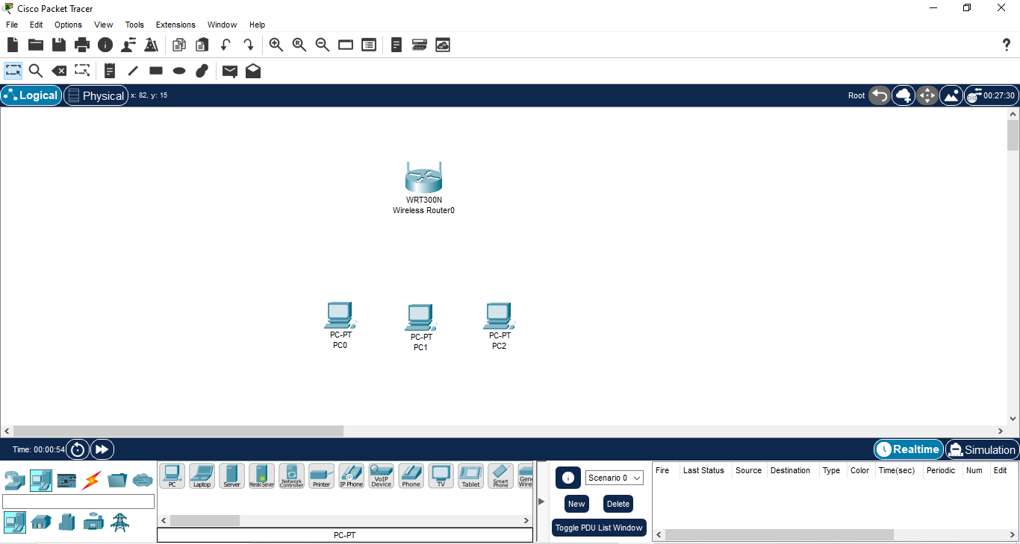

Add Wireless Adapters to PCs -

Click on PC0, Physical Tab, Power Off, Remove Ethernet NIC, Add Linksys-WMP300N,Power On

Do same for all three PC’s

**How to configure the PC’s** **-**

1) Double click on PC0, select Desktop and click IP configuration, select static IP.

IP: 192.168.1.50

Subnet Mask: 255.255.255.0

Gateway: 192.168.1.1

2) Double click on PC1, select Desktop and click IP configuration, select static IP.

IP: 192.168.1.51

Subnet Mask: 255.255.255.0

Gateway: 192.168.1.1

3) Double click on PC2, select Desktop and click IP configuration, select DHCP.

**Wireless Router Configuration**

Double click on wireless router, select GUI tab, select setup.

Type IP Address – 192.168.1.1

Subnet Mask - 255.255.255.0

DHCP Server - Enabled

Start IP - 192.168.1.10

Max Users - 50

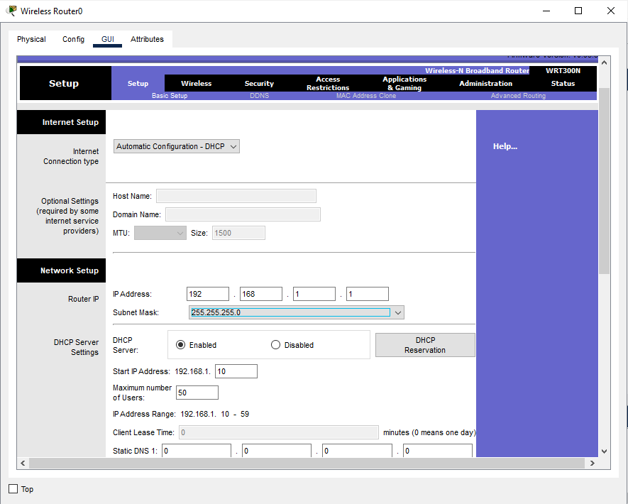

Now, navigate to Wireless section, inside of Basic Wireless Settings

SSID – SecureWLAN

Standard Channel – 6

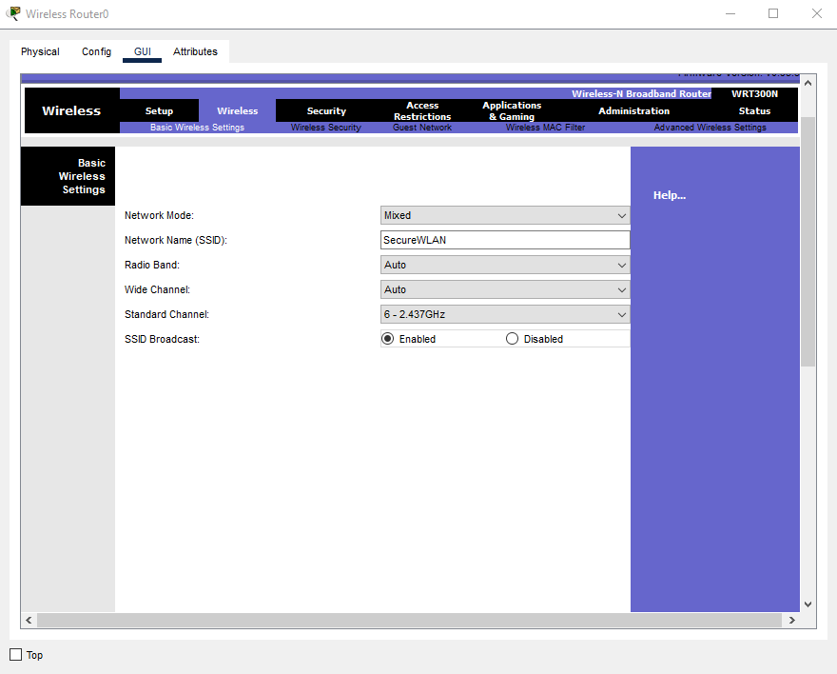

Now change the section to Wireless Security inside Wireless part below

select Authentication – WPA2-PSK

Passphrase – Cisco1234

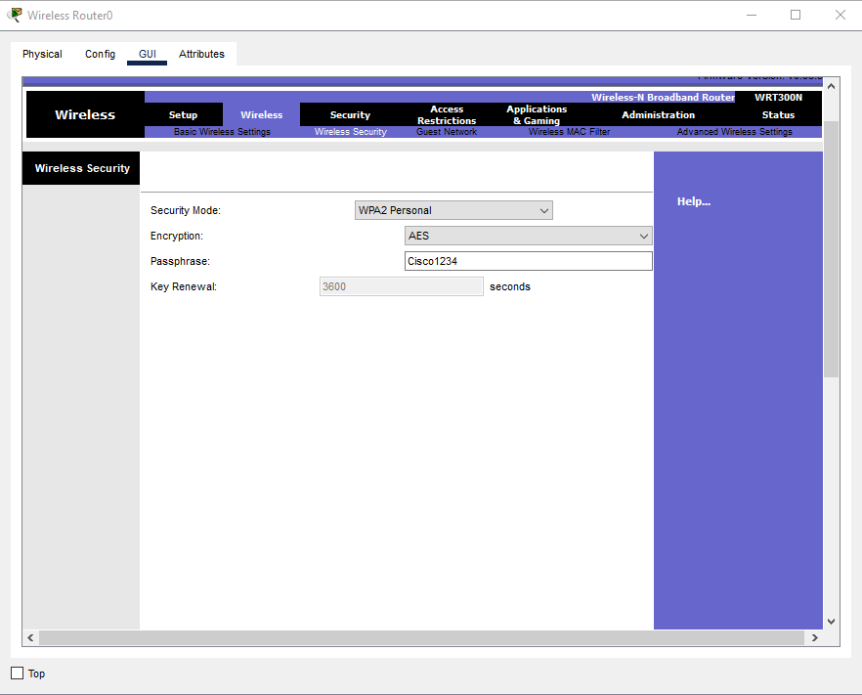

**MAC Security**

Navigate to Wireless MAC Filter inside Wireless tab

Enable the MAC Filtering

Select Prevent PC’s listed below from accessing the wireless network

Add PC2’s MAC address (found under PC2 → Config → Wireless)

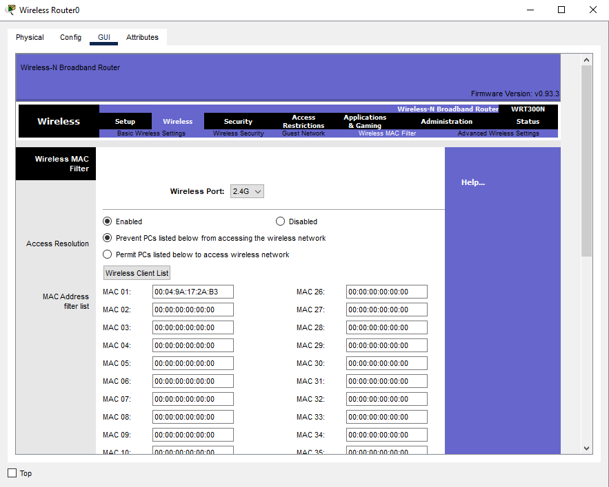

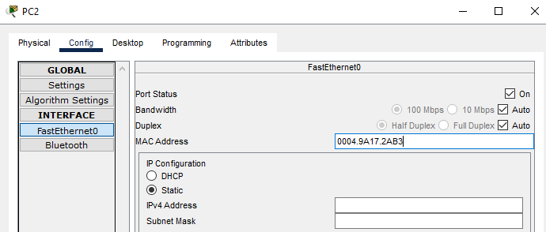

Now double click on PC0, open Desktop, and select PC Wireless, click on connect, you will see SecureWLAN network, click connect and it will ask you for pre-shared key that is your passphrase

which is Cisco1234.

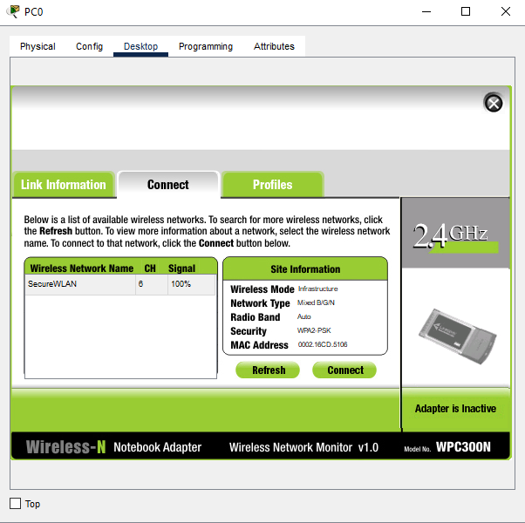

Put your Pre-Shared key i.e. Cisco1234. Click connect.

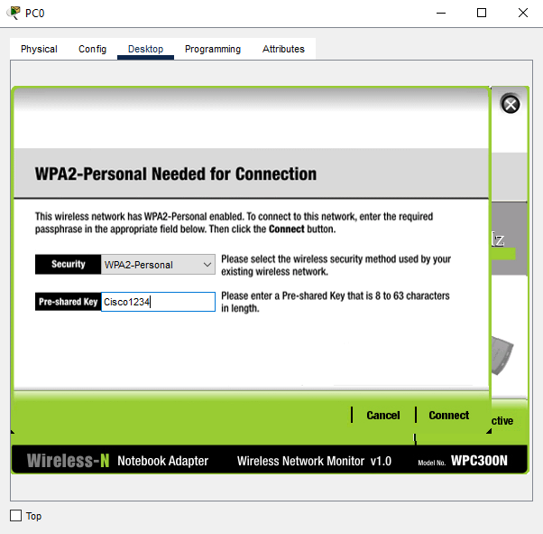

You will see your PC0 is connected with the network.

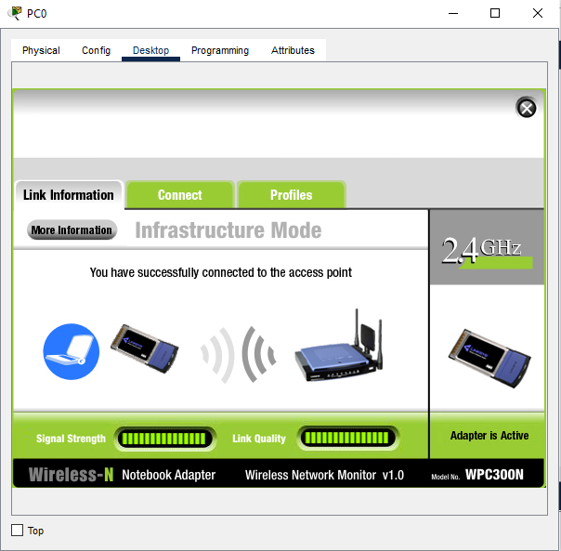

Do same with the PC1 and you will see that PC1 is also connected to the network.

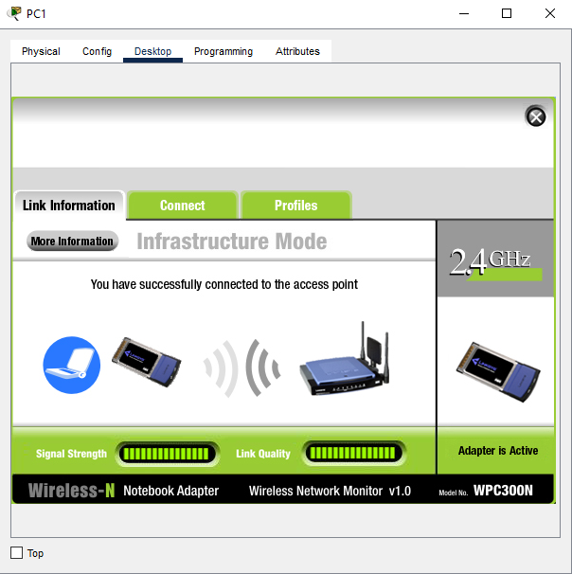

When you try to do same with PC2, you will not able to see the network. This is because you have added the MAC address of PC2 in the MAC Security of Wireless Router0. It prevents the connection between wireless network and your device.

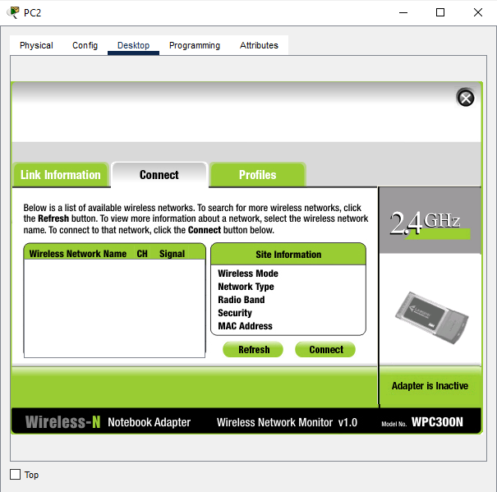

This is the logical view after the Wireless MAC Security configuration.

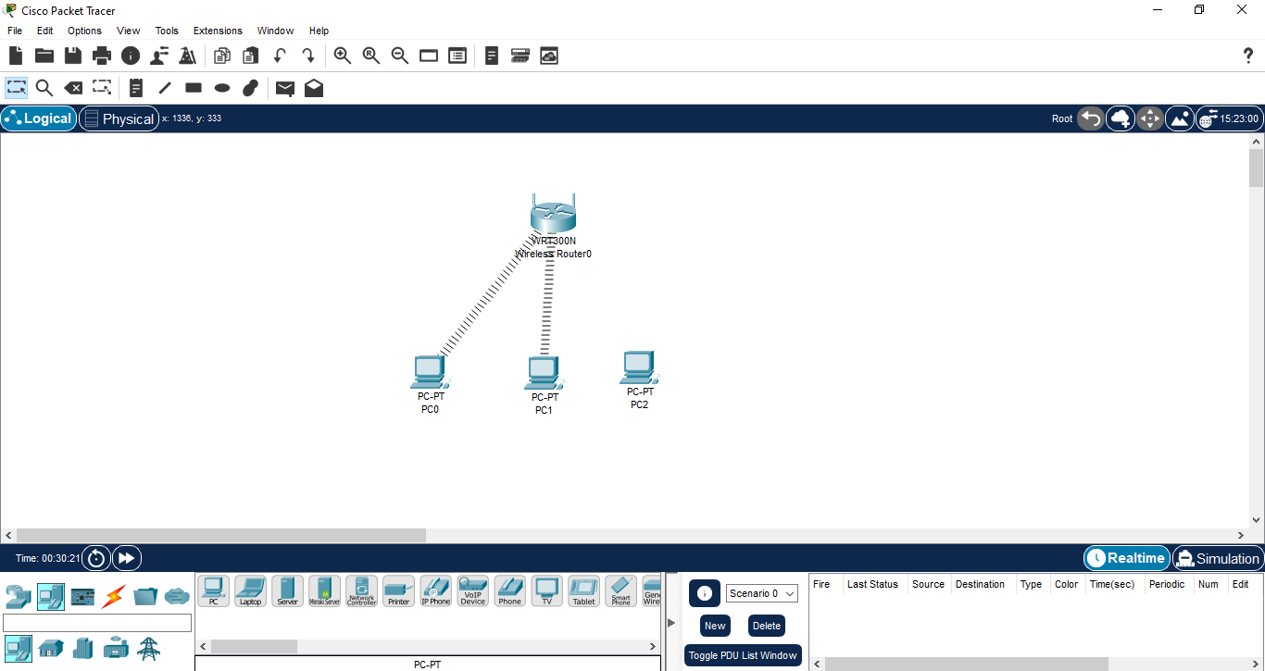

**MAC Filtering**

Here we can filter the Wireless MAC Security. Navigate to the Wireless MAC setting in the GUI tab of Wireless Router0.

Change the setting from Prevent PC’s listed below to Permit PC’s listed below to access wireless network.

At last save the settings.

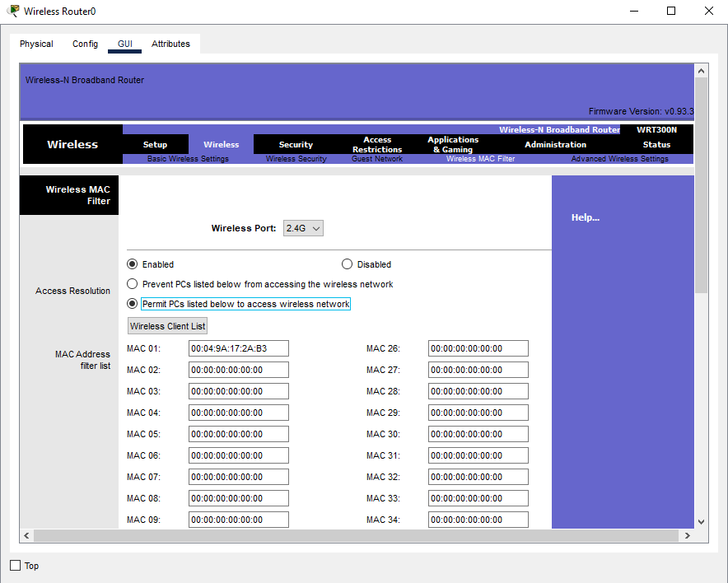

Open PC2, Go to Desktop and click PC Wireless, in connect section you will see the SSID and connect it with pre-shared key i.e. Cisco1234.

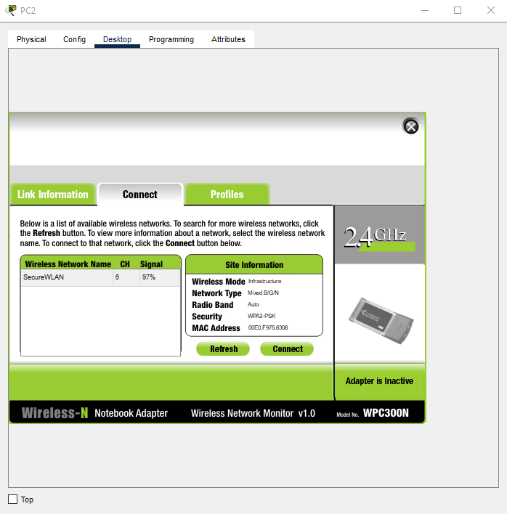

You will see that PC2 is successfully connected to the network.

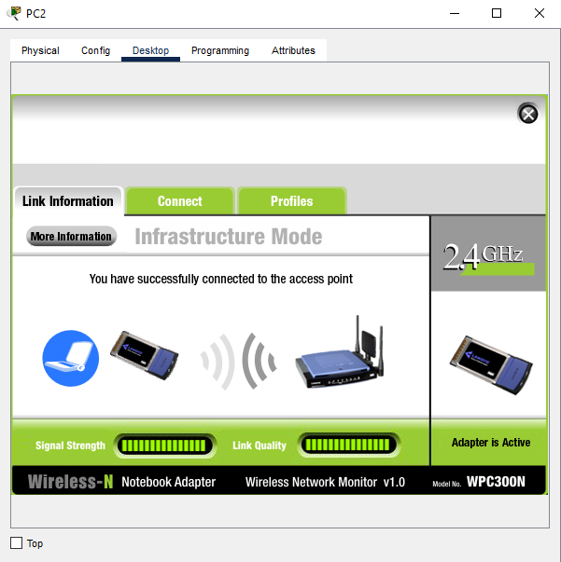

This is the final look after MAC filtering. This will restrict the PCs whose MAC address not saved in the Wireless MAC filter to not to connect to the Wireless Router0.

