SANJIVANI UNIVERSITY
Department of Integrated B.Tech
Kopargaon, Dist. Ahmednagar, Maharashtra
Computer Organization and Architecture (COA)
CO5 Assessment: Micro Project
PIPELINE EXECUTION SIMULATOR
Stages, Hazards and Stalls in a Five-Stage RISC Pipeline
A web-based, step-by-step simulator built with HTML, CSS and JavaScript
Submitted by
SARTHAK TURKANE
PRN | 2125UIDM1080
Class | SY CSE, Integrated B.Tech Computer Science and Engineering
Topic chosen | Topic 4: Pipeline execution (stages, hazards, stalls)
Project type | Individual micro project
Submitted to | Prof. Ankita A (Course Faculty, COA)
Submission date | October 2026 (last date: 22/10/2026)
Deliverables | PipelineSimulator.html (the simulator) and this report

Declaration of Originality
I, Sarthak Turkane (PRN 2125UIDM1080), declare that the simulator and this report were developed by me for the CO5 micro project of Computer Organization and Architecture. The simulator was written from scratch as a single HTML file using only HTML, CSS and JavaScript. It does not use any external library, framework, downloaded project or network resource, and it runs completely offline in a web browser.
The ideas of pipelining, hazards, forwarding and branch handling are taken from standard textbooks, which are listed in the references. All program code, diagrams, test programs and results in this report are my own work.

Signature: ______________________ Date: ______________
Sarthak Turkane, PRN 2125UIDM1080

Contents
1. Introduction
2. Theory of Pipelined Execution
3. Design of the Simulator
4. Implementation
5. User Manual
6. Worked Examples
7. Testing and Results
8. Mapping to the Evaluation Rubric
9. Limitations and Future Scope
10. Conclusion
11. Viva Preparation: Questions and Answers
12. Demonstration Script
References
A. Appendix A: Example Programs
B. Appendix B: Source Code of the Assembler and Engine

1. Introduction

1.1 Background
A processor that executes one instruction completely before starting the next one leaves most of its hardware idle at any moment. While the arithmetic unit works, the instruction memory and the register file wait. Pipelining removes this waste by splitting instruction execution into stages and letting several instructions occupy different stages at the same time, in the same way as workers on an assembly line. In the ideal case one instruction finishes every clock cycle, even though each single instruction still takes several cycles from start to end.
Real programs do not always allow this ideal flow. An instruction may need a value that an earlier instruction has not produced yet, or a branch may change the path of the program after the processor has already fetched the wrong instructions. These situations are called hazards. They force the pipeline to wait (stall) or to throw away work (flush), and they are the main reason that real pipelines run slower than the ideal one-instruction-per-cycle limit.

1.2 Problem statement
The CO5 notice asks every student to build a simulation or model on one of four topics. This project selects Topic 4: Pipeline execution (stages, hazards, stalls). The task is to build an interactive simulator that executes a small program on a five-stage pipeline, shows what happens in every stage in every clock cycle, detects hazards, applies stalls, forwarding and flushing, and reports performance, while letting the user change the program and the pipeline parameters.

1.3 Objectives
- Model a classic five-stage RISC pipeline (IF, ID, EX, MEM, WB) cycle by cycle.
- Show the working step by step, with a clear input (assembly program and initial state) and a clear output (registers, memory, timing diagram, statistics).
- Detect and display data hazards (RAW and load-use), control hazards (branches and jumps) and memory wait states, together with the stall or flush they cause.
- Let the user change parameters: data forwarding on or off, the stage in which a branch is resolved, the branch policy and the memory latency.
- Prove that the pipelined result is correct by comparing it with a simple non-pipelined execution of the same program.
- Provide performance figures (cycles, CPI, stall counts, speedup over no pipelining) and a comparison of several pipeline designs on the same program.

1.4 Scope
The simulator covers an in-order, single-issue, five-stage integer pipeline in the style of the classic MIPS design described in the standard textbooks. It supports thirteen instructions (plus two pseudo instructions), 32 registers and 256 words of data memory. Caches, floating-point units, interrupts and superscalar execution are outside the scope (see Chapter 9).

1.5 Choice of tool
The notice allows Python, C, C++, Java or a web-based HTML and JavaScript simulator. A web-based simulator was chosen for the following reasons:
- Nothing to install. The whole simulator is one HTML file that opens in any modern browser, so it can be demonstrated on any computer and also on a phone.
- Natural visualisation. The timing diagram, the stage boxes, the register file and the memory are tables and boxes that HTML and CSS draw directly, and they update instantly after each step.
- Interactivity. Buttons, drop-down lists and a text editor give the user direct control of the parameters and the program without a command line.
- Easy submission. One self-contained file is easy to upload through the Google form and cannot break because of a missing library.

2. Theory of Pipelined Execution

2.1 The five stages
The simulator follows the classic five-stage organisation. Each stage takes one clock cycle, and pipeline registers between the stages hold the values that move from one stage to the next.
Table 1: The five pipeline stages
Stage | Name | Work done in this stage | Main hardware
IF | Instruction Fetch | Read the instruction at the address in the PC and advance the PC | PC, instruction memory
ID | Instruction Decode | Decode the instruction, read the source registers, check for hazards, handle jumps | Register file, hazard unit
EX | Execute | Perform the ALU operation or compute the memory address, compare for branches | ALU, comparator
MEM | Memory Access | Load from or store to data memory (lw, sw) | Data memory
WB | Write Back | Write the result into the destination register | Register file

2.2 Pipeline performance
Let k be the number of stages and n the number of instructions. Without pipelining, every instruction needs k cycles, so the program needs n x k cycles. In an ideal pipeline the first instruction needs k cycles and every further instruction completes one cycle later:
Non-pipelined cycles = n x k
Ideal pipelined cycles = k + (n - 1)
Ideal speedup = (n x k) / (k + n - 1), tends to k for large n
CPI = total cycles / n
CPI with stalls = 1 + stall cycles per instruction (large n)

Example: five independent instructions on the five-stage pipeline need 5 + 4 = 9 cycles instead of 25. The simulator reproduces this value exactly (Chapter 7). Every stall or flush adds cycles to this ideal figure, so the CPI rises above 1.

2.3 Pipeline hazards
A hazard is a situation that prevents the next instruction from executing in its normal clock cycle. There are three classes.

Structural hazards
Two instructions need the same hardware in the same cycle. The classic five-stage design avoids this by having separate instruction and data memories and by writing the register file in the first half of the clock cycle and reading it in the second half. The simulator therefore has no structural hazard, except that a slow data memory (latency above one cycle) keeps an instruction in MEM and holds back all earlier stages, which the simulator models as memory wait stalls.

Data hazards
An instruction needs a value that an earlier instruction has not yet written back. The dependency types are read after write (RAW), write after read (WAR) and write after write (WAW). In an in-order pipeline where registers are written only in the last stage, WAR and WAW cannot cause wrong results, so only RAW hazards need handling. Example:
add r2, r1, r1 # writes r2 in stage WB, cycle 5
sub r3, r2, r1 # wants r2 in stage ID, cycle 3 (too early)

Control hazards
A branch or jump changes the program counter, but the pipeline has already fetched the instructions that follow it in memory. Until the branch outcome is known the processor does not know which instructions to fetch.

2.4 Resolving data hazards
Stalling. The hazard unit holds the dependent instruction in the ID stage and inserts bubbles (empty slots) into the following stages until the value is available in the register file. Without forwarding, a dependent instruction right behind its producer waits two extra cycles.
Forwarding (bypassing). The result of the ALU is already known at the end of EX. Extra paths carry it from the EX/MEM and MEM/WB pipeline registers directly to the ALU inputs, so the dependent instruction does not have to wait for write back. Forwarding removes almost all data stalls.
Load-use hazard. A load gets its value only at the end of MEM, which is one stage too late for the instruction directly behind it. Even with forwarding, such an instruction must wait one cycle. This is the one data stall that forwarding cannot remove.

2.5 Resolving control hazards
The simulator supports two policies for conditional branches.
- Predict not taken and flush. Fetching simply continues with the next instructions. If the branch turns out to be taken, the wrongly fetched instructions are flushed (turned into bubbles) and the PC is redirected to the target. If the branch is not taken, nothing is lost.
- Stall fetch. As soon as a branch is decoded, fetching stops until the branch is resolved. This wastes slots for every branch, taken or not.
The branch penalty depends on the stage where the branch is resolved. If resolved in ID the penalty is one lost slot, in EX two slots, in MEM three slots. Jumps (j) are always resolved in ID with one lost slot. Resolving early is cheaper, but it needs the comparison operands one stage earlier, which can create a data stall of its own (see Section 6.3).

2.6 Pipeline timing diagram
The standard way to show pipeline behaviour is a table with one row per instruction and one column per clock cycle. Each cell holds the stage that the instruction occupies in that cycle. A stall appears as a repeated stage name, and a flushed instruction is marked as removed. The simulator draws this diagram live (examples in Chapter 6), using a hatched cell for a stall and a black cell with X for a flush so that it prints correctly in black and white.

3. Design of the Simulator

3.1 Requirements
Table 2 lists each requirement of the notice and how the design meets it.
Table 2: Requirements from the notice and how they are met
Requirement in the notice | How the simulator meets it
Simulation of one listed topic | Topic 4: pipeline execution with stages, hazards and stalls
Working shown step by step | One button press executes exactly one clock cycle. A Back button returns one cycle. Play and Run to end are also available.
Clear input | Assembly program editor, initial register values, initial memory values, example programs
Clear output | Stage boxes, timing diagram, register file, data memory, statistics, correctness check
At least a few adjustable parameters | Forwarding on or off, branch resolution stage (ID, EX, MEM), branch policy (predict not taken or stall), memory latency (1 to 6 cycles), plus the program itself
Hazard display | Stalled cells are hatched, flushed cells are black, and a log under the stage boxes names the cause of every stall, flush and forwarding action
Original work | Written from scratch in one HTML file with no external code

3.2 Software architecture
The program is split into small parts with clear jobs (Figure 1). The assembler turns the text of the program into instruction records. The pipeline engine advances the machine by one clock cycle each time it is asked and keeps a history of every cycle. A separate non-pipelined reference model runs the same program to verify the result. The user interface only reads the engine state and the history and draws them, so the simulation logic is independent of the screen.
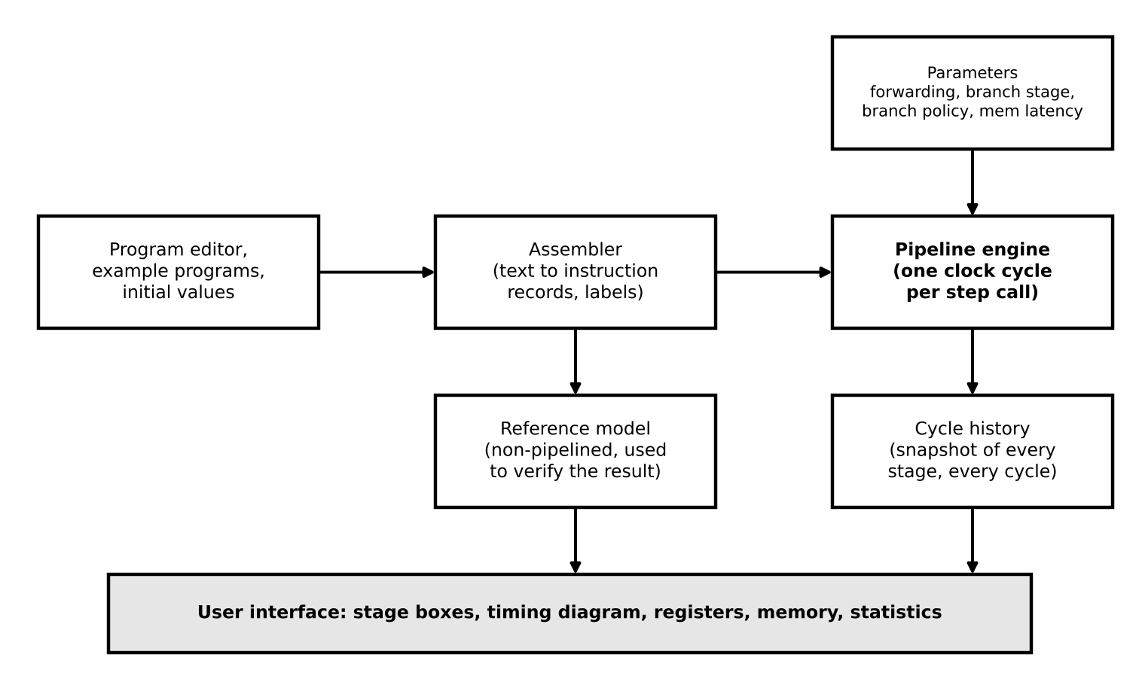
Figure 1: Software architecture of the simulator

3.3 Instruction set
A small MIPS-like instruction set is enough to create every kind of hazard while keeping the programs easy to read.
Table 3: Supported instructions
Instruction | Form | Meaning
add, sub, and, or, slt | op rd, rs, rt | rd = rs op rt (slt sets rd to 1 if rs < rt, else 0)
addi | addi rd, rs, imm | rd = rs + imm
lw | lw rt, off(rs) | rt = memory[rs + off]
sw | sw rt, off(rs) | memory[rs + off] = rt
beq, bne | beq rs, rt, label | Branch to label if rs equals (beq) or differs from (bne) rt
j | j label | Jump to label
nop, halt | nop | Do nothing; halt marks the end of the program
li, move | li rd, imm | Pseudo instructions, assembled as addi rd, r0, imm and add rd, rs, r0
There are 32 registers named r0 to r31 (r0 always reads as zero). MIPS names such as $t0 or $s1 are also accepted. Data memory has 256 words; addresses are in bytes and must be multiples of 4, so word 2 has address 8. An implicit halt is added after the last instruction so that the pipeline always drains.

3.4 Pipeline datapath
Figure 2 shows the organisation that the simulator models. The four grey bars are the pipeline registers (IF/ID, ID/EX, EX/MEM and MEM/WB). Dashed lines are the forwarding paths from EX/MEM and MEM/WB back to the ALU inputs. The dotted line is the redirect of the PC after a branch or jump. The register file is written in WB in the first half of the cycle, so an instruction in ID reads the new value in the same cycle.
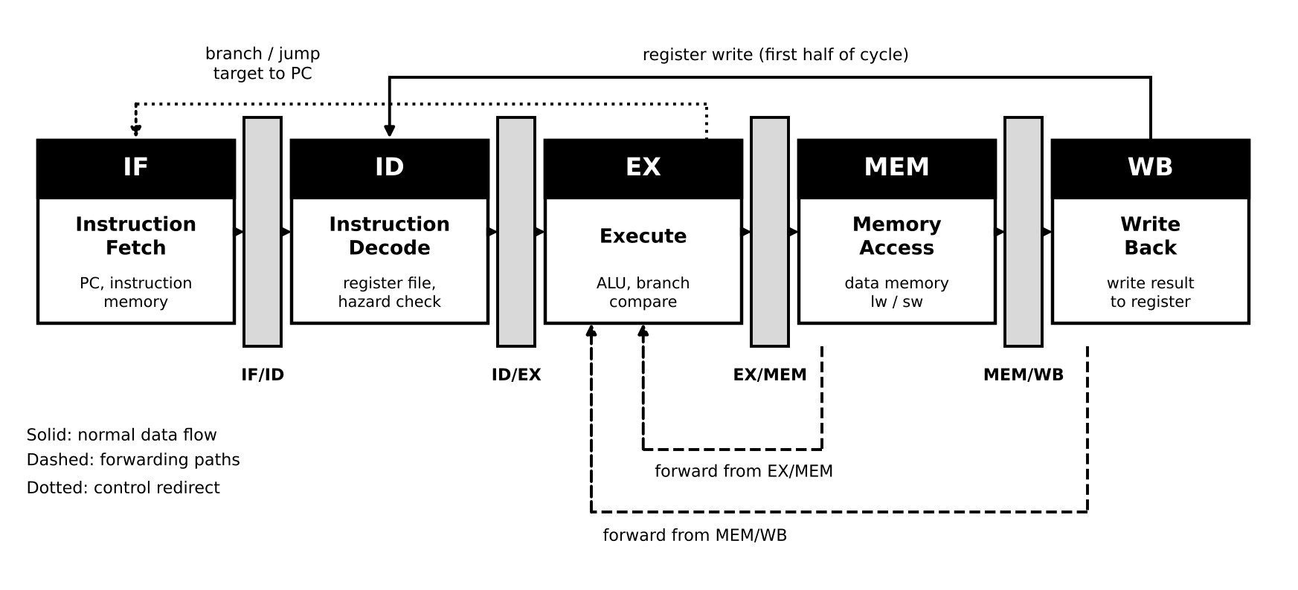
Figure 2: Five-stage pipeline with forwarding paths

3.5 Hazard detection and forwarding rules
Table 4: Rules used by the hazard unit
Situation | Rule applied by the simulator
Forwarding off | An instruction in ID stalls while any source register is the destination of an instruction in EX or MEM. A producer in WB needs no wait because the register file is written in the first half of the cycle.
Forwarding on, ALU producer | No stall. The result is forwarded from EX/MEM (producer one instruction ahead) or from MEM/WB (producer two ahead) to the ALU input of the consumer in EX.
Forwarding on, load producer | Load-use hazard. The consumer stalls in ID for one cycle, then receives the loaded value through MEM/WB.
Branch resolved in ID | The comparison happens in ID. Without forwarding the branch waits for producers in EX and MEM. With forwarding it waits only for a producer in EX, or for a load in MEM; an ALU result in MEM is forwarded to ID.
Slow memory | A lw or sw stays in MEM for the number of cycles set as memory latency. All earlier stages are frozen and each extra cycle counts as a memory wait stall.

3.6 Branch handling model
Table 5: Branch penalty by resolution stage (taken branch, predict not taken)
Resolved in | Slots lost | Why
ID | 1 | Only the instruction fetched in the same cycle is on the wrong path. The branch may also stall in ID if its operands are not ready.
EX | 2 | The instructions in IF and ID are on the wrong path.
MEM | 3 | The instructions in IF, ID and EX are on the wrong path.
With the stall policy the simulator freezes fetching as soon as the branch is decoded and resumes at the correct address when the branch resolves. For a taken branch this costs about the same as flushing, but it also costs cycles when the branch is not taken, which the comparison table in Chapter 6 shows.

3.7 Per-cycle algorithm
Figure 3 gives the flowchart of one clock cycle. The stages are evaluated from the last stage to the first (WB, MEM, EX, ID, IF). This order matters. Evaluating the later stages first means that every stage sees the state that existed at the start of the cycle, exactly as the real clocked hardware does, and a stage can still tell whether it must stall or flush the stages behind it. After all stages are processed, the pipeline registers shift, the cycle is stored in the history and the statistics are updated.
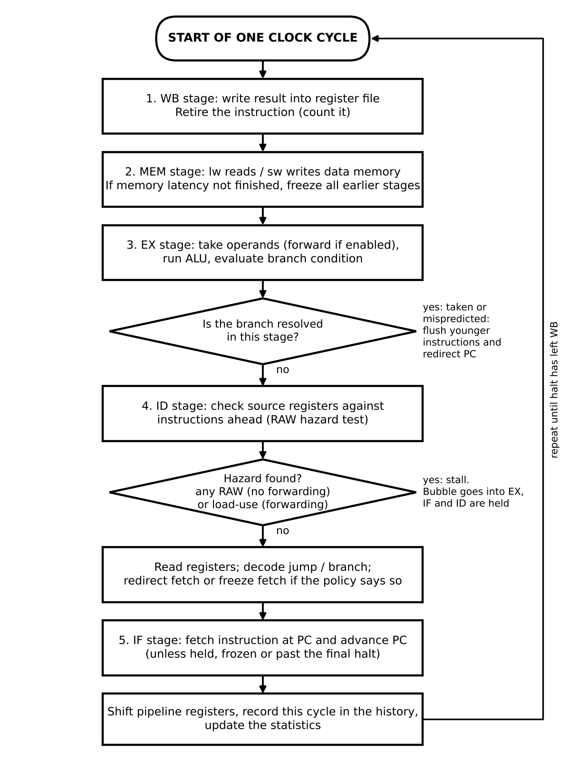
Figure 3: Flowchart of one simulated clock cycle
Pseudo code of one call to step():
step():
cycle = cycle + 1
WB : write result to register file; count the instruction as completed
MEM: if lw/sw: wait until latency is used up (else freeze earlier stages),
then read or write data memory
if branch resolves here: flush younger stages, redirect PC
EX : read operands (forwarded if enabled), run ALU, evaluate branch condition
if branch resolves here: flush younger stages, redirect PC
ID : if a source register is not ready: STALL (bubble to EX, hold ID and IF)
else read registers; jump or early branch: redirect PC, flush IF
IF : fetch instruction at PC (unless held or fetch is frozen)
shift pipeline registers; store snapshot of this cycle; update statistics
stop after the halt instruction has left WB

3.8 Data structures
Table 6: Main data structures
Structure | Contents
Instruction record | op, rd, rs, rt, imm, branch target, source text, plus derived fields: dest (register written, or -1), srcs (registers read), isBranch, isJump, isMem
In-flight record | Instruction id, its program position, operand values, ALU result, branch outcome, memory data, a squashed flag and the remaining memory cycles
occ[0..4] | The in-flight record currently in IF, ID, EX, MEM and WB (or empty for a bubble)
Register file, data memory | Int32Array(32) and Int32Array(256), so arithmetic wraps like 32-bit hardware
History | One snapshot per cycle: the state of every stage (running, stalled, flushed or empty), forwarding events, register or memory write, and the register values
Statistics | Cycles, completed instructions, data stalls, control slots lost, memory stalls, forwards used, branches, taken branches, non-pipelined cycle count

3.9 Design decisions and assumptions
- Every stage takes one clock cycle, except MEM for lw and sw when the user raises the memory latency.
- Instruction fetch always hits. There is no instruction cache and no instruction memory delay.
- The register file is written in the first half of a cycle and read in the second half, so a value written by WB is visible to ID in the same cycle.
- Instructions execute in order and registers are written only in WB, so only RAW hazards are modelled (WAR and WAW cannot occur).
- Branch prediction is static: always predict not taken. There is no dynamic predictor and no branch delay slot.
- Writes to r0 are ignored and r0 always reads as zero, as in MIPS.
- An out-of-range or unaligned memory access stops the simulation with a clear error message instead of failing silently.
- The number of stages is fixed at five, which is the standard textbook pipeline. Depth is varied indirectly through the branch resolution stage and the memory latency.

4. Implementation

4.1 Structure of the code
The deliverable is one file, PipelineSimulator.html, containing HTML for the layout, CSS for the styling and three JavaScript blocks. The same code was kept as three source files during development and merged into the single file by a small build script, so the submitted file needs no other file.
Table 7: Parts of the single file
Part | Lines | Responsibility
Assembler | 160 | Parses the program text, resolves labels, reports errors with line numbers, and also contains the non-pipelined reference interpreter
Pipeline engine | 244 | The cycle-by-cycle simulation: stages, hazards, forwarding, stalls, flushing, memory latency, statistics, history
User interface | about 450 | HTML layout, CSS styling and the script that connects the controls to the engine and draws the screen

4.2 Assembler
The assembler works in two passes over the text. In the first pass it removes comments (starting with #, ; or //), collects labels (a name followed by a colon, possibly on the same line as an instruction) and stores each remaining line as an instruction slot. In the second pass it splits every line into the operation and its operands, checks the number and type of the operands, converts register names and numbers, and resolves branch and jump labels to instruction positions. Every problem is reported with its line number, for example "Line 2: Unknown instruction: foo", and the simulation does not start until the program is correct.
For each instruction the assembler also fills in two derived fields that the hazard logic depends on: dest, the register the instruction writes (or -1 if it writes none, which includes writes to r0), and srcs, the list of registers it reads. For example sw rt, off(rs) reads rs and rt and writes nothing, while lw reads rs and writes rd. A halt instruction is appended automatically.

4.3 Pipeline engine
The engine object keeps the registers, memory, the five in-flight slots and the statistics. Its step() method follows the algorithm of Figure 3. Important implementation details are listed below.
- Stall. When ID finds a hazard, the instruction stays in ID, IF is held, and EX receives an empty slot (a bubble). The cause is stored as a note, for example "load-use hazard on r1 (lw r1, 0(r0))", and shown in the interface.
- Forwarding. In EX the operand value is taken from the instruction in MEM (its ALU result) or from the instruction in WB (its final value) when the destination register matches. Each use is recorded so that the interface can show it and the statistics can count it.
- Flush. When a branch is resolved as taken, the younger in-flight records are marked as squashed. They stay visible for the cycle in which they are flushed, then disappear. Each squashed instruction counts as one lost slot.
- Memory latency. A load or store keeps a counter of remaining MEM cycles. While the counter is above zero the whole pipeline behind it is frozen.
- Termination. The simulation ends when the halt instruction leaves WB. A safety limit of 5000 cycles prevents an endless loop in a user program from freezing the browser.

4.4 Reference model and automatic check
The assembler module also contains a very simple interpreter that executes the program one instruction at a time with no pipeline. When a pipelined run finishes, the interface runs this interpreter on the same program and the same initial values and compares the number of instructions, all 32 registers and all 256 memory words. The result is shown in a box under the statistics: either a passed message or a failure message. This gives the user, and the examiner, direct evidence that stalls, forwarding and flushing never change what the program computes.

4.5 User interface
- Stage boxes. Five boxes show the instruction in each stage in the current cycle with its state (working, stalled, flushed or bubble) and a note explaining the reason.
- Timing diagram. It is built from the history: one row per fetched instruction, one column per cycle. Flushed instructions have their text struck through. The current cycle is outlined and the table scrolls to follow it.
- Back button. The engine is deterministic, so going back one cycle is done by rebuilding the engine and replaying the program to the previous cycle number.
- Compare configurations. One button runs the current program to completion under six different pipeline designs and lists cycles, CPI and stall counts in a table, so the effect of each design choice can be read at once.
- Black and white design. Meaning is never carried by colour alone. A stall is a hatched cell, a flush is a black cell with an X, and the current cycle is a thick outline. The page therefore stays readable in a black-and-white print. The page also works on narrow screens and with the keyboard (Right arrow, Left arrow and Space).
- Safe handling of input. Text from the program is escaped before it is written into the page, so no program text can change the page.

4.6 Definition of the statistics
Table 8: Statistics shown by the simulator
Statistic | Definition
Clock cycles | Cycle in which the last real instruction finishes WB (final value once the run is complete)
Instructions completed | Instructions that reached WB, not counting flushed ones and the final halt
CPI | Total cycles divided by instructions completed (shown after the run ends)
Data-hazard stall cycles | Cycles in which an instruction waited in ID because of a RAW or load-use hazard
Control-hazard lost slots | Instructions flushed from the wrong path plus fetch slots frozen by the stall policy
Memory-wait stall cycles | Extra cycles spent in MEM because the memory latency is above one
Forwarding paths used | Number of operand values taken from EX/MEM or MEM/WB
Speedup vs no pipeline | Cycles a non-pipelined machine needs (5 per instruction, or 4 plus the memory latency for lw and sw) divided by the pipelined cycles

5. User Manual

5.1 Starting the simulator
Double-click PipelineSimulator.html. It opens in the default browser (Chrome, Edge, Firefox or Safari) and needs no internet connection, installation or server. The page opens with the first example program loaded and the simulation ready at cycle 0.

5.2 Screen layout
The left column holds the inputs: 1. Program, 2. Pipeline parameters and 3. Controls. The right column shows the results: a status line, the pipeline stage boxes, the timing diagram, the performance statistics, the configuration comparison, the register file and the data memory. Figure 4 shows the whole screen after five cycles of the load-use example.
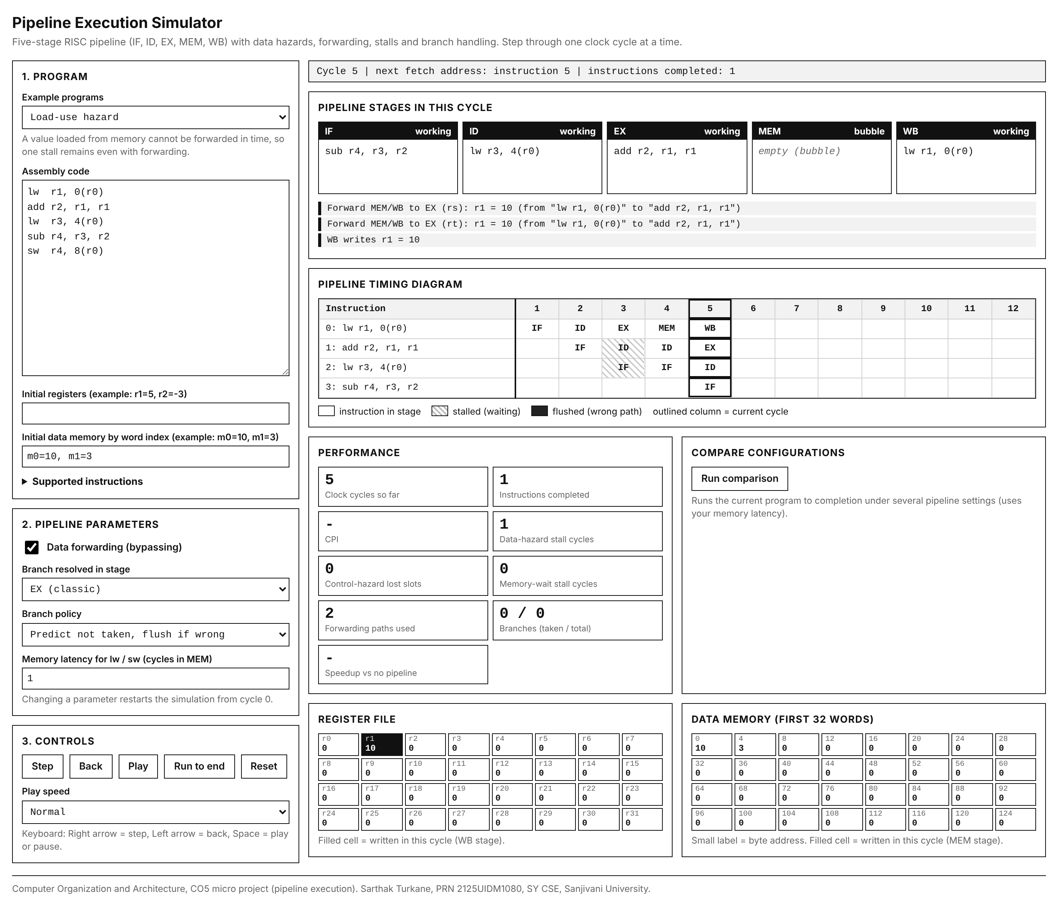
Figure 4: The simulator after five clock cycles of the load-use example

5.3 Running a simulation step by step
- Choose an example program from the list, or type your own program in the assembly box. Optionally set initial register values (for example r1=5, r2=-3) and initial memory words (for example m0=10, m1=3).
- Set the pipeline parameters in section 2. Any change restarts the simulation from cycle 0.
- Press Step. One clock cycle is executed. Read the stage boxes to see which instruction is in each stage, and read the log below them for forwarding, stalls, flushes and register or memory writes (Figure 5 shows the stage boxes at a stall).
- Look at the timing diagram. A new column is added for every cycle. A hatched cell is a stall and a black X cell is a flush.
- Press Back to return one cycle, Play to run automatically at the chosen speed, Run to end to finish at once, and Reset to restart.
- When the program finishes, read the statistics and the check message. Press Run comparison to see how other pipeline designs would perform on the same program.
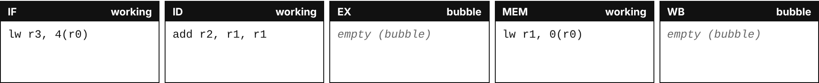
Figure 5: Stage boxes at the cycle where a load-use stall occurs

5.4 Writing your own program
- One instruction per line. Operands are separated by commas, for example add r3, r1, r2.
- Registers are written r0 to r31, or with MIPS names such as $t0. Numbers can be decimal or hexadecimal (0x10) and may be negative.
- Memory operands use the form lw r1, 8(r0). The address must be a multiple of 4 (word 2 is address 8).
- A label is a name followed by a colon, for example loop:, and may share a line with an instruction.
- Comments start with #, ; or //.
- Use the "Supported instructions" box in the Program panel as a quick reference.

5.5 Parameters
Table 9: Adjustable parameters
Parameter | Options | Effect
Data forwarding | On or off | Off: dependent instructions stall until the value is written back. On: results are bypassed; only load-use stalls remain.
Branch resolved in stage | ID, EX, MEM | Sets how many slots a mispredicted branch wastes (1, 2 or 3).
Branch policy | Predict not taken, or stall fetch | Predict: flush only if the branch is taken. Stall: fetch waits for every branch.
Memory latency | 1 to 6 cycles | Number of cycles lw and sw stay in MEM; extra cycles freeze the pipeline.
Play speed | Slow to very fast | Delay between cycles during Play.

5.6 Messages
If the program contains a mistake, the assembly box shows a message with the line number (Figure 6) and the Step button stays disabled until the mistake is fixed. If the running program touches an invalid memory address, the simulation stops and the status line gives the cycle number and the offending instruction.
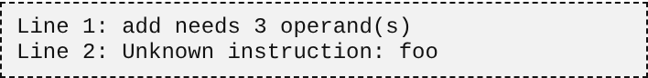
Figure 6: Error messages for an incorrect program

6. Worked Examples
This chapter walks through six programs. Each result was produced by the simulator and checked by hand against the theory of Chapter 2. The programs are listed in Appendix A.

6.1 Dependent chain with and without forwarding
The program has five instructions and every instruction uses the result of the one before it (addi r1, then add r2, r1, r1, sub r3, r2, r1, and r4, r3, r2, or r5, r4, r3). Without forwarding, each of the four dependent instructions waits two cycles for the value to be written back. The expected time is the ideal 5 + 4 = 9 cycles plus 4 x 2 = 8 stall cycles, so 17 cycles. The simulator reports 17 (Figure 7). With forwarding every value is passed on directly and there is no stall, so the run takes the ideal 9 cycles (Figure 8). Forwarding therefore improves this program from CPI 3.40 to CPI 1.80, a speedup of 1.89.
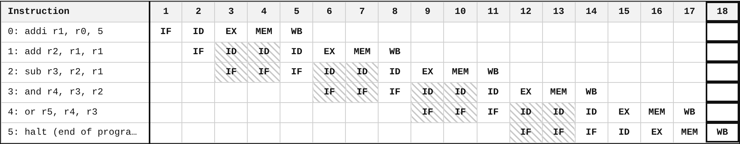
Figure 7: Dependent chain with forwarding off: 17 cycles
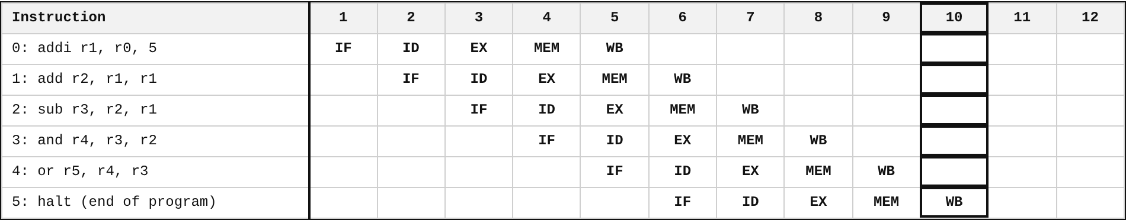
Figure 8: Dependent chain with forwarding on: 9 cycles

6.2 Load-use hazard
In the load-use program a lw is followed directly by an instruction that uses the loaded value, twice. Forwarding cannot remove this stall because the loaded value is available only after MEM. Figure 9 shows the one-cycle stall (hatched cells) after each load. The run takes 9 + 2 = 11 cycles instead of 9. Without forwarding the same program takes 15 cycles. The final register values are r2 = 20 and r4 = -17, and memory word 2 holds -17, and the check box confirms that these match the non-pipelined execution.
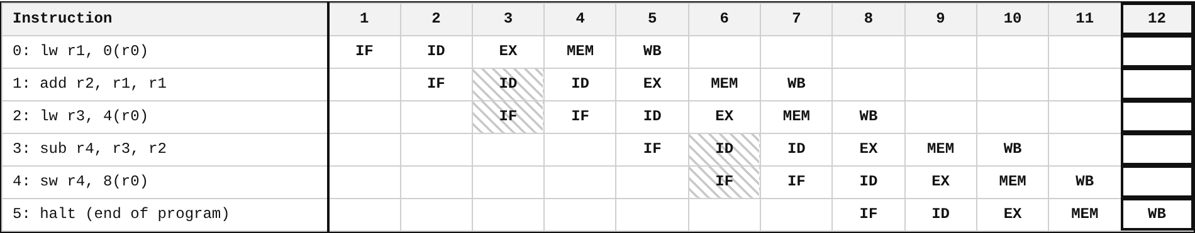
Figure 9: Load-use example with forwarding on: 11 cycles

6.3 Control hazard: taken branch
The branch program sets r1 and r2 to 3, executes beq r1, r2, done, and then has two instructions that must be skipped. With the branch resolved in EX and predict-not-taken, the two wrongly fetched instructions are flushed. Figure 10 shows them struck through in the diagram, with black X cells. Four instructions complete, so the ideal time is 4 + 4 = 8 cycles, and the 2 flushed slots bring it to 10 cycles.
The comparison feature shows an interesting detail. When the branch is resolved in ID, only one slot is lost, but the compare needs r2, which the instruction directly before the branch is still computing, so the branch stalls once in ID. The total is therefore 8 + 1 + 1 = 10 cycles, the same as for EX. Resolving a branch early is therefore not always cheaper: it helps only when the operands are ready in time. Resolving it in MEM is the slowest choice (3 lost slots, 11 cycles).
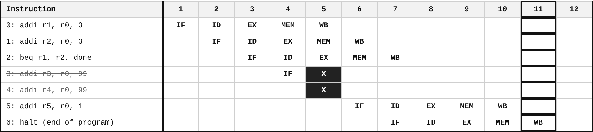
Figure 10: Taken branch resolved in EX: two instructions flushed

6.4 Loops
The array-sum loop adds five memory words (4, 8, 15, 16, 23) into r2 and stores the sum 66 in word 8. It runs 29 instructions and contains a load-use hazard and a loop branch that is taken four times and not taken once. The Fibonacci loop executes 60 instructions and stores the first eight terms 1, 2, 3, 5, 8, 13, 21, 34 into memory. Both finish with a passed check. Table 10 compares the designs on all examples.

6.5 Comparison of pipeline designs
Table 10: Clock cycles for each example under different pipeline designs (memory latency 1)
Program | Instr. | A: no fwd, EX | B: fwd, EX | C: fwd, ID | D: fwd, MEM | E: fwd, EX, stall
Data hazards: dependent chain | 5 | 17 (3.40) | 9 (1.80) | 9 (1.80) | 9 (1.80) | 9 (1.80)
Ideal pipeline: independent instructions | 5 | 9 (1.80) | 9 (1.80) | 9 (1.80) | 9 (1.80) | 9 (1.80)
Load-use hazard | 5 | 15 (3.00) | 11 (2.20) | 11 (2.20) | 11 (2.20) | 11 (2.20)
Branch taken (control hazard) | 4 | 12 (3.00) | 10 (2.50) | 10 (2.50) | 11 (2.75) | 10 (2.50)
Loop: sum of an array | 29 | 61 (2.10) | 46 (1.59) | 47 (1.62) | 50 (1.72) | 48 (1.66)
Loop: Fibonacci numbers | 60 | 102 (1.70) | 78 (1.30) | 79 (1.32) | 85 (1.42) | 78 (1.30)
Values are total clock cycles with CPI in brackets. A: no forwarding, branch resolved in EX, predict not taken. B: forwarding, EX. C: forwarding, branch resolved in ID. D: forwarding, branch resolved in MEM. E: forwarding, EX, stall instead of predicting.
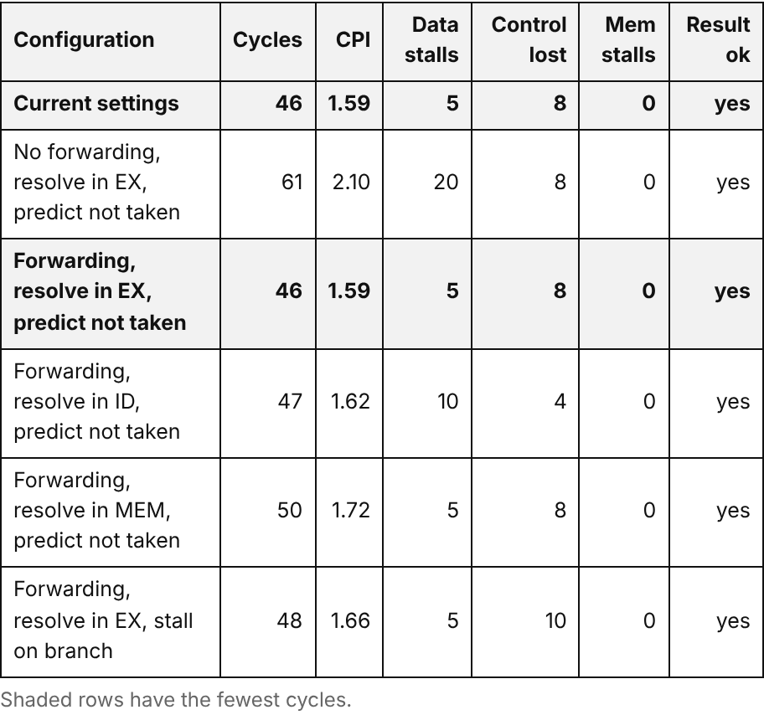
Figure 11: The comparison table inside the simulator (array-sum loop)

6.6 Effect of memory latency
Table 11: Total cycles for different memory latencies (forwarding on, branch resolved in EX)
Program | Latency 1 | Latency 2 | Latency 3
Load-use hazard | 11 | 14 | 17
Loop: sum of an array | 46 | 52 | 58
Loop: Fibonacci numbers | 78 | 86 | 94
Each extra latency cycle adds one cycle for every lw and sw executed. The load-use example has 3 memory instructions, so it grows by 3 cycles per latency step (11, 14, 17). The array-sum loop executes 6 memory instructions (5 loads and 1 store), so it grows by 6 (46, 52, 58). The Fibonacci loop executes 8 stores and grows by 8 (78, 86, 94). These values agree exactly with the model.

7. Testing and Results

7.1 Test strategy
Correctness is the most important property of a simulator, so three layers of testing were used. Directed tests check cycle counts that can be calculated by hand from the theory. A randomised equivalence test checks that the pipeline never changes what a program computes. Automated browser tests check the user interface.

7.2 Directed tests against hand calculation
Each test program was small enough to compute the expected cycle count by hand using the formulas of Section 2.2 and the hazard rules of Chapter 3. n is the number of instructions that complete.
Table 12: Directed tests: hand-calculated and simulated cycle counts
No. | Test | Expected (hand calculation) | Simulated | Result
1 | Five independent addi instructions | 5 + 4 = 9 | 9 | Pass
2 | Three-instruction RAW chain, forwarding on | 3 + 4 = 7, no stall | 7 (0 stalls) | Pass
3 | Same chain, forwarding off | 7 + 4 stall cycles = 11 | 11 (4 stalls) | Pass
4 | lw followed by dependent add, forwarding on | 2 + 4 + 1 load-use = 7 | 7 (1 stall) | Pass
5 | Same pair, forwarding off | 6 + 2 = 8 | 8 (2 stalls) | Pass
6 | Taken branch resolved in ID (operand produced just before) | 3 + 4 + 1 flush + 1 stall = 9 | 9 | Pass
7 | Taken branch resolved in EX | 3 + 4 + 2 flushed = 9 | 9 | Pass
8 | Taken branch resolved in MEM | 3 + 4 + 3 flushed = 10 | 10 | Pass
9 | Same taken branch with the stall policy (ID, EX, MEM) | Same as tests 6, 7, 8 | 9, 9, 10 | Pass
10 | Memory latency 1, 2, 3 on programs with 3, 6 and 8 memory instructions | Grows by 3, 6 and 8 cycles per step | 11, 14, 17 / 46, 52, 58 / 78, 86, 94 | Pass

7.3 Randomised equivalence test
A pipeline is correct only if its final registers and memory are identical to those of non-pipelined execution, whatever hazards occur on the way. To test this on a large number of cases, a test program generated 250 random programs of 8 to 25 instructions (arithmetic, loads, stores, branches and jumps in random mixes with many dependencies), added the array-sum loop, and ran each program under every combination of the parameters: forwarding on or off (2), branch resolution stage ID, EX or MEM (3), branch policy (2) and memory latency 1, 2 or 3 (3). That is 36 configurations for each of 251 programs.
Table 13: Result of the randomised equivalence test
Item | Value
Programs tested | 251 (250 random, 1 loop)
Configurations per program | 36
Simulation runs | 9,036
Runs where registers, memory or instruction count differed from the reference | 0
Runs that stopped with an error | 0
All 9,036 runs matched the reference model exactly. The random branches and jumps only jump forward, so loops are covered by the example loops (array sum and Fibonacci) in all configurations instead.

7.4 User interface tests
The final HTML file was driven by an automated headless browser. The following checks were made and all passed:
- All six example programs load, run to the end and show the "Check passed" message.
- Step, Back, Run to end and Reset give consistent states (for example, Step three times then Back returns to cycle 2 with the same stage contents as before).
- Turning forwarding off after loading an example changes the result as expected (17 cycles for the dependent chain).
- The comparison button produces six rows and marks the fastest design.
- A program with three mistakes shows three messages with the right line numbers, and the Step button is disabled.
- An unaligned memory access (lw r1, 2(r0)) stops the run at cycle 4 with a clear message.
- On a 390 pixel wide screen the page has no horizontal scrolling.
- No JavaScript error or console error occurred in any of these runs.

7.5 Observations from the results
- Forwarding is the most valuable single feature. It reduced the dependent chain from 17 to 9 cycles and the array-sum loop from 61 to 46 cycles (speedup 1.33).
- With forwarding, a loop that has loads still pays for load-use stalls. The array-sum loop has 5 data stall cycles even with forwarding.
- Control hazards are the second large cost. In the array-sum loop 8 slots are lost to flushing because the loop branch is taken four times.
- Early branch resolution helps only if the compare operands are ready. The Fibonacci loop is faster with resolution in EX (78 cycles) than in ID (79) because the branch condition depends on the instruction right before it.
- Among the designs with forwarding, resolving the branch late (MEM) is the worst choice in these tests, and the stall policy is never better than predict-not-taken.
- Speedup over a non-pipelined machine reaches 3.15 on the array-sum loop, below the ideal limit of 5, which matches the theory that hazards reduce the gain.

8. Mapping to the Evaluation Rubric
Table 14: Where each rubric criterion is addressed
Criterion | Marks | Where addressed in the project
Concept understanding and design | 2 | Chapter 2 explains stages, hazards, forwarding and branch handling. Chapter 3 gives the block diagram (Figures 1 and 2), the flowchart (Figure 3) and the reasons for choosing HTML and JavaScript (Section 1.5).
Working and correctness of simulation | 4 | Every stage is shown in every cycle. Results match hand calculations (Section 7.2) and a non-pipelined reference on 9,036 runs (Section 7.3). Any program can be entered, and errors are reported.
Features and customisation | 2 | Four adjustable parameters (Section 5.5), editable program and initial state, timing diagram, hazard log, statistics, back stepping, comparison of designs, black-and-white print-friendly display.
Demonstration and explanation | 2 | Chapter 12 gives a demonstration script. Chapter 11 contains likely questions with answers. The code is organised in three clear parts with comments (Appendix B).

9. Limitations and Future Scope

9.1 Limitations
- The pipeline depth is fixed at five stages. The notice lists the number of pipeline stages as an example parameter; this simulator varies the effective pipeline behaviour through the branch resolution stage and memory latency instead.
- Branch prediction is static (predict not taken). Dynamic predictors are not modelled.
- There are no caches, so instruction fetch and data access always take the configured fixed time.
- Only integer instructions are supported, with a small instruction set and 256 words of data memory.
- The machine is single-issue and in-order. Superscalar issue and out-of-order execution are not modelled.
- The random test programs contain only forward branches; loops were tested with the example programs.

9.2 Future scope
- Let the user choose the number of stages (for example a 3, 5 or 7 stage pipeline) by splitting or merging stages.
- Add a one-bit and two-bit dynamic branch predictor and show prediction accuracy.
- Add instruction and data caches and show their interaction with the pipeline.
- Add export of the timing diagram as an image or CSV file for reports.
- Add a second forwarding option, for example forwarding only from EX/MEM, to compare partial forwarding designs.

10. Conclusion
This project implemented a complete interactive simulator of a five-stage RISC pipeline as a single HTML file. It executes real assembly programs one clock cycle at a time, shows the instruction in every stage, and displays data hazards, load-use stalls, control hazards, flushes, forwarding and memory wait states in a timing diagram. The user can change forwarding, the branch resolution stage, the branch policy and the memory latency, and can compare designs on the same program.
The simulator was checked in three ways: against hand calculation of cycle counts, against a non-pipelined reference model on 9,036 randomised runs with no mismatch, and through automated tests of the interface. The experiments reproduce the main results of pipeline theory: the ideal time of k + n - 1 cycles, the large gain from forwarding, the unavoidable load-use stall and the cost of branches as a function of the resolution stage. Building the simulator gave a detailed understanding of how a pipeline overlaps instructions, why hazards occur and how hardware techniques reduce their cost.

11. Viva Preparation: Questions and Answers
Q1. What is pipelining and why is it used?
Answer: Pipelining overlaps the execution of several instructions by dividing execution into stages. Each clock cycle every stage works on a different instruction, so the processor can finish about one instruction per cycle and the throughput is much higher than without a pipeline.
Q2. What are the five stages in your simulator?
Answer: IF fetches the instruction, ID decodes it and reads registers, EX does the ALU work or address calculation, MEM accesses data memory for lw and sw, and WB writes the result to the register file.
Q3. How many cycles do n instructions need on an ideal k-stage pipeline?
Answer: k + n - 1 cycles. For 5 independent instructions on 5 stages that is 9 cycles, and the simulator shows exactly 9.
Q4. What is a hazard? Name the types.
Answer: A hazard prevents the next instruction from executing in its normal cycle. The types are structural (resource conflict), data (RAW, WAR, WAW) and control (branches and jumps).
Q5. Why does your simulator only handle RAW hazards?
Answer: Instructions run in order and write registers only in WB, so WAR and WAW hazards cannot produce wrong results. Only RAW matters.
Q6. What is forwarding?
Answer: It sends the ALU result straight from the EX/MEM or MEM/WB register to the ALU input of a later instruction, so the instruction does not wait until the value is written to the register file.
Q7. Why does a load-use hazard still stall even with forwarding?
Answer: The loaded value is available only at the end of MEM, but the next instruction needs it at the start of EX in the following cycle, which is one stage too early. One bubble is required.
Q8. What happens when a branch is taken?
Answer: With predict-not-taken the instructions fetched after the branch are on the wrong path. When the branch is resolved they are flushed (turned into bubbles) and fetching restarts at the target. The simulator marks them with black X cells.
Q9. Why does resolving a branch in ID not always help?
Answer: The comparison needs register values earlier. If the instruction just before the branch produces one of them, the branch must wait in ID, which can cancel the saving. The Fibonacci example shows this.
Q10. How do you know your simulator is correct?
Answer: Cycle counts match hand calculation, and after every run the simulator compares the registers and memory with a non-pipelined interpreter. In addition, 9,036 randomised runs showed no difference.
Q11. Why are the stages processed from WB to IF inside one cycle?
Answer: So that each stage sees the state from the start of the clock cycle, like real hardware, and later stages can decide to stall or flush the earlier ones.
Q12. How is the Back button implemented?
Answer: The simulation is deterministic, so Back rebuilds the machine and replays it up to the previous cycle.
Q13. What is CPI and how does speedup relate to it?
Answer: CPI is clock cycles per instruction. The ideal pipeline reaches CPI of 1. Stalls raise it. Speedup over a non-pipelined machine is the non-pipelined cycle count divided by the pipelined cycle count.
Q14. What parameters can the user change?
Answer: Forwarding on or off, the stage where a branch is resolved, the branch policy, the memory latency, and of course the program and the initial register and memory values.

12. Demonstration Script
A demonstration of about five minutes can follow these steps.
- Open PipelineSimulator.html. Point out the three input panels and the result panels (30 seconds).
- Load "Ideal pipeline: independent instructions". Press Step until the end. Show that the diagram forms a staircase and the total is 9 cycles, which matches k + n - 1 (45 seconds).
- Load "Data hazards: dependent chain". Untick forwarding and run to the end: 17 cycles with hatched stall cells. Tick forwarding: 9 cycles. Say that forwarding removes the stalls (60 seconds).
- Load "Load-use hazard". Step to the stall cycle and read the explanation in the stage box: forwarding cannot remove this one (45 seconds).
- Load "Branch taken". Show the two flushed instructions. Change the branch stage to ID and then MEM and explain the changes in lost slots (60 seconds).
- Load "Loop: sum of an array". Run to the end, show the result 66 in memory word 8 and the check message. Press Run comparison and explain the best design (45 seconds).
- Type a small program of your own with a mistake to show the error message, then correct it (30 seconds).
- Show Chapter 3 figures (block diagram and flowchart) and explain that the engine evaluates the stages from WB to IF in each cycle (30 seconds).

References
[1] J. L. Hennessy and D. A. Patterson, Computer Architecture: A Quantitative Approach, Morgan Kaufmann.
[2] D. A. Patterson and J. L. Hennessy, Computer Organization and Design: The Hardware/Software Interface, Morgan Kaufmann.
[3] W. Stallings, Computer Organization and Architecture: Designing for Performance, Pearson.
[4] M. M. Mano, Computer System Architecture, Pearson.
[5] Notice, Sanjivani University, Department of Integrated B.Tech: COA CO5 Assessment: Micro Project, 15/10/2026.

Appendix A: Example Programs

A.1 Data hazards: dependent chain
Every instruction needs the result of the one before it. Toggle forwarding to see stalls appear.
addi r1, r0, 5
add r2, r1, r1
sub r3, r2, r1
and r4, r3, r2
or r5, r4, r3
Initial memory: none. Result: r1=5, r2=10, r3=5, r4=0, r5=5. 9 cycles with forwarding, 17 without.

A.2 Ideal pipeline: independent instructions
No dependencies, so CPI approaches 1. Five instructions finish in 9 cycles.
addi r1, r0, 1
addi r2, r0, 2
addi r3, r0, 3
addi r4, r0, 4
addi r5, r0, 5
Initial memory: none. Result: r1 to r5 = 1 to 5. 9 cycles in every configuration.

A.3 Load-use hazard
A value loaded from memory cannot be forwarded in time, so one stall remains even with forwarding.
lw r1, 0(r0)
add r2, r1, r1
lw r3, 4(r0)
sub r4, r3, r2
sw r4, 8(r0)
Initial memory: m0=10, m1=3. Result: r1=10, r2=20, r3=3, r4=-17, memory word 2 = -17. 11 cycles with forwarding, 15 without.

A.4 Branch taken (control hazard)
The two instructions after beq are fetched on the wrong path and flushed. Change the resolve stage to see the penalty change.
addi r1, r0, 3
addi r2, r0, 3
beq r1, r2, done
addi r3, r0, 99 # skipped
addi r4, r0, 99 # skipped
done: addi r5, r0, 1
Initial memory: none. Result: r1=3, r2=3, r5=1, r3 and r4 unchanged (0). 10 cycles with branch resolved in EX.

A.5 Loop: sum of an array
Adds five words from memory into r2 and stores the sum (66) at word 8. Mixes load-use hazards and a loop branch.
li r1, 0 # byte offset
li r2, 0 # running sum
li r3, 5 # count
loop: lw r4, 0(r1)
add r2, r2, r4
addi r1, r1, 4
addi r3, r3, -1
bne r3, r0, loop
sw r2, 32(r0)
Initial memory: m0=4, m1=8, m2=15, m3=16, m4=23. Result: r2=66 and memory word 8 = 66. 46 cycles with forwarding, 61 without.

A.6 Loop: Fibonacci numbers
Stores the first eight Fibonacci terms into memory starting at word 0.
li r1, 0
li r2, 1
li r3, 8
li r5, 0
fib: add r4, r1, r2
move r1, r2
move r2, r4
sw r4, 0(r5)
addi r5, r5, 4
addi r3, r3, -1
bne r3, r0, fib
Initial memory: none. Result: memory words 0 to 7 = 1, 2, 3, 5, 8, 13, 21, 34. 78 cycles with forwarding, 102 without.

Appendix B: Source Code of the Assembler and Engine
The user interface code (HTML, CSS and the interface script) is inside PipelineSimulator.html and is not repeated here. The two listings below are the core of the simulator: the assembler with the reference interpreter, and the pipeline engine.

B.1 Assembler and reference model (asm.js)
001 (function (root) {
002 'use strict';
003
004 // Register aliases (MIPS style) plus r0..r31, x0..x31, $0..$31
005 const REG_NAMES = {
006 zero: 0, at: 1, v0: 2, v1: 3, a0: 4, a1: 5, a2: 6, a3: 7,
007 t0: 8, t1: 9, t2: 10, t3: 11, t4: 12, t5: 13, t6: 14, t7: 15,
008 s0: 16, s1: 17, s2: 18, s3: 19, s4: 20, s5: 21, s6: 22, s7: 23,
009 t8: 24, t9: 25, k0: 26, k1: 27, gp: 28, sp: 29, fp: 30, ra: 31
010 };
011
012 const R_OPS = ['add', 'sub', 'and', 'or', 'slt'];
013 const MEM_WORDS = 256; // 1 KB of word-addressed data memory
014
015 function regOf(tok) {
016 const t = String(tok).trim().toLowerCase();
017 let m = /^[rx$](\d+)$/.exec(t);
018 if (m) { const n = +m[1]; return n < 32 ? n : -1; }
019 if (t[0] === '$' && REG_NAMES[t.slice(1)] !== undefined) return REG_NAMES[t.slice(1)];
020 return -1;
021 }
022
023 function immOf(tok) {
024 const t = String(tok).trim().toLowerCase();
025 const m = /^([-+]?)(0x[0-9a-f]+|\d+)$/.exec(t);
026 if (!m) return null;
027 const v = Number(m[2]);
028 return m[1] === '-' ? -v : v;
029 }
030
031 // Pure ALU used by both the reference interpreter and the pipeline
032 function alu(ins, a, b) {
033 switch (ins.op) {
034 case 'add': return (a + b) | 0;
035 case 'sub': return (a - b) | 0;
036 case 'and': return a & b;
037 case 'or': return a | b;
038 case 'slt': return a < b ? 1 : 0;
039 case 'addi': case 'lw': case 'sw': return (a + ins.imm) | 0;
040 default: return 0;
041 }
042 }
043
044 function memIndex(addr) {
045 if (addr & 3) throw new Error('Unaligned memory access at address ' + addr);
046 const i = addr >> 2;
047 if (i < 0 || i >= MEM_WORDS) throw new Error('Memory address out of range: ' + addr);
048 return i;
049 }
050
051 function finish(ins) {
052 const writes = R_OPS.indexOf(ins.op) >= 0 || ins.op === 'addi' || ins.op === 'lw';
053 ins.dest = writes && ins.rd > 0 ? ins.rd : -1;
054 const s = [];
055 const add = r => { if (r > 0 && s.indexOf(r) < 0) s.push(r); };
056 if (R_OPS.indexOf(ins.op) >= 0 || ins.op === 'sw' || ins.op === 'beq' || ins.op === 'bne') { add(ins.rs); add(ins.rt); }
057 else if (ins.op === 'addi' || ins.op === 'lw') add(ins.rs);
058 ins.srcs = s;
059 ins.isBranch = ins.op === 'beq' || ins.op === 'bne';
060 ins.isJump = ins.op === 'j';
061 ins.isMem = ins.op === 'lw' || ins.op === 'sw';
062 return ins;
063 }
064
065 function assemble(src) {
066 const labels = {}, items = [], errors = [];
067 String(src).split(/\r?\n/).forEach((raw, i) => {
068 let s = raw.replace(/(#|;|\/\/).*$/, '').trim();
069 for (;;) {
070 const m = /^([A-Za-z_]\w*)\s*:\s*/.exec(s);
071 if (!m) break;
072 if (labels[m[1]] !== undefined) errors.push({ line: i + 1, msg: 'Duplicate label ' + m[1] });
073 labels[m[1]] = items.length;
074 s = s.slice(m[0].length);
075 }
076 if (s) items.push({ s: s, line: i + 1 });
077 });
078
079 const program = [];
080 items.forEach((it, pc) => {
081 const err = msg => errors.push({ line: it.line, msg: msg });
082 const m = /^([A-Za-z]+)\s*(.*)$/.exec(it.s);
083 const ins = { op: '', rd: 0, rs: 0, rt: 0, imm: 0, label: null, target: -1, pc: pc, line: it.line, text: it.s.replace(/\s+/g, ' ').trim() };
084 program.push(ins);
085 if (!m) { err('Cannot read instruction: ' + it.s); ins.op = 'nop'; return finish(ins); }
086 let op = m[1].toLowerCase();
087 const ops = m[2].trim() ? m[2].split(',').map(x => x.trim()) : [];
088 const need = n => { if (ops.length !== n) { err(op + ' needs ' + n + ' operand(s)'); return false; } return true; };
089 const reg = tok => { const r = regOf(tok); if (r < 0) err('Bad register: ' + tok); return Math.max(r, 0); };
090 const imm = tok => { const v = immOf(tok); if (v === null) { err('Bad number: ' + tok); return 0; } return v; };
091
092 if (op === 'li') { if (need(2)) { op = 'addi'; ins.rd = reg(ops[0]); ins.rs = 0; ins.imm = imm(ops[1]); } else op = 'nop'; }
093 else if (op === 'move') { if (need(2)) { op = 'add'; ins.rd = reg(ops[0]); ins.rs = reg(ops[1]); ins.rt = 0; } else op = 'nop'; }
094 else if (R_OPS.indexOf(op) >= 0) { if (need(3)) { ins.rd = reg(ops[0]); ins.rs = reg(ops[1]); ins.rt = reg(ops[2]); } }
095 else if (op === 'addi') { if (need(3)) { ins.rd = reg(ops[0]); ins.rs = reg(ops[1]); ins.imm = imm(ops[2]); } }
096 else if (op === 'lw' || op === 'sw') {
097 if (need(2)) {
098 const mm = /^([-+]?\w*)\s*\(\s*([^)]+)\)$/.exec(ops[1]);
099 if (!mm) err('Use the form ' + op + ' rt, offset(rs)');
100 else {
101 const r = reg(ops[0]);
102 if (op === 'lw') ins.rd = r; else ins.rt = r;
103 ins.imm = mm[1] === '' ? 0 : imm(mm[1]);
104 ins.rs = reg(mm[2]);
105 }
106 }
107 }
108 else if (op === 'beq' || op === 'bne') { if (need(3)) { ins.rs = reg(ops[0]); ins.rt = reg(ops[1]); ins.label = ops[2]; } }
109 else if (op === 'j') { if (need(1)) ins.label = ops[0]; }
110 else if (op === 'nop' || op === 'halt') { need(0); }
111 else { err('Unknown instruction: ' + op); op = 'nop'; }
112 ins.op = op;
113 finish(ins);
114 });
115
116 program.forEach(ins => {
117 if (ins.label !== null) {
118 if (labels[ins.label] === undefined) errors.push({ line: ins.line, msg: 'Unknown label: ' + ins.label });
119 else ins.target = labels[ins.label];
120 }
121 });
122
123 // Implicit HALT at the end so the pipeline always drains
124 program.push(finish({ op: 'halt', rd: 0, rs: 0, rt: 0, imm: 0, label: null, target: -1, pc: program.length, line: 0, text: 'halt (end of program)', implicit: true }));
125 return { program: program, labels: labels, errors: errors };
126 }
127
128 // Non-pipelined golden model, used to check the pipeline
129 function runReference(program, init, maxSteps) {
130 init = init || {};
131 const regs = new Int32Array(32), mem = new Int32Array(MEM_WORDS);
132 Object.keys(init.regs || {}).forEach(k => { if (+k > 0) regs[+k] = init.regs[k] | 0; });
133 Object.keys(init.mem || {}).forEach(k => { mem[+k] = init.mem[k] | 0; });
134 let pc = 0, count = 0, memOps = 0;
135 maxSteps = maxSteps || 100000;
136 while (pc < program.length && count < maxSteps) {
137 const ins = program[pc];
138 if (ins.op === 'halt') break;
139 count++;
140 let next = pc + 1;
141 const a = regs[ins.rs], b = regs[ins.rt];
142 switch (ins.op) {
143 case 'add': case 'sub': case 'and': case 'or': case 'slt': regs[ins.rd] = alu(ins, a, b); break;
144 case 'addi': regs[ins.rd] = alu(ins, a, 0); break;
145 case 'lw': memOps++; regs[ins.rd] = mem[memIndex(alu(ins, a, 0))]; break;
146 case 'sw': memOps++; mem[memIndex(alu(ins, a, 0))] = b; break;
147 case 'beq': if (a === b) next = ins.target; break;
148 case 'bne': if (a !== b) next = ins.target; break;
149 case 'j': next = ins.target; break;
150 }
151 regs[0] = 0;
152 pc = next;
153 }
154 return { regs: regs, mem: mem, count: count, memOps: memOps, truncated: count >= maxSteps };
155 }
156
157 const api = { assemble: assemble, runReference: runReference, alu: alu, memIndex: memIndex, regOf: regOf, REG_NAMES: REG_NAMES, MEM_WORDS: MEM_WORDS };
158 root.PipeAsm = api;
159 if (typeof module !== 'undefined' && module.exports) module.exports = api;
160 })(typeof self !== 'undefined' ? self : globalThis);

B.2 Pipeline engine (engine.js)
001 (function (root) {
002 'use strict';
003 const A = root.PipeAsm || require('./asm.js');
004 const STAGES = ['IF', 'ID', 'EX', 'MEM', 'WB'];
005
006 const DEFAULTS = {
007 forwarding: true, // data forwarding (bypassing) on or off
008 branchResolve: 'EX', // stage where a conditional branch is resolved: ID, EX or MEM
009 branchPolicy: 'not-taken', // 'not-taken' (predict and flush) or 'stall' (freeze fetch)
010 memLatency: 1 // cycles spent in MEM by lw / sw
011 };
012
013 function Engine(program, cfg, init) {
014 this.program = program;
015 this.cfg = Object.assign({}, DEFAULTS, cfg || {});
016 this.init = init || {};
017 this.reset();
018 }
019
020 Engine.prototype.reset = function () {
021 const P = A;
022 this.regs = new Int32Array(32);
023 this.mem = new Int32Array(P.MEM_WORDS);
024 const ir = this.init.regs || {}, im = this.init.mem || {};
025 Object.keys(ir).forEach(k => { if (+k > 0 && +k < 32) this.regs[+k] = ir[k] | 0; });
026 Object.keys(im).forEach(k => { if (+k >= 0 && +k < P.MEM_WORDS) this.mem[+k] = im[k] | 0; });
027 this.cycle = 0; this.nextId = 1; this.done = false; this.error = null;
028 this.blocked = false; this.fetchStopped = false;
029 this.history = [];
030 this.stats = { cycles: 0, retired: 0, dataStalls: 0, ctrlBubbles: 0, memStalls: 0, forwards: 0, branches: 0, taken: 0, seqCycles: 0, totalCycles: 0 };
031 this.pc = 0;
032 this.occ = [null, null, null, null, null];
033 this.occ[0] = this.newRec(this.pc++);
034 if (this.occ[0].ins.op === 'halt') this.fetchStopped = true;
035 };
036
037 Engine.prototype.newRec = function (pc) {
038 return { id: this.nextId++, pc: pc, ins: this.program[pc], squashed: false, exDone: false, resolved: false,
039 ida: 0, idb: 0, a: 0, b: 0, alu: 0, taken: false, memData: 0, memLeft: undefined, wb: 0 };
040 };
041
042 Engine.prototype.getState = function () {
043 return { regs: Array.from(this.regs), mem: Array.from(this.mem), pc: this.pc };
044 };
045
046 Engine.prototype.step = function () {
047 if (this.done) return null;
048 const cfg = this.cfg, P = this.program, st = this.stats, self = this;
049 this.cycle++;
050 const occ = this.occ;
051 const snap = { cycle: this.cycle, stages: [], fwd: [], events: [], regWrite: null, memWrite: null, pcAfter: 0 };
052 const state = [null, null, null, null, null]; // per-stage display state
053 const note = ['', '', '', '', ''];
054 const squash = { IF: false, ID: false, EX: false };
055 let redirect = null, freeze = false, idStall = false, retiredHalt = false;
056
057 const squashRec = (rec, stageIdx) => {
058 if (rec && !rec.squashed) { rec.squashed = true; st.ctrlBubbles++; state[stageIdx] = 'flush'; note[stageIdx] = 'flushed'; }
059 };
060 const applySquash = () => { // called after a resolution sets the flags
061 if (squash.EX) squashRec(occ[2], 2);
062 if (squash.ID) squashRec(occ[1], 1);
063 if (squash.IF) squashRec(occ[0], 0);
064 };
065
066 // ---------- WB ----------
067 if (occ[4]) {
068 const r = occ[4];
069 state[4] = 'run';
070 if (r.ins.dest > 0) { this.regs[r.ins.dest] = r.wb; snap.regWrite = { reg: r.ins.dest, val: r.wb }; }
071 if (r.ins.op === 'halt') retiredHalt = true;
072 else { st.retired++; st.cycles = this.cycle; st.seqCycles += 4 + (r.ins.isMem ? cfg.memLatency : 1); }
073 }
074
075 // ---------- MEM ----------
076 if (occ[3]) {
077 const r = occ[3];
078 state[3] = 'run';
079 if (r.ins.isMem) {
080 if (r.memLeft === undefined) r.memLeft = cfg.memLatency;
081 r.memLeft--;
082 if (r.memLeft > 0) { freeze = true; state[3] = 'stall'; note[3] = 'memory busy'; st.memStalls++; }
083 else {
084 try {
085 const idx = A.memIndex(r.alu);
086 if (r.ins.op === 'lw') { r.memData = this.mem[idx]; r.wb = r.memData; }
087 else { this.mem[idx] = r.b; snap.memWrite = { idx: idx, val: r.b }; }
088 } catch (e) { this.error = e.message + ' (' + r.ins.text + ')'; this.done = true; }
089 }
090 }
091 if (!freeze && r.ins.isBranch && cfg.branchResolve === 'MEM' && !r.resolved) {
092 r.resolved = true; st.branches++;
093 if (r.taken) st.taken++;
094 if (cfg.branchPolicy === 'stall') { this.blocked = false; redirect = { pc: r.taken ? r.ins.target : r.pc + 1 }; }
095 else if (r.taken) redirect = { pc: r.ins.target };
096 if (redirect) { squash.EX = squash.ID = squash.IF = true; applySquash(); snap.events.push('Branch ' + r.ins.text + (r.taken ? ' taken' : ' not taken') + ' resolved in MEM'); }
097 }
098 }
099
100 // ---------- EX ----------
101 if (occ[2] && !occ[2].squashed) {
102 const r = occ[2], ins = r.ins;
103 state[2] = freeze ? 'stall' : 'run';
104 if (!r.exDone) {
105 const get = (reg, fallback, which) => {
106 if (reg === 0) return 0;
107 if (cfg.forwarding) {
108 const m = occ[3], w = occ[4];
109 if (m && m.ins.dest === reg && m.ins.op !== 'lw') { snap.fwd.push({ from: 'EX/MEM', stage: 'EX', operand: which, producer: m.ins.text, to: ins.text, reg: reg, val: m.alu }); st.forwards++; return m.alu; }
110 if (w && w.ins.dest === reg) { snap.fwd.push({ from: 'MEM/WB', stage: 'EX', operand: which, producer: w.ins.text, to: ins.text, reg: reg, val: w.wb }); st.forwards++; return w.wb; }
111 }
112 return fallback;
113 };
114 r.a = get(ins.rs, r.ida, 'rs');
115 r.b = ins.op === 'addi' ? ins.imm : get(ins.rt, r.idb, 'rt');
116 r.alu = A.alu(ins, r.a, r.b);
117 if (ins.op === 'addi') r.alu = (r.a + ins.imm) | 0;
118 if (ins.isBranch) r.taken = ins.op === 'beq' ? r.a === r.b : r.a !== r.b;
119 if (ins.dest > 0 && ins.op !== 'lw') r.wb = r.alu;
120 r.exDone = true;
121 }
122 if (!freeze && ins.isBranch && cfg.branchResolve === 'EX' && !r.resolved) {
123 r.resolved = true; st.branches++;
124 if (r.taken) st.taken++;
125 if (cfg.branchPolicy === 'stall') { this.blocked = false; redirect = { pc: r.taken ? ins.target : r.pc + 1 }; }
126 else if (r.taken) redirect = { pc: ins.target };
127 if (redirect) { squash.ID = squash.IF = true; applySquash(); }
128 snap.events.push('Branch ' + ins.text + (r.taken ? ' taken' : ' not taken') + ' resolved in EX');
129 }
130 } else if (occ[2]) { state[2] = state[2] || 'flush'; }
131
132 // ---------- ID ----------
133 if (!freeze && occ[1] && !occ[1].squashed) {
134 const r = occ[1], ins = r.ins, P1 = occ[2], P2 = occ[3];
135 state[1] = 'run';
136 const wr = (p, reg) => p && !p.squashed && p.ins.dest === reg;
137 const idBranch = ins.isBranch && cfg.branchResolve === 'ID';
138 let why = '';
139 ins.srcs.forEach(s => {
140 if (why) return;
141 if (idBranch) {
142 if (cfg.forwarding) {
143 if (wr(P1, s)) why = 'r' + s + ' still being computed by ' + P1.ins.text;
144 else if (wr(P2, s) && P2.ins.op === 'lw') why = 'r' + s + ' still being loaded by ' + P2.ins.text;
145 } else if (wr(P1, s) || wr(P2, s)) why = 'r' + s + ' not yet written back';
146 } else if (cfg.forwarding) {
147 if (wr(P1, s) && P1.ins.op === 'lw') why = 'load-use hazard on r' + s + ' (' + P1.ins.text + ')';
148 } else if (wr(P1, s)) why = 'RAW hazard on r' + s + ' (' + P1.ins.text + ')';
149 else if (wr(P2, s)) why = 'RAW hazard on r' + s + ' (' + P2.ins.text + ')';
150 });
151 if (why) {
152 idStall = true; state[1] = 'stall'; note[1] = why; st.dataStalls++;
153 snap.events.push('Stall: ' + why);
154 } else {
155 // read the register file (WB has already written this cycle: write-first-half)
156 let a = this.regs[ins.rs], b = this.regs[ins.rt];
157 if (idBranch && cfg.forwarding) {
158 const fw = reg => (reg > 0 && wr(P2, reg) && P2.ins.op !== 'lw') ? P2.alu : null;
159 const fa = fw(ins.rs), fb = fw(ins.rt);
160 if (fa !== null) { a = fa; snap.fwd.push({ from: 'EX/MEM', stage: 'ID', operand: 'rs', producer: P2.ins.text, to: ins.text, reg: ins.rs, val: a }); st.forwards++; }
161 if (fb !== null) { b = fb; snap.fwd.push({ from: 'EX/MEM', stage: 'ID', operand: 'rt', producer: P2.ins.text, to: ins.text, reg: ins.rt, val: b }); st.forwards++; }
162 }
163 r.ida = a; r.idb = b;
164 if (ins.isJump) {
165 redirect = { pc: ins.target }; squash.IF = true; applySquash(); r.resolved = true;
166 snap.events.push('Jump ' + ins.text + ' resolved in ID');
167 } else if (ins.isBranch) {
168 if (idBranch) {
169 r.taken = ins.op === 'beq' ? a === b : a !== b; r.exDone = true; r.resolved = true; st.branches++;
170 if (r.taken) st.taken++;
171 if (cfg.branchPolicy === 'stall') { redirect = { pc: r.taken ? ins.target : r.pc + 1 }; squash.IF = true; applySquash(); }
172 else if (r.taken) { redirect = { pc: ins.target }; squash.IF = true; applySquash(); }
173 snap.events.push('Branch ' + ins.text + (r.taken ? ' taken' : ' not taken') + ' resolved in ID');
174 } else if (cfg.branchPolicy === 'stall') {
175 this.blocked = true; squash.IF = true; applySquash();
176 snap.events.push('Branch decoded: fetch frozen until it resolves in ' + cfg.branchResolve);
177 }
178 }
179 }
180 } else if (occ[1]) { state[1] = state[1] || (occ[1].squashed ? 'flush' : 'stall'); if (freeze) note[1] = 'held'; }
181
182 // ---------- IF ----------
183 if (occ[0]) { if (!state[0]) state[0] = (freeze || idStall) ? 'stall' : 'run'; if (freeze || idStall) note[0] = 'held'; }
184
185 // ---------- build snapshot of this cycle ----------
186 for (let s = 0; s < 5; s++) {
187 const rec = occ[s];
188 snap.stages.push({ rec: rec, state: rec ? (state[s] || 'run') : 'bubble', note: note[s] });
189 }
190
191 // ---------- compute next occupancy ----------
192 const nxt = [null, null, null, null, null];
193 if (freeze) {
194 nxt[3] = occ[3]; nxt[2] = occ[2]; nxt[1] = occ[1]; nxt[0] = occ[0];
195 } else {
196 nxt[4] = occ[3];
197 nxt[3] = occ[2] && !occ[2].squashed ? occ[2] : null;
198 if (idStall) { nxt[2] = null; nxt[1] = occ[1]; nxt[0] = occ[0]; }
199 else {
200 nxt[2] = occ[1] && !occ[1].squashed ? occ[1] : null;
201 nxt[1] = occ[0] && !occ[0].squashed ? occ[0] : null;
202 // squashed IF record: its fetch address is available again
203 if (occ[0] && occ[0].squashed) { this.pc = occ[0].pc; this.fetchStopped = false; }
204 if (redirect) { this.pc = redirect.pc; this.fetchStopped = false; }
205 if (this.blocked) { nxt[0] = null; st.ctrlBubbles++; }
206 else if (this.fetchStopped || this.pc >= P.length) nxt[0] = null;
207 else { nxt[0] = this.newRec(this.pc++); if (nxt[0].ins.op === 'halt') this.fetchStopped = true; }
208 }
209 }
210 this.occ = nxt;
211 snap.pcAfter = this.pc;
212 snap.regs = Array.from(this.regs);
213 this.history.push(snap);
214 st.totalCycles = this.cycle;
215 if (retiredHalt || this.error) this.done = true;
216 snap.error = this.error;
217 return snap;
218 };
219
220 Engine.prototype.run = function (maxCycles) {
221 maxCycles = maxCycles || 5000;
222 while (!this.done && this.cycle < maxCycles) this.step();
223 if (!this.done) this.error = 'Stopped after ' + maxCycles + ' cycles (possible infinite loop)';
224 return this;
225 };
226
227 // Rows for the pipeline timing diagram: one row per fetched instruction
228 Engine.prototype.diagram = function () {
229 const rows = {}, order = [];
230 this.history.forEach(sn => {
231 sn.stages.forEach((sg, s) => {
232 if (!sg.rec) return;
233 const id = sg.rec.id;
234 if (!rows[id]) { rows[id] = { rec: sg.rec, cells: {} }; order.push(id); }
235 rows[id].cells[sn.cycle] = { stage: STAGES[s], state: sg.state };
236 });
237 });
238 return order.map(id => rows[id]);
239 };
240
241 const api = { Engine: Engine, DEFAULTS: DEFAULTS, STAGES: STAGES };
242 root.PipeEngine = api;
243 if (typeof module !== 'undefined' && module.exports) module.exports = api;
244 })(typeof self !== 'undefined' ? self : globalThis);

