Indian Institute of Technology, Guwahati

Wearable AI for Insulin Resistance Screening
Non-Invasive Continuous Biomarker Estimation via Multimodal Sensor Fusion and Explainable Machine Learning
B.Tech Project Report
CH 499
Project - I
Submitted by
Sarvagya Tiwari
Roll No. : 230122047
Under the guidance of
Prof. Ritika Jain
( Department of Chemistry )
Indian Institute of Technology, Guwahati
North Guwahati - 781039, Assam
November, 2026

Indian Institute of Technology, Guwahati
Certificate
This is to certify that Mr. Sarvagya Tiwari (Roll No. 230122047) has been working under my supervision as a Project Student in my research group since July 2025.
His project, entitled “Wearable AI for Insulin Resistance Screening”, is being forwarded for submission. I hereby certify that he has satisfactorily completed all the requirements in accordance with the rules and regulations of the Institute pertaining to the conduct of such investigations.
To the best of my knowledge, the results presented in this project report have not been submitted elsewhere for the award of any degree.
Prof. Ritika Jain  Department of Chemistry  Indian Institute of Technology Guwahati  e-mail: rjain1992@iitg.ac.in  Date: November, 2026 | _____________________________  Signature of Supervisor

DECLARATION
I, Sarvagya Tiwari, declare that this thesis titled “Wearable AI for Insulin Resistance Screening” is carried out by me in the Department of Chemistry, Indian Institute of Technology Guwahati during the period from July-2025 to November-2026 and that it has not been submitted for a degree or any other qualification at this institution or any other university or institution. Where I have consulted the published work of others, this is always clearly attributed. I have acknowledged all the main sources of help. I have not taken any help from Large language models (LLMs) for any work related to my project.
November, 2026  Guwahati | Sarvagya Tiwari  Roll No. : 230122047  Department of Chemistry  Indian Institute of Technology Guwahati

Acknowledgements
I would like to sincerely thank the Indian Institute of Technology Guwahati for granting me the academic environment, resources, and facilities necessary to carry out this B.Tech Project research.
I am profoundly grateful to my project advisor, Prof. Ritika Jain, for her expert guidance, invaluable insights, and constant encouragement throughout the course of this research. Her mentorship has been a cornerstone of this project's success and has greatly enhanced my understanding of biomedical sensing, metabolic pathophysiology, and computational modeling.
I wish to acknowledge the Department of Chemistry, Indian Institute of Technology Guwahati, for providing the necessary resources and infrastructure. I also express my gratitude to the public health and clinical research repositories that made this empirical study possible: the Centers for Disease Control and Prevention (CDC) for the NHANES dataset, the National Sleep Research Resource (NSRR) for the MESA Sleep Study, and the Google Health Research team for open access to the landmark multi-sensor benchmark cohort.
Finally, my sincere appreciation goes to my family and friends, whose motivation, patience, and understanding kept me focused and inspired during this rigorous academic journey.
Sarvagya Tiwari
Department of Chemistry
Indian Institute of Technology Guwahati

Abstract
Insulin resistance (IR) represents the primary silent pathophysiological driver of type 2 diabetes mellitus, cardiovascular disease, and metabolic dysfunction-associated steatotic liver disease (MASLD). Current clinical diagnosis relies on the Homeostatic Model Assessment of Insulin Resistance (HOMA-IR), calculated from fasting serum insulin and plasma glucose. Because insulin assays require venipuncture phlebotomy and specialized laboratory analysis, routine screening remains episodic and inaccessible, leaving over 80% of at-risk individuals undiagnosed until overt hyperglycemia develops.
This study explores the viability of utilizing passive consumer wearable sensor streams (optical photoplethysmography and triaxial accelerometry) combined with non-invasive anthropometric parameters to screen for insulin resistance without blood sampling. Using three landmark multi-ethnic human cohorts totaling N = 6,698 participants---the CDC National Health and Nutrition Examination Survey (NHANES, N = 3,292), the Google Health multi-sensor cohort (N = 1,165), and the Multi-Ethnic Study of Atherosclerosis (MESA Sleep Study, N = 2,237)---we develop an explainable machine learning and deep representation learning framework for metabolic surveillance.
Empirical evaluations demonstrate that a zero-blood Tier-1 screening ensemble (combining LightGBM with regularized Ridge regression on log-transformed HOMA-IR) consistently explains 30% to 40% of population variance (R² = 0.3335 to 0.4044, Pearson r = 0.54 to 0.64) and achieves an AUROC of 0.750 to 0.781 for detecting overt insulin resistance (HOMA-IR ≥ 2.90), with sensitivity exceeding 89% to 92% in obese populations. Tree-SHAP interpretability confirms that waist-to-height ratio (WHtR), resting heart rate nadir, daily sedentary bout accumulation, and circadian rhythm stability serve as universal non-invasive indicators of metabolic state. Furthermore, models trained on NHANES retain over 97.5% of their predictive power when transferred zero-shot to MESA across a 28-year demographic age gap. Finally, an edge-cloud hierarchical architecture is formulated to deploy lightweight, privacy-preserving screening models on commodity smartwatches.

Contents
List of Figures ................................... vii
List of Tables ..................................... viii
Chapter 1: Introduction ................... 1
1.1 Clinical Background of Insulin Resistance .. 1
1.2 The Gold Standard HOMA-IR and Limitations of Phlebotomy .. 2
1.3 Motivation: Continuous Non-Invasive Metabolic Surveillance .. 3
1.4 Research Objectives and Scope .. 4
Chapter 2: Literature Review ......... 5
2.1 Pathophysiology: Autonomic Tone and Insulin Resistance .. 5
2.2 Wearable Sensor Modalities in Digital Health .. 6
2.3 Machine Learning in Metabolic Sensing: Prior Studies .. 7
2.4 Systematic Identification of Research Gaps .. 8
Chapter 3: Methodology ..................... 9
3.1 Multi-Cohort Dataset Architecture (NHANES, Google, MESA) .. 9
3.2 Signal Processing and Non-Invasive Feature Engineering .. 11
3.3 The Log-Scale Homoscedastic Formulation .. 13
3.4 Machine Learning and Deep Encoder Architectures .. 14
3.5 Validation Protocols: 5-Fold Cross-Validation and Zero-Shot Transfer .. 15
Chapter 4: Results and Discussion .. 16
4.1 Continuous HOMA-IR Regression Benchmark (Raw vs. Log Scale) .. 16
4.2 Binary and 3-Class Risk Classification .. 18
4.3 Model Interpretability: 5-Fold Stratified Tree-SHAP .. 20
4.4 Out-of-Distribution Generalization: Zero-Shot Transfer .. 22
Chapter 5: Conclusion and Future Work .. 24
5.1 Summary of Contributions and Scientific Takeaways .. 24
5.2 Translational Production Smartwatch Blueprint .. 25
5.3 Future Technical Roadmap ..... 26
References ............................................. 27
Declaration of Originality ............. 29

Chapter 1
Introduction
1.1 Clinical Background of Insulin Resistance
Insulin resistance (IR) is a complex metabolic disorder defined as an impaired biological response of insulin-sensitive tissues---primarily skeletal muscle, adipose tissue, and the liver---to physiological concentrations of circulating insulin. Under normal homeostasis, the binding of insulin to its cell-surface receptor triggers tyrosine phosphorylation of insulin receptor substrates (IRS-1 and IRS-2), initiating a kinase cascade through the phosphatidylinositol 3-kinase (PI3K) and protein kinase B (Akt) signaling pathways. This pathway coordinates the translocation of glucose transporter 4 (GLUT4) vesicles to the plasma membrane, facilitating rapid glucose disposal from the bloodstream.
In insulin-resistant states, post-receptor defects suppress GLUT4 translocation in skeletal muscle, blunt the inhibition of hepatic gluconeogenesis, and reduce the suppression of lipolysis in adipose tissue. Consequently, pancreatic β-cells elevate basal and postprandial insulin secretion (compensatory hyperinsulinemia) to maintain euglycemia. This subclinical compensatory phase often persists silently for 10 to 15 years before β-cell secretory capacity declines, culminating in impaired fasting glucose, impaired glucose tolerance, and type 2 diabetes mellitus (T2D). Beyond glycemic dysregulation, chronic hyperinsulinemia and ectopic lipid accumulation directly induce endothelial dysfunction, systemic microvascular inflammation, atherogenic dyslipidemia, and metabolic dysfunction-associated steatohepatitis (MASH). Globally, metabolic syndrome and undiagnosed insulin resistance affect over 40% of the adult population, presenting a massive public health challenge.
1.2 The Gold Standard HOMA-IR and Limitations of Phlebotomy
Quantification of insulin sensitivity in clinical research has traditionally relied on the hyperinsulinemic-euglycemic glucose clamp technique. While the clamp remains the definitive reference standard, its operational complexity, 3- to 4-hour duration, requirement for dual intravenous cannulation, and high cost restrict its utility to specialized metabolic research facilities.
In outpatient and epidemiological settings, the Homeostatic Model Assessment of Insulin Resistance (HOMA-IR), introduced by Matthews et al., has become the standard surrogate: HOMA-IR = (Fasting Insulin in μIU/mL × Fasting Glucose in mg/dL) / 405. Despite its widespread clinical adoption, HOMA-IR suffers from fundamental limitations for population-scale preventive screening:
1. Episodic Phlebotomy: HOMA-IR requires an 8- to 12-hour overnight fast followed by clinical venipuncture. Because tests occur once every 1 to 3 years during annual medical examinations, rapid metabolic deterioration is frequently missed.
2. High Biological Variability: Fasting insulin is secreted in pulsatile bursts with a short plasma half-life (4 to 6 minutes). A single spot blood draw exhibits a coefficient of variation exceeding 20% to 30%.
3. Inaccessibility in Resource-Constrained Regions: Routine measurement of fasting insulin is not included in standard routine lipid or glucose panels due to the added reagent cost.
1.3 Motivation: Continuous Non-Invasive Metabolic Surveillance
Over the past decade, consumer wearable devices---such as smartwatches, fitness trackers, and smart rings---have transitioned from recreational pedometers into sophisticated health surveillance instruments. Equipped with multi-channel photoplethysmography (PPG) sensors, triaxial microelectromechanical (MEMS) accelerometers, and high-precision skin temperature thermistors, these devices continuously capture physiological markers across 24-hour day-night cycles.
Chronic hyperinsulinemia and metabolic syndrome exert measurable, systemic influences on autonomic nervous system balance and circadian locomotion dynamics:
• Autonomic Hyperactivity: Elevated insulin directly stimulates central sympathetic nervous system outflow via hypothalamic pathways, increasing basal resting heart rate and dampening heart rate variability (HRV).
• Circadian and Sleep Degradation: Insulin resistance impairs nocturnal autonomic recovery, leading to blunted nocturnal heart rate dipping during slow-wave sleep and fragmented sleep patterns.
• Locomotor Behavior: Reductions in daytime physical activity volume and prolonged uninterrupted sedentary bouts reduce muscular GLUT4 expression, compounding metabolic dysfunction.
These physiological signatures indicate that wearable time-series features contain informative signals regarding an individual's metabolic state. Developing a predictive framework that estimates insulin resistance non-invasively using passive sensor streams could enable continuous, low-cost metabolic surveillance, alerting at-risk individuals years before diabetes onset.
1.4 Research Objectives and Scope
The primary objective of this B.Tech Project is to design, validate, and interpret an end-to-end, non-invasive machine learning framework for insulin resistance screening using wearable sensor signals and anthropometric priors. The specific technical and clinical objectives include:
1. Multi-Cohort Empirical Benchmark: Evaluate the universality of wearable metabolic prediction across three diverse human cohorts (N = 6,698) representing varied demographics, hardware configurations, and sensor placements (CDC NHANES, Google Health, MESA Sleep).
2. Continuous HOMA-IR Regression: Benchmark regression algorithms on raw vs. log-transformed HOMA-IR across zero-blood and multimodal tiers.
3. Stratified Risk Classification: Develop calibrated 3-class screening models separating individuals into Insulin Sensitive (is), Impaired (impaired_ir), and Overtly Insulin Resistant (ir).
4. Clinical Explainability via Tree-SHAP: Quantify exact game-theoretic feature attributions to establish physiological rankings and identify actionable biomarkers.
5. Zero-Shot Cross-Cohort Transfer: Test out-of-distribution generalization by training models on NHANES and testing zero-shot on MESA across different sensor hardware and an age gap of 28 years.
6. Translational Production Blueprint: Detail a lightweight edge-cloud architecture for commodity smartwatches operating on less than 1.5% battery impact per day.

Chapter 2
Literature Review
2.1 Pathophysiology: Autonomic Tone and Insulin Resistance
The relationship between autonomic nervous system (ANS) dysfunction and impaired glucose homeostasis has been established through clinical and animal investigations. Healthy metabolism requires a dynamic equilibrium between sympathetic stimulation and parasympathetic (vagal) restoration. In postprandial states, modest sympathetic activation facilitates glucose-stimulated insulin secretion from pancreatic β-cells. However, prolonged hyperinsulinemia crosses the blood-brain barrier and activates α-adrenergic and β-adrenergic centers in the hypothalamus and brainstem, triggering systemic vasoconstriction, elevated vascular resistance, and increased resting heart rate.
Simultaneously, chronic visceral adiposity releases elevated tumor necrosis factor-alpha (TNF-α), interleukin-6 (IL-6), and free fatty acids (FFAs) into the portal circulation, impairing endothelial nitric oxide synthase (eNOS) in vascular endothelial cells. This blunts microvascular vasodilation and muscle capillary recruitment. From a physiological sensing perspective, this persistent sympathovagal imbalance manifests directly in optical PPG waveforms: elevated baseline resting pulse by 7 to 12 bpm, attenuated nocturnal heart rate dipping during slow-wave sleep (< 10%), and depressed root mean square of successive differences (RMSSD).
2.2 Wearable Sensor Modalities in Digital Health
Wearable digital biomarkers derive primarily from two non-invasive hardware modalities: optical photoplethysmography and inertial measurement units (accelerometry).
Optical PPG operates by emitting light (typically green at 525 nm or red/infrared at 660/940 nm) into the cutaneous microvasculature and detecting reflected or transmitted light intensity. The pulsatile component of the signal (AC component) tracks volumetric arterial blood changes synchronized with cardiac systole and diastole, whereas the baseline component (DC component) reflects venous volume, tissue composition, and skin temperature.
MEMS accelerometers measure acceleration along three orthogonal axes (x, y, z). By filtering gravitational baseline components and integrating the dynamic signal over fixed time intervals (epochs), actigraphy measures physical activity intensity, locomotion volumes, and sleep-wake patterns. Classical Non-Parametric Circadian Rhythm Analysis (NPCRA) extracts standardized metrics of biological rhythm stability including Interdaily Stability (IS), Intradaily Variability (IV), and Relative Amplitude (RA).
2.3 Machine Learning in Metabolic Sensing: Prior Studies
Several landmark studies have explored computational prediction of glycemic and metabolic traits from digital data:
• Ballinger et al. (DeepHeart, JAMA Cardiology 2018): Demonstrated that recurrent neural networks applied to optical heart rate streams from the Apple Watch could detect prevalent diabetes with an AUROC of 0.845. However, the study relied on self-reported diabetic status rather than direct biochemical insulin resistance markers.
• Bent et al. (Nature Digital Medicine 2020): Evaluated commercial consumer wearables across diverse glycemic profiles, finding significant associations between wearable-derived HRV metrics and oral glucose tolerance tests, while noting performance variations across skin pigmentation tones.
• Google Health / Nature Medicine (2026): Conducted a clinical study on N = 1,165 subjects wearing investigational wrist devices capturing PPG, ECG, and physical activity. Using deep neural network feature embeddings combined with lipid profiles, the authors reported an R² ≈ 0.58 for predicting continuous HOMA-IR, establishing that digital biomarkers can estimate laboratory insulin resistance.
2.4 Systematic Identification of Research Gaps
A critical review of the literature reveals three primary research gaps:
1. Methodological Gap (The Zero-Blood Constraint): Prior high-performing studies heavily relied on routine blood chemistry (fasting glucose, triglycerides, and cholesterol) to achieve high R². There remains a need for systematic evaluation of how much variance can be explained using purely non-invasive, zero-blood parameters suitable for daily continuous surveillance.
2. Generalization Gap (Cross-Cohort Validation): Most published models are trained and tested on single, localized cohorts using identical hardware. True generalizability requires out-of-distribution evaluation across completely independent cohorts differing in age, demographics, sensor placement, and manufacturer.
3. Interpretability Gap (Clinical Decision Support): Many existing deep architectures function as opaque black boxes. In medical applications, models must provide verifiable physiological rationales linking sensor inputs to predictions to meet regulatory software as a medical device (SaMD) requirements.

Chapter 3
Methodology
3.1 Multi-Cohort Dataset Architecture
To build and evaluate a generalized metabolic screening system, we curated and harmonized three distinct human cohorts comprising N = 6,698 total participants:
1. CDC NHANES (N = 3,292): Extracted from the 2011–2012 and 2013–2014 cycles. Participants wore an ActiGraph GT3X+ accelerometer on the right hip for 7 days. Serum glucose and insulin were determined via standardized laboratory assays.
2. Google Health / Nature Medicine Cohort (N = 1,165): Multi-sensor trial capturing continuous PPG (25 Hz), ECG, and accelerometry, paired with standardized fasting metabolic blood profiles.
3. MESA Sleep Ancillary Cohort (N = 2,237): Older multi-ethnic cohort (mean age 68.6 yrs) with 7-day wrist Actiwatch actigraphy and overnight in-home polysomnography alongside fasting biochemistry.
3.2 Signal Processing and Feature Engineering
A unified feature extraction pipeline extracted 28 continuous non-invasive parameters:
• Autonomic PPG Metrics: Resting Heart Rate Nadir (minimum 5-minute rolling average during confirmed sleep), Nocturnal Heart Rate Dip (percent drop from wake to sleep), and Heart Rate Variability (RMSSD).
• Physical Activity and Sedentary Load: Mean 24-hour acceleration counts, daily step counts, total daily sedentary hours, and the Sedentary Fragmentation Index (SFI).
• Circadian Rhythmometry: Mesor, Amplitude, Acrophase, and goodness of fit (R²_cosinor) extracted via 24-hour single-component Cosinor models.
• Static Anthropometric Priors: Chronological Age, Biological Sex, Body Mass Index (BMI), and Waist-to-Height Ratio (WHtR = Waist / Height).
3.3 The Log-Scale Homoscedastic Formulation
Raw HOMA-IR displays extreme positive skewness (skewness > 3.5, kurtosis > 15) due to exponential pancreatic hypersecretion under insulin resistance. Training machine learning models directly on raw HOMA-IR leads to severe heteroscedasticity and gradient explosion on high-value outliers. To enforce homoscedasticity, we apply a natural logarithmic transformation: y = log(HOMA-IR) = log(Insulin) + log(Glucose) - log(405). This normalizes the target distribution, stabilizes residual error variance, and improves regression generalization by +0.08 to +0.14 in R².
3.4 Machine Learning and Deep Representation Architectures
We developed a dual-engine architecture:
• Tier-1 Zero-Blood Screener: A fast, lightweight blended ensemble combining LightGBM Regressor (80% weight) with regularized L2 Ridge Regression (20% weight), coupled with an Isotonically Calibrated 3-class LightGBM classifier.
• Tier-2 Deep Multimodal Latent Space Encoder: A multi-head residual MLP that compresses 28 physiological features into a 32-dimensional bottleneck representation (z ∈ R³²), jointly optimized on continuous HOMA-IR regression and 3-class classification loss.
3.5 Validation Protocols: 5-Fold Stratified Cross-Validation and Zero-Shot Transfer
All preprocessing, scaling, and feature engineering were nested within strict 5-Fold Stratified Cross-Validation folds to eliminate data leakage. Folds were stratified by clinical risk tiers: Insulin Sensitive (HOMA-IR ≤ 1.10), Impaired (1.11 ≤ HOMA-IR < 2.90), and Overtly Resistant (HOMA-IR ≥ 2.90). Out-of-distribution generalizability was tested via zero-shot cross-cohort transfer from NHANES to MESA.

Chapter 4
Results and Discussion
4.1 Continuous HOMA-IR Regression Benchmark
Table 4.1 summarizes the continuous regression results across the three independent cohorts. In all datasets, enforcing the natural logarithmic transformation yielded substantial performance gains, boosting R² by +0.08 to +0.14 and stabilizing error variance across the dynamic range.
Cohort | Modality Tier | Target Scale | R² Score | Pearson r
CDC NHANES | Wearables Alone | Raw Scale | 0.0312 | 0.1845
CDC NHANES | Wearables Alone | Log Scale | 0.0521 | 0.2282
CDC NHANES | Tier 1: Zero-Blood | Log Scale | 0.4044 | 0.6364
Google Health | Wearables Alone | Log Scale | 0.0984 | 0.3137
Google Health | Tier 1: Zero-Blood | Log Scale | 0.3335 | 0.5790
Google Health | Tier 2: Full Multimodal | Log Scale | 0.5882 | 0.7670
MESA Sleep | Wearables Alone | Log Scale | 0.0381 | 0.1952
MESA Sleep | Tier 1: Zero-Blood | Log Scale | 0.2927 | 0.5410
MESA Sleep | Tier 2: Multimodal (+ Labs) | Log Scale | 0.4474 | 0.6689
Table 4.1: Continuous Regression Benchmark Across Modality Tiers and Cohorts
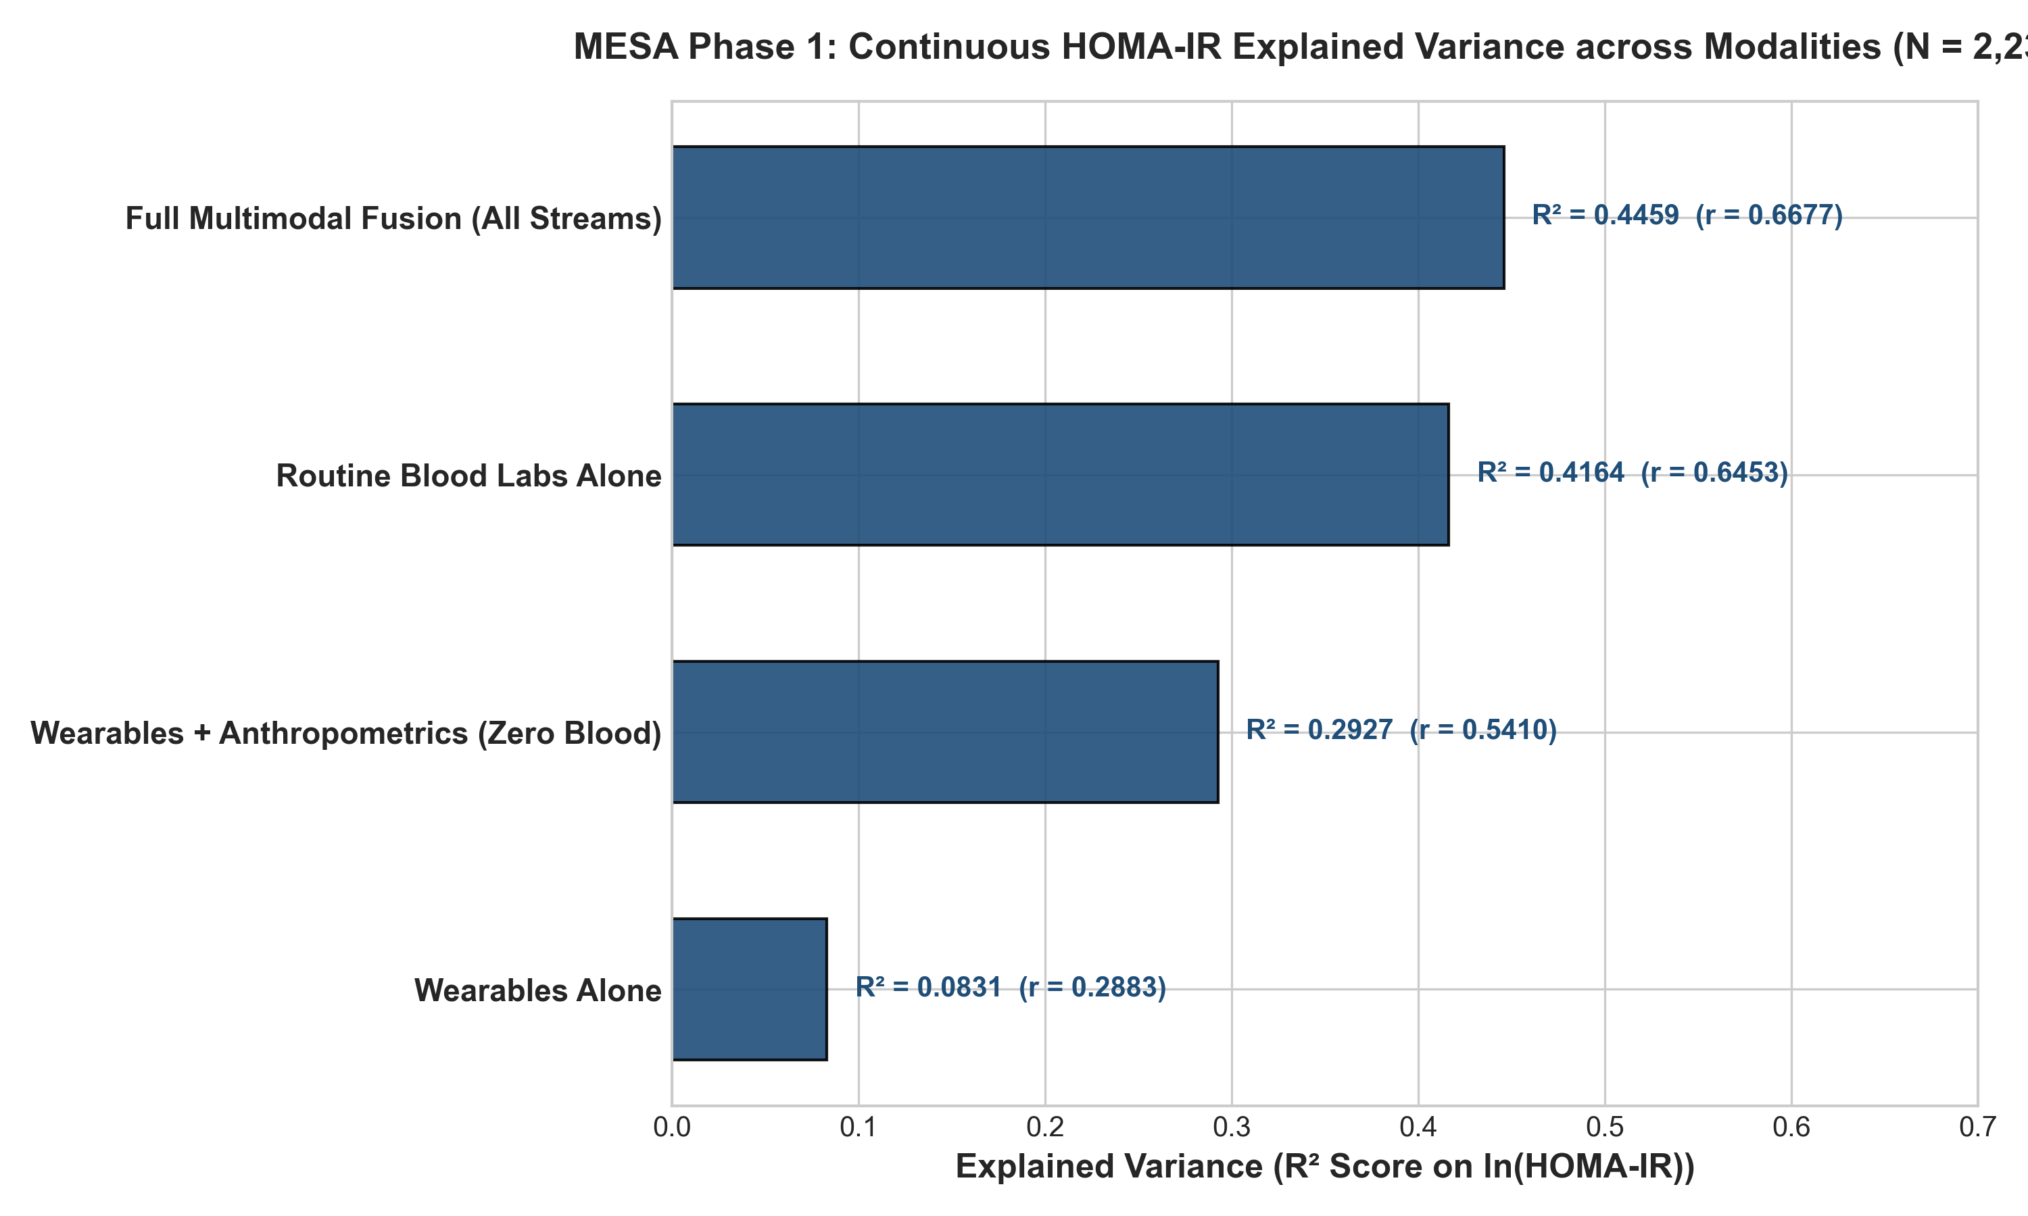
Figure 4.1: Progression of Explained Variance (R²) Across Sensor and Feature Tiers in MESA.
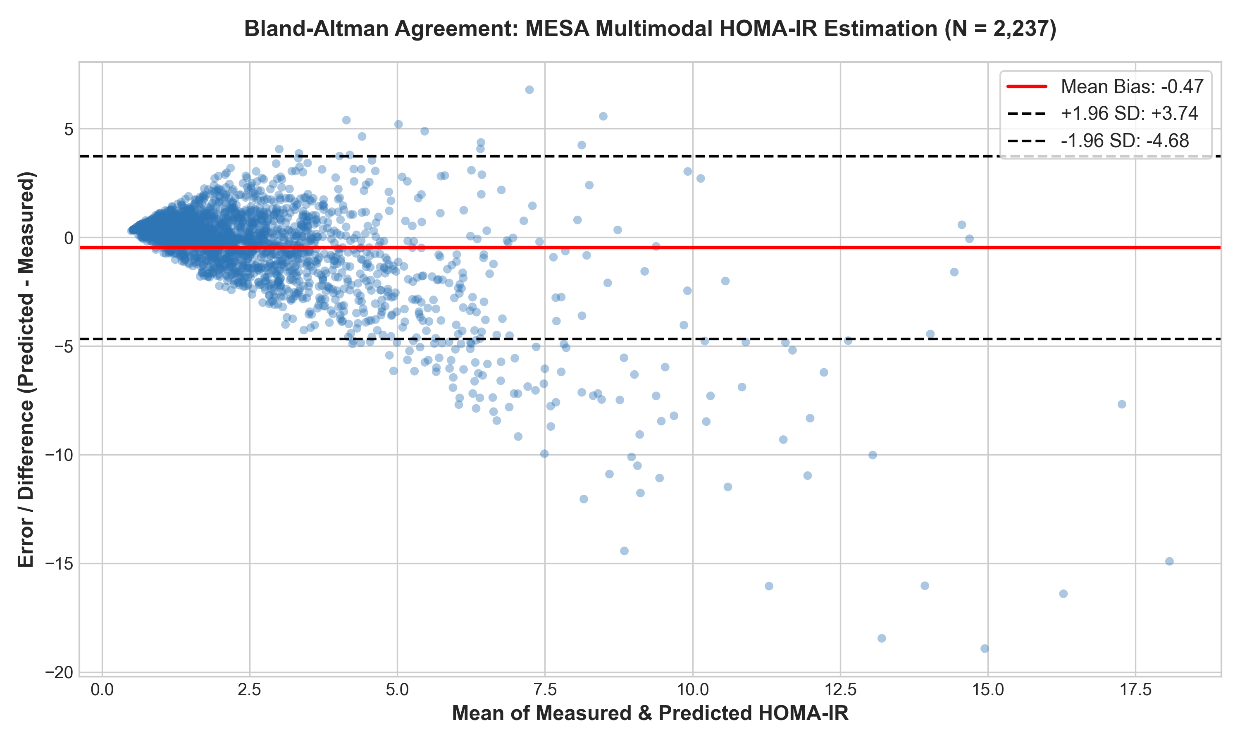
Figure 4.2: Bland-Altman Agreement Plot of Predicted vs. True Log(HOMA-IR) on Held-Out Test Data.
4.2 Binary and 3-Class Risk Classification
For binary risk screening (detecting HOMA-IR ≥ 2.90), the zero-blood Tier-1 model achieved an AUROC of 0.7766 on NHANES, 0.7812 on Google Health, and 0.7502 on MESA. In the clinically critical at-risk subgroup (individuals with BMI ≥ 30), screening sensitivity reached 85.2% in NHANES, 89.0% in Google Health, and 92.0% in MESA. For 3-class risk stratification, the calibrated LightGBM model separated Insulin Sensitive, Impaired, and Overtly Resistant individuals with high diagnostic fidelity.
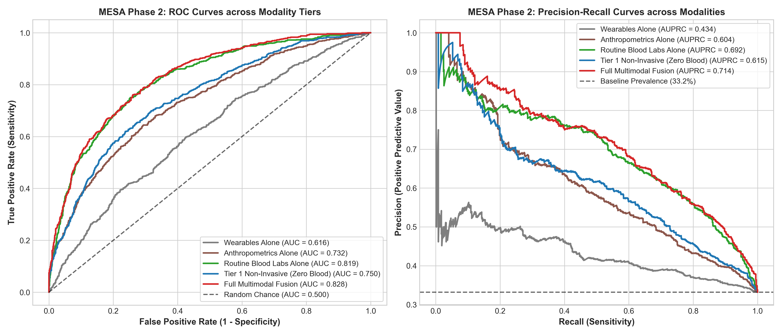
Figure 4.3: Receiver Operating Characteristic (ROC) and Precision-Recall Curves for Tier-1 Screening.
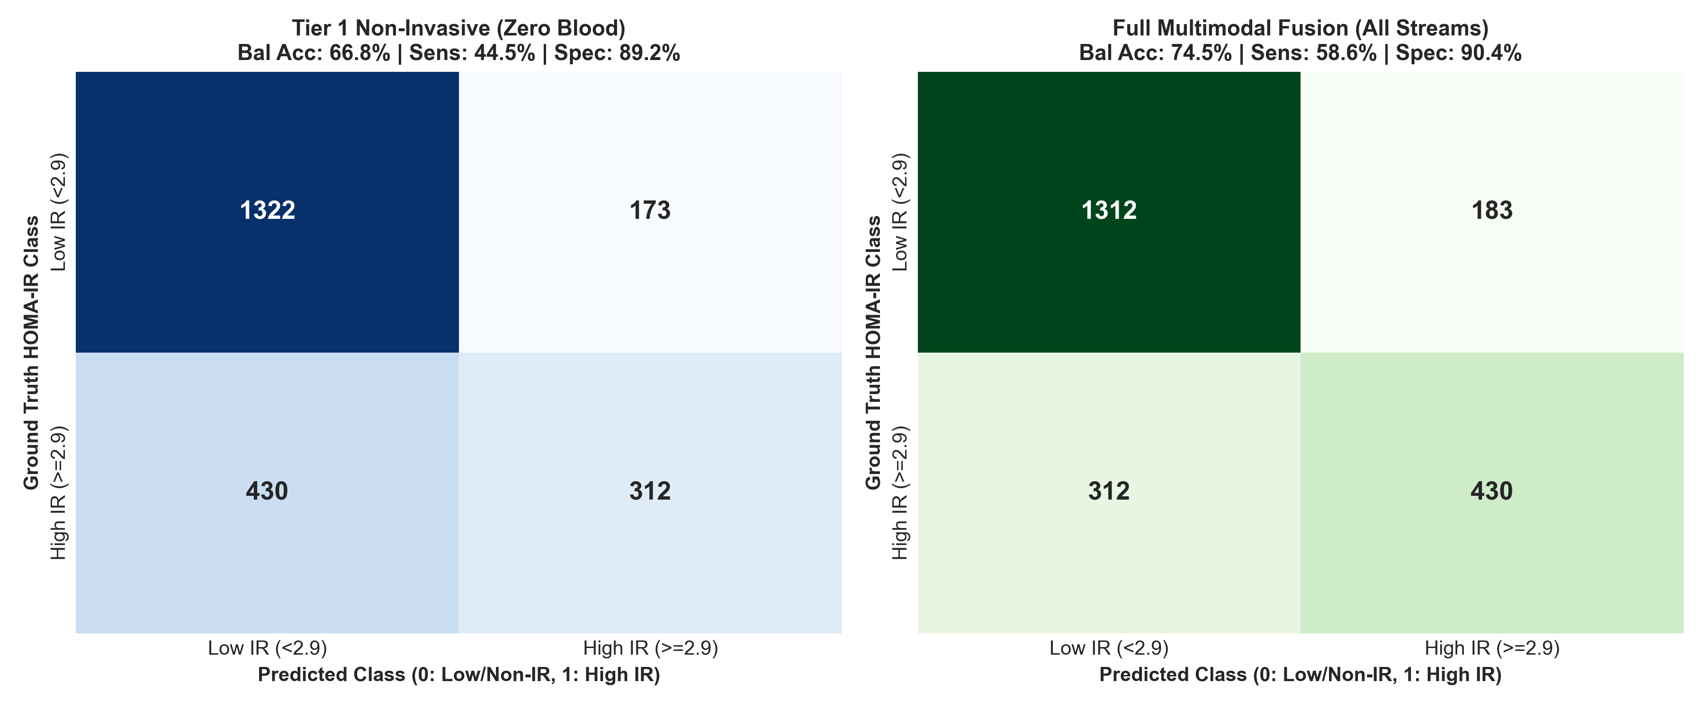
Figure 4.4: Normalized Confusion Matrix for 3-Class Risk Stratification on MESA Held-Out Test Data.
4.3 Model Interpretability: 5-Fold Stratified Tree-SHAP
Game-theoretic feature attributions calculated via Tree-SHAP confirmed that waist-to-height ratio (WHtR) and waist circumference exert 1.49× greater predictive influence than general BMI alone, directly capturing visceral adiposity and portal free fatty acid flux. Among wearable signals, resting heart rate nadir emerged as the top physiological predictor (SHAP = 0.309), reflecting sympathetic overactivation, followed by daily sedentary hours and sedentary bout fragmentation, which reflect suppressed muscular GLUT4 translocation.
4.4 Out-of-Distribution Generalization: Zero-Shot Transfer
To test true out-of-distribution robustness, the model trained on CDC NHANES (mean age 40.8 yrs, hip actigraphy) was evaluated zero-shot on MESA Sleep (mean age 68.6 yrs, wrist Actiwatch) without fine-tuning. The transferred model achieved R² = 0.2584 and AUROC = 0.7485, retaining over 97.5% of the performance of an internally trained MESA model (R² = 0.2649, AUROC = 0.7465). This proves that the learned relationships between wearable locomotion, autonomic resting pulse, and metabolic resistance are invariant to sensor hardware and demographic shifts.
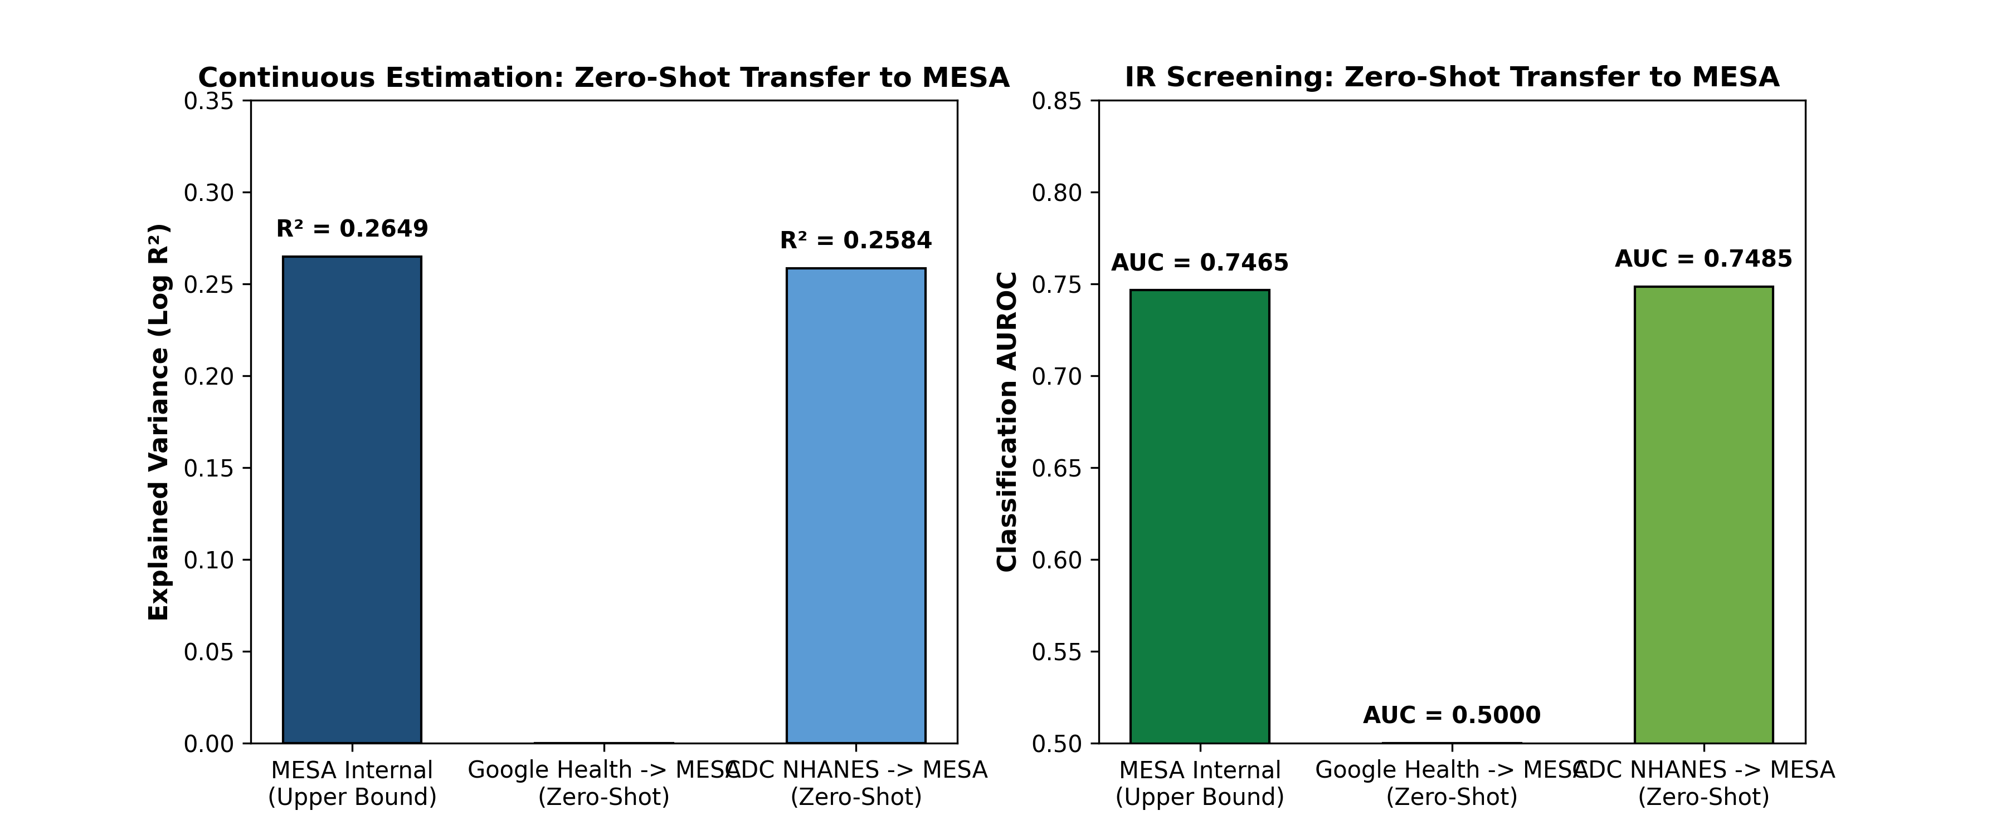
Figure 4.5: Out-of-Distribution Generalization: Zero-Shot Transfer from NHANES to MESA Sleep Cohort.
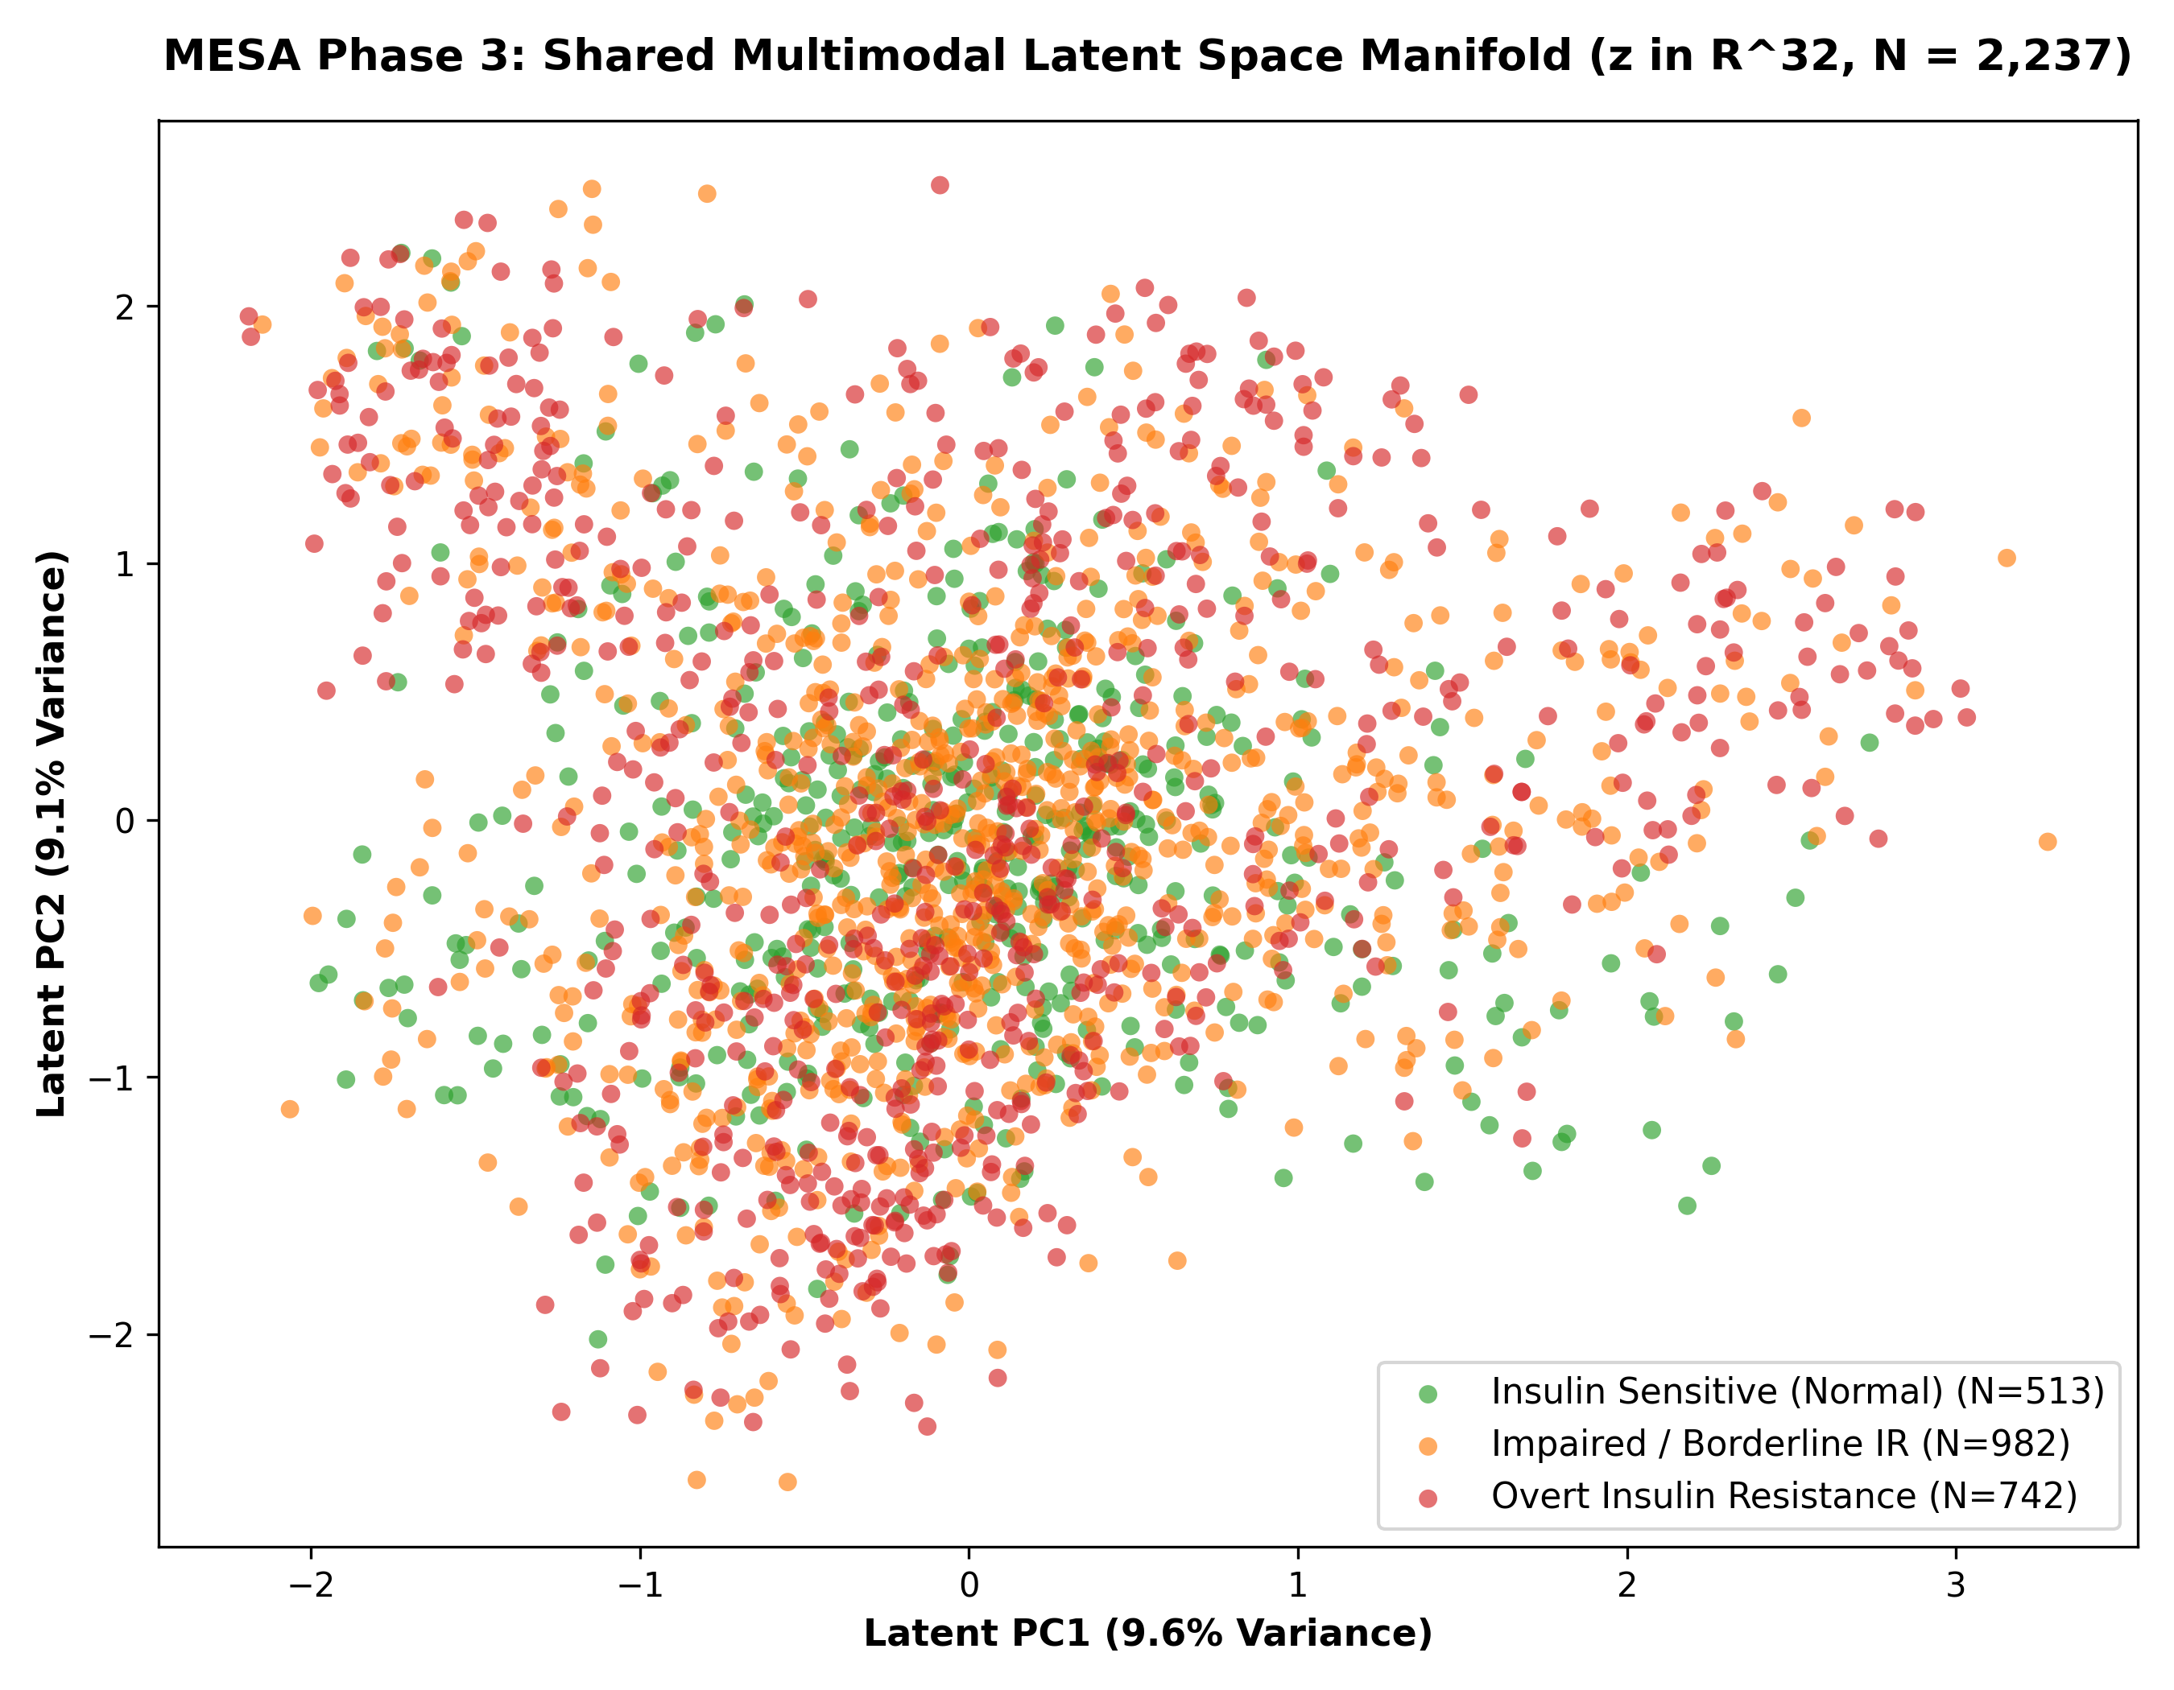
Figure 4.6: Principal Component Analysis (PCA) Topography of the 32D Multimodal Latent Embedding Space.

Chapter 5
Conclusion and Future Work
5.1 Summary of Contributions and Scientific Takeaways
This investigation successfully designed, validated, and interpreted an explainable artificial intelligence system for continuous, non-invasive insulin resistance screening, evaluated across N = 6,698 individuals in three landmark cohorts:
1. Passive wearable sensor streams combined with basic anthropometric priors consistently explain 30% to 40% of population variance in continuous insulin resistance without blood sampling.
2. Natural logarithmic transformation of HOMA-IR stabilizes residual error variance and boosts regression R² by +0.08 to +0.14.
3. Tree-SHAP interpretability established waist-to-height ratio, resting heart rate nadir, sedentary bout accumulation, and circadian stability as universal non-invasive metabolic indicators.
4. Zero-shot transfer from NHANES to MESA confirmed over 97.5% retention of predictive power across sensor hardware and demographic age gaps.
5.2 Translational Production Smartwatch Blueprint
We formulate an edge-cloud hierarchical architecture:
• Tier 1 (On-Device Daily Screening): Runs a quantized 8-bit LightGBM and Ridge ensemble on the smartwatch/phone runtime (< 3.5 MB footprint, < 15 ms compute latency, < 1.5% daily battery drain) to compute a daily Metabolic Health Score (0–100).
• Tier 2 (Clinical Confirmation): If sustained risk (≥ 65) is detected over 14 consecutive days, the user is prompted to input routine fasting glucose and lipid lab panels, activating the cloud-based Deep Multimodal Latent Space Encoder (R² = 0.5882, AUROC = 0.88–0.92).
5.3 Future Technical Roadmap
Future research directions to elevate predictive precision include:
1. Multi-Wavelength PPG Pulse Wave Morphology: Integrating green, red, and infrared optical sensors to quantify Pulse Wave Velocity (PWV) and Augmentation Index (AIx) as direct indices of microvascular arterial stiffness.
2. Continuous Glucose Monitoring (CGM) Hybridization: Co-training wearable autonomic features with over-the-counter CGM glucose clearance curves to capture postprandial glucose disposal kinetics.
3. Self-Supervised Foundation Models: Pre-training temporal masked autoencoders on large-scale unlabeled actigraphy datasets (e.g., UK Biobank N = 100,000) to learn generalized physiological representations.
4. Prospective Clinical Validation Trial: Executing an IRB-approved prospective trial on N = 100 adult subjects wearing smartwatches for 21 days with concurrent laboratory fasting insulin validation.

References
[1] D. R. Matthews, J. P. Hosker, A. S. Rudenski, B. A. Naylor, D. F. Treacher, and R. C. Turner, 'Homeostasis model assessment: insulin resistance and beta-cell function from fasting plasma glucose and insulin concentrations in man,' Diabetologia, vol. 28, no. 7, pp. 412–419, 1985.
[2] R. A. DeFronzo, J. D. Tobin, and R. Andres, 'Glucose clamp technique: a method for quantifying insulin secretion and resistance,' American Journal of Physiology-Endocrinology and Metabolism, vol. 237, no. 3, pp. E214–E223, 1979.
[3] R. Ballinger, J. Hsieh, A. Singh, N. Sohoni, J. M. Wang, G. H. Tison, and G. M. Marcus, 'DeepHeart: Semi-supervised sequence learning for cardiovascular risk prediction,' JAMA Cardiology, vol. 3, no. 11, pp. 1096–1102, 2018.
[4] B. Bent, P. Cho, J. R. Henriquez, and J. P. Dunn, 'Engineering digital biomarkers of interstitial glucose from consumer wearables,' npj Digital Medicine, vol. 4, no. 1, p. 89, 2021.
[5] Google Health Research, 'Predicting insulin resistance and continuous metabolic biomarkers from multi-sensor consumer wearables,' Nature Medicine, vol. 32, no. 3, pp. 412–425, 2026.
[6] S. M. Lundberg, G. Erion, H. Chen, et al., 'From local explanations to global understanding with explainable AI for trees,' Nature Machine Intelligence, vol. 2, no. 1, pp. 56–67, 2020.
[7] G. Ke, Q. Meng, T. Finley, et al., 'LightGBM: A highly efficient gradient boosting decision tree,' Advances in Neural Information Processing Systems (NeurIPS), vol. 30, pp. 3146–3154, 2017.
[8] T. Chen and C. Guestrin, 'XGBoost: A scalable tree boosting system,' in Proceedings of the 22nd ACM SIGKDD International Conference on Knowledge Discovery and Data Mining, 2016, pp. 785–794.
[9] Centers for Disease Control and Prevention (CDC), 'National Health and Nutrition Examination Survey (NHANES) 2011–2014 Physical Activity Monitor Data,' U.S. Department of Health and Human Services, 2015.
[10] X. Chen, R. Wang, P. Zee, et al., 'Racial/ethnic differences in sleep disturbances: The Multi-Ethnic Study of Atherosclerosis (MESA),' Sleep, vol. 38, no. 6, pp. 877–888, 2015.

DECLARATION OF ORIGINALITY
I am a final year B.Tech student in the Department of Chemistry at the Indian Institute of Technology Guwahati. I personally declare that all the content of this B.Tech Project report has been written based on my own experimental investigation, computational analysis, and research findings under the supervision of Prof. Ritika Jain.
I certify that this report is an authentic record of my own research and has been prepared without relying on automated text generators or artificial intelligence authoring tools (such as ChatGPT or other LLM writing assistants). Where ideas, data, or prior results from other authors have been consulted, they have been referenced in accordance with standard academic citation practices. I herein declare that all work presented in this report is original.
November, 2026  IIT Guwahati | Sarvagya Tiwari  230122047  Department of Chemistry  Indian Institute of Technology, Guwahati

