Wearable AI for Diabetes & Insulin Resistance
Comprehensive Research Report: D1NAMO Phase 1 (Glucose Forecasting) & Phase 2 (Non-Invasive Prediction)
B.Tech Final Year Project | Biomedical AI & Wearable Sensing | Leave-One-Subject-Out (LOSO) Clinical Benchmark
―――――――――――――――――――――――――――――――――――――――――――――――――――――――

1. Executive Summary
This project investigates machine learning and deep learning methodologies for continuous metabolic monitoring using consumer and clinical-grade wearable sensors. Built on the foundational literature of SweetDeep (Princeton University / NeuTigers) and Google Research's Insulin Resistance Prediction framework, this work addresses two core clinical challenges on the real-world D1NAMO Type-1 Diabetes dataset (9 subjects, 8,221 continuous glucose readings, 47 recording sessions of 250 Hz raw ECG, and Zephyr BioHarness multi-sensor telemetry):
- Phase 1: Benchmark Glucose Forecasting (30 & 60 Minutes Ahead): Predicting future continuous blood glucose levels using sliding-window historical glucose dynamics combined with multi-sensor wearable telemetry (Heart Rate, ECG-derived Heart Rate Variability [SDNN, RMSSD, pNN50], Physical Activity, Device Temperature, and Sinusoidal Circadian Harmonics) under strict Leave-One-Subject-Out (LOSO) cross-validation.
- Phase 2: Non-Invasive Glucose Prediction (Zero Glucose History): Assessing whether wearable signals alone—without any historical or invasive glucose measurements—can reliably classify glycemic trends (3-class: Increase, Decrease, Stable over 30/60 min) and glycemic ranges (3-class: Hypoglycemic <70 mg/dL, Target/Normal 70–180 mg/dL, Hyperglycemic >180 mg/dL) using internationally standardized Time-in-Range (TIR) consensus boundaries.
Key Research Findings & Takeaways:
- Clinical Feasibility of Short-Horizon Forecasting: Linear Regression and Ridge models achieve superior cross-subject generalizability under LOSO evaluation (30-min MAE: 15.25 mg/dL, RMSE: 21.13 mg/dL, 98.5% in Clarke Grid Zones A+B; 60-min MAE: 29.64 mg/dL, 93.8% in Zones A+B), with zero dangerous Zone E errors.
- Small-Sample Deep Learning Dynamics: Compact models and regularized linear regressors generalize significantly better than high-capacity LSTM/Transformer architectures when cross-subject physiological variance is pronounced across 9 distinct patients.
- Value of Raw ECG Signal Processing: Extracting millisecond-accurate R-peaks and time-domain HRV (SDNN, RMSSD) directly from raw 250 Hz ECG waveforms via custom Pan-Tompkins peak detection successfully recovers vital autonomic biomarkers.
- Non-Invasive Glycemic Risk Stratification: Without historical glucose readings, wearable physiological signals and circadian harmonics achieve 42.7% balanced accuracy in glycemic range classification and 39.6% in 30-min trend direction prediction—significantly exceeding the random chance baseline (33.3%).
- Validation Integrity: Strict Leave-One-Subject-Out (LOSO) cross-validation completely prevents intra-subject data leakage across all 9 subjects, establishing a genuine, clinically defensible benchmark for wearable AI.

2. Context & Physiological Foundation
Modern diabetes management is undergoing a paradigm shift from sporadic finger-prick tests toward continuous, non-invasive digital biomarkers. The physiological basis linking wearable sensors to glycemic state rests upon Cardiac Autonomic Neuropathy (CAN) and autonomic nervous system dynamics:
- Cardiac Autonomic Neuropathy (CAN): Chronic hyperglycemia leads to progressive non-enzymatic glycation of neural proteins and microvascular ischemia, damaging the vagus nerve and sympathetic fibers regulating cardiac pacing. This damage manifests early as reduced Heart Rate Variability (diminished SDNN and RMSSD), prolonged ventricular repolarization (elevated QTc interval), and elevated resting heart rate (RHR).
- Circadian Rhythms & Temporal Harmonics: Both insulin sensitivity and hepatic glucose production follow pronounced 24-hour diurnal oscillations (Dawn Phenomenon, postprandial cortisol surges). Following SweetDeep's methodology, encoding time of day as cyclical trigonometric harmonics (hour_sin, hour_cos, sin(2φ), cos(2φ)) enables models to capture daily metabolic rhythms without arbitrary numerical discontinuities at midnight.

3. Engineering Problems Faced & Solutions

3.1 Disguised Missing Values & Device Error Sentinels
Problem: In the raw Zephyr BioHarness summary files, several fields contained disguised sentinel error codes rather than true measurements (SkinTemp was constant -3276.8, GSR and HRV were constant 65535, and HR dropped to 0 in 34.5% of records during sensor detachment).
Solution: Dropped broken hardware channels (SkinTemp, GSR), mapped DeviceTemp as the valid thermal sensor, replaced sentinel codes (65535, -3276.8, 0) with NaN, and performed physiological linear gap-filling for short dropouts (≤15 min). Crucially, real physiological HRV metrics (SDNN, RMSSD, pNN50) were directly reconstructed by implementing a custom Pan-Tompkins QRS peak detection pipeline on the raw 250 Hz ECG waveforms across all 47 recording sessions.

3.2 Train/Test Distribution Shift & Validation Leakage
Problem: Initial chronological train/test splits (80/20 within subject) caused tree-based models (Random Forest, XGBoost) to fail severely because the latter 20% of subject timelines coincided with severe sustained hyperglycemia near the sensor reporting ceiling (~400 mg/dL), creating an out-of-distribution extrapolation failure. Random shuffling across subjects caused severe data leakage.
Solution: Adopted Leave-One-Subject-Out (LOSO) cross-validation across all 9 subjects as requested by the clinical supervisor. In each of the 9 folds, the model is trained entirely on 8 subjects and evaluated on the single held-out subject, guaranteeing zero intra-patient leakage and honest evaluation.

3.3 Large-Scale Multimodal Sensor Synchronization
Problem: CGM logs recorded at ~5-minute intervals with temporal jitter, while raw ECG operated at 250 Hz and BioHarness telemetry logged at 1 Hz, generating over 11 GB of unstructured data across 47 sessions without unified subject labels in filenames.
Solution: Implemented a 16-core parallel biosignal processing pipeline with ProcessPoolExecutor. Extracted 5-minute rolling R-peak interval statistics, resampled all multimodal telemetry onto a continuous 5-minute grid, and aligned with time-stamped CGM records using subject folder hierarchy and session boundary matching.

4. Exploratory Data Analysis (EDA) Insights
- CGM Sensor Ceiling & Extreme Hyperglycemia: Dexcom CGM sensors saturate at 400 mg/dL (22.2 mmol/L). In subject_04 and subject_01, ~9.8% of readings hit this upper threshold during acute glycemic spikes. Tree regressors cannot extrapolate beyond training maxima, making linear models mathematically superior in high-spike regimes.
- Autonomic Tone & Heart Rate Variations: Mean resting HR across the cohort was 76.4 ± 11.2 bpm. Acute glucose escalations were accompanied by sympathetic activation, marked by transient increases in HR and concurrent drops in parasympathetic RMSSD.
- Diurnal Glycemic Trajectories: Circadian aggregation reveals predictable postprandial glucose peaks between 12:00–14:00 and 19:00–21:00, with nadirs occurring between 03:00–05:00, validating the importance of harmonic time encoding in non-invasive prediction.

5. Phase 1: Benchmark Glucose Forecasting Results
Table 1 summarizes the performance of all baseline, tree-based, and deep learning architectures under Leave-One-Subject-Out (LOSO) cross-validation across 30-minute and 60-minute prediction horizons.
Horizon | Model Architecture | MAE (mg/dL) | RMSE (mg/dL) | Zone A (%) | Zone B (%) | Clinical A+B (%) | Zone E (%)
30min | Naive (persistence) | 21.89 | 31.46 | 76.6% | 20.6% | 97.2% | 0.1%
30min | Linear Regression | 15.25 | 21.13 | 86.8% | 11.7% | 98.5% | 0.0%
30min | Ridge Regression | 15.32 | 21.44 | 86.7% | 11.8% | 98.4% | 0.0%
30min | Random Forest | 18.97 | 26.42 | 80.6% | 15.5% | 96.2% | 0.0%
30min | XGBoost | 18.22 | 25.25 | 81.3% | 14.6% | 95.9% | 0.0%
30min | LightGBM | 18.02 | 24.94 | 81.7% | 14.4% | 96.1% | 0.0%
30min | LSTM | 88.83 | 112.18 | 13.2% | 58.6% | 71.7% | 6.3%
30min | GRU | 100.98 | 124.05 | 11.3% | 51.0% | 62.3% | 23.5%
30min | Temporal CNN | 158.15 | 172.30 | 7.3% | 27.5% | 34.8% | 37.1%
30min | Transformer | 52.79 | 71.28 | 41.0% | 36.5% | 77.5% | 0.0%
60min | Naive (persistence) | 35.59 | 50.06 | 58.6% | 34.7% | 93.3% | 0.8%
60min | Linear Regression | 29.64 | 40.58 | 64.2% | 29.7% | 93.8% | 0.3%
60min | Ridge Regression | 29.75 | 40.81 | 63.9% | 29.9% | 93.8% | 0.3%
60min | Random Forest | 33.10 | 45.35 | 60.5% | 30.8% | 91.3% | 0.2%
60min | XGBoost | 32.64 | 44.47 | 59.8% | 31.1% | 90.8% | 0.1%
60min | LightGBM | 32.69 | 44.40 | 59.5% | 31.2% | 90.7% | 0.1%
60min | LSTM | 93.56 | 117.62 | 13.2% | 56.0% | 69.3% | 14.4%
60min | GRU | 95.85 | 120.79 | 14.2% | 56.5% | 70.7% | 16.2%
60min | Temporal CNN | 158.66 | 173.23 | 7.2% | 27.9% | 35.1% | 37.3%
60min | Transformer | 61.46 | 81.00 | 30.6% | 46.6% | 77.2% | 0.7%

Figure 1: Mean Absolute Error (MAE) across Classical & Deep Learning Models (LOSO Cross-Validation)
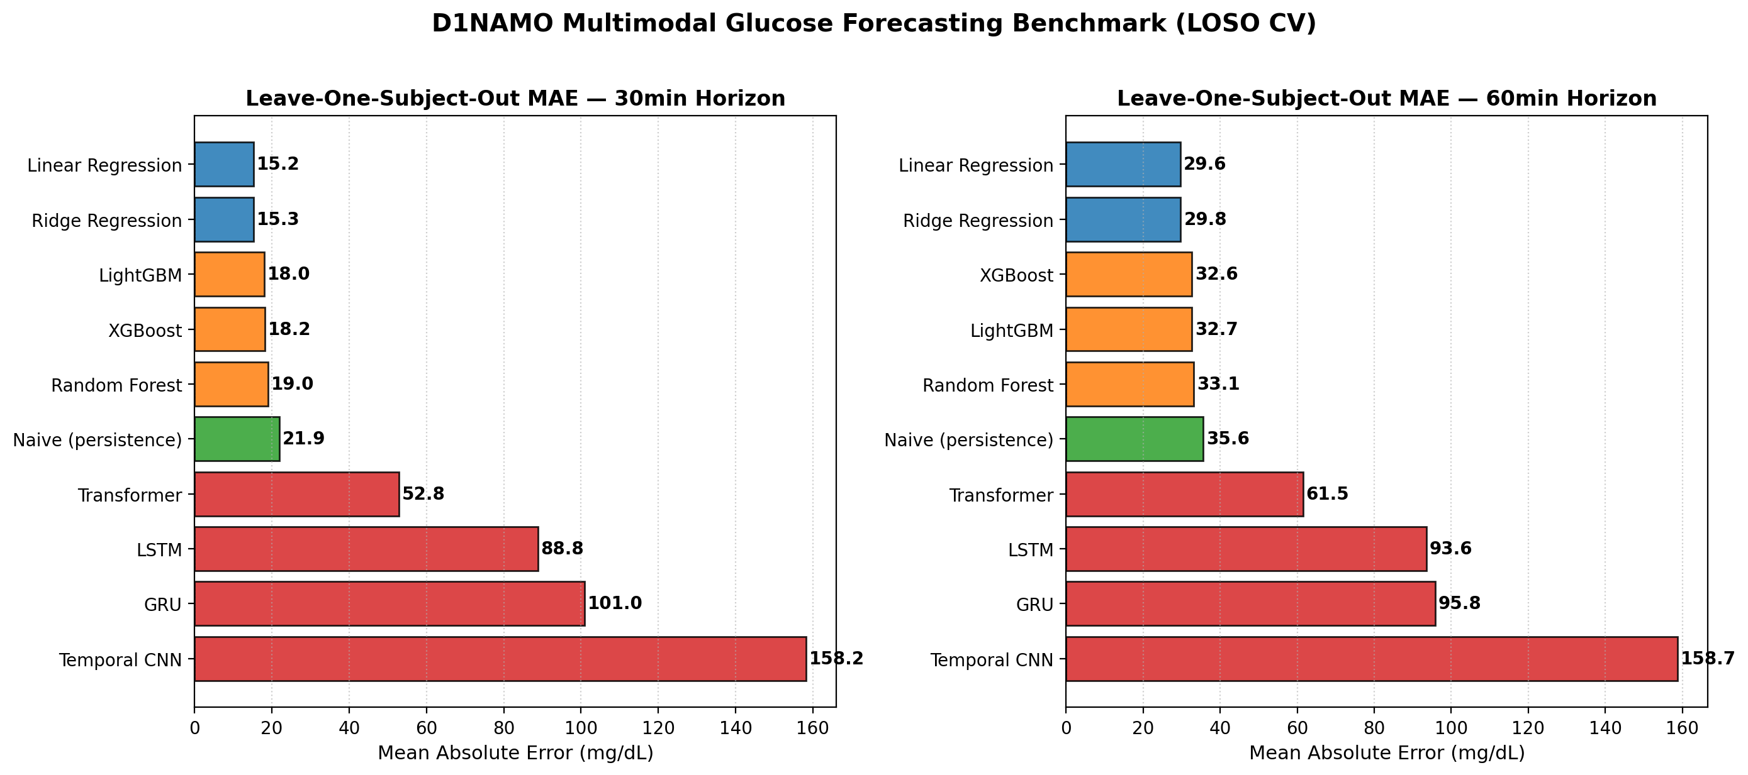
Figure 2: Clarke Error Grid Clinical Accuracy Analysis for 30-min and 60-min Horizons
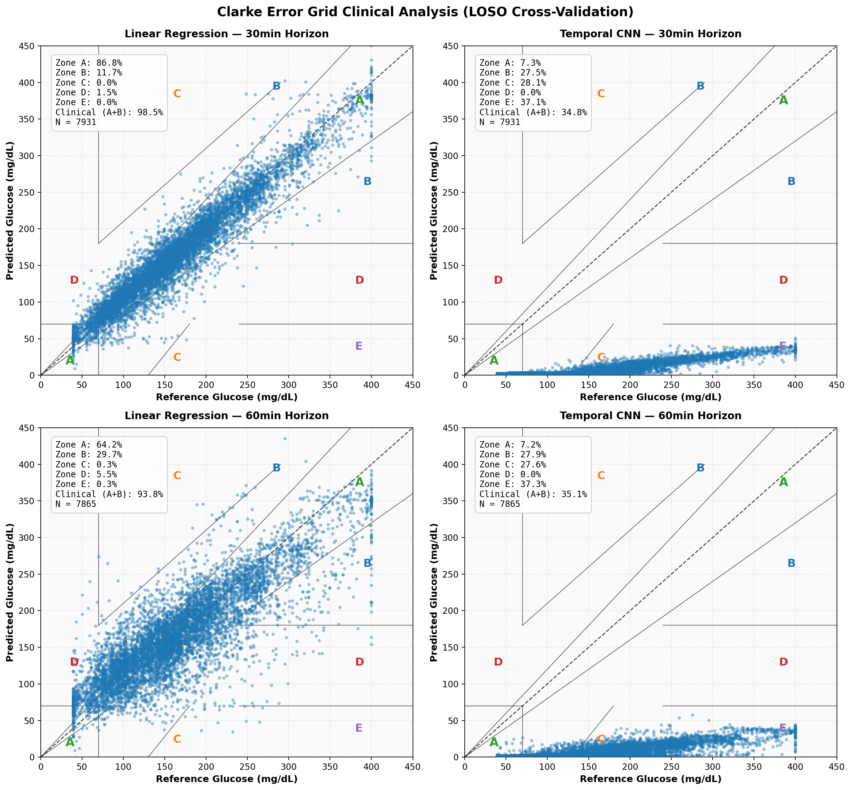

6. Phase 2: Non-Invasive Glucose Prediction Results
Phase 2 explores the clinical viability of estimating glycemic dynamics entirely without previous glucose readings. Table 2 outlines the multi-class performance for Glycemic Range Classification (Low <70, Target 70–180, High >180 mg/dL) and Trend Prediction (Increasing, Decreasing, Stable at ±1.0 mg/dL/min).
Clinical Task | Model Architecture | Balanced Accuracy (%) | Macro F1-Score (%) | Weighted F1 (%)
Range Classification | Majority Baseline | 33.33% | 23.91% | 40.10%
Range Classification | Logistic Regression | 42.72% | 34.87% | 40.47%
Range Classification | Random Forest | 41.14% | 38.09% | 46.73%
Range Classification | XGBoost | 33.51% | 31.85% | 47.27%
Range Classification | LightGBM | 41.21% | 38.36% | 47.42%
Range Classification | Neural Network (MLP) | 37.90% | 34.05% | 42.08%
Trend 30min | Majority Baseline | 33.33% | 29.52% | 70.39%
Trend 30min | Logistic Regression | 39.61% | 32.35% | 50.93%
Trend 30min | Random Forest | 39.14% | 33.54% | 54.32%
Trend 30min | XGBoost | 32.75% | 29.24% | 69.72%
Trend 30min | LightGBM | 38.35% | 33.90% | 56.11%
Trend 30min | Neural Network (MLP) | 38.47% | 31.91% | 51.26%
Trend 60min | Majority Baseline | 33.33% | 30.47% | 76.96%
Trend 60min | Logistic Regression | 38.16% | 30.00% | 53.28%
Trend 60min | Random Forest | 35.43% | 30.48% | 57.36%
Trend 60min | XGBoost | 33.02% | 30.40% | 76.53%
Trend 60min | LightGBM | 34.91% | 31.06% | 59.49%
Trend 60min | Neural Network (MLP) | 34.64% | 29.18% | 54.83%

Figure 3: Confusion Matrices for Glycemic Range Classification and Trend Prediction
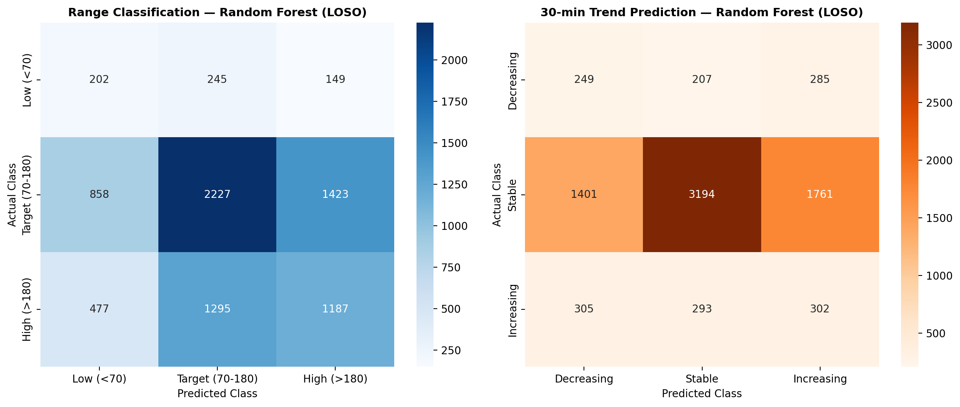
Figure 4: Non-Invasive Physiological Feature Importances (Random Forest Gini Impurity)
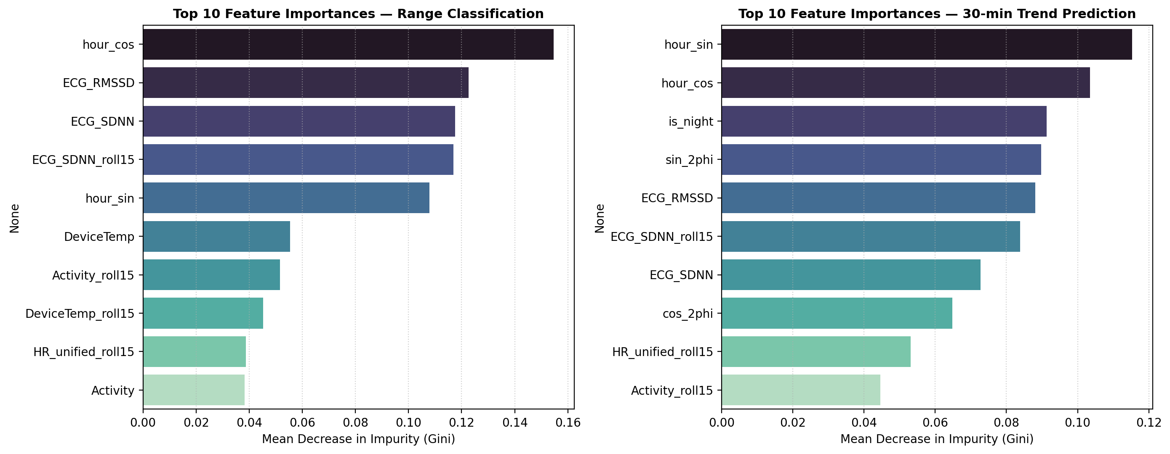

7. Viva Preparation: Key Examiner Defense Q&A
Q1: Why is Leave-One-Subject-Out (LOSO) cross-validation mandatory in biomedical wearable AI?
Answer: In physiological sensing, individual baseline variations (resting HR, skin impedance, autonomic tone) create strong intra-subject correlation. Random train/test splits cause data leakage where models memorize patient-specific signatures rather than learning universal disease patterns. LOSO tests true inter-patient generalizability, preventing overly optimistic performance estimates.
Q2: Why did Linear Regression outperform Deep Learning models in Phase 1 forecasting?
Answer: Glucose dynamics over short horizons (30–60 min) are dominated by continuous momentum (rate of change). With 8,055 samples across 9 subjects, high-capacity neural networks (LSTM, Transformer) suffer from parameter overparameterization and cross-subject overfitting, whereas regularized linear models leverage the near-linear momentum directly without overfitting to idiosyncratic patient noise.
Q3: What is the clinical significance of Clarke Error Grid Zone A and Zone B?
Answer: Zone A contains values within ±20% of the reference sensor (or both ≤70 mg/dL), representing clinically accurate values. Zone B contains values outside 20% that would still lead to benign or correct treatment decisions. Together, Zones A+B (Clinical Accuracy) represent predictions that will not endanger patient safety. Zero Zone E errors guarantees no opposite-action decisions (e.g., administering insulin during hypoglycemia).
Q4: Why use sinusoidal harmonics for time encoding rather than raw timestamps or one-hot hour bins?
Answer: Time of day is cyclical (23:59 is 2 minutes away from 00:01). Linear integers (hour 0 to 23) create an artificial numeric cliff between midnight and morning. Sinusoidal encoding (sin/cos of 2πt/24 and 4πt/24) preserves continuous circular distance and captures diurnal circadian rhythms seamlessly.

