AWS CLOUD PRACTITIONER PROJECT
Hands-on AWS Services Demonstration & Evidence Documentation
Prepared for GitHub Portfolio Upload

1. Project Overview
This project documents hands-on exploration of AWS cloud services through the AWS Management Console and related developer tools. The screenshots provide visual evidence of work involving web hosting, storage lifecycle management, analytics, compute, content delivery, generative AI, NLP, computer vision and voice application testing.

2. Objectives
- Understand and practice core AWS cloud services.
- Explore compute, storage, analytics and content-delivery workflows.
- Experiment with AWS AI/ML services such as Bedrock, Comprehend and Rekognition.
- Understand how cloud services can support real-world application development.
- Maintain organized screenshot evidence suitable for a GitHub portfolio.

3. Services and Activities
# | Service / Activity | Demonstration
1 | HTML/CSS Web Interface | Navigation bar and dashboard-style menu.
2 | Amazon S3 | Lifecycle transitions and object expiration.
3 | Amazon Athena | SQL query results for e-commerce data.
4 | Amazon CloudFront | Website accessed through a CloudFront distribution.
5 | Amazon EC2 | Instance states, types, zones and status checks.
6 | Alexa Developer Console | Alexa skill testing using the simulator.
7 | Amazon Bedrock | Generative AI prompt and response testing.
8 | Amazon Rekognition | Text detection from an image.
9 | Amazon Comprehend | Key-phrase extraction from text.
10 | Amazon Rekognition | Image properties and dominant-color analysis.

4. Project Flow
The practical activities can be viewed as a collection of cloud building blocks: compute and hosting with EC2, object storage with S3, data querying with Athena, content delivery with CloudFront, and AI/ML experimentation with Bedrock, Alexa, Comprehend and Rekognition.

5. Detailed Evidence

Web Navigation Bar
A simple HTML/CSS interface containing Home, About, Services and Contact navigation items, along with a dashboard-style menu containing Dashboard, Profile, Settings and Logout.
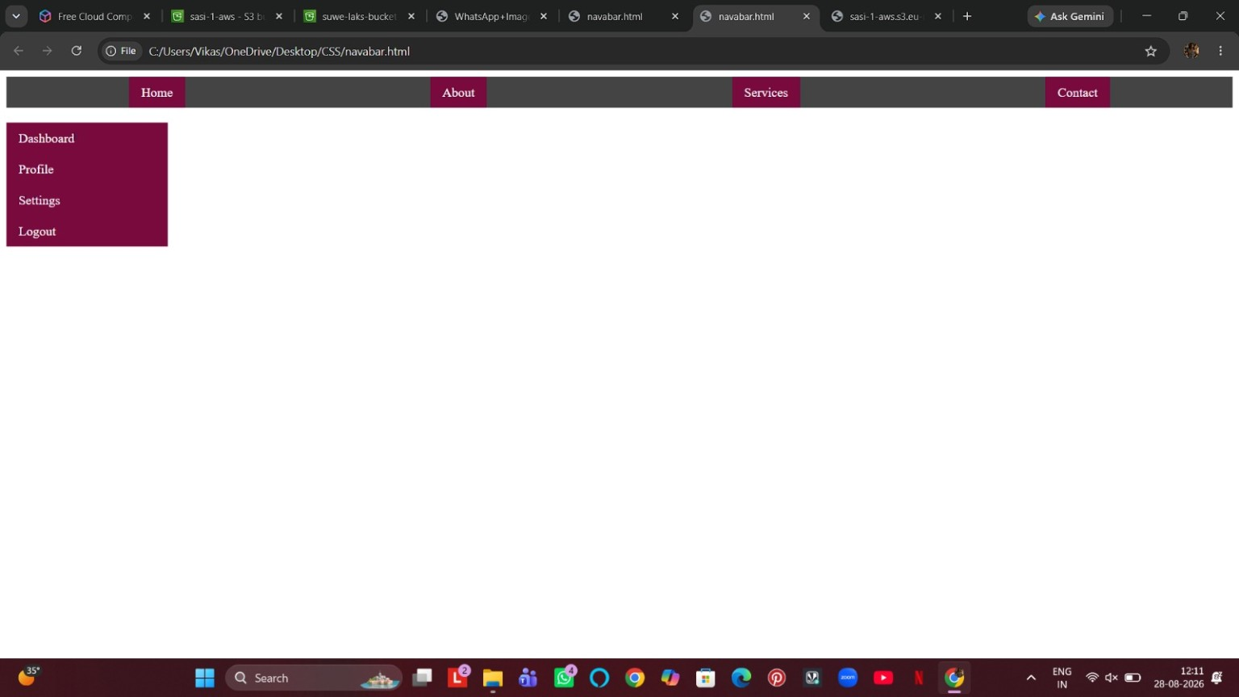
Figure 1: Web Navigation Bar

Amazon S3 Lifecycle Configuration
The lifecycle rule demonstrates automated storage management. Objects are uploaded on Day 0, transition to Standard-IA on Day 10, transition to One Zone-IA on Day 30, and are configured to expire later. This helps reduce storage cost and automate retention.
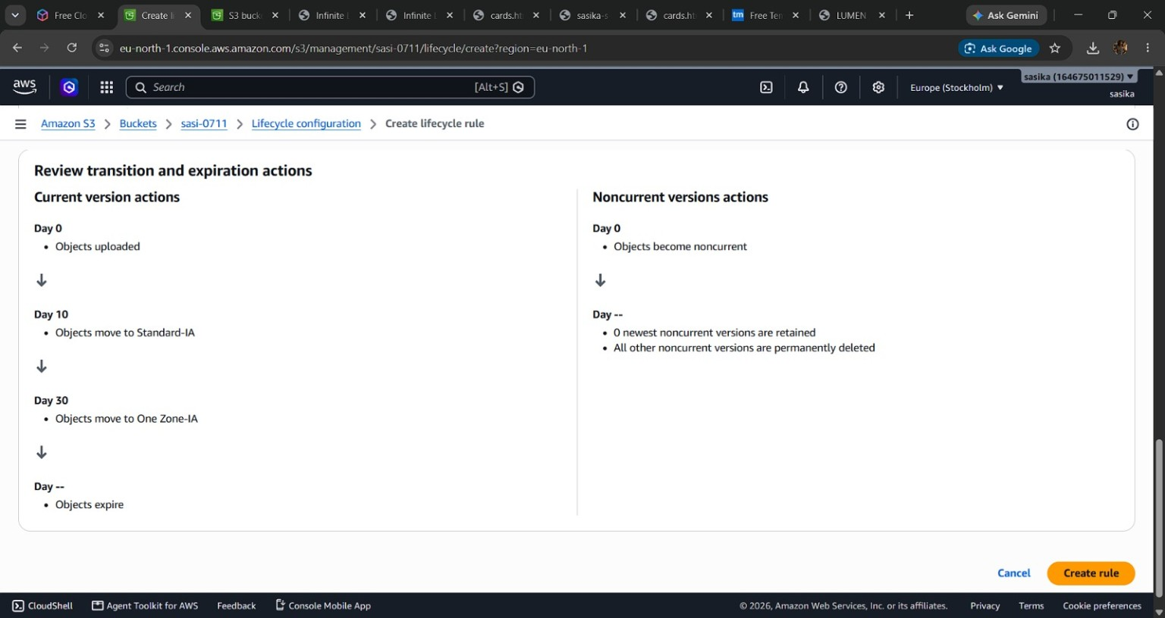
Figure 2: Amazon S3 Lifecycle Configuration

Amazon Athena Query Results
The Athena query editor displays an e-commerce/order dataset. Visible columns include order ID, customer ID, product ID, quantity, discount, payment method, status, age and city.
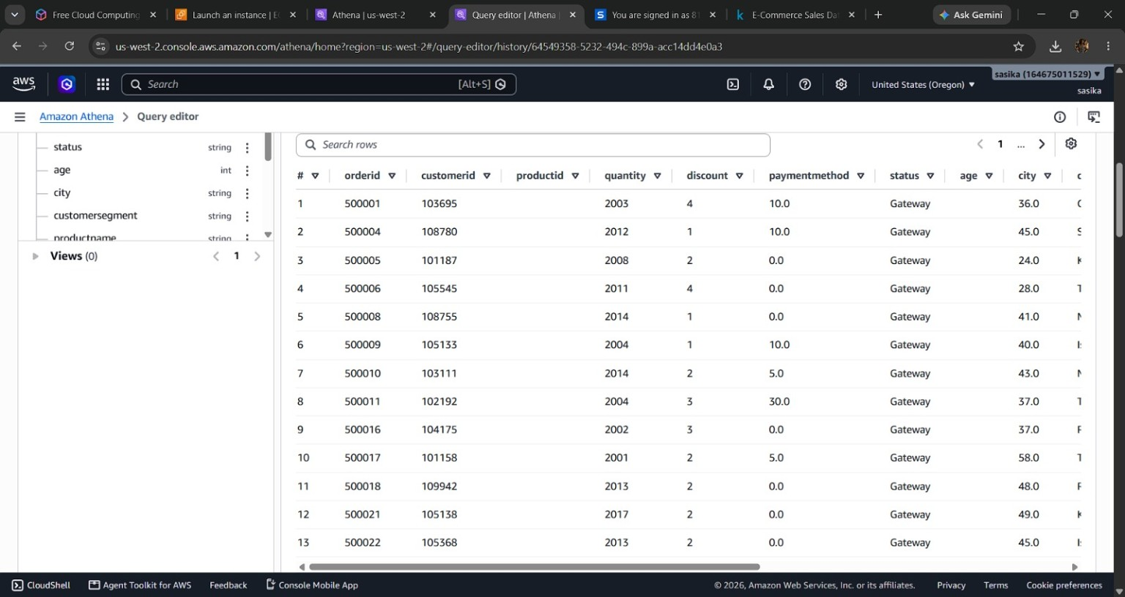
Figure 3: Amazon Athena Query Results

Amazon CloudFront Hosted Website
The browser shows a deployed website being served through a CloudFront distribution. The page presents the LUMEN // 80 furniture and spatial-design interface.
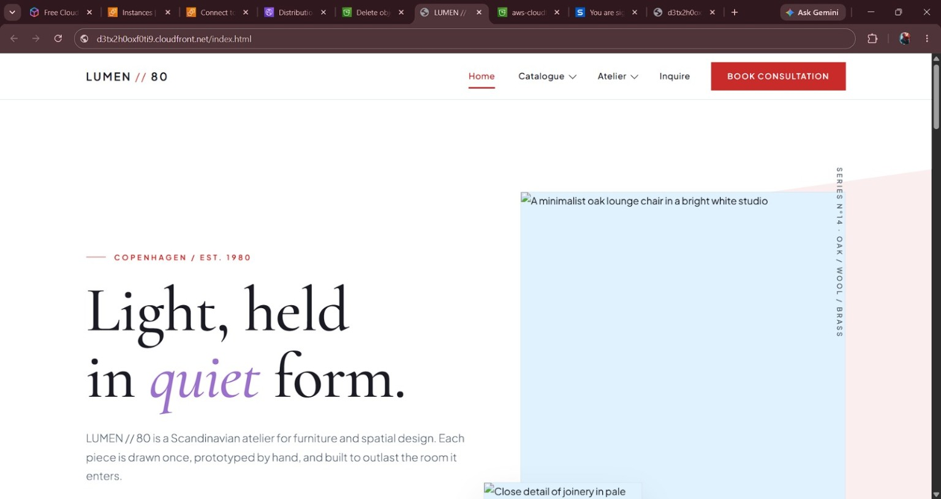
Figure 4: Amazon CloudFront Hosted Website

Amazon EC2 Instances
The EC2 console shows several instances in Running or Terminated states. The view also displays instance IDs, instance types, status checks and availability zones.
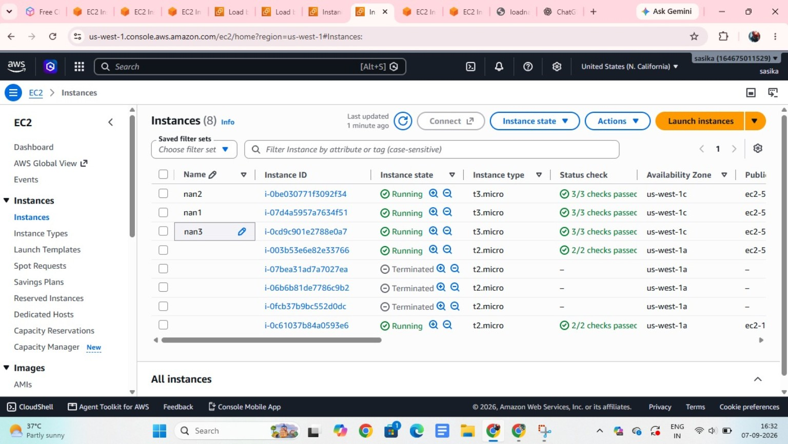
Figure 5: Amazon EC2 Instances

Alexa Developer Console
The Alexa Developer Console simulator is used to test a skill. The screenshot shows the testing environment, skill I/O, device display and an example response.
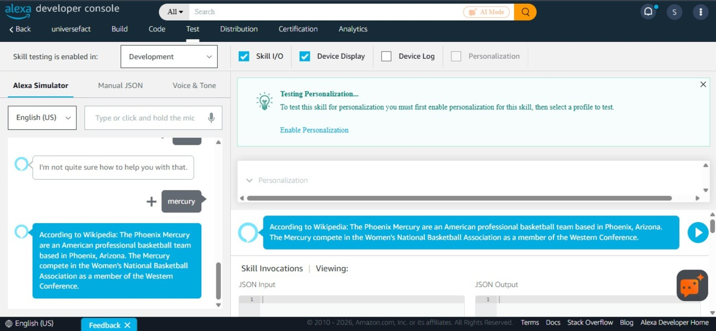
Figure 6: Alexa Developer Console

Amazon Bedrock Playground
The Bedrock Playground is used to test a foundation model with a prompt and generated response. The screenshot demonstrates managed generative-AI experimentation inside AWS.
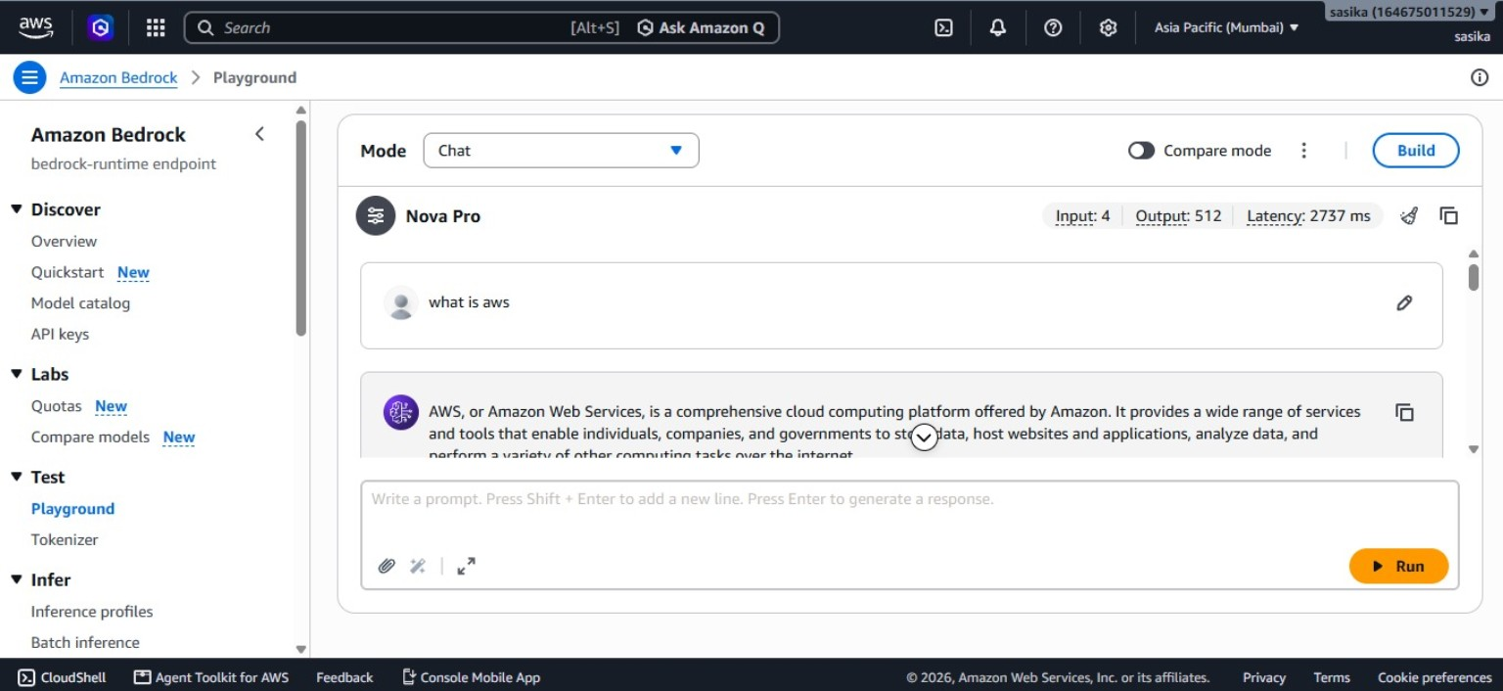
Figure 7: Amazon Bedrock Playground

Amazon Rekognition – Text Detection
Rekognition detects text appearing in an image. The example returns detected words such as FIND, BALANCE and IN LIFE with result information.
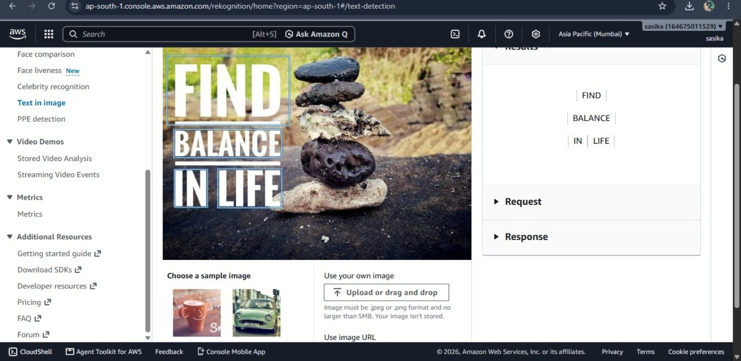
Figure 8: Amazon Rekognition – Text Detection

Amazon Comprehend – Key Phrase Analysis
Comprehend analyzes natural-language text and extracts key phrases with confidence scores. The example analyzes an office-network troubleshooting paragraph.
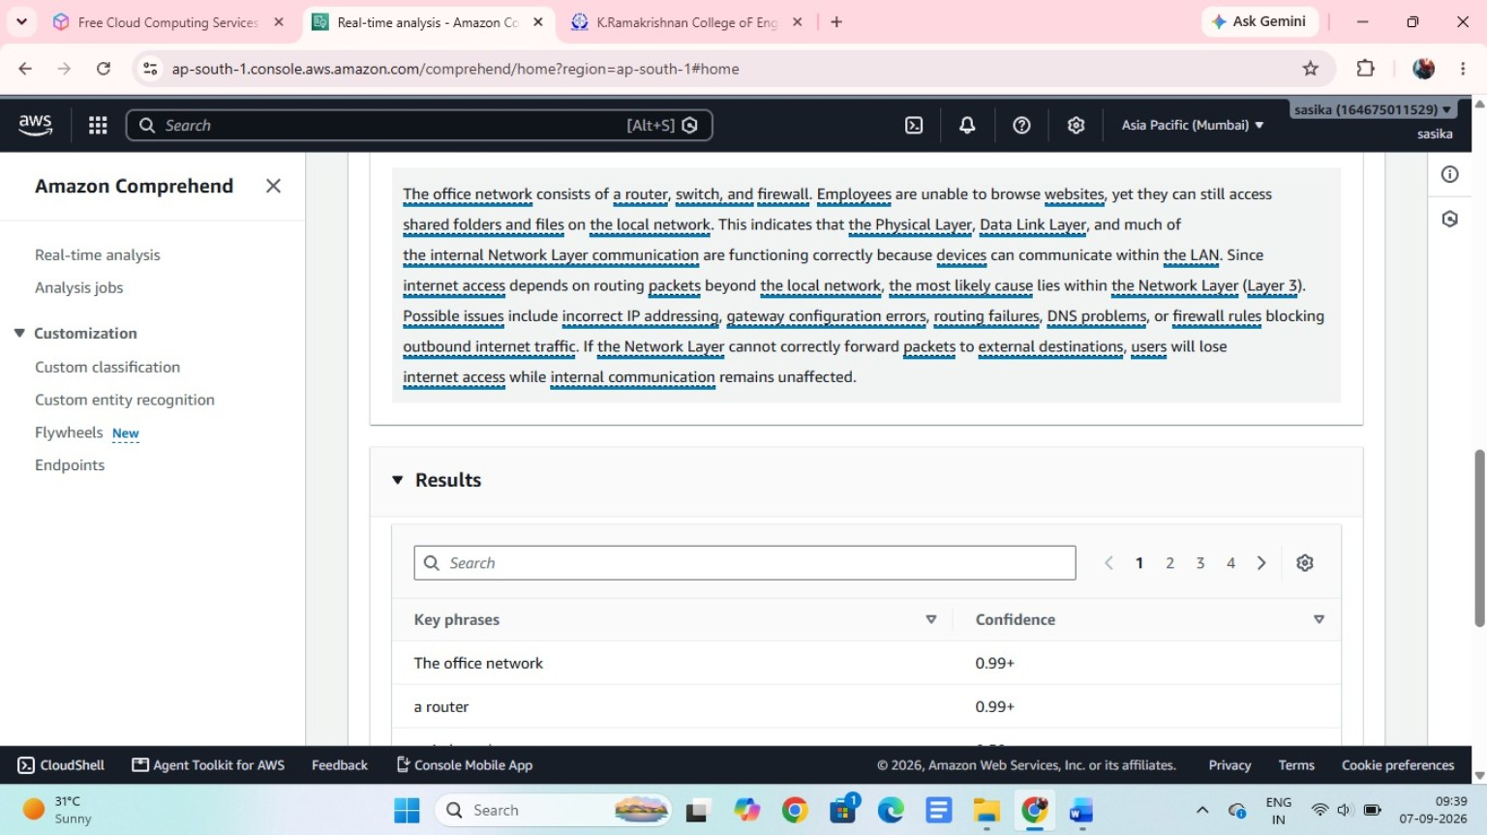
Figure 9: Amazon Comprehend – Key Phrase Analysis

Amazon Rekognition – Image Properties
Rekognition analyzes visual properties of an image, including dominant colors and image-quality information such as brightness.
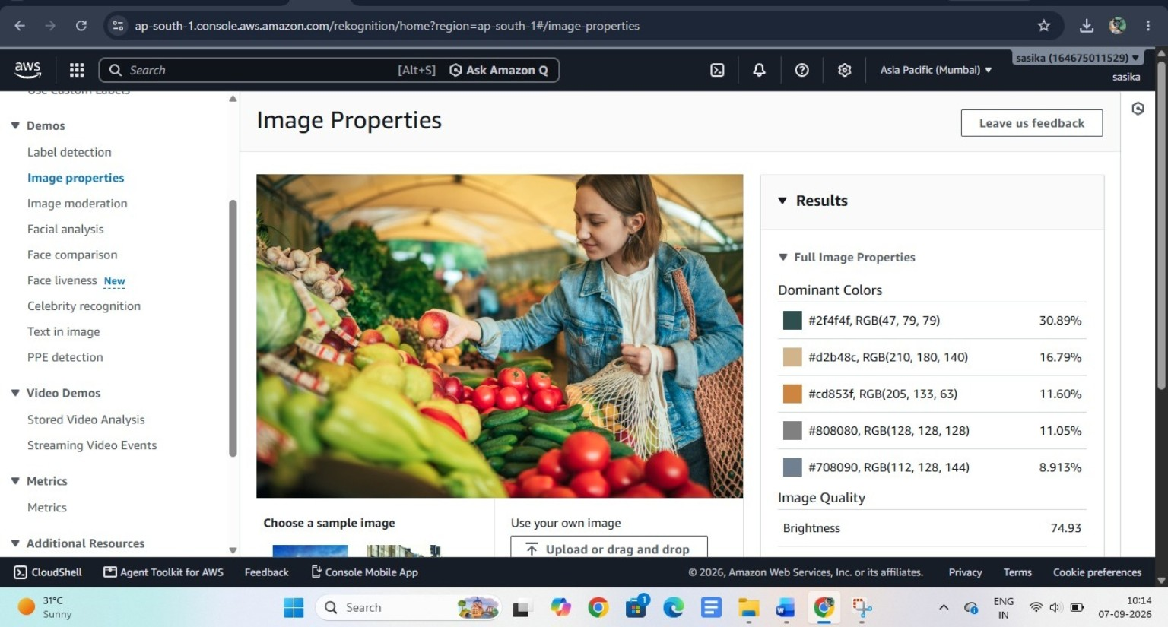
Figure 10: Amazon Rekognition – Image Properties

6. Key Learning Outcomes
The project demonstrates practical familiarity with the AWS console and with several major cloud service categories. It also shows how AWS can be used across the application lifecycle—from hosting and storage to querying, delivery and intelligent image/text processing.
- Cloud compute: EC2
- Object storage and lifecycle management: S3
- Serverless SQL analytics: Athena
- Content delivery: CloudFront
- Generative AI: Amazon Bedrock
- Voice/skill development: Alexa Developer Console
- Natural-language processing: Amazon Comprehend
- Computer vision and OCR: Amazon Rekognition

7. GitHub Repository Structure
Keep the README.md at the repository root and store the evidence images under screenshots/. The full Word documentation is kept under docs/.
aws-cloud-practitioner-project/
├── README.md
├── docs/
│ └── AWS_Cloud_Practitioner_Project_Documentation.docx
└── screenshots/
├── 01_Web_Navigation_Bar.jpg
├── 02_S3_Lifecycle_Configuration.jpg
├── 03_Amazon_Athena_Query_Results.jpg
├── 04_Amazon_CloudFront_Website.jpg
├── 05_Amazon_EC2_Instances.jpg
├── 06_Alexa_Developer_Console.jpg
├── 07_Amazon_Bedrock_Playground.jpg
├── 08_Amazon_Rekognition_Text_Detection.jpg
├── 09_Amazon_Comprehend_Key_Phrases.jpg
└── 10_Amazon_Rekognition_Image_Properties.jpg

8. Public GitHub Safety Checklist
Before making the repository public, check the screenshots and files for information that should not be exposed publicly.
- AWS account IDs and account-specific identifiers
- IAM usernames or internal organization details
- Access keys, secret keys, tokens or passwords
- Private URLs, endpoints or internal hostnames
- Personally identifiable information
- Any dataset that is not licensed for public sharing

