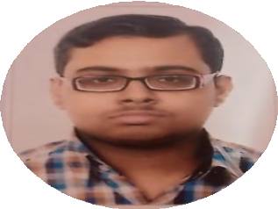

 8334876618,9875440692

→ [saswatadhar97@gmail.com](mailto:saswatadhar97@gmail.com)

 https://github.com/SASWATA1997

↑ https://[www.linkedin.com/in/saswata-](http://www.linkedin.com/in/saswata-) dhar-71662917b/

 North 24 Parganas, W.Bengal, India

SASWATA DHAR

Software Developer

# Career Objective

To work with a company which appreciates innovation so that I can enhance my knowledge and skills to give my best growth of the company.

# KEY SKILLS

**Software Development**

**Requirement Gathering**

**Unit Testing**

**Agile Methodology**

**Documentation**

**Coordination**

**Troubleshooting**

**Automation**

**EDUCATION**

**TECHNO INDIA UNIVERSITY,WEST BENGAL** Aug '17 - Present

**IMCA, DEPT- Computer APPLICATION**

**RAMAKRISHNA VIVEKANANDA MISSION VIDYABHAVAN,BARRACKPORE**

**10+2 (WBCHSE) BOARD EXAM**

# TECHNICAL SKILLS

**8.28 CGPA**

**67.8%**

KOLKATA,W.B

Apr '16

24 PGS(N),W.B

**Languages**: Python, Java, Asp.NET, HTML, CSS, JavaScript.

**OS**: Windows, Linux. **Software**: Apache. **Database**: MySQL, Oracle .

# CERTIFICATIONS

SAP S4 HANA DEVELOPMENT(ABAP)

# PROJECT

* Encrypted Database system research based python project(MCA Final year)
* Covid Details Portal(AJS)
* ONLINE SHOPPING CART(J2EEE ),ONLINE MATRIMONY(ASP.NET)

RESULTMANAGEMENTSYSTEM(ASP. NET)

* ASSISTANCE BOT(AIML PYTHON PROJECT)

# EXTRA CARICULAM

COORDINATOR IN COLLEGE FEST.

PLAYING CLASICAL MUSICAL INSTRUMENT(TABLA).

EXCELLENCE AWARD GIVEN FOR BEST DTP DESIGNER IN A PUBLICATION HOUSE(MR.BOOK PUBLICATION) DRAWING,BOOK READING.

CHESS.

# DECLARATION

**I hereby declared that above all information are correct. thank you.**