SASFIT

Program for fitting elementary structural models to small angle scattering data
Joachim Kohlbrecher
(joachim.kohlbrecher@psi.ch)
Paul Scherrer Institute
Spallation Source Division (ASQ)
CH-5232 Villigen PSI

Abstract: sasfit has been written for analyzing and plotting small angle scattering data. It can calculate integral structural parameters like radius of gyration, scattering invariant, Porod constant, as well as size distribution of different formfactors. The program is written to fulfill the needs at the small angle neutron scattering facility at PSI (sans.web.psi.ch).

Contents
Contents 1
Introduction 2
System Requirements and Software Installation 2
Quick overview 2
Data I/O formats 2
Integral structural parameters 2
Analytical size distribution 2
Reference 3

Introduction

System Requirements and Software Installation
Sasfit is a script written in tcl/tk. For the plotting of the data the tcl extension blt has been used. The last version 0.5alpha of sasfit has been tested with the tcl/tk version 8.3 and the blt version 2.4q.

Quick overview

Data I/O formats

Integral structural parameters

Analytical size distribution
Sphere:
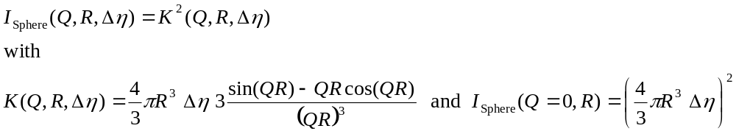
Spherical Shell 1:
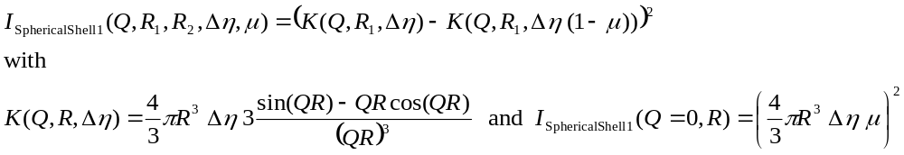

Spherical Shell 2:

Spherical Shell 3:
R₁
R₂
μ Δη
Δη
R
νR
μ Δη
Δη
ΔR
R
Δη₁
Δη₂

Rotational Ellipsoid with half axis R, R, νR:
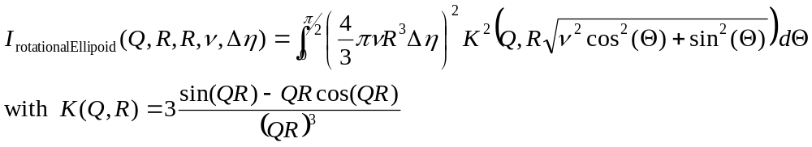
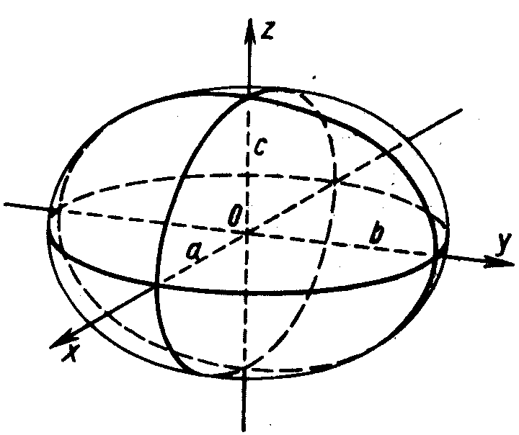
Disc:
Rod:
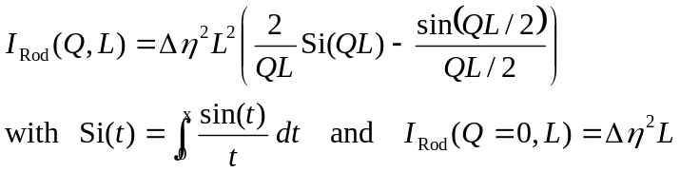
Gauss coil:
Star polymer with Gaussian statistics:
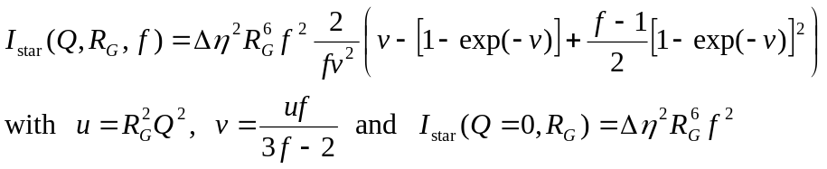

Reference

