Two new structure factors are included in this test version:

“S_pp MC pickering” and “S_pp pickering”

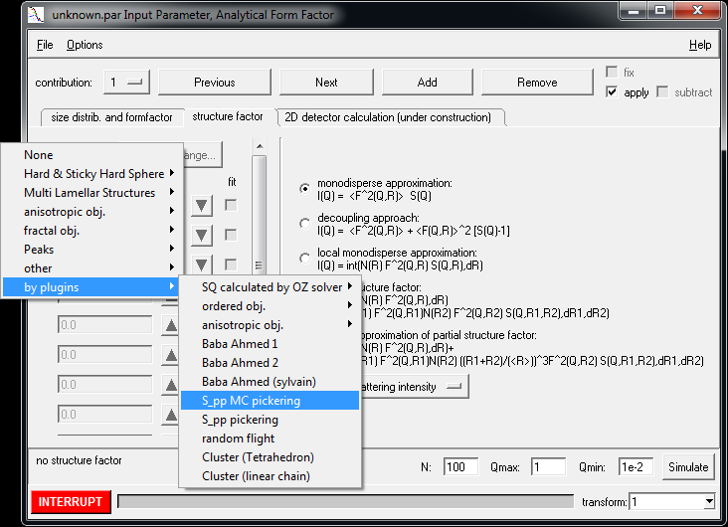

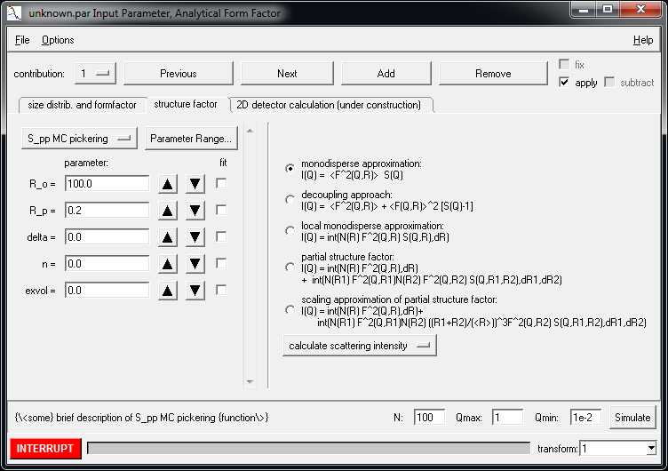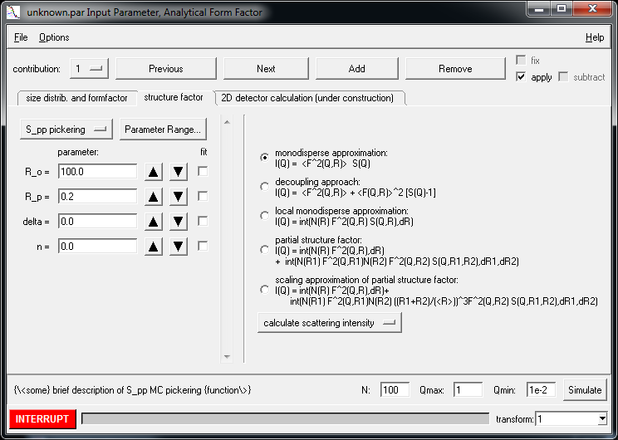

The Monte Carlo version has the input parameters

R0: radius of the particle carrying the micelles

Rp: radius of the micelles or pickering particles

: penetration depth of the pickering particles, =1, no penetration, =-1, full penetration  
in the model it is assumed, that the centers of the micelles are all located at a distance R0+Rp

n: number of micelles per carrier particle

exvol: exvol=0 micelles are allowed to overlap

exvol=1: micelles are not allowed to overlap

Via the menu interface of the simulation or fitting menu one can set some configuration parameters via the menu bar [Options|Cusomize…]

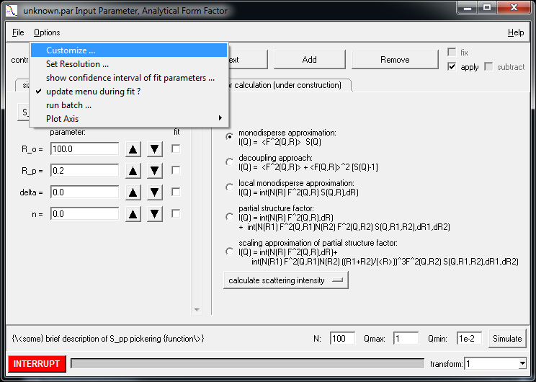 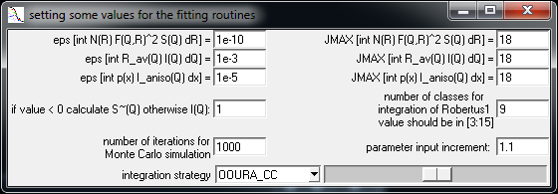

The parameter number of iterations for Monte Carlo simulations is by default set to 1000 but in my test I have found that it might be much lower, depending on the number of particle on the surface. The minimum number of MC representations is internally set to 20, i.e. in case the the input value in the menu is below 20 the entry will be ignored and 20 will be used instead. The maximum is set to 10000. The time tocalculate the structure factor scales with the number of MC representations

The parameter n in the model function strongly influences the calculation time of the MC model. It scales with n^2. The maximum value of n is limited to 1000.