**Precision resection of bone tumor and**

**modeling of personalized bone defect repair**

Ge Qi

Background

Bone tumor is one of the most common and harmful diseases. The treatment of bone tumor is mainly limb salvage surgery, which is very complicated and completely depends on the clinical experience of doctors, and is faced with problems such as recurrence caused by insufficient resection and difficult recovery caused by excessive resection. In addition, how to reconstruct the autogenous bone and fixation plate with a higher matching degree is also an urgent problem to be solved.

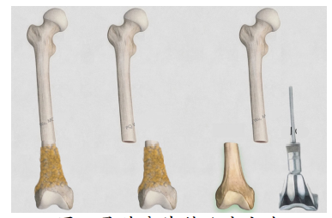

Figure 1: limb salvage surgery

Completed work

Firstly, multimodal registration of CT images and MRI images was performed

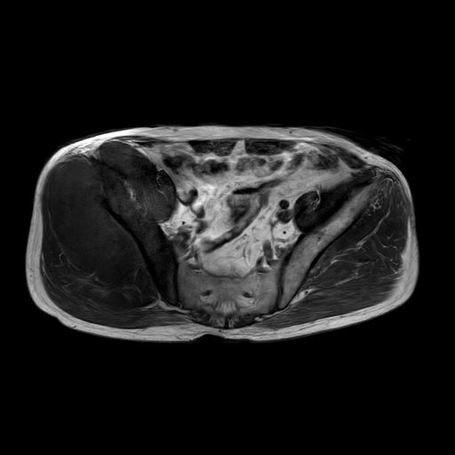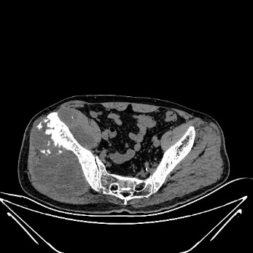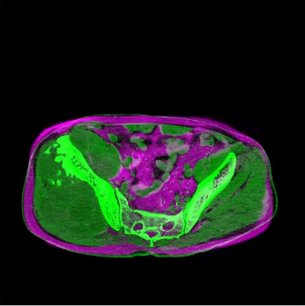

Figure 2: CT and MRI registration (left: MRI, mid: CT, right: registration results)

Secondly, Automatic tumor segmentation was performed by window adjustment, seed point selection and contour extraction

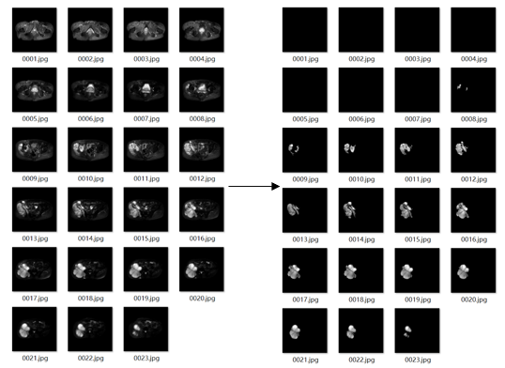

Figure 3: tumor segmentation

3D reconstruction of bone and tumor was performed according to the matrix obtained by registration

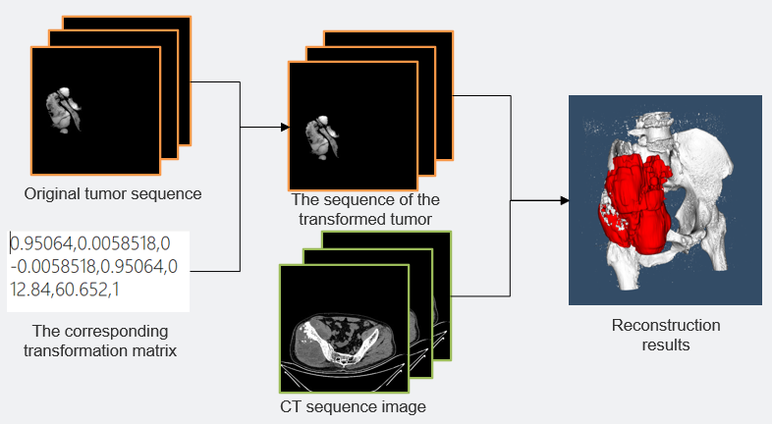

Figure 4: 3D reconstruction

Prospects

According to the 3D reconstruction results and the calculation of the biological force line, the tumor and the lesion bone were excised accurately, then carry out the 3D reconstruction of the graft bone model, and the steel plate for fixation was reversed and reconstructed according to the anchor point technology

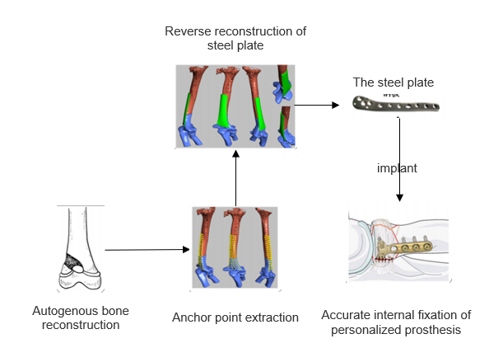

Figure 5: prospects