Git and GitHub both are not same.

1)VCS and Git Repo

2)Staging Area and Commits

3)Branches

4)Issues and pull requests

What is Git?

-------------

--> It is a version control system.

--> Version changes and project save

Installing the Git:-

-----------------------

--> Go to the browser and download the Git.exe file and install.

-->Check the Git installed or not

--> Open command prompt and type git --version

-->Repo is nothing but a folder/project

-->GitHub is one example of remote repository hosting service

1) Remote Repository

2)Local Repository

3)Staging Area --> Staging area is nothing changes yet to be committed area.

4)Working Directory --> it is nothing but untracked section

--> Intialize the git repository to work by using the following command

C:\Users\MSATHEES\OneDrive - Capgemini\Desktop\Network>git init

Initialized empty Git repository in C:/Users/MSATHEES/OneDrive - Capgemini/Desktop/Network/.git/

--> .git folder will be created.

--> To check the status

C:\Users\MSATHEES\OneDrive - Capgemini\Desktop\Network>git status

On branch master

No commits yet

nothing to commit

C:\Users\MSATHEES\OneDrive - Capgemini\Desktop\Network>

--> After creating one file in the folder

C:\Users\MSATHEES\OneDrive - Capgemini\Desktop\Network>git status

On branch master

No commits yet

Untracked files:

(use "git add <file>..." to include in what will be committed)

SRX.docx

nothing added to commit but untracked files present (use "git add" to track)

C:\Users\MSATHEES\OneDrive - Capgemini\Desktop\Network>

--> We will move the files one by one from the working directory to staging area

--> But we will all the files at a time from staging area to local repository(commit), local repository to remote repository (push).

--> In staging area and local repository dont have option to select the files which needs be moved.

The below files are in working directory.

By using git add command we will move the files one by one to the staging area.

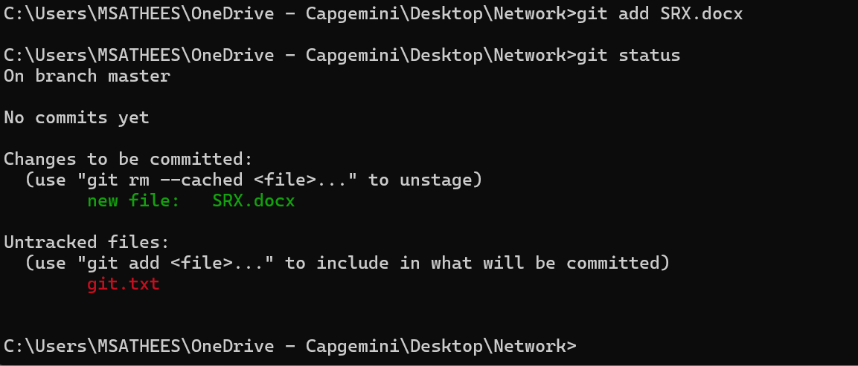

By using git commit command we will move the all files from staging area to local repository at a time with message.

Creating the branch in local repository , master is the default branch in local repository.

The next step is login to the github and create repository.



