**PROGRAM:**

**import** pandas **as** pd

**import** numpy **as** np

**from** sklearn.preprocessing **import** StandardScaler

**from** sklearn.linear_model **import** LogisticRegression

**from** sklearn.model_selection **import** train_test_split

**from** sklearn.metrics **import** accuracy_score, confusion_matrix

**import** matplotlib.pyplot **as** plt

**import** seaborn **as** sns

In [2]:

*#read the data file*

data **=** pd**.**read_csv("/kaggle/input/diabetes-data-set/diabetes.csv")

data**.**head()

Out[2]:

|  | **Pregnancies** | **Glucose** | **BloodPressure** | **SkinThickness** | **Insulin** | **BMI** | **DiabetesPedigreeFunction** | **Age** | **Outcome** |
| --- | --- | --- | --- | --- | --- | --- | --- | --- | --- |
| **0** | 6 | 148 | 72 | 35 | 0 | 33.6 | 0.627 | 50 | 1 |
| **1** | 1 | 85 | 66 | 29 | 0 | 26.6 | 0.351 | 31 | 0 |
| **2** | 8 | 183 | 64 | 0 | 0 | 23.3 | 0.672 | 32 | 1 |
| **3** | 1 | 89 | 66 | 23 | 94 | 28.1 | 0.167 | 21 | 0 |
| **4** | 0 | 137 | 40 | 35 | 168 | 43.1 | 2.288 | 33 | 1 |

In [3]:

data**.**describe()

Out[3]:

|  | **Pregnancies** | **Glucose** | **BloodPressure** | **SkinThickness** | **Insulin** | **BMI** | **DiabetesPedigreeFunction** | **Age** | **Outcome** |
| --- | --- | --- | --- | --- | --- | --- | --- | --- | --- |
| **count** | 768.000000 | 768.000000 | 768.000000 | 768.000000 | 768.000000 | 768.000000 | 768.000000 | 768.000000 | 768.000000 |
| **mean** | 3.845052 | 120.894531 | 69.105469 | 20.536458 | 79.799479 | 31.992578 | 0.471876 | 33.240885 | 0.348958 |
| **std** | 3.369578 | 31.972618 | 19.355807 | 15.952218 | 115.244002 | 7.884160 | 0.331329 | 11.760232 | 0.476951 |
| **min** | 0.000000 | 0.000000 | 0.000000 | 0.000000 | 0.000000 | 0.000000 | 0.078000 | 21.000000 | 0.000000 |
| **25%** | 1.000000 | 99.000000 | 62.000000 | 0.000000 | 0.000000 | 27.300000 | 0.243750 | 24.000000 | 0.000000 |
| **50%** | 3.000000 | 117.000000 | 72.000000 | 23.000000 | 30.500000 | 32.000000 | 0.372500 | 29.000000 | 0.000000 |
| **75%** | 6.000000 | 140.250000 | 80.000000 | 32.000000 | 127.250000 | 36.600000 | 0.626250 | 41.000000 | 1.000000 |
| **max** | 17.000000 | 199.000000 | 122.000000 | 99.000000 | 846.000000 | 67.100000 | 2.420000 | 81.000000 | 1.000000 |

In [4]:

data**.**isnull()**.**sum()

Out[4]:

Pregnancies 0

Glucose 0

BloodPressure 0

SkinThickness 0

Insulin 0

BMI 0

DiabetesPedigreeFunction 0

Age 0

Outcome 0

dtype: int64

We can see there few data for columns Glucose , Insulin, skin thickenss, BMI and Blood Pressure which have value as 0. That's not possible,right? you can do a quick search to see that one cannot have 0 values for these. Let's deal with that. we can either remove such data or simply replace it with their respective mean values. Let's do the latter.

In [5]:

*#here few misconception is there lke BMI can not be zero, BP can't be zero, glucose, insuline can't be zero so lets try to fix it*

*# now replacing zero values with the mean of the column*

data['BMI'] **=** data['BMI']**.**replace(0,data['BMI']**.**mean())

data['BloodPressure'] **=** data['BloodPressure']**.**replace(0,data['BloodPressure']**.**mean())

data['Glucose'] **=** data['Glucose']**.**replace(0,data['Glucose']**.**mean())

data['Insulin'] **=** data['Insulin']**.**replace(0,data['Insulin']**.**mean())

data['SkinThickness'] **=** data['SkinThickness']**.**replace(0,data['SkinThickness']**.**mean())

In [6]:

*#now we have dealt with the 0 values and data looks better. But, there still are outliers present in some columns.lets visualize it*

fig, ax **=** plt**.**subplots(figsize**=**(15,10))

sns**.**boxplot(data**=**data, width**=** 0.5,ax**=**ax, fliersize**=**3)

Out[6]:

<Axes: >

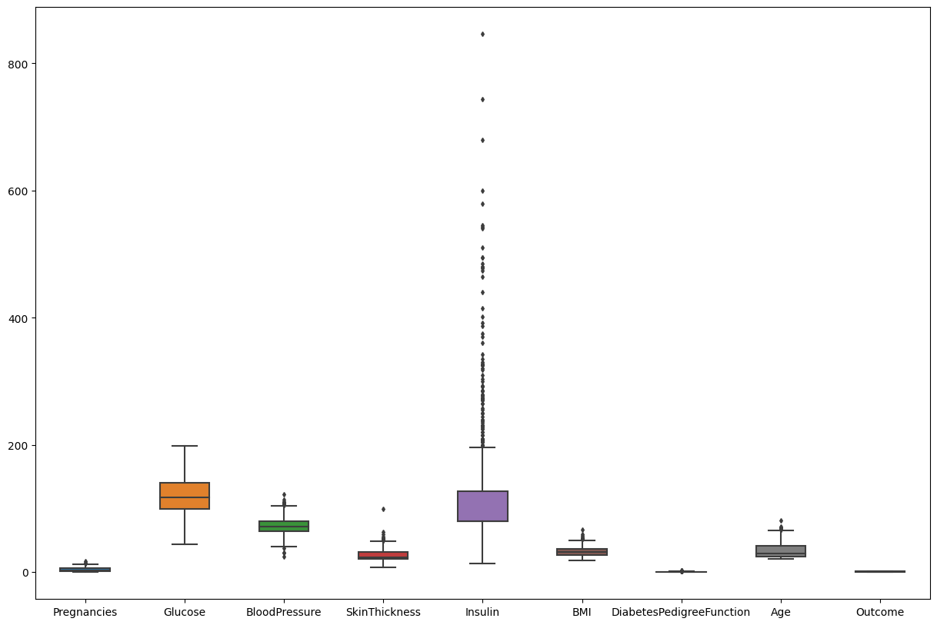

In [7]:

data**.**head()

Out[7]:

|  | **Pregnancies** | **Glucose** | **BloodPressure** | **SkinThickness** | **Insulin** | **BMI** | **DiabetesPedigreeFunction** | **Age** | **Outcome** |
| --- | --- | --- | --- | --- | --- | --- | --- | --- | --- |
| **0** | 6 | 148.0 | 72.0 | 35.000000 | 79.799479 | 33.6 | 0.627 | 50 | 1 |
| **1** | 1 | 85.0 | 66.0 | 29.000000 | 79.799479 | 26.6 | 0.351 | 31 | 0 |
| **2** | 8 | 183.0 | 64.0 | 20.536458 | 79.799479 | 23.3 | 0.672 | 32 | 1 |
| **3** | 1 | 89.0 | 66.0 | 23.000000 | 94.000000 | 28.1 | 0.167 | 21 | 0 |
| **4** | 0 | 137.0 | 40.0 | 35.000000 | 168.000000 | 43.1 | 2.288 | 33 | 1 |

In [8]:

*#segregate the dependent and independent variable*

X **=** data**.**drop(columns **=** ['Outcome'])

y **=** data['Outcome']

In [9]:

*# separate dataset into train and test*

X_train, X_test, y_train, y_test **=** train_test_split(X,y,test_size**=**0.25,random_state**=**0)

X_train**.**shape, X_test**.**shape

Out[9]:

((576, 8), (192, 8))

In [10]:

**import** pickle

*##standard Scaling- Standardization*

**def** scaler_standard(X_train, X_test):

*#scaling the data*

scaler **=** StandardScaler()

X_train_scaled **=** scaler**.**fit_transform(X_train)

X_test_scaled **=** scaler**.**transform(X_test)

*#saving the model*

file **=** open('standardScalar.pkl','wb')

pickle**.**dump(scaler,file)

file**.**close()

**return** X_train_scaled, X_test_scaled

In [11]:

X_train_scaled, X_test_scaled **=** scaler_standard(X_train, X_test)

In [12]:

X_train_scaled

Out[12]:

array([[ 1.50755225, -1.09947934, -0.89942504, ..., -1.45561965,

-0.98325882, -0.04863985],

[-0.82986389, -0.1331471 , -1.23618124, ..., 0.09272955,

-0.62493647, -0.88246592],

[-1.12204091, -1.03283573, 0.61597784, ..., -0.03629955,

0.39884168, -0.5489355 ],

...,

[ 0.04666716, -0.93287033, -0.64685789, ..., -1.14021518,

-0.96519215, -1.04923114],

[ 2.09190629, -1.23276654, 0.11084355, ..., -0.36604058,

-0.5075031 , 0.11812536],

[ 0.33884418, 0.46664532, 0.78435594, ..., -0.09470985,

0.51627505, 2.953134 ]])

In [13]:

log_reg **=** LogisticRegression()

log_reg**.**fit(X_train_scaled,y_train)

Out[13]:

LogisticRegression()

**In a Jupyter environment, please rerun this cell to show the HTML representation or trust the notebook.  
On GitHub, the HTML representation is unable to render, please try loading this page with nbviewer.org.**

In [14]:

*## Hyperparameter Tuning*

*## GridSearch CV*

**from** sklearn.model_selection **import** GridSearchCV

**import** numpy **as** np

**import** warnings

warnings**.**filterwarnings('ignore')

*# parameter grid*

parameters **=** {

'penalty' : ['l1','l2'],

'C' : np**.**logspace(**-**3,3,7),

'solver' : ['newton-cg', 'lbfgs', 'liblinear'],

}

In [15]:

logreg **=** LogisticRegression()

clf **=** GridSearchCV(logreg, *# model*

param_grid **=** parameters, *# hyperparameters*

scoring**=**'accuracy', *# metric for scoring*

cv**=**10) *# number of folds*

clf**.**fit(X_train_scaled,y_train)

Out[15]:

GridSearchCV(cv=10, estimator=LogisticRegression(),

param_grid={'C': array([1.e-03, 1.e-02, 1.e-01, 1.e+00, 1.e+01, 1.e+02, 1.e+03]),

'penalty': ['l1', 'l2'],

'solver': ['newton-cg', 'lbfgs', 'liblinear']},

scoring='accuracy')

**In a Jupyter environment, please rerun this cell to show the HTML representation or trust the notebook.  
On GitHub, the HTML representation is unable to render, please try loading this page with nbviewer.org.**

In [16]:

clf**.**best_params_

Out[16]:

{'C': 1.0, 'penalty': 'l2', 'solver': 'liblinear'}

In [17]:

clf**.**best_score_

Out[17]:

0.763793103448276

let's see how well our model performs on the test data set.

In [18]:

y_pred **=** clf**.**predict(X_test_scaled)

accuracy = accuracy_score(y_test,y_pred) accuracy

In [19]:

conf_mat **=** confusion_matrix(y_test,y_pred)

conf_mat

Out[19]:

array([[117, 13],

[ 26, 36]])

In [20]:

true_positive **=** conf_mat[0][0]

false_positive **=** conf_mat[0][1]

false_negative **=** conf_mat[1][0]

true_negative **=** conf_mat[1][1]

In [21]:

Accuracy **=** (true_positive **+** true_negative) **/** (true_positive **+**false_positive **+** false_negative **+** true_negative)

Accuracy

Out[21]:

0.796875

In [22]:

Precision **=** true_positive**/**(true_positive**+**false_positive)

Precision

Out[22]:

0.9

In [23]:

Recall **=** true_positive**/**(true_positive**+**false_negative)

Recall

Out[23]:

0.8181818181818182

In [24]:

F1_Score **=** 2**\***(Recall **\*** Precision) **/** (Recall **+** Precision)

F1_Score

Out[24]:

0.8571428571428572

Ln[25]:

**import** pickle

file **=** open('modelForPrediction.pkl','wb')

pickle**.**dump(log_reg,file)

file**.**close()