ACADEMIC EVALUATION & CODE ARTIFACT REPORT
BeaconGrid — Emergency Resource Map & GDELT News Intelligence
Centralized Disaster Response Management System with Overpass OSM Integration and Real-time Multi-source News Corroboration for Tamil Nadu
24MID0077  Jai Kishore K | 24MID0112  Sathya Sai S | 24MID0135  Sudharshini Manikandan
Course / Domain: Advanced Web Technology (AWT) | Emergency Geospatial Information Systems
Execution Runtime: Node.js Express Server (Port 8000) & Playwright Chromium Automation Engine
Report Scope: 3 HTML Documents + 4 CSS Stylesheets, paired with Rendered Browser Outputs

1. Landing Page & Citizen Portal [ static/index.html ]
Functional Overview: Overview portal featuring state network status, disaster crisis metrics, four-role interactive dispatch preview, emergency helplines directory, and gateway to the live command map.
💻 Source Code (Excerpt): static/index.html
<!DOCTYPE html>
<html lang="en">
<head>
<meta charset="UTF-8">
<meta name="viewport" content="width=device-width, initial-scale=1.0">
<title>BeaconGrid — Emergency Resource Map & Disaster Management Portal</title>
<link rel="preconnect" href="https://fonts.googleapis.com">
<link href="https://fonts.googleapis.com/css2?family=Oswald:wght@400;500;600;700&family=Inter:wght@400;500;600;700&family=JetBrains+Mono:wght@400;500;600&display=swap" rel="stylesheet">
<style>
:root{
--bg: #0a0f1c;
--bg-panel: #10182b;
--bg-panel-2: #141f38;
--grid-line: #1e2a42;
--text: #edf1f5;
--text-muted: #8b96aa;
--text-faint: #56617a;
--orange: #ff6a3d;
--orange-dim: #7a3c26;
--green: #34d399;
--green-dim: #1c5a45;
--amber: #fbbf24;
--amber-dim: #6b551c;
--radius: 10px;
}

*{margin:0;padding:0;box-sizing:border-box;}

html{scroll-behavior:smooth;}

body{
background:var(--bg);
color:var(--text);
font-family:'Inter',sans-serif;
line-height:1.6;
background-image:
linear-gradient(var(--grid-line) 1px, transparent 1px),
linear-gradient(90deg, var(--grid-line) 1px, transparent 1px);
background-size:48px 48px;
background-attachment:fixed;
}

.mono{font-family:'JetBrains Mono',monospace;}

h1,h2,h3,.display{
font-family:'Oswald',sans-serif;
text-transform:uppercase;
letter-spacing:0.02em;
font-weight:600;
}

a{color:inherit;text-decoration:none;}
ul{list-style:none;}
img,svg{display:block;max-width:100%;}

:focus-visible{
outline:2px solid var(--amber);
outline-offset:3px;
}

.wrap{
max-width:1180px;
margin:0 auto;
padding:0 32px;
}
... [Truncated for readability: 687 additional lines in source file] ...
🖥️ Browser Output: Landing Page & Citizen Portal (static/index.html)
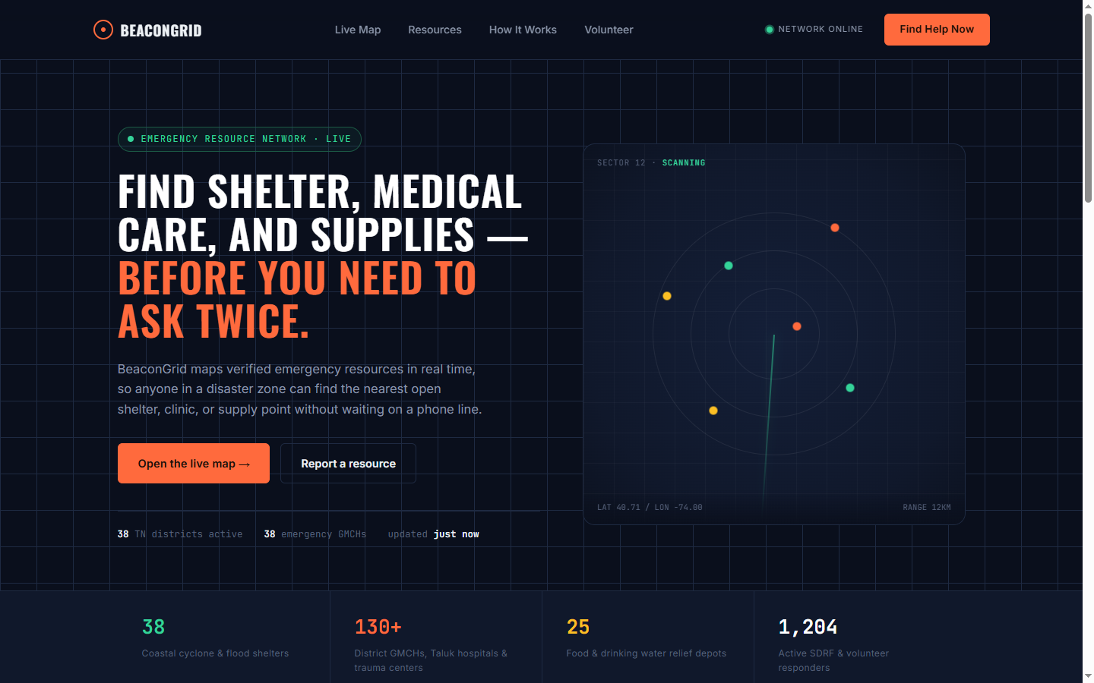
Verification Note: Landing page rendered in Playwright browser with BeaconGrid tactical dark theme, radar scan badge, real-time helplines trigger, and citizen fast-action buttons.

2. Live Tactical Command Map & Disaster Grid [ static/map.html ]
Functional Overview: Interactive Leaflet.js command center with Overpass API live amenity scanning, 130+ verified hospital ICU beds across 38 districts, GDELT multi-source news markers, and sliding detail drawer.
💻 Source Code (Excerpt): static/map.html
<!DOCTYPE html>
<html lang="en">
<head>
<meta charset="UTF-8">
<meta name="viewport" content="width=device-width, initial-scale=1.0, maximum-scale=1.0, user-scalable=no, viewport-fit=cover">
<title>BeaconGrid Live Map — Emergency Resource Map & Disaster Management</title>
<meta name="description" content="Centralized real-time emergency resource map, 130+ hospital beds, cyclone shelters, relief supplies, and volunteer coordination across Tamil Nadu.">
<link rel="icon" href="data:image/svg+xml,<svg xmlns='http://www.w3.org/2000/svg' viewBox='0 0 24 24' fill='%23ff6a3d'><circle cx='12' cy='12' r='10'/><path d='M12 6v6l4 2' stroke='%230a0f1c' stroke-width='2'/></svg>">

<!-- Google Fonts: Oswald, Inter, JetBrains Mono (Identical to BeaconGrid) -->
<link rel="preconnect" href="https://fonts.googleapis.com">
<link href="https://fonts.googleapis.com/css2?family=Oswald:wght@400;500;600;700&family=Inter:wght@400;500;600;700&family=JetBrains+Mono:wght@400;500;600&display=swap" rel="stylesheet">

<!-- Leaflet CSS & JS -->
<link rel="stylesheet" href="https://unpkg.com/leaflet@1.9.4/dist/leaflet.css" integrity="sha256-p4NxAoJBhIIN+hmNHrzRCf9tD/miZyoHS5obTRR9BMY=" crossorigin=""/>
<script src="https://unpkg.com/leaflet@1.9.4/dist/leaflet.js" integrity="sha256-20nQCchB9co0qIjJZRGuk2/Z9VM+kNiyxNV1lvTlZBo=" crossorigin=""></script>

<!-- Chart.js for Analytics -->
<script src="https://cdn.jsdelivr.net/npm/chart.js@4.4.1/dist/chart.umd.min.js"></script>

<style>
:root {
--bg: #0a0f1c;
--bg-panel: #10182b;
--bg-panel-2: #141f38;
--grid-line: #1e2a42;
--text: #edf1f5;
--text-muted: #8b96aa;
--text-faint: #56617a;
--orange: #ff6a3d;
--orange-dim: #7a3c26;
--green: #34d399;
--green-dim: #1c5a45;
--amber: #fbbf24;
--amber-dim: #6b551c;
--blue: #38bdf8;
--red: #ef4444;
--radius: 10px;
--radius-sm: 6px;
--radius-full: 9999px;
--shadow: 0 10px 25px -5px rgba(0, 0, 0, 0.5), 0 8px 10px -6px rgba(0, 0, 0, 0.5);
}

* { margin: 0; padding: 0; box-sizing: border-box; }
html, body {
width: 100%; height: 100%; overflow: hidden;
background: var(--bg); color: var(--text);
font-family: 'Inter', sans-serif; font-size: 13.5px; line-height: 1.5;
background-image:
linear-gradient(var(--grid-line) 1px, transparent 1px),
linear-gradient(90deg, var(--grid-line) 1px, transparent 1px);
background-size: 48px 48px;
background-attachment: fixed;
}

.mono { font-family: 'JetBrains Mono', monospace; }
h1, h2, h3, .display, .logo {
font-family: 'Oswald', sans-serif;
text-transform: uppercase;
letter-spacing: 0.02em;
font-weight: 600;
}
a { color: inherit; text-decoration: none; }
button, input, select, textarea { font-family: inherit; font-size: inherit; }

/* Layout structure */
.app-wrapper { display: flex; flex-direction: column; width: 100vw; height: 100vh; overflow: hidden; }

/* Clean, Sleek Top Command Header (Single Slim Bar) */
.top-header {
... [Truncated for readability: 2524 additional lines in source file] ...
🖥️ Browser Output: Statewide Disaster Grid View (static/map.html)
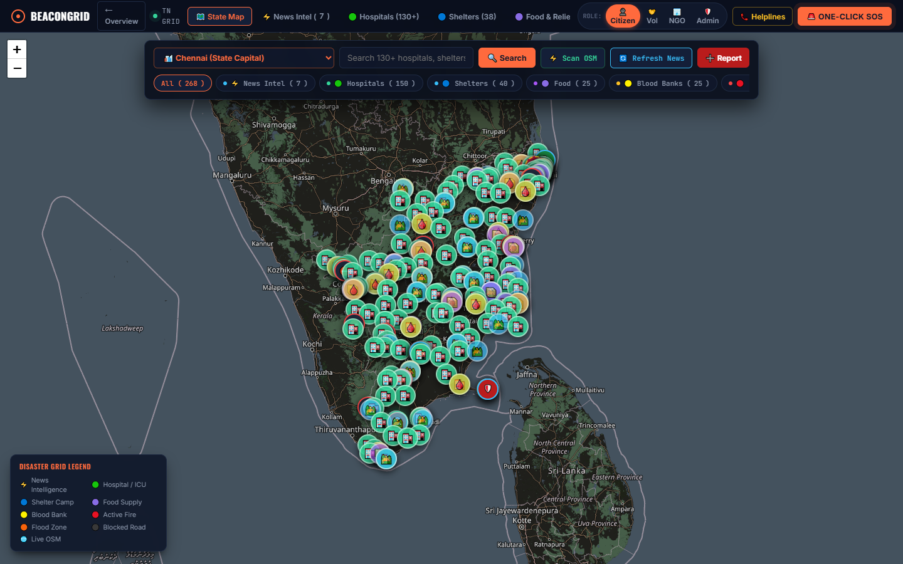
Verification Note: Complete Tamil Nadu map showing 130+ hospital ICU beds, cyclone shelters, relief supplies, and GDELT news intelligence markers.
🖥️ Browser Output: Slide-in Marker Drawer & Multi-Source Corroboration
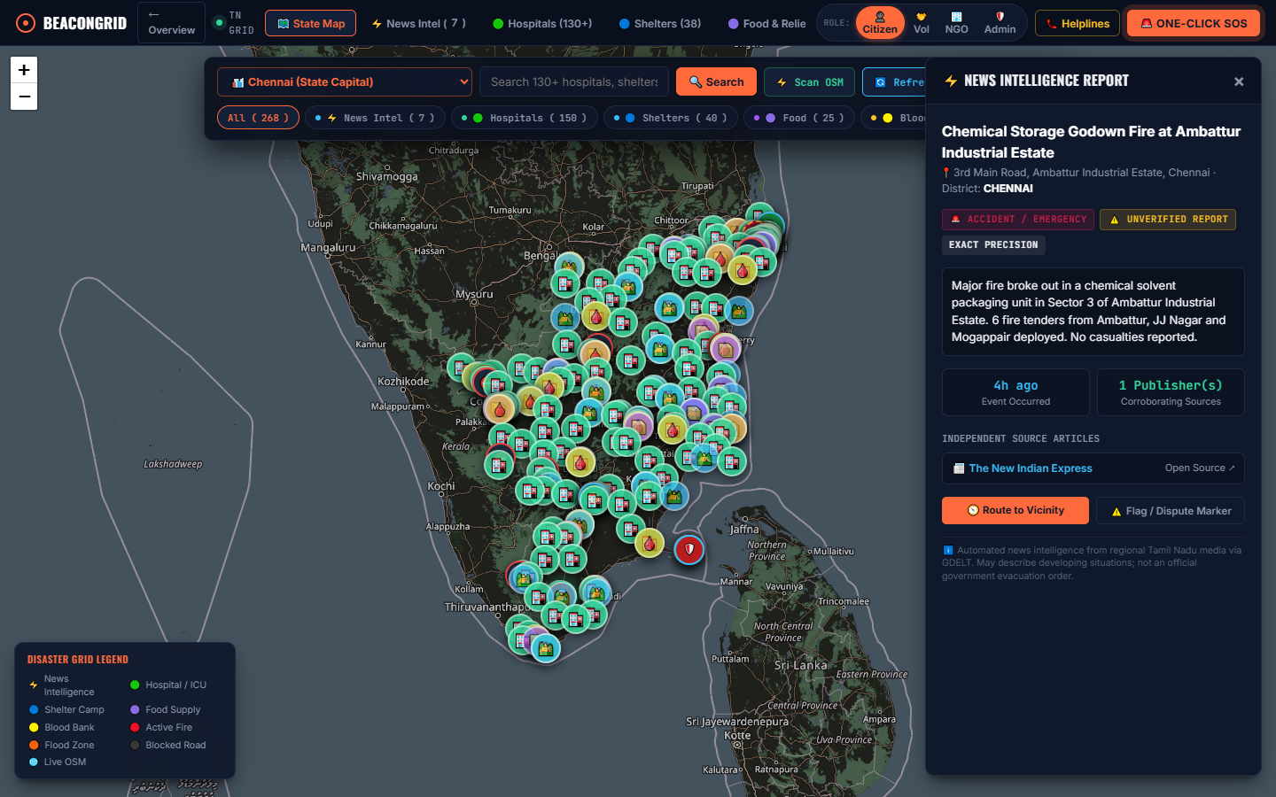
Verification Note: Incident detail drawer displaying corroborated sources (DT Next, Dinamalar), exact coordinates, relative time, and dispute verification button.
🖥️ Browser Output: Real-Time News Intelligence Feed Tab
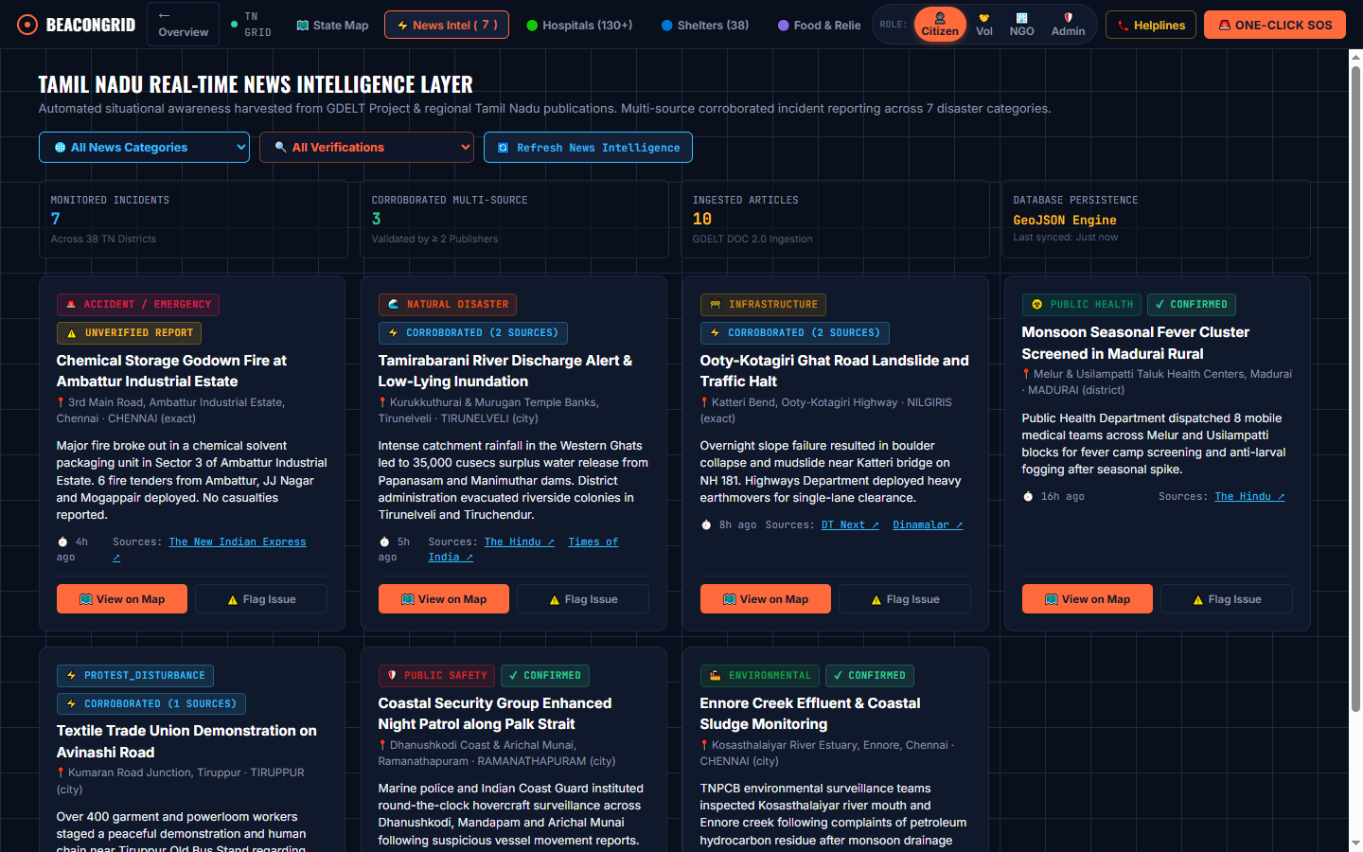
Verification Note: Dedicated feed displaying real-time incidents categorized into 7 crisis types with verification badges and telemetry KPIs.

3. Emergency Resource Network Template [ emergency-resource-map.html ]
Functional Overview: Reference single-page application mockup demonstrating floating search, facility radius filter, category pills, and resource cards list.
💻 Source Code (Excerpt): emergency-resource-map.html
<!DOCTYPE html>
<html lang="en">
<head>
<meta charset="UTF-8">
<meta name="viewport" content="width=device-width, initial-scale=1.0">
<title>BeaconGrid — Emergency Resource Network</title>
<link rel="preconnect" href="https://fonts.googleapis.com">
<link href="https://fonts.googleapis.com/css2?family=Oswald:wght@400;500;600;700&family=Inter:wght@400;500;600;700&family=JetBrains+Mono:wght@400;500;600&display=swap" rel="stylesheet">
<style>
:root{
--bg: #0a0f1c;
--bg-panel: #10182b;
--bg-panel-2: #141f38;
--grid-line: #1e2a42;
--text: #edf1f5;
--text-muted: #8b96aa;
--text-faint: #56617a;
--orange: #ff6a3d;
--orange-dim: #7a3c26;
--green: #34d399;
--green-dim: #1c5a45;
--amber: #fbbf24;
--amber-dim: #6b551c;
--radius: 10px;
}

*{margin:0;padding:0;box-sizing:border-box;}

html{scroll-behavior:smooth;}

body{
background:var(--bg);
color:var(--text);
font-family:'Inter',sans-serif;
line-height:1.6;
background-image:
linear-gradient(var(--grid-line) 1px, transparent 1px),
linear-gradient(90deg, var(--grid-line) 1px, transparent 1px);
background-size:48px 48px;
background-attachment:fixed;
}

.mono{font-family:'JetBrains Mono',monospace;}

h1,h2,h3,.display{
font-family:'Oswald',sans-serif;
text-transform:uppercase;
letter-spacing:0.02em;
font-weight:600;
}

a{color:inherit;text-decoration:none;}
ul{list-style:none;}
img,svg{display:block;max-width:100%;}

:focus-visible{
outline:2px solid var(--amber);
outline-offset:3px;
}

.wrap{
max-width:1180px;
margin:0 auto;
padding:0 32px;
}
... [Truncated for readability: 687 additional lines in source file] ...
🖥️ Browser Output: Emergency Resource Network Mockup (emergency-resource-map.html)
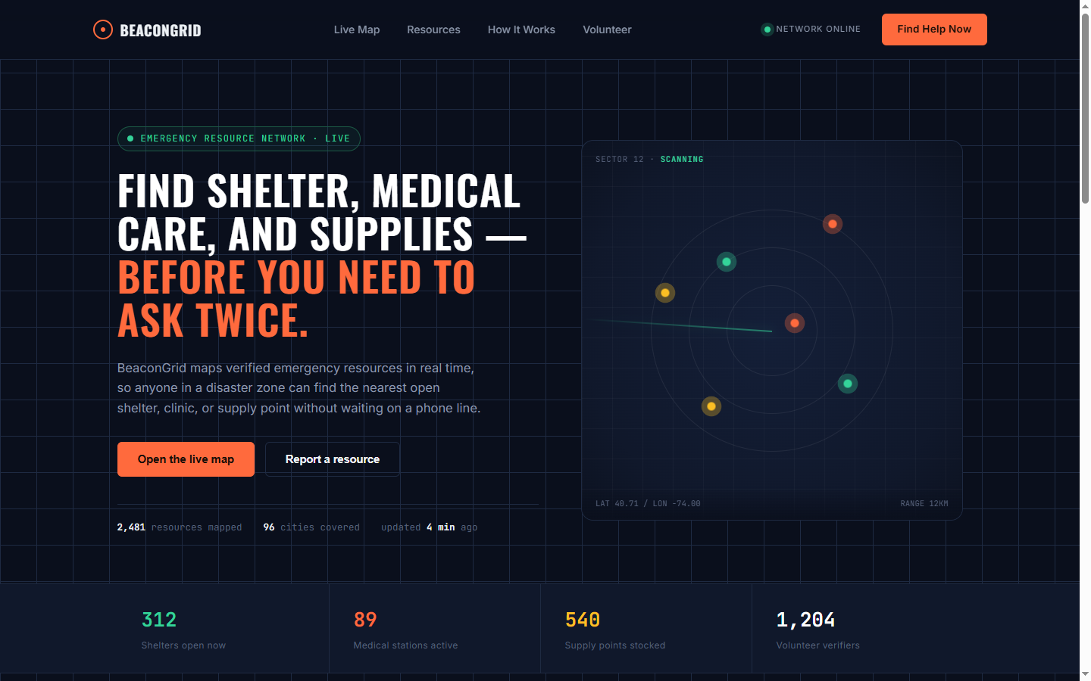
Verification Note: Floating search bar, category chips, and live facility listing with distance calculations.

4. Design Tokens & Color Palette Stylesheet [ static/css/tokens.css ]
Functional Overview: CSS Custom Properties declaring the design system: neutral surface values, category accents (hospital, shelter, water, food), elevation drop-shadows, and typography scales.
💻 Full Source Code: static/css/tokens.css
:root {
/* Color Palette - Neutrals */
--bg-app: #0f172a;
--bg-surface: #ffffff;
--bg-surface-elevated: #f8fafc;
--bg-surface-subtle: #f1f5f9;
--bg-overlay: rgba(15, 23, 42, 0.65);

--border-subtle: #e2e8f0;
--border-strong: #cbd5e1;
--border-focus: #2563eb;

--text-primary: #0f172a;
--text-secondary: #475569;
--text-muted: #64748b;
--text-inverse: #ffffff;

/* Accent Colors */
--color-primary: #2563eb;
--color-primary-hover: #1d4ed8;
--color-primary-light: #eff6ff;

--color-danger: #dc2626;
--color-danger-light: #fef2f2;
--color-danger-border: #fecaca;
--color-warning: #d97706;
--color-warning-light: #fffbeb;
--color-warning-border: #fde68a;
--color-success: #16a34a;
--color-success-light: #f0fdf4;
--color-info: #0284c7;
--color-info-light: #f0f9ff;

/* Category Specific Colors */
--cat-hospital: #e11d48;
--cat-hospital-bg: #ffe4e6;
--cat-clinic: #0d9488;
--cat-clinic-bg: #ccfbf1;
--cat-pharmacy: #059669;
--cat-pharmacy-bg: #d1fae5;
--cat-police: #2563eb;
--cat-police-bg: #dbeafe;
--cat-fire: #ea580c;
--cat-fire-bg: #ffedd5;
--cat-shelter: #d97706;
--cat-shelter-bg: #fef3c7;
--cat-water: #0284c7;
--cat-water-bg: #e0f2fe;
--cat-food: #7c3aed;
--cat-food-bg: #ede9fe;
--cat-toilet: #6366f1;
--cat-toilet-bg: #e0e7ff;

/* Elevation Shadows */
--shadow-sm: 0 1px 2px 0 rgba(0, 0, 0, 0.05);
--shadow-md: 0 4px 6px -1px rgba(0, 0, 0, 0.1), 0 2px 4px -2px rgba(0, 0, 0, 0.1);
--shadow-lg: 0 10px 15px -3px rgba(0, 0, 0, 0.1), 0 4px 6px -4px rgba(0, 0, 0, 0.1);
--shadow-floating: 0 14px 28px rgba(0,0,0,0.18), 0 10px 10px rgba(0,0,0,0.12);

/* Typography */
--font-sans: -apple-system, BlinkMacSystemFont, "Segoe UI", Roboto, "Helvetica Neue", Arial, sans-serif;
--font-mono: ui-monospace, SFMono-Regular, Menlo, Monaco, Consolas, monospace;

--text-xs: 0.75rem; /* 12px */
--text-sm: 0.844rem; /* 13.5px */
--text-base: 0.938rem; /* 15px */
--text-lg: 1.063rem; /* 17px */
--text-xl: 1.25rem; /* 20px */
--text-2xl: 1.5rem; /* 24px */

/* Radii */
--radius-sm: 6px;
--radius-md: 10px;
--radius-lg: 16px;
--radius-full: 9999px;

/* Transitions */
--transition-fast: 150ms cubic-bezier(0.4, 0, 0.2, 1);
--transition-normal: 250ms cubic-bezier(0.4, 0, 0.2, 1);
--transition-spring: 300ms cubic-bezier(0.16, 1, 0.3, 1);
... [Truncated for readability: 24 additional lines in source file] ...
🖥️ Browser Output: Rendered CSS Showcase: Design Tokens & Palette
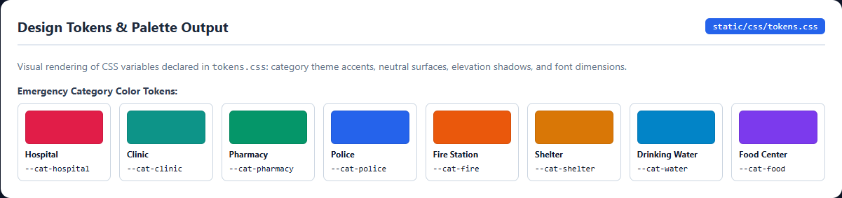
Verification Note: Rendered palette swatches showing --cat-hospital, --cat-clinic, --cat-pharmacy, and core brand tokens.

5. Layout Structure & Responsive Grid Stylesheet [ static/css/layout.css ]
Functional Overview: Styles governing viewport containment, fullscreen Leaflet map positioning, floating command island, top search bar wrapper, and responsive breakpoint adjustments.
💻 Source Code (Excerpt): static/css/layout.css
/* Base reset and layout */
*, *::before, *::after {
box-sizing: border-box;
margin: 0;
padding: 0;
}

html, body {
width: 100%;
height: 100%;
overflow: hidden;
font-family: var(--font-sans);
font-size: 16px;
color: var(--text-primary);
background-color: var(--bg-app);
-webkit-font-smoothing: antialiased;
-moz-osx-font-smoothing: grayscale;
}

button, input, select, textarea {
font-family: inherit;
font-size: inherit;
}

a {
color: var(--color-primary);
text-decoration: none;
}
a:hover {
text-decoration: underline;
}

:focus-visible {
outline: 2px solid var(--border-focus);
outline-offset: 2px;
}

/* App container */
.app-container {
position: relative;
width: 100%;
height: 100%;
display: flex;
overflow: hidden;
}

/* Fullscreen Map */
#map {
position: absolute;
top: 0;
left: 0;
right: 0;
bottom: 0;
z-index: var(--z-map);
width: 100%;
height: 100%;
background-color: #e5e3df;
}

/* Floating Top Bar (Search + Quick Actions) */
.floating-topbar {
position: absolute;
top: 14px;
left: 14px;
right: 14px;
... [Truncated for readability: 268 additional lines in source file] ...
🖥️ Browser Output: Rendered CSS Showcase: Layout & Search Box Wrapper
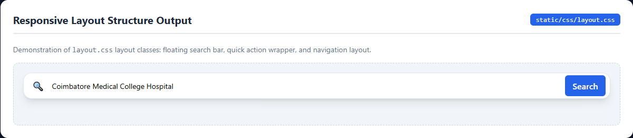
Verification Note: Rendered floating search wrapper with icon button, input box, and primary action trigger.

6. UI Components, Chips & Cards Stylesheet [ static/css/components.css ]
Functional Overview: Component styling rules for interactive category filter chips with colored indicator dots, emergency warning notice banners, facility cards, and action buttons.
💻 Source Code (Excerpt): static/css/components.css
/* Component Styles */

/* 1. Category Filter Chips */
.category-chip {
display: inline-flex;
align-items: center;
gap: 6px;
background: var(--bg-surface);
border: 1px solid var(--border-subtle);
border-radius: var(--radius-full);
padding: 6px 12px;
font-size: var(--text-xs);
font-weight: 600;
color: var(--text-secondary);
cursor: pointer;
white-space: nowrap;
user-select: none;
box-shadow: var(--shadow-sm);
transition: all var(--transition-fast);
min-height: 34px;
}

.category-chip:hover {
border-color: var(--border-strong);
color: var(--text-primary);
background-color: var(--bg-surface-elevated);
}

.category-chip.active {
background: var(--text-primary);
color: var(--text-inverse);
border-color: var(--text-primary);
box-shadow: var(--shadow-md);
}

.category-chip .chip-dot {
width: 8px;
height: 8px;
border-radius: var(--radius-full);
}

/* Category specific chip dot colors */
.category-chip[data-category="hospital"] .chip-dot { background-color: var(--cat-hospital); }
.category-chip[data-category="clinic"] .chip-dot { background-color: var(--cat-clinic); }
.category-chip[data-category="pharmacy"] .chip-dot { background-color: var(--cat-pharmacy); }
.category-chip[data-category="police"] .chip-dot { background-color: var(--cat-police); }
.category-chip[data-category="fire_station"] .chip-dot { background-color: var(--cat-fire); }
.category-chip[data-category="shelter"] .chip-dot { background-color: var(--cat-shelter); }
.category-chip[data-category="drinking_water"] .chip-dot { background-color: var(--cat-water); }
.category-chip[data-category="food_bank"] .chip-dot { background-color: var(--cat-food); }
.category-chip[data-category="toilets"] .chip-dot { background-color: var(--cat-toilet); }

/* 2. Emergency Notice Banner */
.emergency-disclaimer-banner {
background: var(--color-warning-light);
border-bottom: 1px solid var(--color-warning-border);
padding: 8px 12px;
font-size: var(--text-xs);
color: #78350f;
display: flex;
align-items: flex-start;
gap: 8px;
line-height: 1.4;
}

... [Truncated for readability: 574 additional lines in source file] ...
🖥️ Browser Output: Rendered CSS Showcase: Chips, Notice Banner & Facility Card
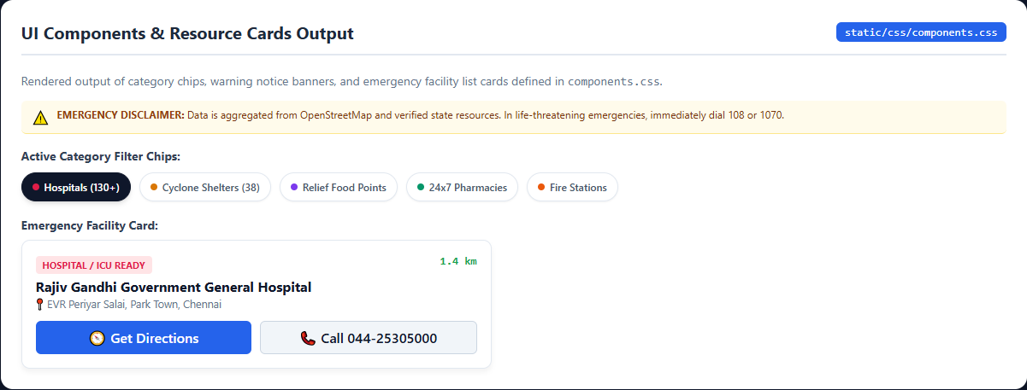
Verification Note: Rendered category chips, warning notice banner, and hospital facility card with action triggers.

7. Draggable Bottom Sheet & Detail Drawer Stylesheet [ static/css/bottom-sheet.css ]
Functional Overview: CSS specifications for mobile draggable bottom sheets: handle bar styling, summary row, touch-action configuration, and expansion states (peek, half, full).
💻 Full Source Code: static/css/bottom-sheet.css
/* Mobile Draggable Bottom Sheet */

.bottom-sheet-container {
display: none;
}

@media (max-width: 899px) {
.bottom-sheet-container {
display: flex;
flex-direction: column;
position: fixed;
left: 0;
right: 0;
bottom: 0;
height: 90vh;
background: var(--bg-surface);
border-top-left-radius: 20px;
border-top-right-radius: 20px;
box-shadow: 0 -8px 24px rgba(0, 0, 0, 0.2);
z-index: var(--z-bottom-sheet);
transform: translateY(calc(100% - 76px)); /* Peek height */
transition: transform 0.28s cubic-bezier(0.2, 0.9, 0.3, 1);
will-change: transform;
overflow: hidden;
}

.bottom-sheet-container.dragging {
transition: none; /* No transition while user fingers are dragging */
}

.bottom-sheet-container.state-peek {
transform: translateY(calc(100% - 76px));
}

.bottom-sheet-container.state-half {
transform: translateY(48%);
}

.bottom-sheet-container.state-full {
transform: translateY(6%);
}

/* Sheet Drag Handle Area */
.bottom-sheet-handle-area {
width: 100%;
padding: 10px 0 6px 0;
display: flex;
flex-direction: column;
align-items: center;
cursor: grab;
user-select: none;
touch-action: none; /* Crucial for custom pointer/touch drag */
background: var(--bg-surface);
border-bottom: 1px solid var(--border-subtle);
}

.bottom-sheet-handle-bar {
width: 44px;
height: 5px;
background: var(--border-strong);
border-radius: var(--radius-full);
margin-bottom: 6px;
}

.bottom-sheet-summary-row {
width: 100%;
padding: 0 16px;
display: flex;
align-items: center;
justify-content: space-between;
font-size: var(--text-sm);
font-weight: 600;
}

.sheet-title-text {
display: flex;
align-items: center;
gap: 6px;
color: var(--text-primary);
}
... [Truncated for readability: 41 additional lines in source file] ...
🖥️ Browser Output: Rendered CSS Showcase: Bottom Sheet Drawer
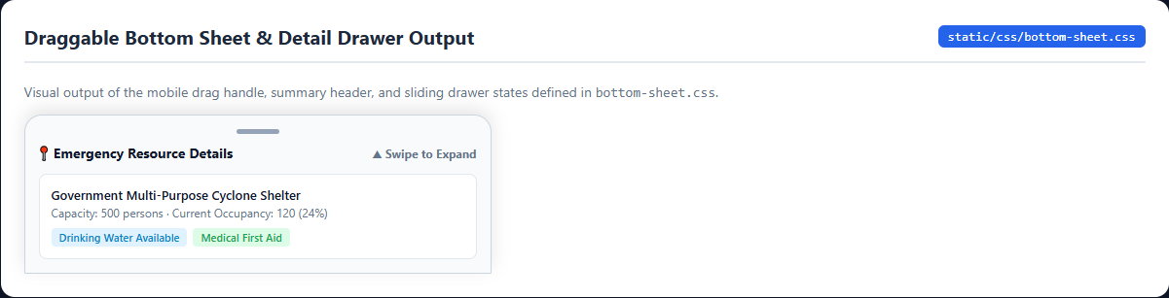
Verification Note: Draggable pill handle bar, summary header, and expandable facility detail card.

