**Predicting IMDb Scores Project Design and Innovation**

|  |  |
| --- | --- |
| **Date** | **04-10-2023** |
| **Team ID** | **3866** |
| **Project Name** | **Predicting IMDb Scores** |

**Table of Contents**

|  |  |
| --- | --- |
| 1 | Introduction |
| 2 | Problem Statement |
| 3 | Design and Innovation Strategies |
| 3.1 | Data Collection and Feature Engineering |
| 3.2 | Model Selection and Training |
| 3.3 | Market Sentiment Analysis |
| 3.4 | Continuous Learning |
| 4 | Conclusion |

**IMDb Score Prediction System Development**

**1. Introduction**

The objective of this document is to provide a comprehensive overview of the design and innovation strategies for the development of an IMDb score prediction system. This system aims to efficiently and accurately predict movie ratings based on various features while addressing concerns such as inefficiency, accuracy, and user-friendliness in the IMDb score prediction process. Ultimately, it will offer valuable insights to movie enthusiasts and professionals in the film industry.

**2. Problem Statement**

The central problem of this project is to create a system capable of predicting IMDb (Internet Movie Database) scores for movies, aiming to estimate the popularity and quality of films accurately. The model will be trained on a comprehensive dataset containing movie attributes such as genre, premiere date, runtime, and language, and it will provide IMDb score predictions as its output. The primary objective is to assist users in identifying highly rated movies that align with their preferences, enhancing their movie-watching experience. The project's success will be measured by the model's ability to deliver precise predictions, making it a valuable tool for both movie enthusiasts and film industry professionals. This predictive system seeks to streamline movie selection and recommendation processes by leveraging data-driven insights. To achieve this, we need to address the following key concerns and requirements:

**3. Design and Innovation Strategies**

**3.1 - Data Collection and Feature Engineering**

* Innovation: Comprehensive Data Gathering
* Implement advanced data collection techniques, including web scraping and real-time API integration, to gather diverse movie-related data such as historical IMDb scores, movie metadata, user ratings, and reviews.
* Apply innovative feature engineering methods to extract meaningful insights from both structured and unstructured data sources. Techniques like sentiment analysis and keyword extraction will be explored to enhance prediction accuracy.

**3.2 - Model Selection and Training**

* Innovation: Advanced Machine Learning Algorithms
* Explore a wide range of machine learning algorithms, including regression, decision trees, and neural networks, to determine the most effective model for IMDb score prediction.
* Investigate ensemble learning techniques, such as Random Forests and Gradient Boosting, to combine the strengths of multiple models and improve prediction accuracy.
* Leverage deep learning models, like convolutional neural networks (CNNs) or recurrent neural networks (RNNs), to capture complex patterns within the data.

**3.3 - Market Sentiment Analysis**

* Innovation: Incorporating External Data Sources
* Integrate external data sources, such as real-time social media sentiment analysis and news sentiment, to gauge market sentiment and its potential impact on IMDb scores.
* Develop advanced NLP techniques for sentiment analysis, including topic modelling and sentiment lexicons tailored to the film industry, to extract valuable insights.

**3.4 - Continuous Learning**

* Innovation: Real-time Model Updates
* Establish a continuous learning framework that continuously updates the prediction model with real-time user feedback and new data.
* Implement automated data pipelines for seamless data ingestion, processing, and model retraining, ensuring that the system remains up-to-date and accurate.

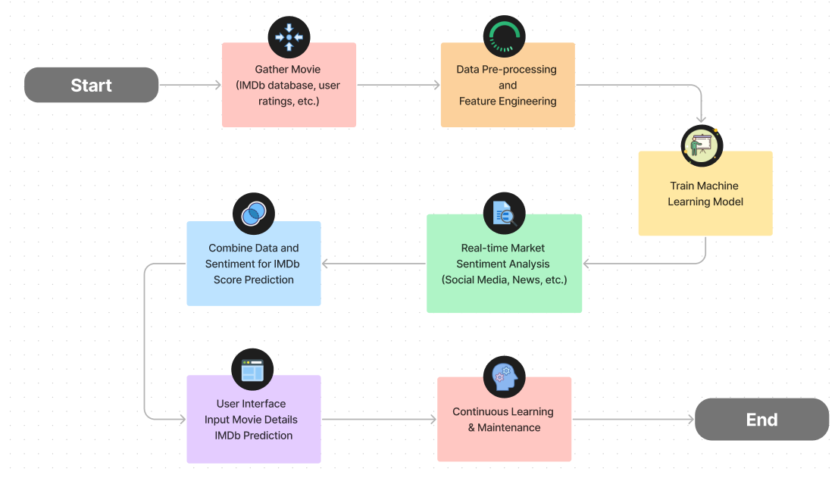

**4. Conclusion**

The IMDb score prediction system project adopts a holistic approach to address the challenges of IMDb score prediction. By implementing innovative strategies such as comprehensive data collection, advanced machine learning algorithms, market sentiment analysis, and continuous learning, our goal is to create an efficient, accurate, and user-friendly system. This system will not only provide valuable insights to movie enthusiasts and industry professionals but also contribute to the advancement of IMDb score prediction through cutting-edge technologies and techniques.