Assignment :- 1

Q 1 ) Create a private repository on GitHub. Inside that repository, under the master branch, add an index.html file.

Then, create a Jenkins job to deploy the index.html file from the remote repository to the HTTP server.

Ans:- 1) integrate Jenkins with git

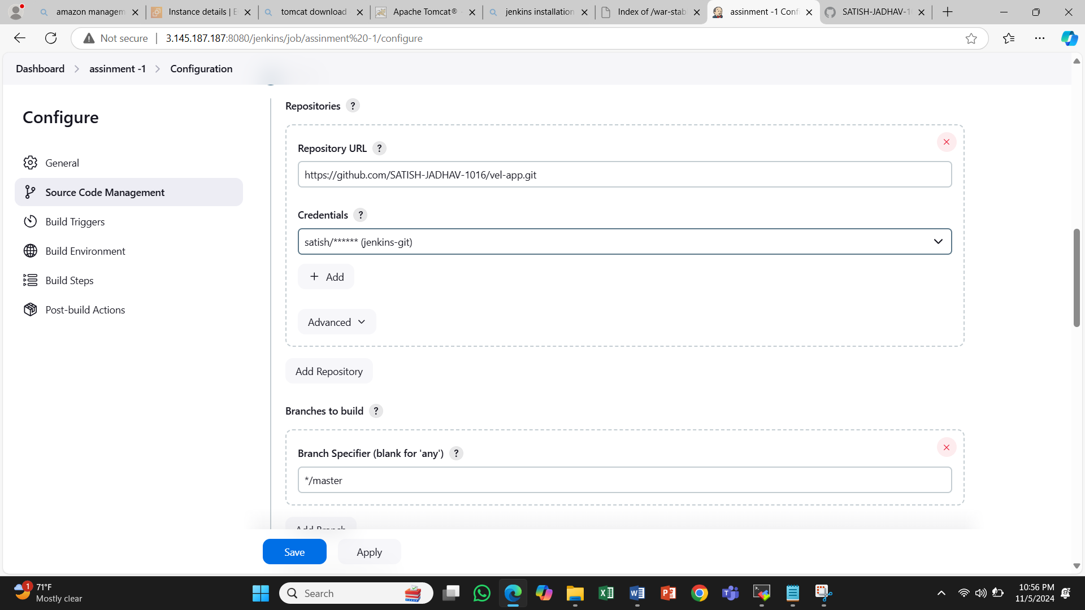

2)Build Step

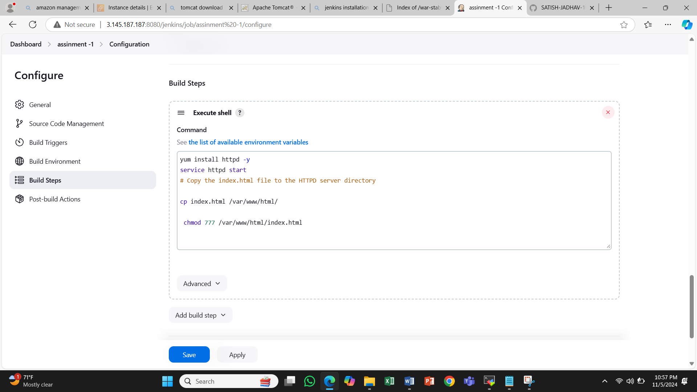

3) Build Execute Status

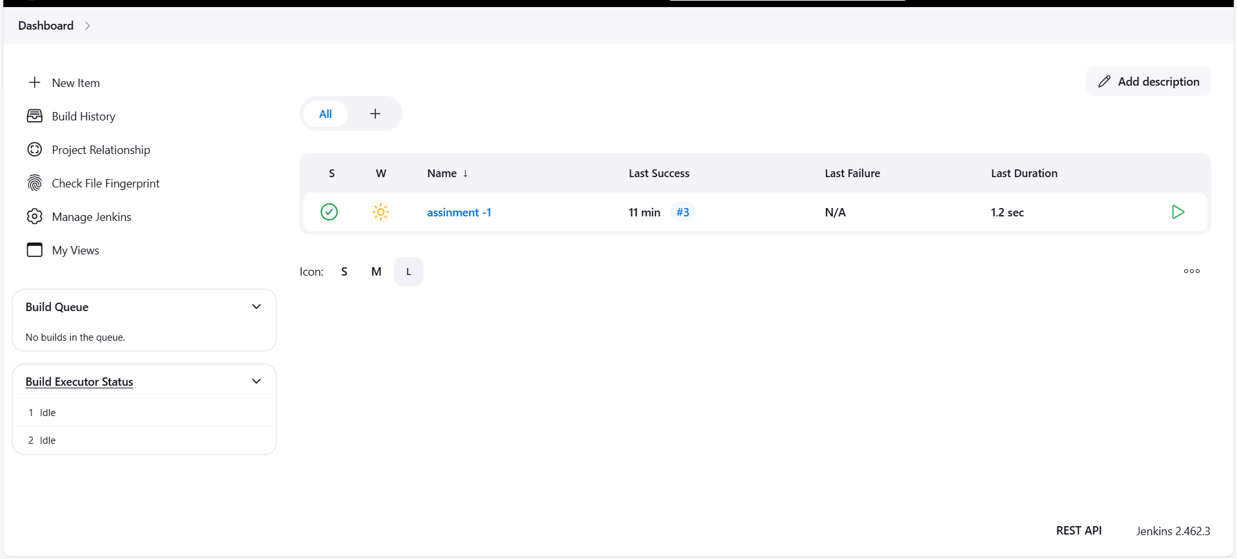

Started by user satish jadhav

Running as SYSTEM

Building in workspace /root/.jenkins/workspace/assinment -1

[WS-CLEANUP] Deleting project workspace...

[WS-CLEANUP] Deferred wipeout is used...

The recommended git tool is: NONE

using credential jenkins-git

Cloning the remote Git repository

Cloning repository https://github.com/SATISH-JADHAV-1016/vel-app.git

> git init /root/.jenkins/workspace/assinment -1 # timeout=10

Fetching upstream changes from https://github.com/SATISH-JADHAV-1016/vel-app.git

> git --version # timeout=10

> git --version # 'git version 2.40.1'

using GIT_ASKPASS to set credentials jenkins-git

> git fetch --tags --force --progress -- https://github.com/SATISH-JADHAV-1016/vel-app.git +refs/heads/*:refs/remotes/origin/* # timeout=10

> git config remote.origin.url https://github.com/SATISH-JADHAV-1016/vel-app.git # timeout=10

> git config --add remote.origin.fetch +refs/heads/*:refs/remotes/origin/* # timeout=10

Avoid second fetch

> git rev-parse refs/remotes/origin/master^{commit} # timeout=10

Checking out Revision 2246c1dc4abf03d9e0c1500817537ec9b0ad797c (refs/remotes/origin/master)

> git config core.sparsecheckout # timeout=10

> git checkout -f 2246c1dc4abf03d9e0c1500817537ec9b0ad797c # timeout=10

Commit message: "Update index.html"

First time build. Skipping changelog.

[assinment -1] $ /bin/sh -xe /mnt/server/apache-tomcat-9.0.96/temp/jenkins16649771343588122318.sh

+ yum install httpd -y

Loaded plugins: extras_suggestions, langpacks, priorities, update-motd

Resolving Dependencies

--> Running transaction check

---> Package httpd.x86_64 0:2.4.62-1.amzn2.0.2 will be installed

--> Processing Dependency: httpd-filesystem = 2.4.62-1.amzn2.0.2 for package: httpd-2.4.62-1.amzn2.0.2.x86_64

--> Processing Dependency: httpd-tools = 2.4.62-1.amzn2.0.2 for package: httpd-2.4.62-1.amzn2.0.2.x86_64

--> Processing Dependency: /etc/mime.types for package: httpd-2.4.62-1.amzn2.0.2.x86_64

--> Processing Dependency: httpd-filesystem for package: httpd-2.4.62-1.amzn2.0.2.x86_64

--> Processing Dependency: mod_http2 for package: httpd-2.4.62-1.amzn2.0.2.x86_64

--> Processing Dependency: system-logos-httpd for package: httpd-2.4.62-1.amzn2.0.2.x86_64

--> Processing Dependency: libapr-1.so.0()(64bit) for package: httpd-2.4.62-1.amzn2.0.2.x86_64

--> Processing Dependency: libaprutil-1.so.0()(64bit) for package: httpd-2.4.62-1.amzn2.0.2.x86_64

--> Running transaction check

---> Package apr.x86_64 0:1.7.2-1.amzn2 will be installed

---> Package apr-util.x86_64 0:1.6.3-1.amzn2.0.1 will be installed

--> Processing Dependency: apr-util-bdb(x86-64) = 1.6.3-1.amzn2.0.1 for package: apr-util-1.6.3-1.amzn2.0.1.x86_64

---> Package generic-logos-httpd.noarch 0:18.0.0-4.amzn2 will be installed

---> Package httpd-filesystem.noarch 0:2.4.62-1.amzn2.0.2 will be installed

---> Package httpd-tools.x86_64 0:2.4.62-1.amzn2.0.2 will be installed

---> Package mailcap.noarch 0:2.1.41-2.amzn2 will be installed

---> Package mod_http2.x86_64 0:1.15.19-1.amzn2.0.2 will be installed

--> Running transaction check

---> Package apr-util-bdb.x86_64 0:1.6.3-1.amzn2.0.1 will be installed

--> Finished Dependency Resolution

Dependencies Resolved

================================================================================

Package Arch Version Repository Size

================================================================================

Installing:

httpd x86_64 2.4.62-1.amzn2.0.2 amzn2-core 1.4 M

Installing for dependencies:

apr x86_64 1.7.2-1.amzn2 amzn2-core 130 k

apr-util x86_64 1.6.3-1.amzn2.0.1 amzn2-core 101 k

apr-util-bdb x86_64 1.6.3-1.amzn2.0.1 amzn2-core 22 k

generic-logos-httpd noarch 18.0.0-4.amzn2 amzn2-core 19 k

httpd-filesystem noarch 2.4.62-1.amzn2.0.2 amzn2-core 25 k

httpd-tools x86_64 2.4.62-1.amzn2.0.2 amzn2-core 89 k

mailcap noarch 2.1.41-2.amzn2 amzn2-core 31 k

mod_http2 x86_64 1.15.19-1.amzn2.0.2 amzn2-core 149 k

Transaction Summary

================================================================================

Install 1 Package (+8 Dependent packages)

Total download size: 1.9 M

Installed size: 5.3 M

Downloading packages:

--------------------------------------------------------------------------------

Total 8.9 MB/s | 1.9 MB 00:00

Running transaction check

Running transaction test

Transaction test succeeded

Running transaction

Installing : apr-1.7.2-1.amzn2.x86_64 1/9

Installing : apr-util-1.6.3-1.amzn2.0.1.x86_64 2/9

Installing : apr-util-bdb-1.6.3-1.amzn2.0.1.x86_64 3/9

Installing : httpd-tools-2.4.62-1.amzn2.0.2.x86_64 4/9

Installing : httpd-filesystem-2.4.62-1.amzn2.0.2.noarch 5/9

Installing : generic-logos-httpd-18.0.0-4.amzn2.noarch 6/9

Installing : mailcap-2.1.41-2.amzn2.noarch 7/9

Installing : mod_http2-1.15.19-1.amzn2.0.2.x86_64 8/9

Installing : httpd-2.4.62-1.amzn2.0.2.x86_64 9/9

Verifying : apr-util-bdb-1.6.3-1.amzn2.0.1.x86_64 1/9

Verifying : httpd-2.4.62-1.amzn2.0.2.x86_64 2/9

Verifying : apr-1.7.2-1.amzn2.x86_64 3/9

Verifying : mod_http2-1.15.19-1.amzn2.0.2.x86_64 4/9

Verifying : apr-util-1.6.3-1.amzn2.0.1.x86_64 5/9

Verifying : mailcap-2.1.41-2.amzn2.noarch 6/9

Verifying : generic-logos-httpd-18.0.0-4.amzn2.noarch 7/9

Verifying : httpd-tools-2.4.62-1.amzn2.0.2.x86_64 8/9

Verifying : httpd-filesystem-2.4.62-1.amzn2.0.2.noarch 9/9

Installed:

httpd.x86_64 0:2.4.62-1.amzn2.0.2

Dependency Installed:

apr.x86_64 0:1.7.2-1.amzn2

apr-util.x86_64 0:1.6.3-1.amzn2.0.1

apr-util-bdb.x86_64 0:1.6.3-1.amzn2.0.1

generic-logos-httpd.noarch 0:18.0.0-4.amzn2

httpd-filesystem.noarch 0:2.4.62-1.amzn2.0.2

httpd-tools.x86_64 0:2.4.62-1.amzn2.0.2

mailcap.noarch 0:2.1.41-2.amzn2

mod_http2.x86_64 0:1.15.19-1.amzn2.0.2

Complete!

+ service httpd start

Redirecting to /bin/systemctl start httpd.service

+ cp index.html /var/www/html/

+ chmod 777 /var/www/html/index.html

Finished: SUCCESS

