1. **DAY 1**

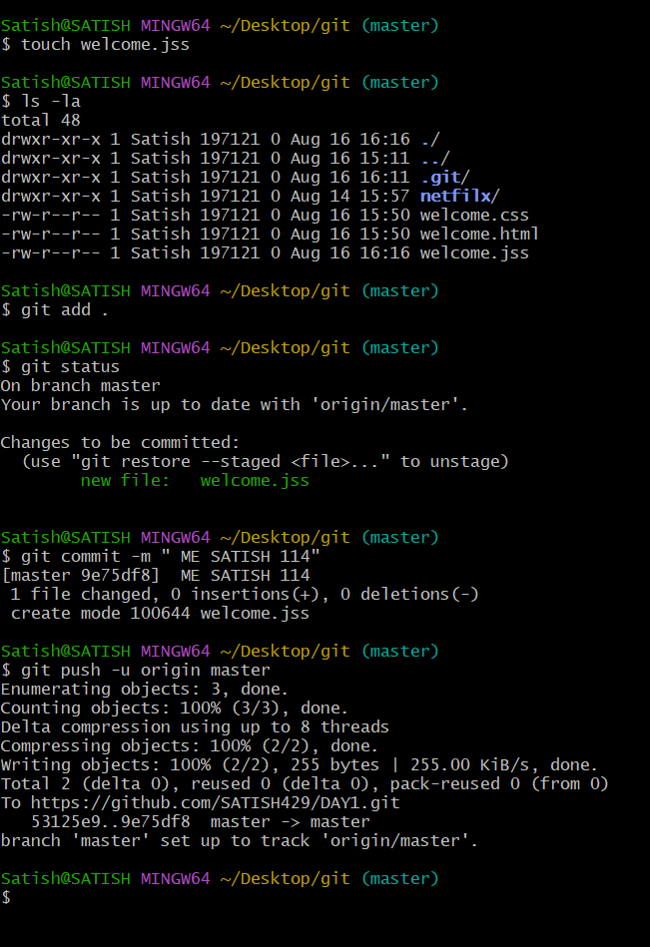

**DAY2**

**TO UPLOAD A DOCUMENT short cut**

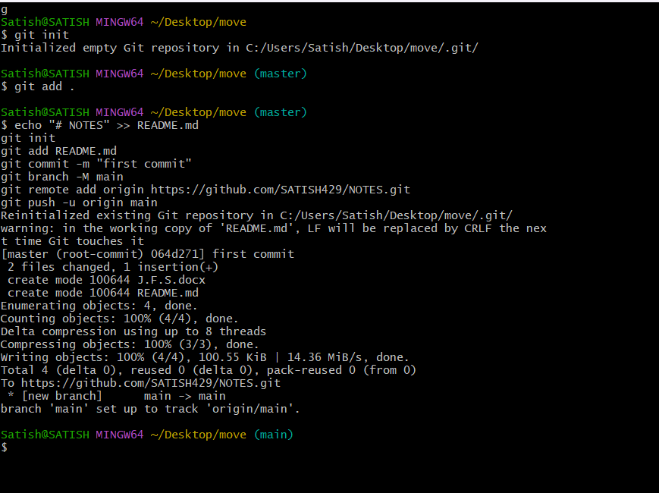

**TO REMOVE THE DATA IN GIT HUB**

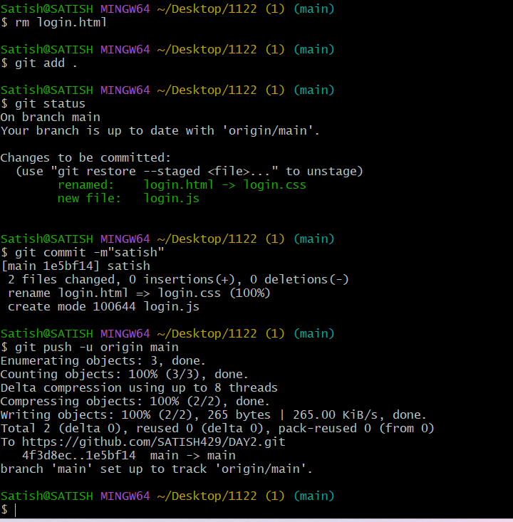

***Interview point of question***

**1.What is water fall and agiler ?**

1. **What htpp and https ?**
2. **What is meant by port ?**
3. **What is difference between 64 &34 bit**
4. **How to convert ip address into binary form**
5. **What is difference between mac,lenux,windows**
6. **What is meant by ssl,ssh**
7. **What is ment by commit in git bas**
8. **How git hub differ with another platforms**

**10.What is meant by remove add origin n**

**What is meant by key gen**

**11.What is dieffert between push,pull,clone**

**12.what is the use authentication token**

**13. how linex differ bt window**

**14.how u can able to provide the other users and previlazors**

**15.what is use of branches**

**16, difference betyween git space . git space add space file name**

**17, what is the use of zira**

**18. what is the use of scrum**

**19,what is the difference between software and hardware**

**20, where you see after 5 years**

***Interview point of question 2***

1. **NAME THREE TYPES WHICH ARE DIPLVATED**
2. **WHAT IS DIFFERENCE BETWWEN RELATIVE URL AND ABSOULD URL**
3. **WHAT IS MEANT BY AREA TAG**
4. **HOW U CAN USE MAP TAG**
5. **SYNTAX OF TABLE TAG**
6. **WHAT IS DIFFER BETWWEN ORDER AND UN ORDER LIST**
7. **WHAT IS USE OF I FRAME**
8. **WHAT IS MENT BY NOSCRIPT**
9. **WHAT IS MENT BY TEXT AERA**
10. **NAME DIFFER WAY IMPLENT IN CSS**
11. **WHAT IS USE OF VISUVAL CODE**
12. **WHAT IS CODE TAG**
13. **NAME ENTERCUTE SET OF PRESENT IN VIDEO TAG**
14. **WHAT IS THE ELEMENT INHTML**
15. **NAME THE PORT WHERE THE LIVE SERVER WORKS**
16. **WHAT IS USE OF INSPECT**
17. **WHAT IS MENT BT BOXSIZING\*\*\*\*\*\*\*\*\*\*\***
18. **HOW ABLE TO CALUCULATE PERFORMANCE OF AN WEBSITE**

***Use for 4k***

**Pixles**

**Freepic\*\*\*\***

**Svg=animation**

**Png=**

**Jpg=**

**To update the data**

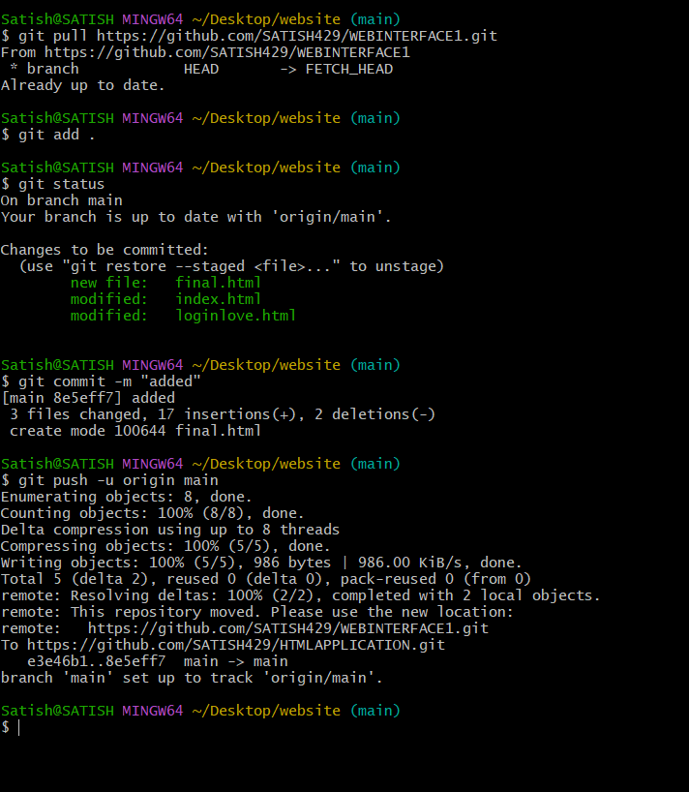

**Company works on these 7 steps**

