Java Introduction:-

Language:- To Communicate we need Some Language. If we want to communicate with Machine we need Some Language.

Programming Language:- We need to use Some Languages C,C++, Java, Python

How can we communicating with a machine without programming Language

Any machine can understand 2 electronic pulses like on and off true/false and 0/1.

Programming Language:- One Person wants to communicating with the machine we need programming Language.

Types of Programming Language:-

1. Machine Understandable Language:- Binay Format
2. Assembly level Language:- Low Level Langugage needs compiler and Interpreter which helps to convert into Machine Language

MS Dos , Assembly

1. High Language

Why do we need to communicate with Machines:- To perform some Tasks

Project vs Product:- Series of Steps to prepare a product is called a project. Developers involves to build a product.

Product end result is called product which is deliverable to the market by a company.

Procedure Oriented Programming Language:- Model which is derived from structured programming. Pascal, COBOL, C

Object Oriented Programming:- Programming model which based upon the concepts of Objects. Objects contain data in the form of attributes and code in the form of Methods. Java, C++, C#, Python,

PHP, JavaScript, Ruby, Perl, Objective-C, Dart, Swift, Scala.

Introduction to Java:- Java is a high-level, robust, Object-oriented Programming Language but it is not pure object oriented Language because it supports Primitive data types.

Platform independent Language.

Java codes are compiled into byte code or machine-independent code. This byte code is run on JVM (Java Virtual Machine)

The syntax is Java is almost the same as C/C++. But java does not support low-level programming functions like pointers.

Java is one of the most popular programming languages in use, especially for client-server web applications.

Java was developed by James Ghosling, Patrick Naughton, Mike Sheridan at Sun Microsystems Inc. in 1991. It took 18 months to develop the first working version.

The initial name was **Oak** but it was renamed to **Java** in 1995 as OAK was a registered trademark of another Tech company.

**Features of Java**

1. Simple:- Easy to learn and its syntax is quite simple, clean and easy to understand
2. Object Oriented:- In Java Everything is an object which has some data and behavior.

It has some basic oops principles.

Object,Class,Inheritance,Polymorphism,Abstraction,Encapsulation.

1. Robust:- Robust. Java is robust as it is **capable of handling run-time errors**, supports automatic garbage collection and exception handling, and avoids explicit pointer concept. Java has a strong memory management system. automatic **Garbage Collector** and **Exception Handling**.
2. Platform Independent:- Write once Run Anywhere.

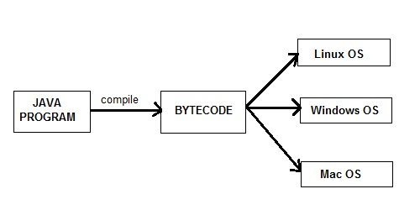

1. Secure When it comes to security, Java is always the first choice. With java secure features it enable us to develop virus free, temper free system. Java program always runs in Java runtime environment with almost null interaction with system OS, hence it is more secure.
2. Architectural Neutral:- You don't have to recompile your Java source code for 32-bit or 64-bit. (So, "architecture" refers to the CPU architecture).
3. Multithreading:- It makes it possible to program that can do many tasks simultaneously. Error checking, It uses the same memory and other resources to execute the multiple threads simultaneously.
4. Portable:- Java program can be carried to any platform means

d) Portable

e) High performance

f) Robust:- Robust. Java is robust as it is **capable of handling run-time errors**, supports automatic garbage collection and exception handling, and avoids explicit pointer concept. Java has a strong memory management system.

g) Secure:- Automatic Garbage Collection and Type safety means that the compiler will validate types while compiling, and throw an error if you try to assign the wrong type to a variable.

h)Multithreaded

i) Distributed

j) Dynamic

k) Oops