HTML vs HTML5

Video and Audio:- There is no Audio and Video but HTML5 supports

Vector Graphics:- It is possible with the help of flash in html but it is an integral part of HTML5 which is used in canvas and SVG

Storage:- We can use the browser cache in html, Application cache, web Application cache is used for Storage.

Webbrowser support

Ease of Use

**New Elements in HTML5:-**

Canvas Tag

<menu > & <figure> tags

<audio> and <video> tag

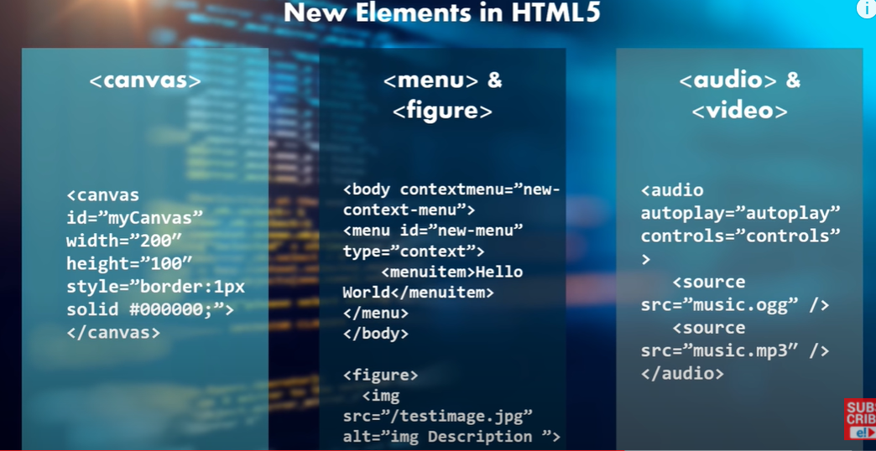

1. **Difference between HTML Elements and Tags**

Element is an individual component which represents the meaning. Ex. <title>

Tag is an root in the html page. <head tag specifies all the elements in head tag.

1. Attributes in html?

It defines the type of the tag

For example <input type=”text”>

<input type=”radio”>

1. Block level element and inline element?

Block level elements is drawn as a block <div> <img> <section>

Inline elements are the elements used in only particular space. <span>, <a>, <b>,<strong>

1. Use of comments in HTML?

To understand the code easily. It will not display in browser. <!—comment -- >

1. What are the tags used to display data in table form?

<table>,<tr><th><td>

1. How to create an hyper link?

<a href=”calendar.jpg”

1. Name some common list for when we design elements?

OrderedList

UnorderedList

Deninition List.

1. What is semantic in HTML?

It is a coding Style. It is used to reinforce the html content in a good way. Example instead of using <b> and <i> we will use <strong> </strong>

1. How to create nested webpage in html?

<iframe src=” [www.google.com](http://www.google.com) “height=400 width=300></iframe>

1. What is an image map?

It is used to linking many different webpages into a single imagWe will use <map>

1. Does hyperlink works for only Text? No it works for both image and text.
2. What is a style sheet?

For adding different styles as templates.

1. Explain the layouts of html?

<htm>

<head>

<tilte>

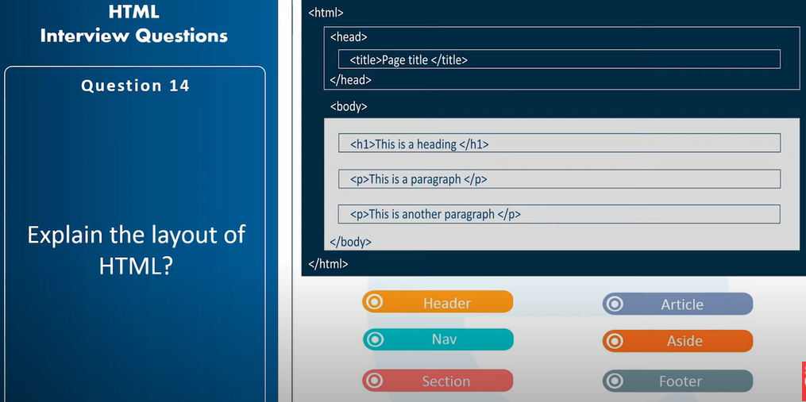

1. Marquee:- used to scrrol,the text,image
2. How to different a page <blockquote>
3. What is the use of alternative text? It is used to understand about what the image about ?
4. How to create a new element ?

<myelement>text </myelement> or <script>document.createElement(“myElement”); </script>

1. <!Doctype> its not an html tag it is used to instruct the browser that this is an HTML page.
2. URL encoded in HTML? It is used to convert the non- ASCII characters into ASCII characters by using % symbol followed by hexadecimal
3. Can we create multi-colored text on webpage?

<font color=”red” ></font>

1. How to make background image in a webpage? <body background=”a1.jpeg”>
2. Use of span Tag? It is used to highlight the text, add color to the text, add background to the text.
3. What is the advantage of collapsing whitespace? To reduce the multiple spaces into single space. This enables you to organize the html code in neat way.
4. Explain the key difference of local storage and session storage objects ? It stores long time but session storge objects will be deleted when session closes. Data will be shared in local storage but it will be specific to partiucal session.
5. What happens when we try to open an external CSS file.? Browser cant open css file because the entension is different. It will be placed inside the html as a link.
6. What is the hierarchy that will be followed in style sheet? Inline, embedded, external stylesheet.
7. How did u create a text that allows you to send an email when it is clicked? <a href=”mailto:sattibabu@gmail.com> </a>
8. How are active links are different from normal links? Based on the color when we place mouse or focus.
9. Are there any instances that text will appear outside of the browser? Yes <td> width which beyonds the browser width. Ideally it will be wrapped to appear inside the browser.
10. Advantages of grouping several checkboxes together?
11. What are the limits of the textfield size? 13 characters by default. If we set size to 0 it will set default 13 characters.
12. What is the use of SVG? SVG is used to determine the two dimensional vector raster graphics. SVG images and behaviors are defined in XML text. We can edit it.

<svg width=”100” height=”100”>

<circle cx=”50” cy=”50” rd=”40” fill=”red” ></circle>   
</svg>

1. List the media types supported by HTML5

IMAGES

AUDIO

VIDOE

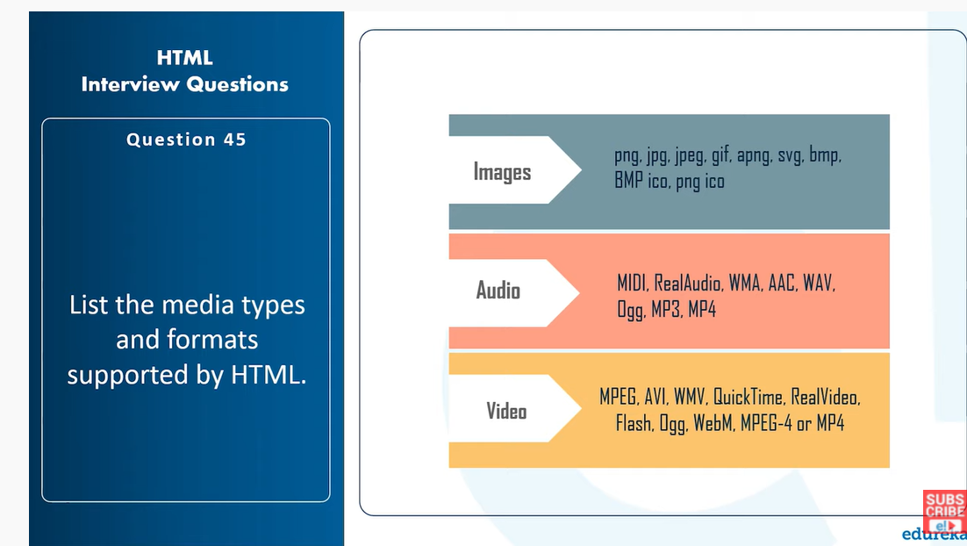

1. What is the difference between Cellspacing and Cellpadding ? Cellspacing is used to define the space between the cells and cellpadding is used to define the space between cell content and boarder.
2. Difference between HTML and XHTML?

HTML static web page---- XHTML dynamic webpage

HTML has pre defined tags---- XHTML user can create his own tags.

HTML is about to displaying an information --- XHTML is about to defining an information.

1. Logical and Physical tags in html? Logical tags are used to mention the browser importance of the encoded text. <strong></strong>

Physical tags. ---How to display the text inside the enclosed the tag.

1. How can you include the javascript ?

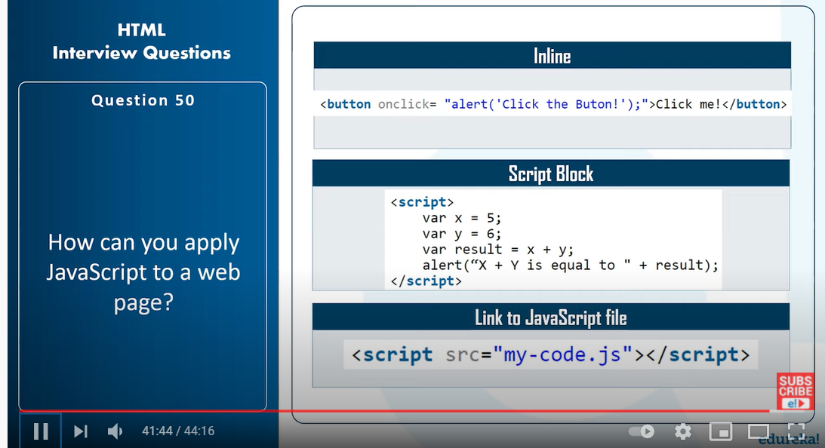

**CSS Interview questions**

1. What is the box Model? What are the properties in BOX model?
2. A BOX which wraps around every single element which includes the content.

Width, height, border,background-color, margin,content.

<link rel=*"stylesheet"* href=*"mystyle.css"*/>

**div**{

height:*100px*;

width: *100px*;

padding: *10px*;

border:*20px* *solid* *red*;

margin:*30px*;

background-color:*blue*;

box-sizing: *border-box*;

}

1. What is specificity?

A)Specificity is to choose when we apply multiple styles to the same text. Browser has to choose which one to pick it up . Means

**div**{

background-color: *green*;

}

**div**{

background-color: *red*;

}

Rules:-

1. 1. It gives important to the Id(1)
2. It gives important to class
3. By default it will pick up the lastone

But when we write div{ background-color:red !important} it will be set by default.

1. How can we align a block element inside another element?

We can use tables, CSS grids, flex box. Plain old CSS

**div***.outer*{

height:*400px*;

width:*400px*;

background-color:*yellow*;

position:*relative*;

}

*.inner*{

height:*100px*;

width:*100px*;

background-color:*green*;

position:*absolute*;

top:*50%*;

left:*50%*;

transform:*translate(-50%,-50%)*;

}

1. Difference between static, relative absolute and Fixed position?

Static is default

Relative:- It will move but will not disturb other elements

Absolute:- It will be placed on another element

Fix:- It wont change the position even we move the scroll bar

1. Difference between visibility hidden and display none. ? It occupies space visibility:hidden; display:none it will not occupy element will not load in DOM.
2. Shadow DOM? Usually Css is global one element style will impact on the other element. Ideally it should not be happened. Shadow dom is a scoped subtree inside an element.

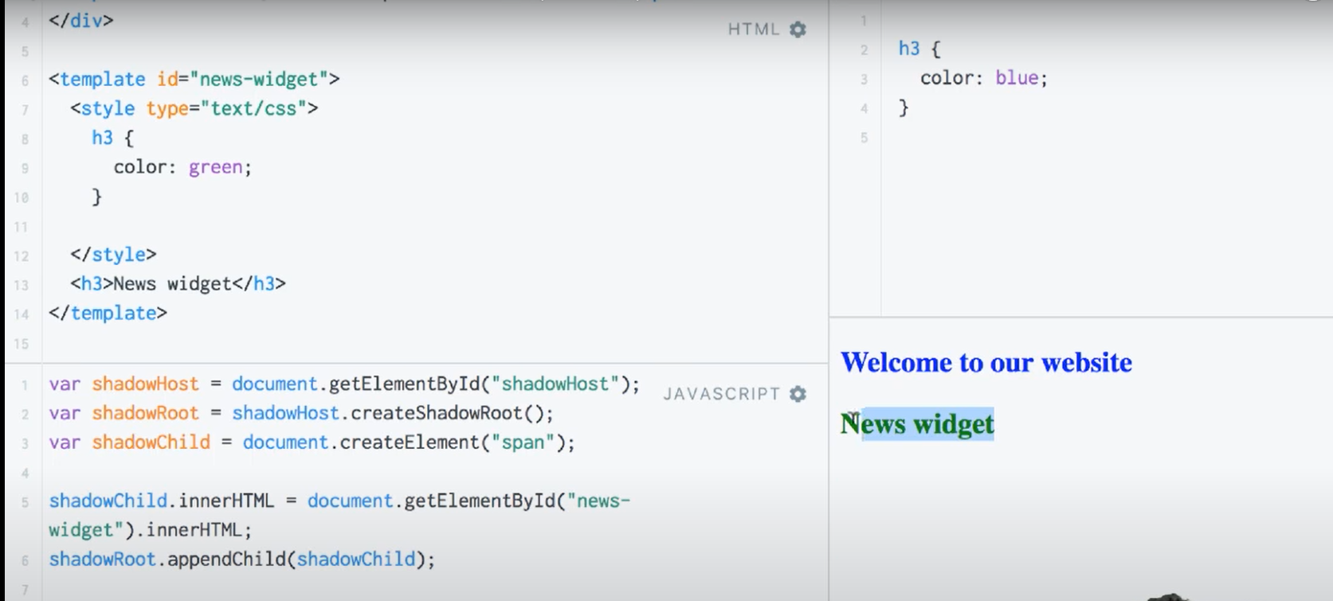

1. Create a triangle?

Create a Rectangle and remove height and width. Border-top:10px solid transparent;border-bottom:100px solid transparent;

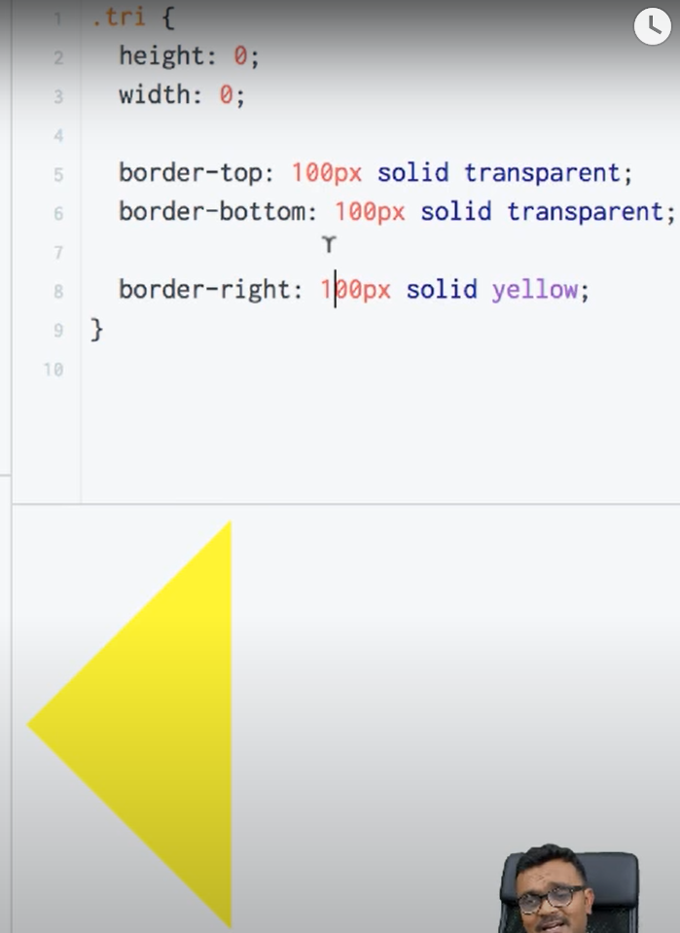

1. What are psudo elements in CSS?

Psudo elements are the elements which are used to add some extra effect to the elements without disturbing any other environment.

<p>Hi

</p>

P::after{

Content: I am injecting to P tag.

}

P::before{

}

P:hover::before{

}

: -- psudo class :: psudo element

1. What are the Data Attributes?

In html if we wanna store data u can use Data Attributes because regular attributes are not suitable to store the data.

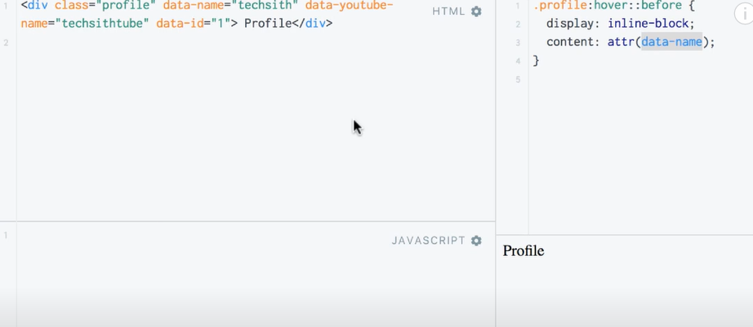

**JavaScript Questions**

1. Difference between let and var?

Let is the scope only within the block. Var can be accessed through out the function scope. Let variable does not availbe before it defines but var variable will be available.

1. Difference between == and ===?

They both are used to comparator operators used to compare values at left and right hand side.

== compares value but not type

=== compares value and type.

1. Difference between let and const?

Once I Assign I cant change for const but I can reassing any number of times for let variable

Const c=1;

C=2; //Argument assignment error.

Need to initialization mandatory

Const c=[1,2];

c.push(3);

console.log(c); //[1,2,3]

c=[1,2,3,4] // error Assignment to constant variable.

1. Difference between undefined and null?

Both represents empty value. If we define and not assign undefined will be placed . place-holder. Developer will assign null.

typeOf(undefined)= undefined;

typeOf(null) =object.

1. What is the use of Arrow function?

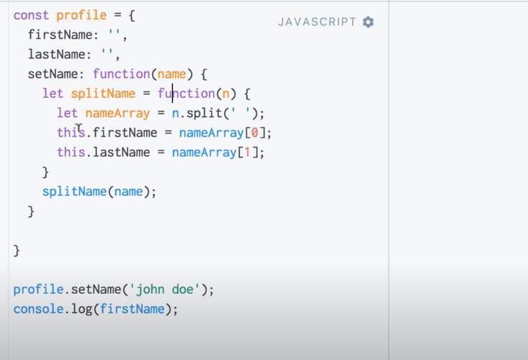

Arrow function will used to set the value to the function instead of window. It is an inner function.

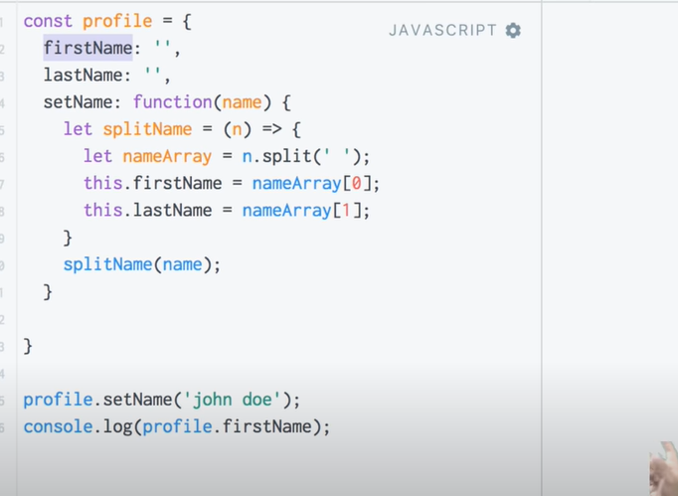

1. What is prototypal inheritance in javascript or prototype based inheritance ?

The property of one object will be used in another object

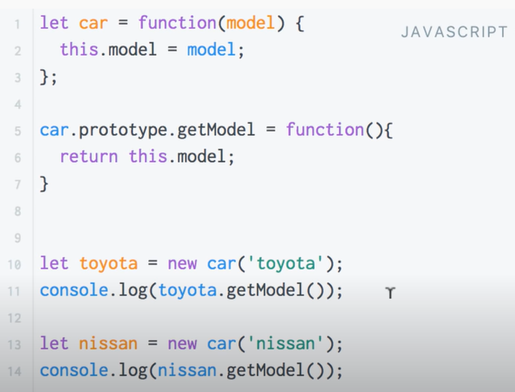

1. Diff between function declaration and function expression?

Just declaring a function anonymous function is called function declaration and assigning the function value to a variable is called function expression.

If we try to access the function which is declared before it will throw an error.

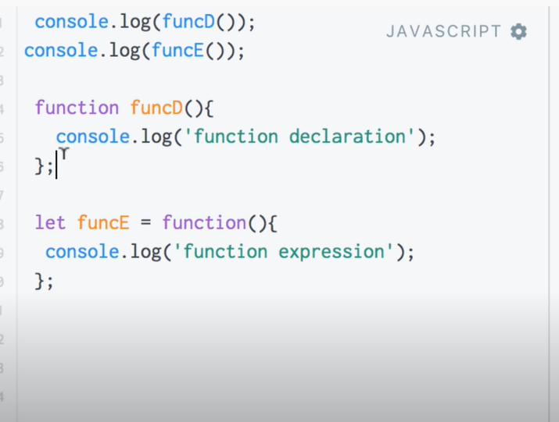

1. What is promises why do we use it ?